Supplemental Fig. 1. Graphical presentation of WHO (solid lines) and pooled SEANUTS (dashed lines) weight-for-age curves (P3, P50 and P97) in boys.
Supplemental Fig. 2. Graphical presentation of WHO (solid lines) and pooled SEANUTS (dashed lines) weight-for-age curves (P3, P50 and P97) in girls.
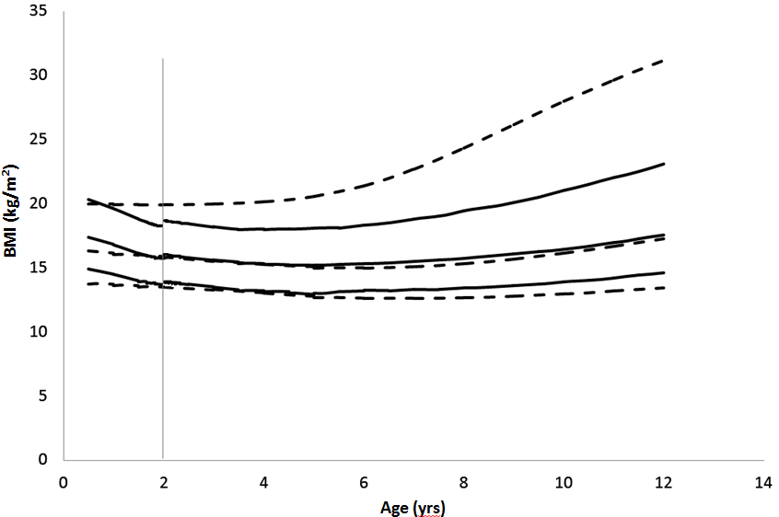
Supplemental Fig. 3. Graphical presentation of WHO (solid lines) and pooled SEANUTS (dashed lines) BMI-for-age curves (P3, P50 and P97) in boys

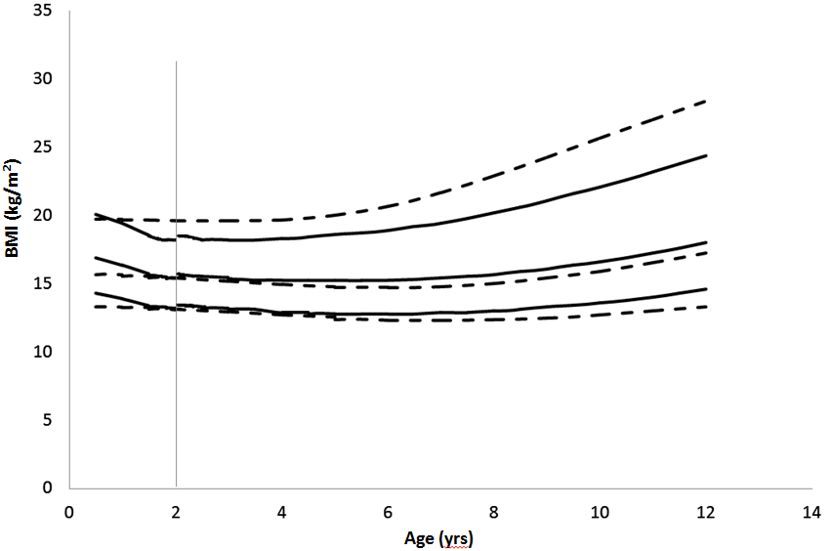
Supplemental Fig. 4. Graphical presentation of WHO (solid lines) and pooled SEANUTS (dashed lines) BMI-for-age curves (P3, P50 and P97) in girls.

