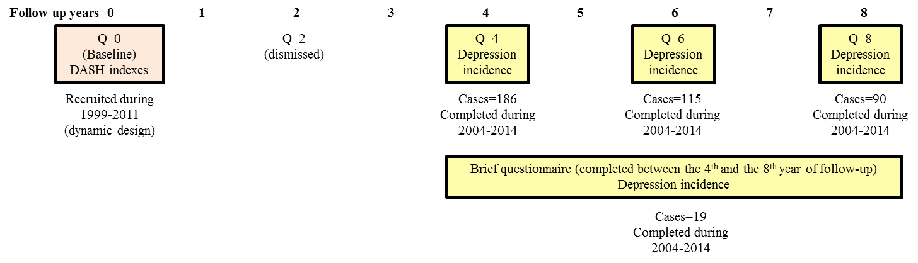
Supplemental Fig. 1: Diagram of the SUN-project including the number of incident cases in each follow-up questionnaire. If incident depression was missing in any of the follow-up questionnaires (Q_4, Q_6 or Q_8) we used the participants' answers to a brief questionnaire (a shorter version of the follow-up questionnaires only used when participants, after several reminders, do not answer to the full-length follow up questionnaires). Abbreviation: DASH, Dietary Approaches to Stop Hypertension; FFQ, Food Frequency Questionnaire.
The SUN (Seguimiento Universidad de Navarra, University of Navarra Follow-up) Project 1999–2011.

