SUPPLEMENTARY MATERIAL

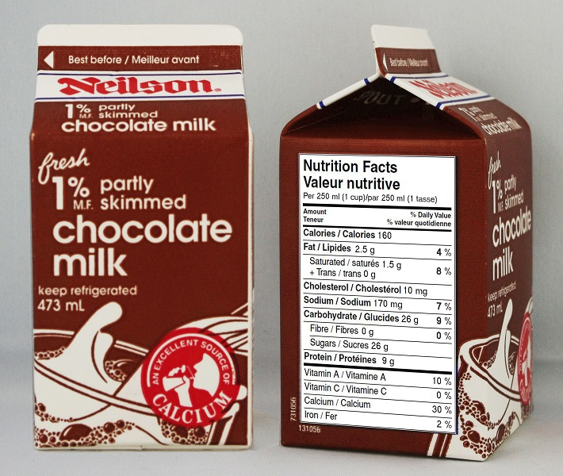

Example milk carton image

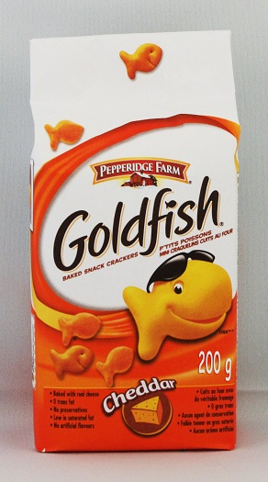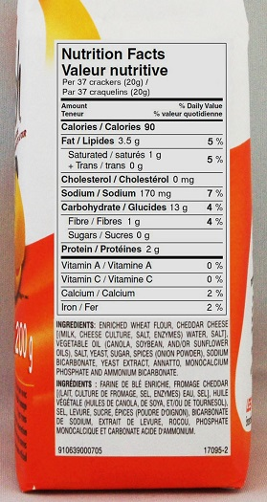
Example cracker package image

Fig. S1 Examples of food package images shown to participants

