Supplementary material
METHODS
Participant demographics
Twelve individuals with TT LL (11/1 males/female; mean age: 33.667± 7.560 years) and eight individuals with TF LL (8 males; mean age: 35.375 ± 8.228 years) participated in the study. All participants were screened to ensure the ability to walk for a minimum of fifteen minutes without the use of an assistive device (beyond the prosthesis) and employment of a prosthesis for a period greater than 6 months (TT LL: 29.100 ± 31.900 months; TF LL: 147.400 ± 137.500 months). Participants in both groups were free of vestibular, auditory, or visual deficits that influence cognitive and/or walking performance and reported an absence of any medication known to alter the activity of the central nervous system. In addition, participants were screened to ensure: i) they did not have any cognitive impairments or decreased learning capabilities as assessed via the Mini Mental State Examination (MMSE) and ii) freedom from drug and alcohol use at the time of participation (assessed by employing a urine screen test and breathalyzer, respectively). All participants wore passive energy storage and return prosthetic feet with suction suspension and demonstrated normal strength and sagittal range of motion for the contralateral uninjured limb. Individuals with TF LL used a mixture of microprocessor controlled as well as mechanical controlled knees. It must be noted, one belt of the treadmill was set to move at the same self-selected speed during the seated conditions to standardize treadmill generated noise across all experimental conditions.

Statistical analysis
Due to a substantial loss of the NASA-TLX¹data for the TF LL group, the analysis of variance (ANOVA) assumptions were not met and thus a non-parametric approach was employed. Specifically, for each group and for each of the six dimensions, the NASA-TLX scores were subjected to a Friedman test in order to detect any difference among the four experimental conditions which were a combination of task condition and difficulty (i.e., low demand seated; high demand seated; low demand walking; high demand walking). Post-hoc analyses were conducted by employing Wilcoxon signed rank to run all the possible pairwise comparisons between the four experimental conditions. Then the false discovery rate (FDR) was employed to control for the multiple comparisons conducted on the six dimensions of the NASA-TLX. All criterion alpha levels were set to p < .050. For consistency the same approach was employed for both groups of participants.

RESULTS
Mental demand
For the mental demand dimension, a difference between the four experimental conditions was identified for the TT (χ² (3) = 20.490, p < .001) and TF (χ² (3) = 9.977, p < .019) LL groups. Post-hoc analyses revealed that for the TT LL group, the mental demand was further elevated as the cognitive task demand increased for both the seated (z = -2.715, p = .016) and the walking (z = -2.937, p =.016) conditions. Mental demand did not differ as a function of difficulty or condition for the TF LL individuals (p > .050) (Figure S1, first row).

Physical demand
A difference between the four experimental conditions was also observed for both the TT (χ² (3) = 19.194, p < .001) and the TF (χ² (3) = 9.966, p < .020) LL participants. Post-hoc analyses revealed that for the TT group, the physical demand was greater as the individuals performed the cognitive task during the walking relative to the seated condition for both the low (z = -2.631, p = .020) and high (z = -2.673, p = .016) cognitive demand. No post-hoc difference was detected for the TF group (p > .050, all comparisons considered) (Figure S1, second row).

Temporal demand
For this dimension, the four experimental conditions were significantly different only for the TT LL group (χ² (3) = 14.735, p < .002). Post-hoc analyses revealed that the temporal demand was larger for the high compared to the low demand for both the seated (z = -2.807, p = .016) and the walking (z = -2.587, p = .020) conditions for the TT LL group. Temporal demand did not differ as a function of difficulty or condition for the TF LL individuals (p > .050) (Figure S1, third row).

Performance
For this subscale, a difference between the four experimental conditions was observed for the TT (χ² (3) = 18.206, p < .001) as well as the TF (χ² (3) = 11.327, p < .010) LL participants. Post-hoc analyses revealed that the TT LL group had a higher perceived performance for the low compared to the high cognitive task demand for the seated (z = -2.675, p = .016) but not for the walking (z = -2.049, p = .093) condition. The same post hoc analysis did not reach the significance level for the TF LL group (p > .050, for all comparisons) (Figure S1, fourth row).

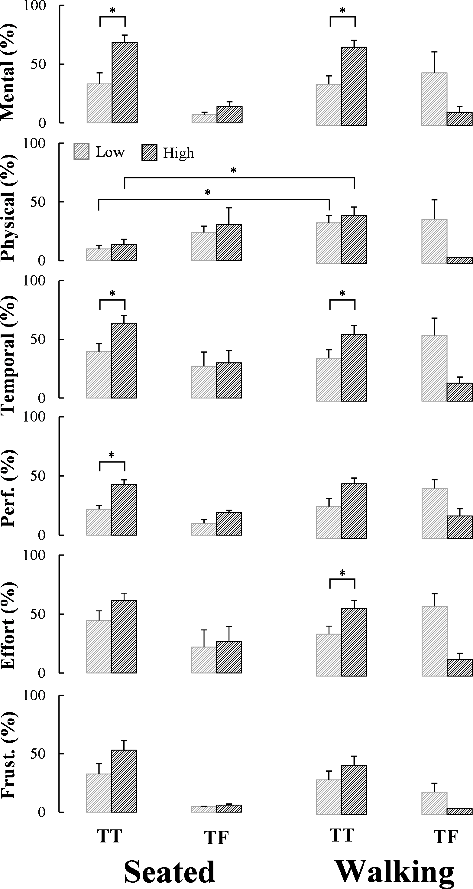
Figure S1: Mean and standard error for the scores of each NASA-TLX dimension for individuals with TT and TF LL while performing the cognitive task under low (stripped gray bars) and high (stripped black bars) demand in the seated (left column) and walking (right column) conditions. Mental: Mental demand; Physical: Physical demand; Temporal: Temporal demand; Perf.: Performance; Effort: Effort; F: Frust. (see Hart et al. (1988) for the description of each question). *: p < .05; **: p < .01; ***: p < .001.
Effort
A significant difference of the sense of effort between the four experimental conditions was detected for both the TT (χ² (3) = 14.730, p < .003) and TF (χ² (3) = 9.438, p < .024) LL groups. Post-hoc analyses revealed that for the TT LL group the sense of effort was augmented as the cognitive task demand increased for the walking (z = -2.609, p = .020) but not for the seated (z = -1.889, p = .125) condition. No such post-hoc difference was detected for the TF LL group (p > .050, all comparisons considered) (Figure S1, fifth row).

Frustration
For this dimension the four experimental conditions significantly differed only for the TF LL group (χ² (3) = 8.143, p < .043). However the post-hoc analysis did not reveal any specific differences (Figure S1, sixth row).

REFERENCES
Hart, S. G., & Staveland, L. E. (1988). Development of NASA-TLX (task load index): Results of
empirical and theoretical research. In P. A. Hancock, & N. Meshkati (Eds.). Human mental workload. Amsterdam: North Holland Press.

¹One and three score sheets were unavailable and thus not included in the analysis for individuals with TT and TF LL.

