Appendix 1. Supplementary Methods
Participants
Participants were diagnosed in multidisciplinary clinical consensus conferences based upon the results of a comprehensive neurological evaluation, a 60-minute standard neuropsychological assessment, and a functional interview with an informant. Participants were excluded if they presented with a major psychiatric illness, another neurological condition affecting cognition, a history of substance abuse, or a major medical illness. A Clinical Dementia Rating score > 0 and a Geriatric Depression Scale >15 were exclusionary for controls.

Neuroimaging Data Acquisition and Image Processing
Whole brain T1 images were acquired using Magnetization-prepared rapid gradient echo (MPRAGE) in the axial plane: TR=2300ms; TE=3.43ms; TI=900 ms; flip angle=9; slice thickness=1 mm; FOV=256*224 mm; voxel size=1 mm*1mm; matrix size=256*224; and number of slices=176. Diffusion Weighted Images (DTI) were acquired using single-short spin-echo sequence with the following parameters: TR=5300 ms; TE=88 ms; TI=2500 ms; flip angle=90; FOV=256*256 mm; two diffusion values of b=0 and 1000 s/mm; 12 diffusion directions; four repeats; 40 slices; matrix size=128*128; voxel size=2 mm*2 mm; slice thickness=3 mm; and GRAPPA=2.
For DTI images, we used FSL software to co-register the diffusion direction images with the b = 0 image, then applied a gradient direction eddy current and distortion correction. Diffusion tensors were calculated using a non-linear least-squares algorithm from Diffusion Imaging in Python (Dipy; Garyfalidis et al., 2014). After quality control, participants' tensors (four dimensional images) were registered linearly and non-linearly into a common space using DTI-TK (Zhang, Yshkevich, Alexander, & Gee, 2006). Tensors were moved into the group template. Once in the group space, diffusion tensor images were diagonalized to extract the diffusion metrics like FA using Dipy (Garyfalidis et al., 2014).

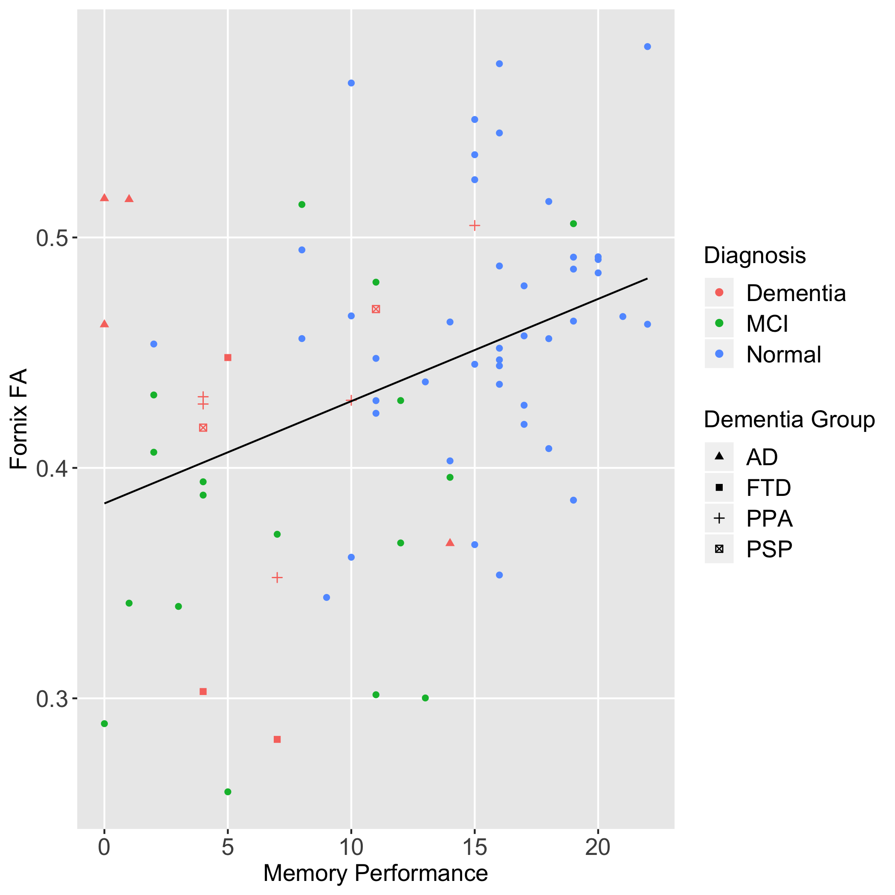
Supplementary Figure 1. Scatter plot of Favorites memory performance and FA of the column and body of the fornix by diagnostic group.
Note. MCI= mild cognitive impairment; AD= Alzheimer’s disease; FTD= behavioral variant frontotemporal dementia; PPA= primary progressive aphasia; PSP= progressive supranuclear palsy syndrome

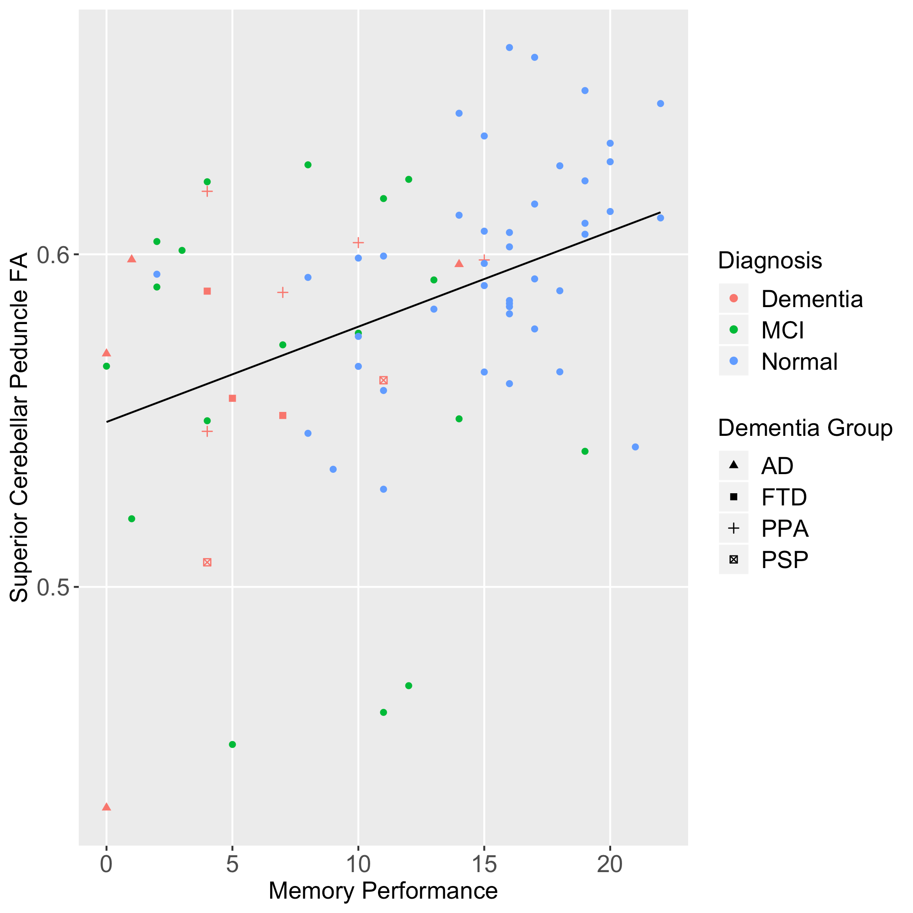

Supplementary Figure 2. Scatter plot of Favorites memory performance and FA of the superior cerebellar peduncle by diagnostic group.
Note. MCI= mild cognitive impairment; AD= Alzheimer’s disease; FTD= behavioral variant frontotemporal dementia; PPA= primary progressive aphasia; PSP= progressive supranuclear palsy syndrome
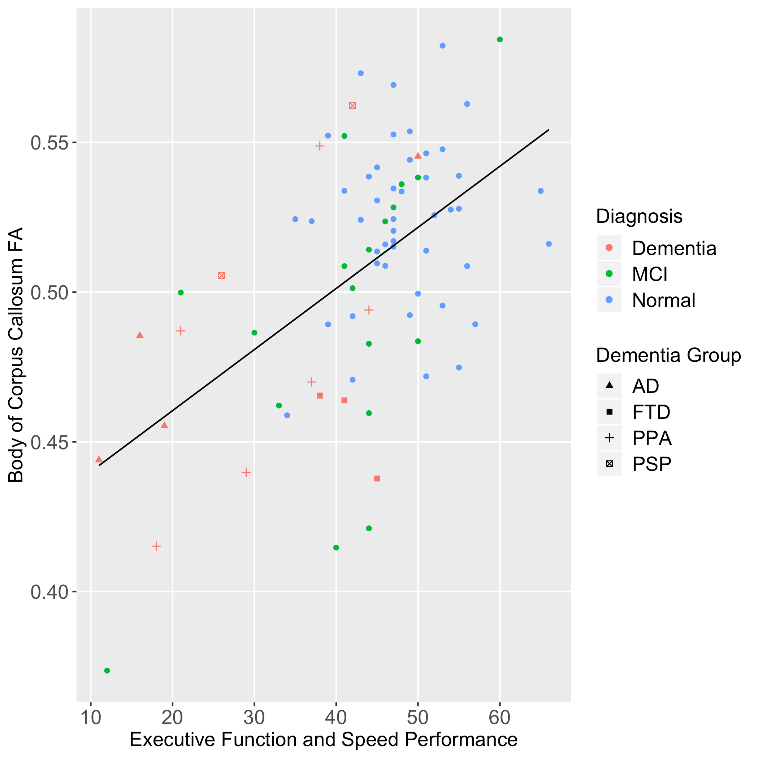

Supplementary Figure 3. Scatter plot of Match executive function and speed performance and FA of the superior cerebellar peduncle by diagnostic group.
Note. MCI= mild cognitive impairment; AD= Alzheimer’s disease; FTD= behavioral variant frontotemporal dementia; PPA= primary progressive aphasia; PSP= progressive supranuclear palsy syndrome

Supplementary Table 1. Correlations of Memory and Executive Function/Speed Performance with white matter tracts.
 |  |  | Memory: Favorites |  | Executive/Speed: Match
Frontal tracts
Superior longitudinal fasciculus |  |  | 0.40* |  | 0.42*
Cingulate gyrus |  |  | 0.30 |  | 0.40*
Anterior corona radiata |  |  | 0.29 |  | 0.30
Posterior corona radiata |  |  | 0.10 |  | 0.14
Superior corona radiata |  |  | 0.13 |  | 0.18
Callosal tracts
Genu of corpus callosum |  |  | 0.33 |  | 0.46*
Body of corpus callosum |  |  | 0.38* |  | 0.54*
Splenium of corpus callosum |  |  | 0.32 |  | 0.43*
Tapetum |  |  | 0.14 |  | 0.11
Temporal tracts
Column and body of fornix |  |  | 0.44* |  | 0.33*
Fornix stria terminalis |  |  | 0.46* |  | 0.34*
Cingulum hippocampus |  |  | 0.34 |  | 0.28
Uncinate fasciculus |  |  | 0.34 |  | 0.36*
Posterior tracts
Sagittal stratum |  |  | 0.34 |  | 0.35*
Superior fronto-occipital fasciculus |  |  | 0.14 |  | 0.23
Subcortical tracts
Anterior limb of internal capsule |  |  | 0.18 |  | 0.27*
Posterior limb of internal capsule |  |  | 0.19 |  | 0.23
Retrolenticular part of internal capsule |  |  | 0.25 |  | 0.23
External capsule |  |  | 0.32 |  | 0.40*
Posterior thalamic radiation |  |  | 0.20 |  | 0.32
Pontine crossing tract |  |  | 0.24 |  | 0.08
Cerebral peduncle |  |  | 0.33 |  | 0.29
Superior cerebellar peduncle |  |  | 0.40* |  | 0.32
Inferior cerebellar peduncle |  |  | 0.22 |  | 0.16
Middle cerebellar peduncle |  |  | 0.28 |  | 0.14
Note. All correlations control for age and sex.
*Significant after multiple comparisons correction (p < 0.0024 for Favorites, p < 0.0033 for Match).

Supplementary Table 2. Correlations of visuospatial performance with white matter tracts.
 |  |  | Visuospatial: Line Orientation
Frontal tracts
Superior longitudinal fasciculus (L) |  |  | -0.11
Superior longitudinal fasciculus (R) |  |  | -0.15
Cingulate gyrus (L) |  |  | -0.19
Cingulate gyrus (R) |  |  | -0.09
Anterior corona radiata (L) |  |  | -0.20
Anterior corona radiata (R) |  |  | -0.23
Posterior corona radiata (L) |  |  | 0.02
Posterior corona radiata (R) |  |  | 0.02
Superior corona radiata (L) |  |  | -0.01
Superior corona radiata (R) |  |  | 0.07
Callosal tracts
Genu of corpus callosum |  |  | -0.24
Body of corpus callosum |  |  | -0.26
Splenium of corpus callosum |  |  | -0.16
Tapetum (L) |  |  | -0.04
Tapetum (R) |  |  | 0.08
Temporal tracts
Column and body of fornix |  |  | -0.04
Fornix stria terminalis (L) |  |  | -0.20
Fornix stria terminalis (R) |  |  | -0.18
Cingulum hippocampus (L) |  |  | -0.09
Cingulum hippocampus (R) |  |  | -0.09
Uncinate fasciculus (L) |  |  | -0.18
Uncinate fasciculus (R) |  |  | -0.13
Posterior tracts
Sagittal stratum (L) |  |  | -0.19
Sagittal stratum (R) |  |  | -0.17
Superior fronto-occipital fasciculus (L) |  |  | -0.03
Superior fronto-occipital fasciculus (R) |  |  | -0.11
Subcortical tracts
Anterior limb of internal capsule (L) |  |  | -0.16
Anterior limb of internal capsule (R) |  |  | -0.15
Posterior limb of internal capsule (L) |  |  | -0.03
Posterior limb of internal capsule (R) |  |  | 0.01
Retrolenticular part of internal capsule (L) |  |  | 0.03
Retrolenticular part of internal capsule (R) |  |  | 0.15
External capsule (L) |  |  | -0.23
External capsule (R) |  |  | -0.19
Posterior thalamic radiation (L) |  |  | -0.23
Posterior thalamic radiation (R) |  |  | -0.14
Pontine crossing tract |  |  | 0.06
Cerebral peduncle (L) |  |  | -0.11
Cerebral peduncle (R) |  |  | -0.03
Superior cerebellar peduncle (L) |  |  | 0.03
Superior cerebellar peduncle (R) |  |  | 0.01
Inferior cerebellar peduncle (L) |  |  | -0.06
Inferior cerebellar peduncle (R) |  |  | -0.06
Middle cerebellar peduncle |  |  | 0.00
Note. All correlations control for age and sex.
*Significant after multiple comparisons correction (p < 0.00114 for Line Orientation).

Supplementary Table 3. Summary of backward elimination regression models for regions predicting memory performance.
Model/Order of region removed | B | 95% CI for B | p value
1. Body of corpus callosum | 0.51 | (-78.12, 79.14) | 0.99
2. Sagittal stratum | -12.30 | (-72.42, 47.82) | 0.68
3. Cingulum hippocampus | 15.07 | (-41.58, 71.71) | 0.60
4. External capsule | -19.74 | (-98.55, 59.06) | 0.62
5. Uncinate fasciculus | 15.86 | (-33.03, 64.75) | 0.52
6. Cingulate gyrus | -11.79 | (-61.21, 37.63) | 0.64
7. Cerebral peduncle | 12.68 | (-28.67, 54.02) | 0.54
8. Genu of corpus callosum | 14.99 | (-29.92, 59.90) | 0.51
9. Superior longitudinal fasciculus | 38.54 | (-15.13, 92.21) | 0.16
10. Splenium of corpus callosum | -34.16 | (-84.81, 16.50) | 0.18
11. Fornix stria terminalis | 40.67 | (-6.22, 87.56) | 0.09
12. Superior cerebellar peduncle | 41.76 | (12.02, 71.49) | 0.007*
Column and body of fornix | 30.78 | (12.44, 49.12) | 0.001*
Age | 0.20 | (0.07, 0.34) | 0.004*
Gender | 0.46 | (-1.97, 2.89) | 0.71
Note. *p<.05

Supplementary Table 4. Summary of backward elimination for regions predicting executive and speed performance
Note. *p<.05
Model/Order of region removed | B | 95% CI for B | p value
1. Cingulate gyrus | -1.47 | (-106.48, 103.55) | 0.98
2. Sagittal stratum | -4.51 | (-109.76, 100.75) | 0.93
3. Fornix stria terminalis | 5.88 | (-94.09, 105.85) | 0.91
4. Uncinate fasciculus | -11.88 | (-98.52, 74.75) | 0.79
5. External capsule | 39.65 | (-104.97, 184.28) | 0.59
6. Splenium of corpus callosum | -31.33 | (-155.04, 92.39) | 0.62
7. Column and body of fornix | 9.31 | (-29.46, 48.08) | 0.63
8. Superior cerebellar peduncle | 17.33 | (-41.24, 75.89) | 0.56
9. Cingulum hippocampus | -37.61 | (-122.37, 47.15) | 0.38
10. Genu of corpus callosum | 56.57 | (-45.51, 158.65) | 0.27
11. Superior longitudinal fasciculus | 72.41 | (-29.41, 174.23) | 0.16
12. Anterior corona radiata | -81.93 | (-181.93, 18.07) | .11
13. Body of corpus callosum | 143.50 | (91.95, 195.04) | <0.001*
Age | -0.09 | (-0.32, 0.15) | 0.45
Gender | 0.98 | (-3.36, 5.31) | 0.66

