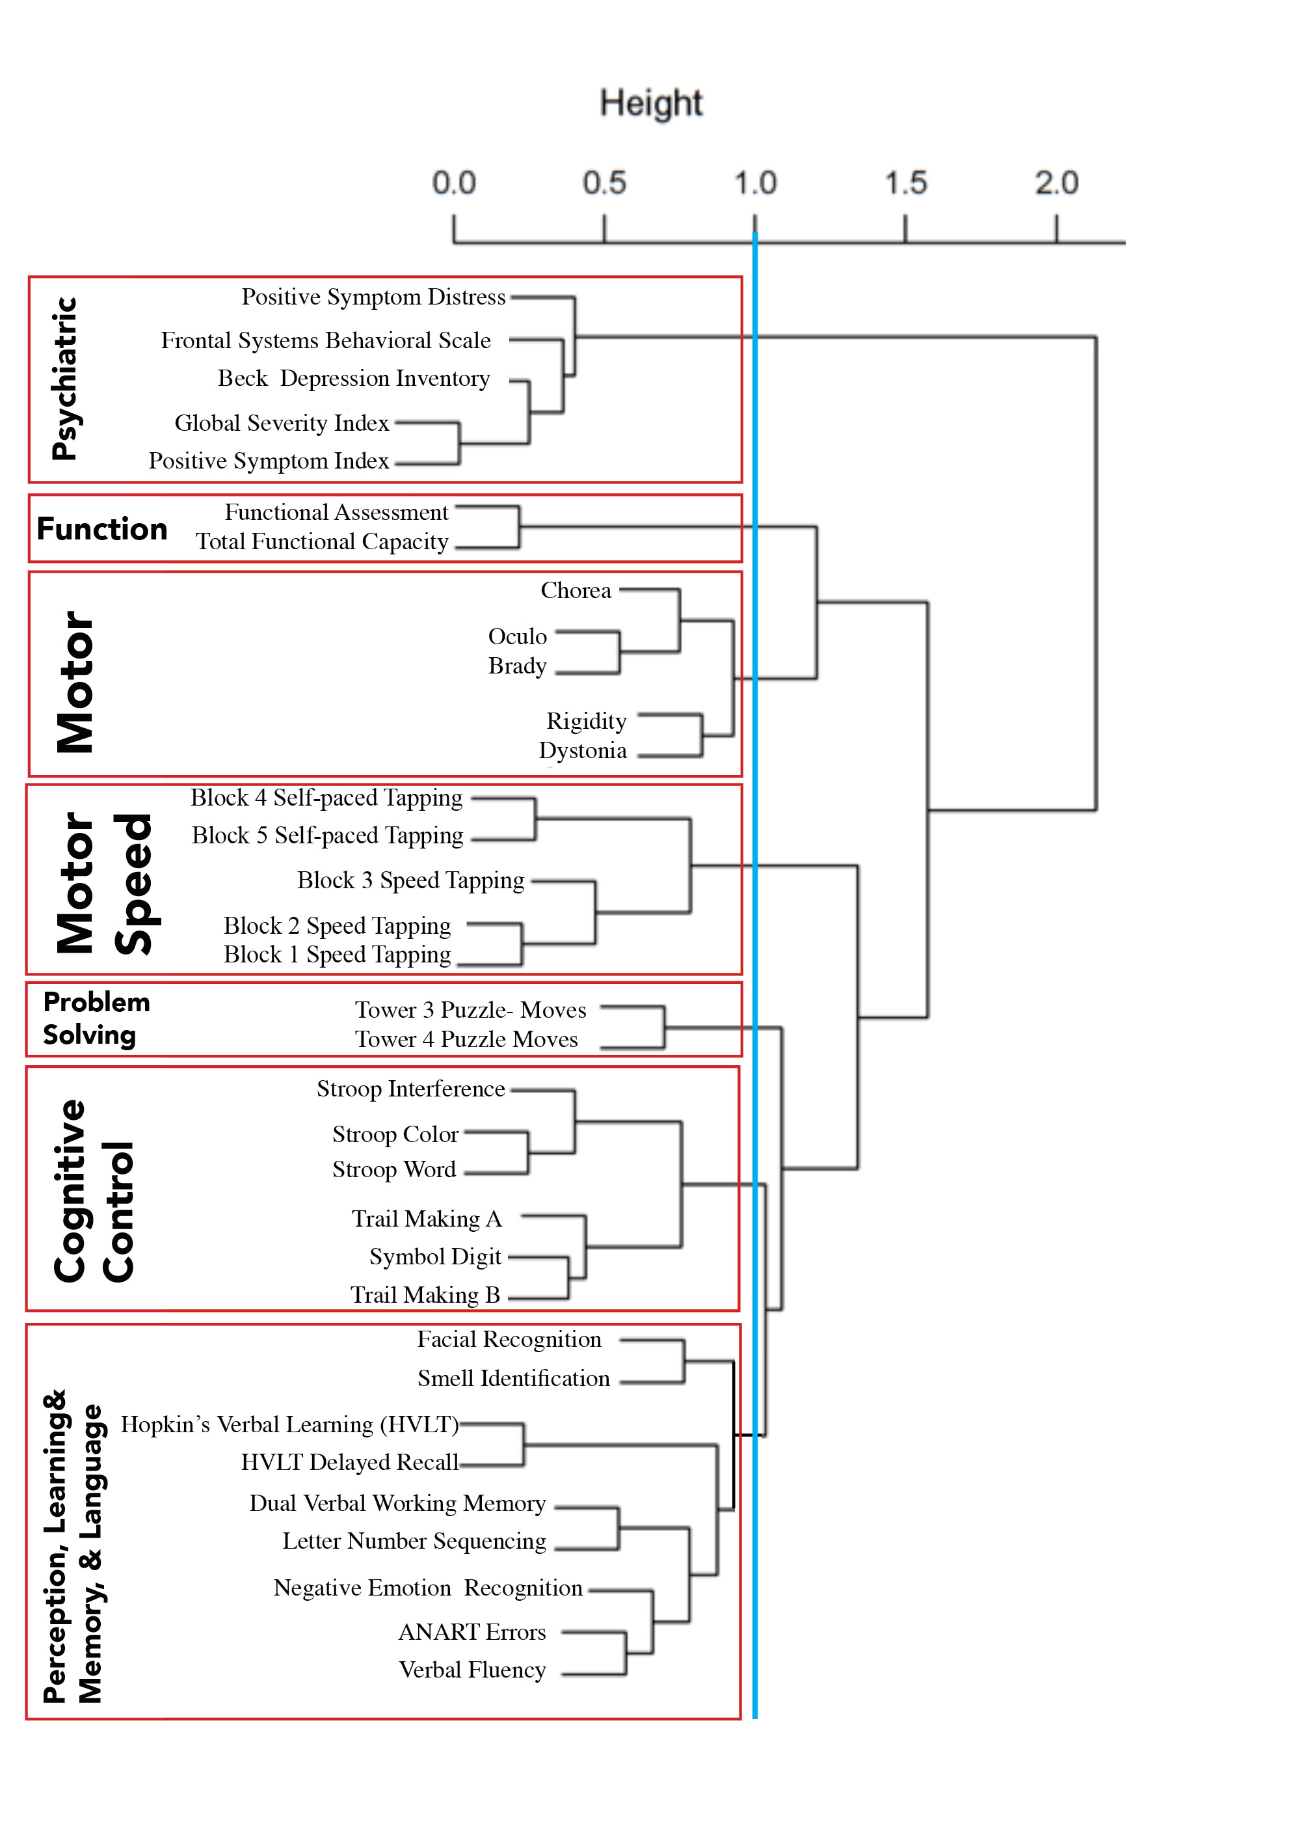
Figure 1. Clustering chart.

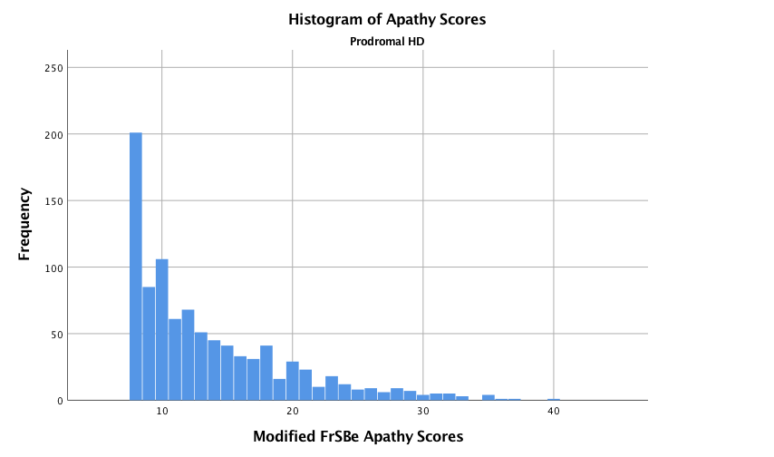
Supplementary Figure 2. Distribution of Apathy scores of prHD individuals
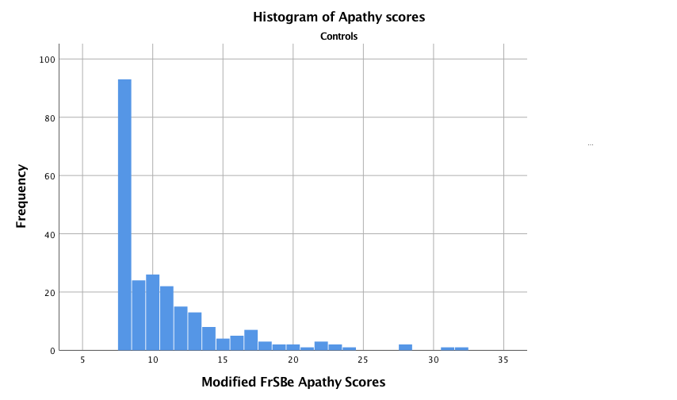
Supplementary Figure 3. Distribution of Apathy scores of controls

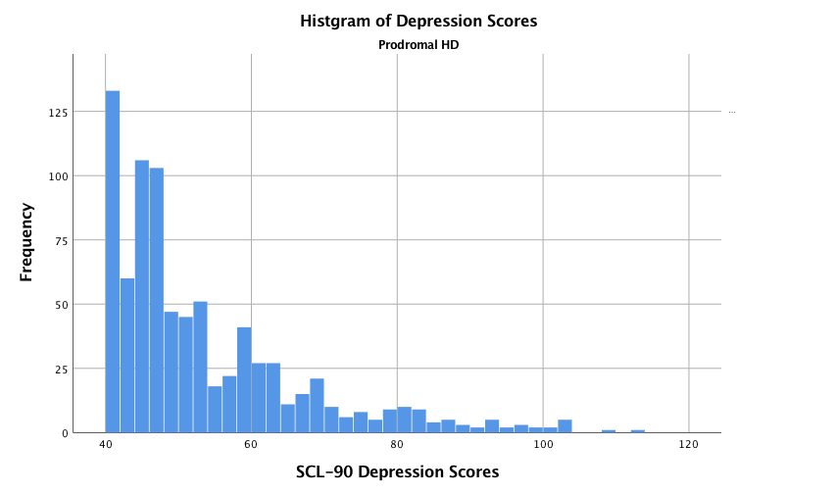
Supplementary Figure 4. Distribution of Depression scores of prHD individuals
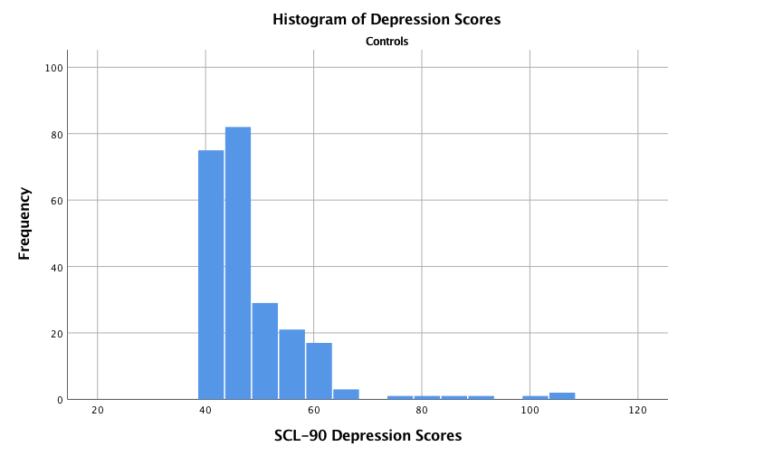
Supplementary Figure 5. Distribution of Depression scores of controls

