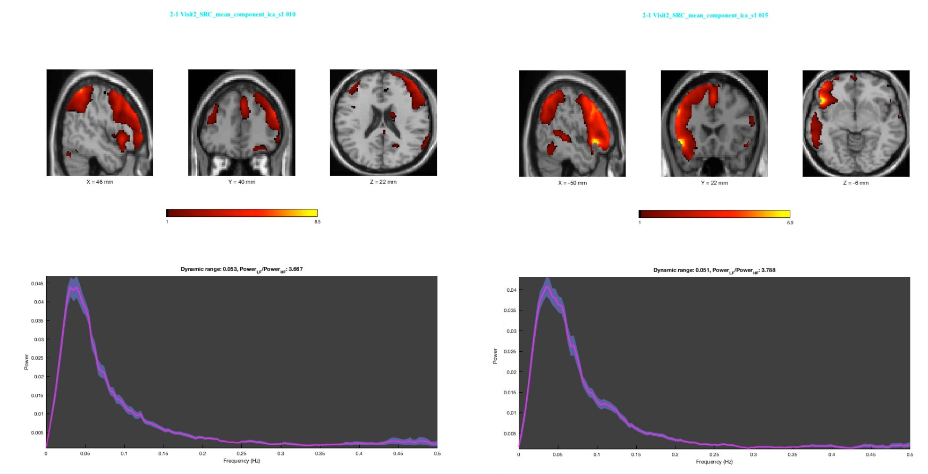
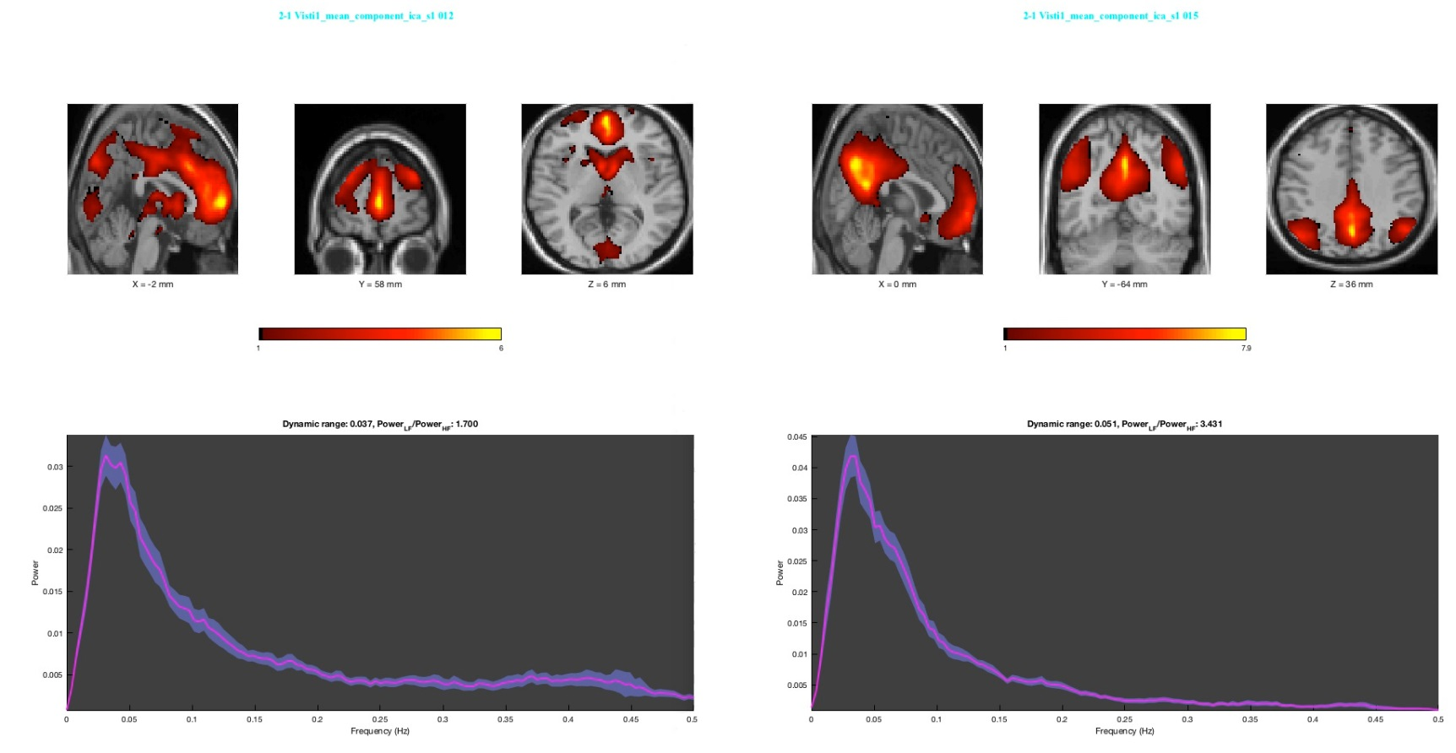
Supplemental Figure S1. Graph of dynamic range and low/high frequency ratio for the final selected components. Component A and B indicate group independent component analysis across time (time 1 + time 2) for the SRC group. Component A: dynamic range = 0.053, Power_{low frequency}/Power_{high frequency} = 3.667; Component B: dynamic range = 0.051, Power_{low frequency}/Power_{high frequency} = 3.788. Component C and D indicate group independent component analysis for time 1 for the SRC group and control group. Component C: dynamic range = 0.037, Power_{low frequency}/Power_{high frequency} = 1.70; Component D: dynamic range = 0.051, Power_{low frequency}/Power_{high frequency} = 3.431. Component analyses are combined in this way as to provide unbiased selection of components not overly weighted by any one group/time point.
A
B
C
D
Supplemental Figure S2. Scatter plot of power ratio versus dynamic range for estimated components in the group independent component analysis for SRC group and control group and across time (time 1 + time 2).

Supplemental Figure S3. Final components selected for further analyses based on spatial correlation with the default mode network. Surviving components were based on a cutoff of correlation value > 0.3. Component A and B indicate group independent component analysis across time (time 1 + time 2) for the SRC group. Component C and D indicate group independent component analysis for time 1 for the SRC group and control group. Component analyses are combined in this way as to provide unbiased selection of components not overly weighted by any one group/time point.
A
B
C
D

Supplemental Table S1. Multiple regression analyses within the SRC group for Time 1 and Time 2 separately to assess correlations between DMN component functional connectivity and performance on visual-motor coordination composite scores of the ImPACT. A positive correlation indicates slower visual-motor speed is associated with functional connectivity in these brain regions, and negative correlation indicates faster visual-motor speed is associated with functional connectivity in these brain regions. No other composite scores (reaction time or impulse control) or total symptoms scores (TSS) was correlated with functional connectivity at either Time 1 or Time 2.
A. Correlation with rs-fMRI and visual-motor coordination scores at Time 1
Positive correlation
Region | MNI coordinates | Cluster size | FDR-corrected p-value
R Precuneus | 0 -50 54 | 226 | 0.028
B. Correlation with rs-fMRI and visual-motor coordination scores at Time 2
Negative correlation
Region | MNI coordinates | Cluster size | FDR-corrected p-value
R Parahippocampal Gyrus | 48 -6 -22 | 190 | 0.029
L Lingual Gyrus | -6 -76 -10 | 241 | 0.013
L Precuneus | -6 -64 50 | 353 | 0.002
Abbreviations: : L, left hemisphere; R, right hemisphere.

