Supplementary Figure 1

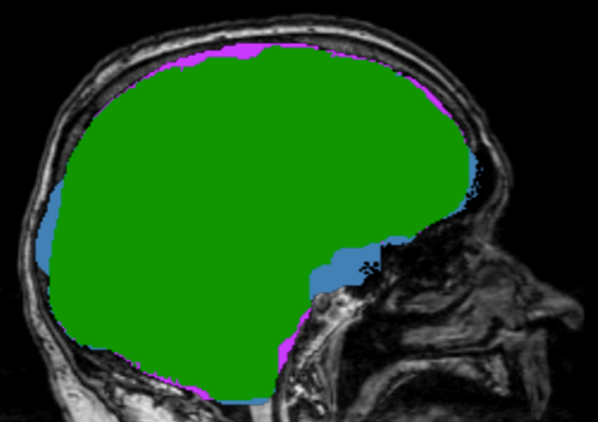
Supplementary Fig. 1 Image displaying overlap between manual TICV and Brainmask volumetric estimations. Blue = Brainmask estimation only. Pink = Manual only. Green = overlap between manual TICV and Brainmask.

Supplementary Table 1

Demographic statistics for the total sample, controls and individuals with PD
 | Total | Control | PD
Sex (M:F) | 65:15 | 33:7 | 32:8
Age (Yrs) | 68.00±5.00 | 68.18 ± 4.64 | 67.80 ± 5.44
Education (Yrs) | 16.50±2.70 | 16.75 ± 2.35 | 16.28 ± 3.03
Cognition (MMSE) | 29.10±.99 | 29.30±0.97 | 29.00±0.99
Charlston Comorbidity | 0.29±0.66 | 0.28 ± .61 | 0.30 ±0 .72
UPDRS-III | -- | 2.75 ± 3.36 | 17.58 ± 10.74
H&Y | -- | -- | 7.50 ± 5.15
Disease Duration (Yrs) | -- | -- | 7.50 ± 5.15
TICV (manual) | 1665±166 | 1603±138 | 1727±170
All measures are presented with as mean ± standard deviation. MMSE=Mini-Mental State Examination.

