Supplemental Material

Patterns of cortical and subcortical amyloid burden across stages of preclinical Alzheimer’s disease

Emily C. Edmonds,¹ Katherine J. Bangen,^{1,2} Lisa Delano-Wood,^{1,2} Daniel A. Nation,³ Ansgar J. Furst,^{4,5} David P. Salmon,⁶ Mark W. Bondi,^{1,2} for the Alzheimer’s Disease Neuroimaging Initiative*

Supplemental analyses using ADNI’s original diagnoses
Methods
These analyses included 132 individuals originally classified as “cognitively normal” by ADNI (the other 325 participants in the study had been diagnosed with MCI by ADNI). ADNI’s criteria for being classified as normal are: 1) no subjective memory complaint; 2) Mini-Mental State Exam score of 24-30; 3) global Clinical Dementia Rating score of 0; 4) intact memory function documented by scoring within the education adjusted ranges on Story A of the Wechsler Memory Scale-Revised Logical Memory II subtest; and 5) no significant impairment in cognitive functions or activities of daily living (Petersen et al., 2010).
The subset of 132 participants had a mean age of 73.7 years (SD=6.1), a mean education level of 16.7 years (SD=2.5); participants were 50.0% male and 23.5% of the sample carried an APOE-ε4 allele. The MCI participants (n=325) had a mean age of 71.7 years (SD=7.6), a mean education level of 16.1 years (SD=2.7); MCI participants were 53.5% male and 50.9% of the sample carried an APOE-ε4 allele. The groups differed significantly on age (p=.003) and proportion of APOE carriers (p=<.001).

Results
The pattern of results for amyloid deposition in the cortical and allocortical/subcortical regions across stages of preclinical AD in this subsample was remarkably similar to the results found in the full sample of 312 participants who were classified as “cognitively normal” based on actuarial neuropsychological criteria. This was the case when stages of preclinical AD were based on either: (1) our method of using the number of abnormal biomarkers or cognitive markers that each individual possessed to determine their stage of preclinical AD (see Supplemental Figure 1), or (2) the NIA-AA criteria for preclinical AD (Sperling et al., 2011; see Supplemental Figure 2). However, some variability was seen in the groups that were left with a very small number of participants (i.e., n=3 in “3 biomarkers” and “Stage 3,”; n=2 in “Unclassified”).

References
Petersen, R.C., Aisen, P.S., Beckett, L.A., Donohue, M.C., Gamst, A.C., Harvey, D.J., …
Weiner, M.W. (2010). Alzheimer's Disease Neuroimaging Initiative (ADNI): Clinical characterization. Neurology, 74(3), 201-209. doi: 10.1212/WNL.0b013e3181cb3e25
Sperling, R.A., Aisen, P.S., Beckett, L.A., Bennett, D.A., Craft, S., Fagan, A.M., … Phelps, C.H.
(2011). Toward defining the preclinical stages of Alzheimer’s disease: Recommendations from the National Institute on Aging-Alzheimer’s Association workgroups on diagnostic guidelines for Alzheimer’s disease. Alzheimer’s & Dementia, 7, 280-292. doi: 10.1016/j.jalz.2011.03.003

Supplemental Figure 1: Mean standard uptake ratio (SUVR) for (A) cortical and (B) subcortical regions in preclinical AD stages based on the number of abnormal biomarkers and MCI. Error bars denote standard error of the mean.
(A)
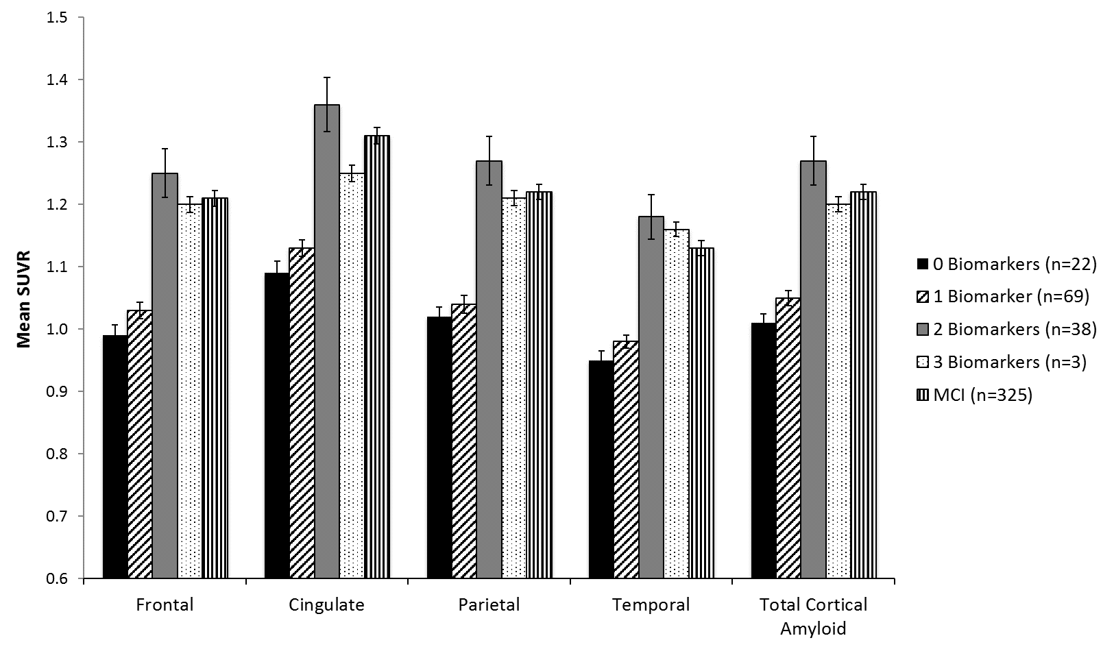
(B)
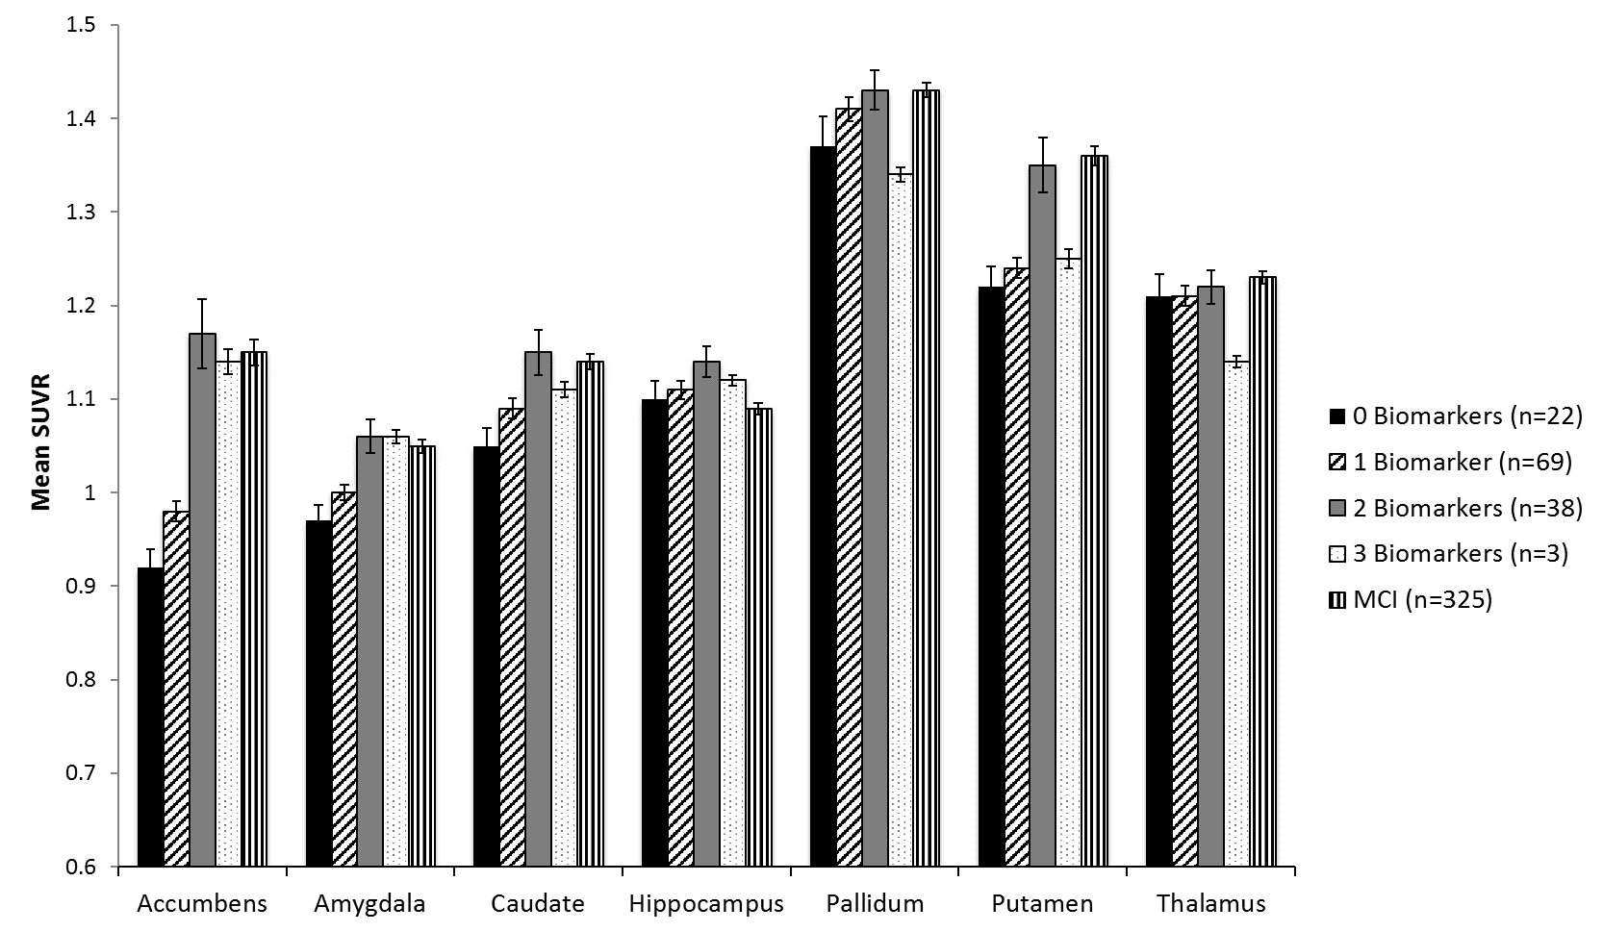
Supplemental Figure 2: Mean standard uptake ratio (SUVR) for cortical (A) and subcortical (B) regions in NIA-AA preclinical AD stages and MCI. Error bars denote standard error of the mean.
(A)
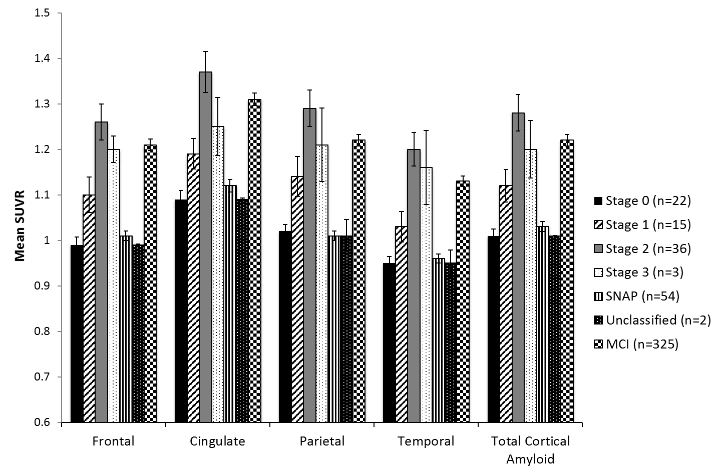
(B)
