**Supplementary Figure.** Pair-wise scatterplots of primary variables.

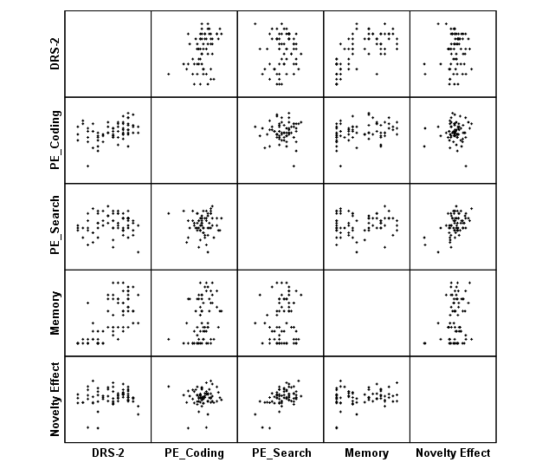

*Note.* DRS-2=Age and education adjusted scaled scores for the Mattis Dementia Rating Scale, 2nd edition. PE_Coding=practice effect calculated as difference between time 2 and time 1 raw scores on WAIS-IV Coding. PE_Search=practice effect calculated as difference between time 2 and time 1 raw scores on WAIS-IV Symbol Search. Memory=Rey Auditory Verbal Learning Test total delayed recall. Novelty Effect=difference in motor planning times between first and second blocks of a motor learning task.