Supplementary Data 1:

1- Extended Results

1.A. Motion parameters: correlation results:

To corroborate whether there was a possible residual motion effect on the graph theory results, we performed a correlation analysis between (a) the mean translational and rotational parameters, and (b) the NC results (we only included the networks yielding significant differences). To this end, we averaged the NC values within the binary networks in which differences were more consistent across comparisons (90 to 100% of positive connections):
Supplementary Table 1: Correlation results between motion parameters and NC.
 |  | Frontotemporo insular network (bilateral) | Frontotemporo insular network (right regions) | Frontotemporo insular network (left regions) | Cingulo opercular network (bilateral)
All groups | Translational parameters | R = -.09;  p = .60 | R = -.23;  p = .19 | R = .09;  p = .60 | R = -.08;  p = .65
All groups | Rotational parameters | R = -.05;  p = .76 | R = -.24;  p = .16 | R = .17;  p = .32 | R = -.00;  p = .96
Controls | Translational parameters | R = .06;  p = .85 | R = -.04;  p = .89 | R = .14;  p = .64 | R = -.34;  p = .28
Controls | Rotational parameters | R = .24;  p = .45 | R = -.02;  p = .94 | R = .39;  p = .20 | R = -.33;  p = .30
bvFTD | Translational parameters | R = .24;  p = .42 | R = -.07;  p = .80 | R = .47;  p = .10 | R = -.17;  p = .58
bvFTD | Rotational parameters | R = .25;  p = .40 | R = -.15;  p = .61 | R = .57;  p = .04* | R = -.01;  p = .96
Stroke | Translational parameters | R = -.25;  p = .51 | R = -.22;  p = .57 | R = -.18;  p = .63 | R = -.11;  p = .78
Stroke | Rotational parameters | R = -.29;  p = .45 | R = -.12;  p = .75 | R = -.32;  p = .40 | R = -.22;  p = .56

Correlations between motion parameters and NC results were not significant, except for the positive correlation of bvFTD in the left hubs of the frontotemporoinsular network. This positive correlation indicates that increased rotational motion in bvFTD is associated with a rise of NC. Hence, even considering this positive result, the direction of the association does not explain the reduction of NC in the bvFTD sample. (If the correlation had been negative, this would have suggested a motion bias in our results.) In conclusion, these results converge with the lack of between-group differences to rule out the possible effects of motion on network results.

1.B. Small-world organization:

To analyze whether small-world properties are present in the network matrices from the selected thresholds (50 to 100% of positive connections), we compared the characteristic path length (L) and average clustering coefficient (C) of each group with random networks (preserving the same number of nodes and edges). L is the average of the minimum number of edges that must be crossed to go from one node to any other node on the network . C indicates how strongly a network is locally interconnected .
Small-world properties are fulfilled if: (a) L from real networks is equal to or smaller than L from random networks, and (b) C from real networks is higher than C from random networks.. We employed the same cluster-based statistical approach that was used for NC (for details, please see the statistical section of the main manuscript). Supplementary Figure 1 and Supplementary Table 2 show that each group presents significant clusters, indicating higher C of real networks compared to C of random graphs, and the opposite pattern of differences for L. Such results support the validity of the thresholds selected for analysis, given that these networks present a clear small-world organization over the whole range selected.
Supplementary Figure 1
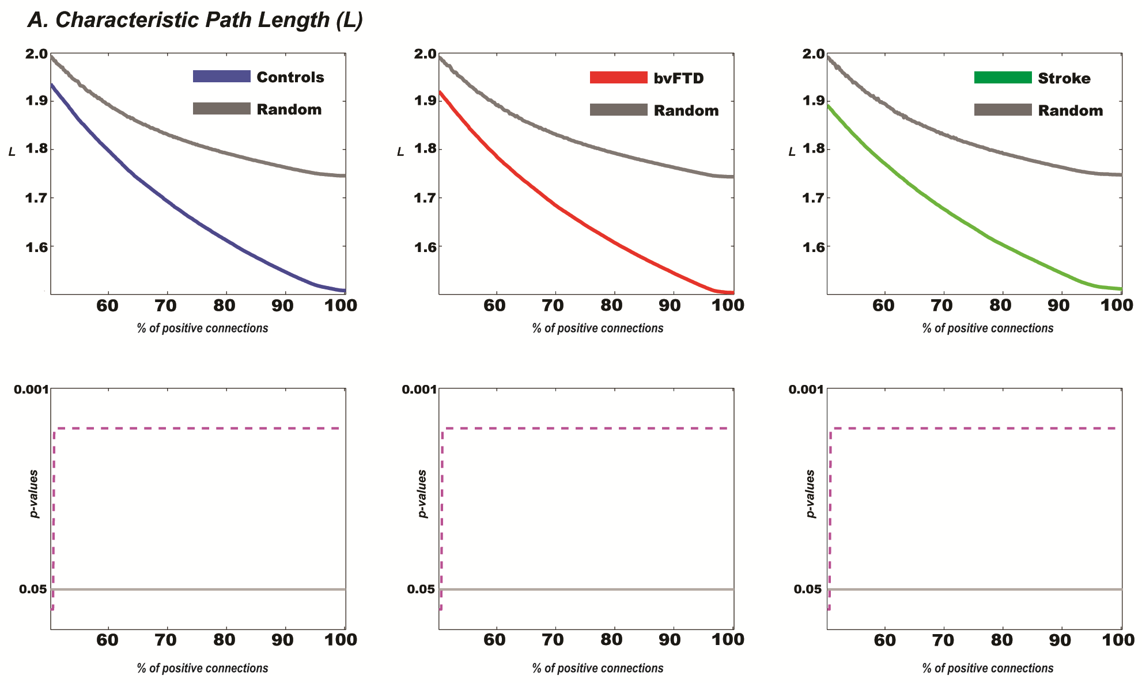

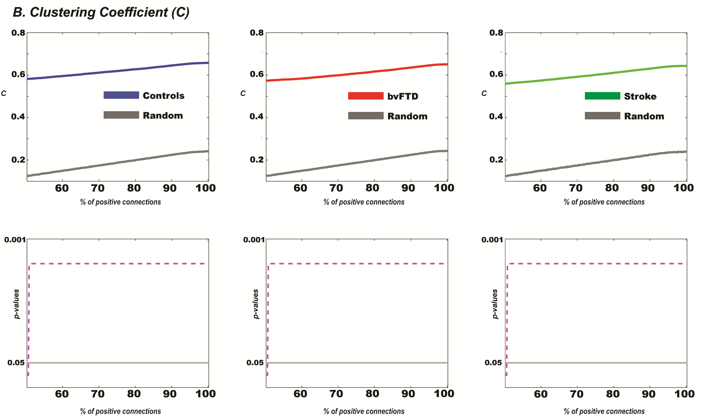

Supplementary Table 2
Small world organization
Controls vs random networks
 |  |  | Cluster network range |  | Cluster t | p | Cohen’s d
L |  |  | 50 to 100% |  | > -300 | < .01* | 1.53
C |  |  | 50 to 100% |  | > 300 | < .01* | 17
bvFTD vs random networks
 |  | Cluster network range |  |  | Cluster t | p | Cohen’s d
L |  | 50 to 100% |  |  | > -300 | < .01* | 1.64
C |  | 50 to 100% |  |  | > 300 | < .01* | 14
Stroke vs random networks
 | Cluster network range |  |  | Cluster t |  | p |  | Cohen’s d
L | 50 to 100% |  |  | > -300 |  | < .01* |  | 1.85
C | 50 to 100% |  |  | > 300 |  | < .01* |  | 13

1.C NC analysis of anatomical regions from resting state networks:

Cluster analyses revealed no group differences in the Default Mode (DMN), the cingulo-opercular (CON), the fronto-parietal (FPN), the sensorimotor (SMN), the visual (VN), or the cerebellar (CBR) networks between groups. The only exception was the CON in stroke patients, who showed decreased NC relative to controls (see Fig 3 and Supplementary Table 3):

Supplementary Table 3
Network Centrality of cingulo-opercular network (CON)
Controls vs stroke
 | Cluster network range | Mean (SD) Controls | Mean (SD) Stroke | Cluster t | p | Cohen’s d
Bilateral hubs (first cluster) | 80 to 96% | 75.16 (8.09) | 63.95 (10.78) | 213.98 | .01* | 1.18
Bilateral hubs (second cluster) | 50 to 65% | 113.82  (27.18) | 93.57  (13.23) | 204.87 | .01* | 0.94

1.D. ANCOVA tests for NC comparisons.

Given that the groups exhibited significant age differences (see Table 1A), we performed an ANCOVA test adjusted for this variable. To this end, we averaged the NC values within the binary networks in which differences were more consistent across comparisons (the 90 to 100% of positive connections). Differences among groups remained the same after adjustment.

Supplementary Table 4: ANCOVA Results
 | bvFTD | Controls | Stroke | F | p | Pos-hoc comparison  (Tukey’s HSD)
A Network Centrality of the frontotemporoinsular network
Bilateral hubs | 68.18 (6.5) | 75.74 (3.96) | 75.19 (7.00) | 4.76 | .01* | bvFTD-Controls < .01  bvFTD-Stroke < .01
Right hubs | 68.88 (9.00) | 75.96 (6.51) | 78.74 (9.07) | 3.69 | .03* | bvFTD-Stroke = .02
Left hubs | 67.48 (8.10) | 75.50 (6.51) | 72.96 (9.20) | 2.95 | .06# | bvFTD-Controls = .02
B Network Centrality of the cingulo-opercular network
Bilateral hubs | 67.38 (8.17) | 71.27 (8.14) | 60.59 (11.94) | 3.60 | .04* | Stroke-controls = .03
Mean (SD) / # tendency differences / * significant differences /

1. E. Executive performance and social cognition:
Significant differences were found in EF [F (2, 26) = 13.27, p <.01], emotion recognition [F (2, 21) = 12.424, p < .01], ToM [F (2, 25) = 25.50, p < 0.01] and the composite scores of SCS [F (2, 21) = 25.27, p < 0.01] and SEP [F (2, 21) = 30.54, p < 0.01] among groups. A Tukey post-hoc comparison revealed that bvFTD patients had lower scores across all behavioral tasks [EF: MSE= 223.52, df= 26; emotion recognition: MSE= 134.17, df= 21 ToM: MSE= 113.24, df= 25; SCS: MSE= 81.90, df= 21 and SEP: MSE= 72.14, df= 21] compared to controls and stroke patients (p < 0.01 for both groups across all tasks and scores). No differences were found between the last two groups in none of these tasks and global scores [EF: p= 0.99; emotion recognition: p= 0.94; ToM: p= 0.98; SCS: p= 0.99; SEP: p= 0.99].

1.F. NC contribution to behavioral performance:
NC of the frontotemporoinsular network: NC in the bilateral frontotemporoinsular network was associated with participant performance in EF [IFS, F (2, 27) = 3.86, p = 0.06, β = 0.35, R² = 0.12], emotion recognition [TASIT, F (2, 22) = 4.47, p = 0.04, β = 0.41, R² = 0.17] and the composite scores of SCS [F (2, 22) = 6.77, p = 0.02, β = 0.48, R² = 0.23] and SEP [F (2, 22) = 5.04, p = 0.03, β = 0.43, R² = 0.18]. No significant associations were found between the MMSE scores and this bilateral network [F (2, 26) = 2.12, p = 0.15, β = 0.27, R² = 0.07], neither with its right [F (2, 26) = 1.97, p = 0.17, β = 0.26, R² = 0.07] or left sides [F (2, 26) = 1.14, p = 0.29, β = 0.20, R² = 0.04].
The right nodes of this network were also related to an improved performance in executive functions [IFS, F (2, 27) = 5.58, p = 0.02, β = 0.41, R² =0.17], emotion recognition [TASIT, F (2, 22) = 8.27, p < 0.01, β = 0.52, R² = 0.27], SCS [F (2, 22) = 8.89, p < 0.01, β= 0.53, R²=0.28], and SEP [F (2, 22) = 7.92, p = 0.01, β = 0.51, R² = 0.26].
In contrast, the results of the left hub were not significantly associated with either of the composite scores, SCS [F (2, 22) = 1.16, p = 0.29] and SEP [F (2, 22) = 0.58, p = 0.45], and they were only marginally related to ToM accuracy [F (2, 26) = 3.90, p = 0.06, β = 0.36, R² = 0.13].
Finally, as shown in Figure 2E, the value of one stroke patient was extreme (though not an outlier). Thus, we re-ran all the simple regression analyses without this subject to rule out bias in our findings. These results are described in Supplementary Table 5. The main findings of our report were replicated despite the exclusion of this patient.

Supplementary Table 5: NC contribution to behavioral performance (without an stroke patient)
Frontotemporo insular network | Behavioral performance | F | P | R²
Bilateral hubs | EF | 4.60 | .04* | .15
Bilateral hubs | SCS | 8.60 | <.01* | .29
Bilateral hubs | SEP | 6.81 | .02* | .24
Right hubs | EF | 6.00 | .02* | .18
Right hubs | SCS | 8.91 | < .01* | .29
Right hubs | SEP | 8.53 | < .01* | .28
Left hubs | EF | .55 | .46 | .02
Left hubs | SCS | .76 | .39 | .03
Left hubs | SEP | .37 | .55 | .01
* significant differences / EF: executive functions / SCS: social cognition score / SEP: social-executive performance

Simple linear regressions of bvFTD participants: We repeated the regression analysis only for the bvFTD participants. For these, we divided the main network into three different regions: i) frontal structures: anterior cingulate cortex, orbitofrontal cortex, gyrus rectus, inferior frontal gyrus and anterior frontal middle gyrus (modifies the anterior parts of the frontal middle gyrus); ii) temporal structures: hippocampus, parahippocampus, amygdala, caudate nucleus, putamen and pallidum; and iii) insular regions. We found that (a) an increased NC in the left insular hubs was associated with a worse performance in emotion recognition [emotion recognition, F (1, 18) = 8.13, p = 0.02, β = -0.73, R² = 0.53] and SCS [F (1, 18) = 9.30, p = 0.02, β = -0.75, R² = 0.57] and that (b) the right frontal nodes were marginally associated with impaired ToM [F (1, 18) = 4.23, p = 0.06, β = -0.54, R² = 0.29].

Resting-state networks and global scores performance: the NC of any other network was associated neither with SCS [DMN: F (2, 22) = 2.52, p = 0.12; CO: F (2, 21) = 0.59, p = 0.44; FPN: F (2, 22) = 0.00, p = 0.95; SMN: F (2, 22) = 0.14, p = 0.70; VN: F (2, 20) = 0.43, p = 0.51; CBR: F (2, 22) = 0.77, p = 0.38] nor the SEP [DMN: F (2, 22) = 1.94, p = 0.17; CO: F (2, 21) = 0.20, p = 0.65; FPN: F (2, 22) = 0.03, p = 0.84; SMN: F (2, 22) = 0.29, p = 0.59; VN: F (2, 20) = 0.01, p = 0.91; CBR: F (2, 22) = 0.71, p = 0.40].
1.G. Group discrimination based on NC and SEP:
Observation of a scatter plot for NC of the bilateral frontotemporoinsular network and social executive performance (SEP) showed a perfect linear separation of bvFTD from controls and stroke patients (Figure 2E). This suggests that those two variables can be good predictors of bvFTD from control sample and, also, from patients with other neurological impairment. In order to further study that, we took a conservative approach by fitting the simplest possible model, one which coincides with the result of a k-means cluster analysis: a model that splits space into Voronoi cells . The model simply involves computing a centroid for each group by averaging corresponding data. Given that our main goal was to discriminate bvFTD patients from the other samples, centroids were calculated for two groups: one encompassed by bvFTD patients and the other composed by controls and stroke patients. Then, a predicted group for an individual would be given by the closest centroid. Such is a conservative approach because it only considers averages, disregarding information about cluster shapes. It is appropriate because, given our sample size, averages should be reasonably robust, but cluster shapes may not. The point being made is about the predictive power of the two aforementioned variables, not about the properties of an optimal classifier, which could be the object of further research. Once again, because of sample size, a leave-one-out cross-validation was the reasonable approach to take in order to see if classifier performance would generalize well to new data. When applying this approach to the whole data, 95% of data were correctly classified. Cross-validation yielded correct classification for 23 out of 24 models. In the light of this result, it can be expected that a classifier based on NC and SEP should perform well in classifying new data.
The other classification method used was the nearest neighbors’ classification analysis, which allows to calculate the sensitivity and specificity of NC and SEP for group discrimination. This analysis yielded a high sensitivity (100%) and high specificity (100%) for discriminating bvFTD from controls.
To control whether our two classification methods employed were biased by the inclusion of stroke patients alongside with controls, we re-ran these discrimination analysis but excluding this group of patients. This new model, which considered the bvFTD sample and healthy controls as the groups to calculate two centroids, had a 95% correct classification rate [19 out of 20], and a leave-one-out cross-validation yielded 95% correct classification rate [19 out of 20]. In the same way, the other complementary method used, the nearest neighbors’ classification analysis, also yielded a high sensitivity (100%) and a high specificity (100%) to classify bvFTD from healthy controls.
In conclusion, results from two different classification methods (and two different set of data) provided solid evidence regarding the combination of SEP and NC of the frontotemporoinsular network as discrimination variables for bvFTD.

1.H. Logistic regression based on NC alone.

A logistic regression performed to predict groups (bvFTD vs control and stroke patients) from NC of bilateral frontotemporoinsular network showed a statistically significant effect (Wald z = 2.63, p = .01, β = .33, odds-ratio = 1.4, McFadden pseudo-R2 = .37, Cragg & Uhler pseudo-R2 = .54, ML pseudo-R2 = .40). To control a possible bias of the stroke group in this result, we evaluated the regression model without this sample. Observed effects remained significant in this complementary analysis (Wald z = 2.47, p = 0.01, β = 0.31, odds-ratio = 1.37, McFadden pseudo-R2 = .32, Cragg & Uhler pseudo-R2 = .48, ML pseudo-R2 = .36). These results support the relevance of NC of the frontotemporoinsular network in the discrimination of bvFTD patients from controls and a different patient group.

Supplementary Data 2:

ROIs included in the frontotemporoinsular network.
Frontotemporo insular regions | Voxel-based morphometry and meta-analysis studies
Tzourio-Mazoyer (2002) | Schroeter (2007) | Schroeter (2008) | Pan (2012) | Boccardi (2005) | Seeley (2008) | Whitwell (2009)
-Anterior cingulate
Cortex
-Orbitofrontal cortex
-Gyrus rectus
-Inferior frontal gyrus
-Anterior frontal middle gyrus
-Amygdala
-Basal ganglia (Caudate nucleus, putamen, pallidum)
-Insula
-Hippocampus and parahippocampus*
*Atrophy in these structures has also been reported in several other studies on bvFTD .
Supplementary Data 3:

Main anatomical regions from the six resting state-networks

Default mode network
Beckmann (2005) | - Frontal pole  - Precuneus  - Occipital parietal junction |  |  | - Posterior cingulate cortex  - Posterior parietal cortex
Damoiseaux (2006) | - Prefrontal  - Inferior temporal gyrus |  |  | -Anterior and posterior cingulate cortex  - Superior parietal regions
van den Heuvel (2008) | - Superior frontal gyrus  - Posterior cingulate cortex  - Inferior temporal gyrus  - Supramarginal gyrus |  |  | - Medial frontal gyrus  - Precuneus  - Middle temporal gyrus
Kalcher (2012) | - Ventro-medial prefrontal cortex  - Posterior cingulate cortex |  |  | - Dorsal prefrontal cortex  - Hippocampus
Smith (2009) | - Ventro-medial frontal cortex  - Precuneus |  |  | - Posterior cingulate cortex  - Inferior-lateral parietal cortex
AAL atlas*  Tzourio-Mazoyer (2002) | - Superior medial frontal gyrus (FMG-FMD)  - Medial orbitofrontal cortex (FMOG-FMOD)  - Posterior cingulated cortex (CIPG-CIPD) |  |  | - Middle orbitofrontal cortex (F2OG-F2OD)  - Anterior cingulate cortex (CIAG-CIAD)  - Precuneus (PQG-PQD)  - Inferior parietal lobe (P2G-P2D)  - Angular gyrus (GAG-GAD)
Salience/ Attention / Auditory network#
Beckmann (2005) | - Anterior cingulate cortex  - Heschl’s gyrus  -Thalamus |  |  | - Posterior insular cortex  -Lateral superior temporal gyrus  -Supramarginal gyrus
Damoiseaux (2006) | - Insular cortex  - Postcentral cortex |  |  | - Superior temporal gyrus
van den Heuvel (2008) | - Insular cortex  - Superior temporal cortex |  |  | - Cingulate cortex
Kalcher (2012) | -Not reported
Smith (2009) | - Posterior insular cortex  - Heschl’s gyrus |  |  | - Superior temporal gyrus
AAL atlas*  Tzourio-Mazoyer (2002) | - Insula (ING-IND) |  | - Anterior cingulated cortex (CIAG-CIAD)
Frontoparietal network
Beckmann (2005) | - Middle and superior frontal gyrus.  - Lateral occipito-parietal cortex |  |  | - Intraparietal sulcus  - Inferior parietal cortex
Damoiseaux (2006) | - Middle frontal gyrus  - Posterior cingulate cortex  - Superior parietal cortex. |  |  | - Orbitofrontal cortex  - Middle temporal gyrus
van den Heuvel (2008) | - Superior frontal gyrus  - Inferior parietal cortex  - Supramarginal gyrus |  |  | - Middle frontal gyrus  - Inferior parietal cortex
Kalcher (2012) | - Ventral prefrontal cortex  - Superior temporal gyrus |  |  | - Dorso-lateral prefrontal cortex  - Lateral parietal cortex
Smith (2009) | - Bilateral frontal and parietal areas
AAL atlas*  Tzourio-Mazoyer (2002) | - Superior frontal gyrus (F1G-F1D)  - Inferior frontal gyrus (F3TG-F3TD)  - Inferior parietal lobe (P2G-P2D) |  |  | - Middle frontal gyrus (F2G-F2D)  - Superior parietal lobe (P1G-P1D)  - Supramarginal gyrus (GSMG-GSMD)
Sensorimotor network
Beckmann (2005) | - Precentral Cortex |  |  | - Postcentral cortex
Damoiseaux (2006) | -Not reported
van den Heuvel (2008) | - Precentral cortex  - Cingulate cortex  - Peristriate cortex |  |  | - Postcentral cortex  - Occipital cortex
Kalcher (2012) | - Precentral Cortex |  |  | - Postcentral cortex
Smith (2009) | - Sensorimotor cortex  - Secondary somatosensory cortex |  |  | - Supplementary motor cortex
AAL atlas*  Tzourio-Mazoyer (2002) | - Precentral gyrus (FAG-FAD)  - Supplementary motor area (SMAG-SMAD) |  |  | - Rolandic operculum (ORG-ORD)  - Postcentral gyrus (PAG-PAD)
Visual network
Beckmann (2005) | - Calcarine sulcus  - Inferior division of the precuneus |  |  | - Lingual gyrus  - Geniculate nucleus of the thalamus
Damoiseaux (2006) | - Peristriate cortex |  |  | - Lateral and superior occipital cortex
van den Heuvel (2008) | - Not reported
Kalcher (2012) | - Occipital lobe
Smith (2009) | - Medial occipital cortex  - Lateral visual areas |  |  | - Occipital pole
AAL atlas*  Tzourio-Mazoyer (2002) | - Superior occipital gyrus (O1G-O1D)  - Inferior occipital gyrus (O3G-O3D)  - Cuneus (QG-QD)  - Fusiform gyrus (FUSIG-FUSID) |  |  | - Middle occipital gyrus (O2G-O2D)  - Calcarine cortex (V1G-V1D)  - Lingual gyrus (LINGG-LINND)
Cerebellar network
This network is based on the anatomical division of the AAL atlas |  | - Cerebellum (CERCRU1G-CERCRU1D; CERCRU2G-CERCRU2D; CER3G-CER3D; CER4_5G-CER4_5D; CER6G-CER6D; CER7BG-CER7BD; CER8G-CER8D; CER9G-CER9D; CER10G-CER10D)  - Vermis (VER1_2; VER3; VER4_5; VER6; VER7;
* Regions selected from the AAL atlas for the resting state network division used in the present study.
# In the present study, the salience network is labeled cingulo-opercular network, based on the main areas selected from the AAL atlas: the insula and the ACC

References:

Aurenhammer, F. (1991). Voronoi Diagrams - A Survey of a Fundamental Geometric Data Structure. ACM Computing Surveys, 23(3), 345-405.
Galton, C. J., Gomez-Anson, B., Antoun, N., Scheltens, P., Patterson, K., Graves, M., . . . Hodges, J. R. (2001). Temporal lobe rating scale: application to Alzheimer's disease and frontotemporal dementia. J Neurol Neurosurg Psychiatry, 70(2), 165-173.
Grossman, M., McMillan, C., Moore, P., Ding, L., Glosser, G., Work, M., & Gee, J. (2004). What's in a name: voxel-based morphometric analyses of MRI and naming difficulty in Alzheimer's disease, frontotemporal dementia and corticobasal degeneration. Brain, 127(Pt 3), 628-649. doi: 10.1093/brain/awh075
Watts, D. J., & Strogatz, S. H. (1998). Collective dynamics of 'small-world' networks. Nature, 393(6684), 440-442.

