Figure Legend. Receiver Operating Characteristic curves for the sum of free recall from the pFCSRT+IR and MMSE score.

Figure.

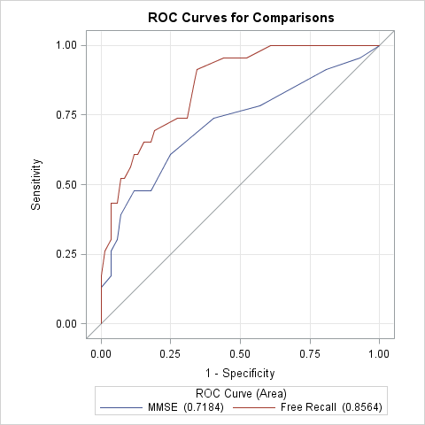

ROC Association Statistics
ROC Model | Mann-Whitney |  |  |  | Somers' D  (Gini) | Gamma | Tau-a
 | Area | Standard  Error | 95% Wald  Confidence Limits
MMSE | 0.7184 | 0.0671 | 0.5869 | 0.8499 | 0.4369 | 0.4768 | 0.1488
Free Recall | 0.8564 | 0.0400 | 0.7780 | 0.9347 | 0.7127 | 0.7282 | 0.2428

