SUPPLEMENTARY MATERIAL

Methods

Six-minute walk test
Two 6-minute walk tests (6MWTs) were performed on the same day. Subjects rested for at least 10 mins before performing the first 6MWT and for a minimum of 30 mins between tests or until oxygen saturation, dyspnoea, and heart rate returned to resting levels for the second test. All 6MWTs were performed in the physiotherapy gymnasium at Royal Prince Alfred Hospital on a continuous 32-m track marked with black tape for easy visibility. Standardized instructions were given before each test, with encouragement given each minute throughout the test.¹

Before and immediately after the 6MWT, oxygen saturations and heart rate were monitored using a portable saturation monitor (RAD-5v Masimo Corp, Irvine, United States), and dyspnoea was measured using the modified Borg scale (0–10).² Predicted values were calculated using Jenkins’ formulae.³

Brachial artery flow-mediated dilatation
An ATL HDI 5000 ultrasound machine (Phillips, Bothell, united States) as previously described by us⁴ with a 5–12 MHz linear array transducer, and electrocardiogram gating by a single technician in the morning after an overnight fast. Prior to testing subjects lay quietly for 10 minutes. Arterial diameter was determined using automated Brachial Analyzer software (Medical Imaging Applications, Coralville, United States); measurements were taken at end-diastole. Following baseline measurement an occlusive cuff was inflated on the forearm to 250 mm Hg for 5 minutes. After deflation of the cuff, timing of peak hyperaemic flow was determined by pulse wave Doppler and the maximal arterial diameter was determined. After 10 min to allow for vessel recovery, a further baseline scan was made and then the response to a 400mcg dose of sublingual glyceryl trinitrate (Pohl-Boskamp, Hohenlockstedt, Germany) was determined.

Peripheral artery tonometry
Testing was performed in the morning after an overnight fast in a quiet, temperature controlled room with dimmed lighting. Following a 10-minute rest period, the arterial pulsatile volume of the right index finger (or in subjects who had previously had a subclavian to pulmonary artery shunt, the left index finger was tested) was assessed before and after 5 minutes of forearm ischaemia. The contralateral finger was assessed to control for systemic influences.

Plasma assays of vascular biomarkers
Blood was collected in K₃EDTA-anticoagulated vacutainer tubes, (BD Biosciences, Oxford, United Kingdom) and centrifuged for 15 minutes at 1000 x g at 4º C within 30 minutes of collection. Plasma was aliquoted and stored at -80º C until assayed.

Plasma levels for asymmetric dimethylarginine, endothelin-1, 3-nitrotyrosine and high sensitivity C-reactive protein were quantified utilising commercially available ELISA kits according to the manufacturer’s instructions (DLD Diagnostika GMBH, Hamburg, Germany, R & D Systems, Minneapolis, United States, Bluegene Biotech, Shanghai, China, BioVendor, Karasek, Czech Republic, respectively). All measurements were read at 450nM with reference wavelength as specified by individual kits using a microplate spectrophotometer (Benchmark Plus with Microplate Manager MPM 111 1.8 - version 10.2 Software, BioRad Laboratories, Hercules, United States).

Circulating endothelial progenitor cell analysis

Flow cytometric assessment of circulating endothelial progenitor cells
Within 1 hour of collection, 100μL per tube was incubated for 30 minutes at 4° C, with a combination of the following mouse anti-human fluorochrome–labelled monoclonal antibodies; CD45 – Phycoerythrin Cyanin 7 and CD34 – R Phycoerythrincyanin 5.1 (Immunotech, Marseille, France), CD133/1 (AC133) – R-Phycoerythrin (Miltenyi Biotec GmbH, Cologne, Germany), and KDR R2/KDR – Carboxyfluorescein (R&D Systems, Abingdon, United Kingdom). Tubes contained either all four antibodies or fluorescence minus one (FM0) controls for each fluorochrome–labelled monoclonal antibody to distinguish negative from positive populations
At the end of the incubation period, the samples were treated with VersaLyse Lysing Solution (Immunotech, Marseille, France), for at least 10 minutes at room temperature (18 – 25° C), protected from light, in order to lyse red blood cells. To avoid the loss of cells, a lyse/no-wash protocol was employed. Fluorescence minus one (FM0) controls were prepared as gating controls.

Data was acquired using the FC500 flow cytometer (Beckman Coulter, Fullerton, California) equipped with a 488nm Argon laser and were analysed using Kaluza Analysis software v.2.

Accurate enumeration of CD34⁺ cells represents a rare event analysis therefore a minimum of 500,000 total events per tube was acquired. Samples were counterstained with the CD45-MAb to identify the total number of leukocytes.

To account for differing amounts of erythrocytes in the samples after lysis, in particular the higher numbers in cyanotic subjects, which would contribute to total number of events, we analysed the number of CD45⁺ cells in the sample (Figure 1b) and expressed our CD34⁺ cells as a percentage of CD45⁺ cells to normalise between different samples instead of normalising to total events. The number of CD45⁺ cells were higher although not significantly in the acyanotic controls (CD45⁺ after lysis, 99.05±0.17 vs. 97.39±0.83; acyanotic vs cyanotic).

This correction for the number of CD45⁺ cells and expression as a proportion of white blood cells in the sample, allowed the elimination of debris and nonspecifically stained events from the analysis, as well as the generation of a reliable denominator (i.e., leukocytes), against which to measure CD34⁺ cells.

Our analysis focused on CD34⁺ cells, which were dim for CD45 fluorescence and had low side scatter (CD34⁺CD45^{dim}SS^{low}).

Endothelial progenitor cell culture
The addition of CD133 & KDR allowed for further immunophenotyping of CD34⁺ cells (Figure1g and 1h) and served to identify the CD34⁺ cell subsets that may more specifically represent EPCs. A simplified version of the gating strategy applied can be found in Supplementary Figure 1.

Briefly, after initial centrifugation, the volume of packed cells was measured and diluted in a 1:2 ratio with phosphate buffered saline so that both cyanosed and normal samples were made up to a similar packed cell volume. Mononuclear cells were then isolated using Lymphoprep (Axis-Shield, Oslo, Norway), a density gradient separation, and seeded into 24-well tissue culture plates pre-coated with human fibronectin (BD Biosciences, Franklin Lakes, United States) at 1 × 10⁷ cells/ml in endothelial cell growth medium-2 (EGM-2) media (Lonza, Walkersville, United States). After 24-h culture, nonadherent cells were discarded. Cells were then cultured for 7 days to obtain early EPCs.⁵

Cultured cells were assessed for the ability to ingest AcLDL (4 μg/ml) (Invitrogen, Carlsbad, United States) and to bind fluorescein isothiocyanate–Ulex europaeus agglutinin lectin (10 μg/ml, Sigma, St. Louis, United States). After staining, fluorescence was examined using a Zeiss AxioImager M1 microscope (Carl Zeiss, Thornwood, United States). Images were acquired with the manufacturer’s software. Cell counts were performed manually by a single-blinded observer.

Figure 1: Strategy for flow cytometric analysis of endothelial progenitor cells
a. b.
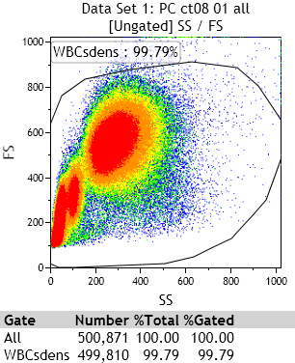

c. d.

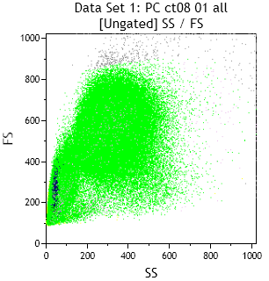
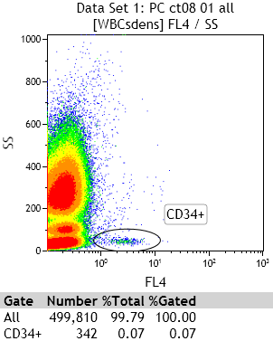

e. f.

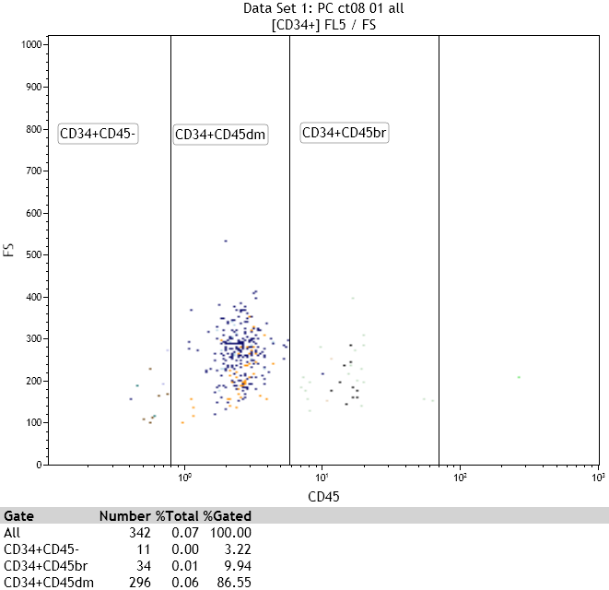
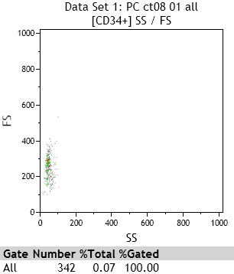

g. h.

Figure 1 legend:

a: The Leukocyte gate, a bivariate density plot of Forward Scatter (FS) versus Side Scatter (SS) displaying all events acquired (a minimum of 500,000 per sample), with gating of all WBCs (WBCs dens).
b: Overlay plot of 2 single parameter histogram of CD45-PECy7 cells, using FM0 minus CD45-MAb (blue) as the negative population and gating CD45⁺ (green) beyond the negative gate. This displays all CD45^{dim} to CD45^{bright} cells and excludes debris, platelets and unlysed erythrocytes, which are all CD45^{neg} but may be collected in the WBCs dens gate;
y-axis: count, x-axis: fluorescence intensity.
c: CD34-PE versus SS bivariate density plot displaying total CD34⁺ expressing cells as a distinct population which can be described as CD34⁺, SS^{low}.
d: Ungated bivariate dot plot of FS versus SS using colour precedence to back-gate on the CD34⁺ gate and forming a discrete population (blue) in the lympho-monocyte region of the plot.
e: A bivariate dot plot of FS versus SS of the CD34⁺ gate showing the discrete CD34⁺ population (blue) seen in histogram 5, and appearing in the same position.
f: A bivariate dot plot of CD45-PECy7 vs FS, gated on the CD34⁺ population in histogram c and showing the 3 distinct populations separated by the intensity of their CD45⁺ staining into CD34⁺ and CD45 ^{neg}, ^{dim} or ^{bright}.
g: Overlay plot of 2 single parameter histograms: FM0 minus KDR-MAb (blue) set as negative population and CD34⁺CD45^{dim}KDR⁺ (green); y-axis: count, x-axis: fluorescence intensity.
h: Overlay plot of 2 single parameter histograms: FM0 minus CD133-MAb (blue) set as negative population and CD34⁺CD45^{dim}CD133⁺ (red); y-axis: count, x-axis: fluorescence intensity.

Results

Comparison of plasma assays and endothelial function assessment in cyanosed subjects on targeted therapy for pulmonary hypertension vs: cyanosed subjects not on therapy (mean ± SEM)

 | On therapy | No therapy | p Value*
Endothelin-1 (pg/ml) | 4.1 ± 1.2 | 2.1 ± 0.2 | 0.10
ADMA (μmol/L) | 0.75 vs. 0.12 | 0.63 ± 0.05 | 0.29
HsCRP (μg/ml) | 4.73 ± 2.70 | 2.48 ± 0.94 | 0.36
Retinal artery max. dilation (%) | 102.9 ± 1.3 | 103.0 ± 1.0 | 0.95
Retinal vein max. dilation (%) | 102.7 ± 0.3 | 103.6 ± 0.3 | 0.15
FMD (%) | 2.32 ± 0.20 | 4.66 ± 1.01 | 0.20
PAT-index | 1.76 ± 0.27 | 1.64 ± 0.14 | 0.68
CD34+45dimKDR+133+  (per million white blood cells) | 14 ± 9 | 18 ± 4 | 0.65
Endothelial progenitor cell culture (cells per 10x field) | 102 ± 33 | 81 ± 16 | 0.54
* p values have not been adjusted for multiple comparisons

REFERENCES

1. ATS statement: guidelines for the six-minute walk test. Am J Respir Crit Care Med 2002;166:111-7.
2. Borg GA. Psychophysical bases of perceived exertion. Med Sci Sports Exerc 1982;14:377-81.
3. Jenkins S, Cecins N, Camarri B, Williams C, Thompson P, Eastwood P. Regression equations to predict 6-minute walk distance in middle-aged and elderly adults. Physiother Theory Pract 2009;25:516-22.
4. Celermajer DS, Sorensen KE, Gooch VM, et al. Non-invasive detection of endothelial dysfunction in children and adults at risk of atherosclerosis. Lancet 1992;340:1111-5.
5. Asahara T, Murohara T, Sullivan A, et al. Isolation of putative progenitor endothelial cells for angiogenesis. Science 1997;275:964-7.

