15 included in Silhouettes-A |  | 15 excluded from Silhouettes-A
Item | R  MCI(n=211)  AD(n=139) | Item | R  MCI(n=211)  AD(n=139)
kangaroo | 0.624*  0.27  0.05 | deckchair | 0.354*  0.25  0.12
rabbit | 0.559*  0.20 | glasses | 0.323*  0.17  0.10
penguin | 0.552*  0.70  0.38 | crocodile | 0.307*  0.24  0.17
bear | 0.549*  0.32  0.22 | rhinoceros | 0.277*  0.11  0.10
tractor | 0.509*  0.56  0.41 | snail | 0.238*  0.08  0.02
ladder | 0.495*  0.46  0.31 | pick axe | 0.204*  0.11  0.13
binoculars | 0.492*  0.36  0.27 | watch | 0.190*  0.19  0.19
spanner | 0.450*  0.62  0.54 | key | 0.162*  0.31  0.27
bike | 0.489*  0.51  0.27 | dustpan | 0.161*  0.11  0.08
pig | 0.487*  0.36  0.40 | cup | 0.155*  0.98  0.94
elephant | 0.443*  0.80  0.63 | frog | 0.127  0.03  0.01
cow | 0.348*  0.55  0.50 | duck | 0.120  0.03  0.04
shoe | 0.305*  0.67  0.60 | cockscrew | 0.115  0.05  0.04
scissors | 0.291*  0.71  0.68 | sheep | 0.102  0.28  0.37
camel | 0.288*  0.95  0.89 | seal | 0.093  0.04  0.03
Supplementary Table 1. Item-total score correlation coefficients of Silhouettes test.

Notes: Silhouettes-A: the Abbreviated version of Silhouettes test; R: Spearman correlation coefficients; *: p<0.001.

Supplementary Table 2 Effect of age, gender, and education on Silhouettes-A in NC (multivariate linear regression)
 | Unstandardised coefficients |  | Standardised coefficients |  | P
 | B | Standard error | Beta | T
Constant | 12.920 | 1.327 | - | 9.737 | <0.001
Gender | -0.764 | 0.282 | -0.176 | -2.707 | 0.007
Age | -0.033 | 0.019 | -0.124 | -1.772 | 0.078
Education | 0.139 | 0.055 | 0.177 | 2.531 | 0.012
Notes: NC: cognitively normal controls; Silhouettes-A: the Abbreviated version of Silhouettes test.

Supplemantary Table 3 Correlation analysis between Silhouettes-A and other neuropsychological tests
Test | R |  | P
BNT |  | 0.616 |  | <0.001
AVLT-DR |  | 0.587 |  | <0.001
ST |  | 0.432 |  | <0.001
STT-B |  | -0.430 |  | <0.001
CFT-C |  | 0.403 |  | <0.001
DSST |  | 0.385 |  | <0.001
JLO |  | 0.339 |  | <0.001
Notes: Silhouettes-A: the Abbreviated version of Silhouettes test. BNT: Boston Naming Test; AVLT-DR: Auditory Verbal Learning Test Delayed Recall; ST: Similarity Test; STT-B: Shape Trail test B; CFT-C: Rey Complex Figure Test Copy; DSST: Digit Symbol Substitution Test; JLO: Judgment of Line Orientation test; R: Spearman correlation coefficients.

Supplemantary Table 4 Effect of BNT, AVLT-DR, ST, STT-B, CFT-C, DSST and JLO.on Silhouettes-A
 | Unstandardised coefficients |  | Standardised coefficients |  | P
 | B | Standard error | Beta | T
Constant | 0.237 | 0.886 | - | 0.267 | 0.789
BNT | 0.228 | 0.024 | 0.333 | 9.410 | <0.001
AVLT-DR | 0.387 | 0.041 | 0.335 | 9.453 | <0.001
ST | 0.068 | 0.022 | 0.104 | 3.055 | 0.002
STT-B | -0.003 | 0.001 | -0.075 | -2.097 | 0.036
CFT-C | 0.049 | 0.023 | 0.075 | 2.133 | 0.033
DSST | 0.001 | 0.008 | 0.003 | 0.080 | 0.936
JLO | 0.035 | 0.018 | 0.062 | 1.974 | 0.049
Notes: Silhouettes-A: the Abbreviated version of Silhouettes test. BNT: Boston Naming Test; AVLT-DR: Auditory Verbal Learning Test Delayed Recall; ST: Similarity Test; STT-B: Shape Trail test B; CFT-C: Rey Complex Figure Test Copy; DSST: Digit Symbol Substitution Test; JLO: Judgment of Line Orientation test.

Supplementary Figure 1. Receiver Operating Characteristic Curve Analysis of Silhouettes-A and the Other Comparable Tests to Discriminate between NC, MCI and AD: (1) NC vs. MCI, (2) MCI vs. AD.
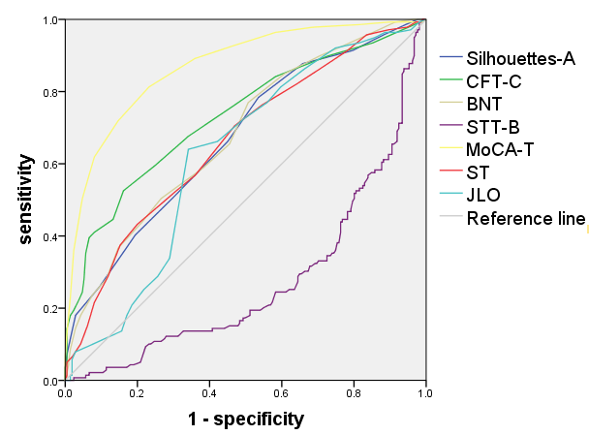
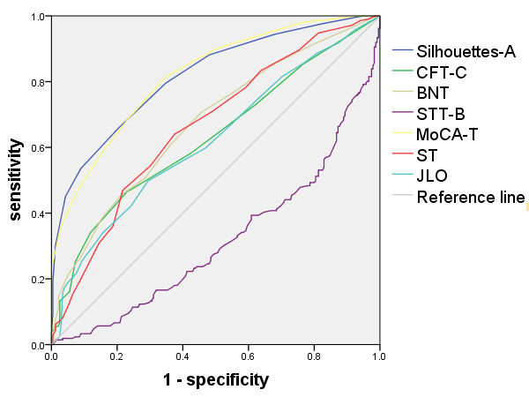
- (2)

Notes: NC: cognitively normal controls; MCI: mild cognitive impairment; AD: Alzheimer’s disease; Silhouettes-A: the Abbreviated version of Silhouettes test; CFT-C: Rey Complex Figure Test Copy; BNT: Boston Naming Test; STT-B: Shape Trail test B; BNT: Boston Naming Test; STT-B: Shape Trail test B; ST: Similarity Test; JLO: Judgment of Line Orientation test; MoCA-T: Total score of Montreal Cognitive Assessment.

