(A)

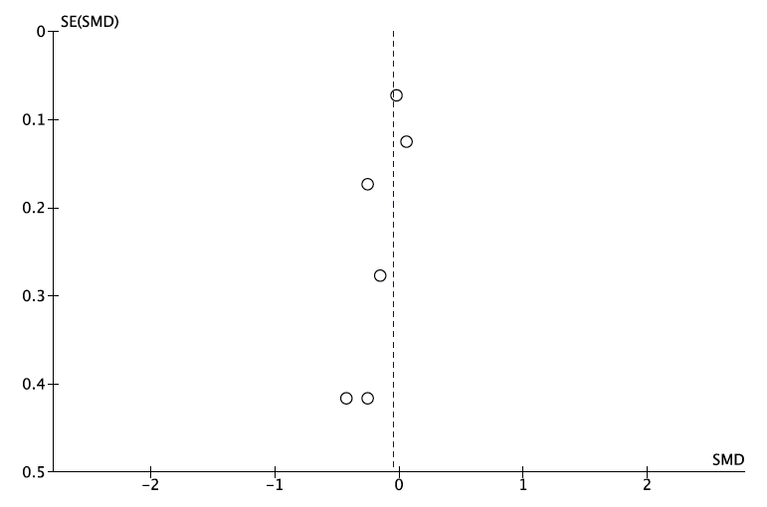

(B)

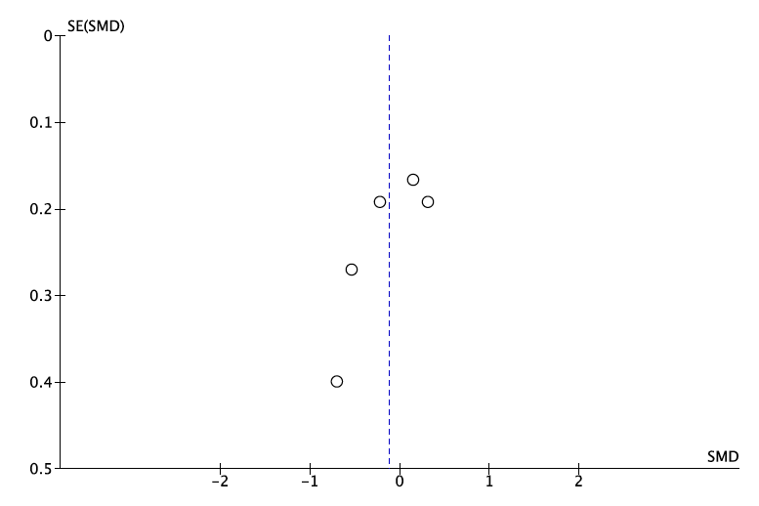

(C)

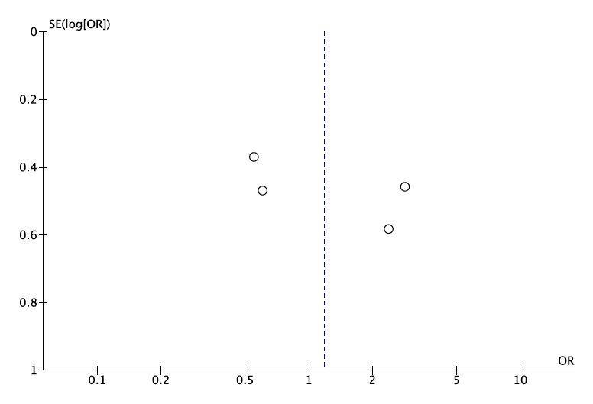

(D)

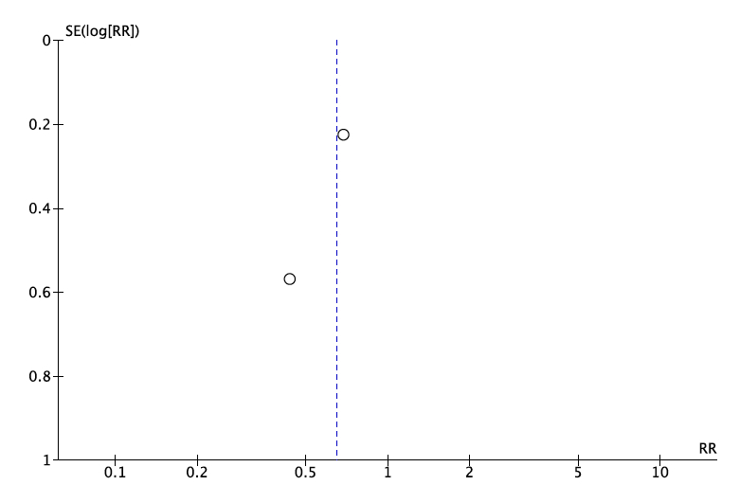

**Supplemental figure 1.** Funnel plots of trials included in four meta-analyses of treatment with folate and/or vitamin B12 compared with placebo: (A) change in the severity of depressive symptoms among adults without a depressive disorder; (B) change in the severity of depressive symptoms among adults with a depressive disorder; (C) odds of clinically significant improvement in adults with a depressive disorder; (D) risk of a depressive episode in adults at risk of a depressive disorder.

(A)



(B)



(C)



**Supplemental figure 2.** Post-hoc analyses showing changes in meta-analytical summary estimates after the exclusion of each individual study. The diamonds indicate the meta-analytical summary estimate and the whiskers its 95% confidence limits. (A) changes in the severity of depressive symptoms among people without a depressive disorder; (B) changes in the severity of depressive symptoms among people with a depressive disorder; (C) changes in the odds of clinically significant improvement among people with a depressive disorder. For (A) and (B), movements of the summary estimate to the right of ‘all studies included’ indicate that the study excluded contained data that excessively favoured the use of vitamins compared with placebo; whereas shifts to the left indicate the opposite association. Panel (C) shows the odds of clinically significant improvement associated with folate and/or vitamin B12 treatment compared with placebo. In this case, shifts to the left of ‘all studies included’ indicate that the study that was excluded excessively favoured the use of vitamins (and vice-versa). A decrease in the length of the whiskers further indicates that the study excluded contributed to increase the variance of the meta-analytical estimate.