Supplementary Table 1. Summary of Model Fit Indices of Latent Class Growth Models for Physical-Social and Emotional Functioning in Older Women’s Health Initiative Clinical Trial Participants (N = 2,281)
Number of Trajectory Groups | Bayesian Information Criteria (BIC) | Akaike Information Criteria (AIC)
Physical Social Functioning
7 | −17,866.97 | −17,798.29
6 | −17,886.09 | −17,831.72
5 | −17,915.84 | −17,867.20
4 | −17,971.44 | −17,937.10
3 | −18,054.59 | −18,031.70
2 | −18,476.69 | −18,465.24
Emotional Functioning
7 | −15,112.55 | −15,055.27
6 | −15,091.85 | −15,034.57
5 | −15,130.41 | −15,084.59
4 | −15,231.00 | −15,193.76
3 | 15,309.66 | 15,283.88
2 | 15,535.48 | 15,518.29

Supplementary Table 2. Estimated Group-Specific Trajectory Parameters of Physical-Social Functioning in Older Women’s Health Initiative Clinical Trial Participants (N = 2,281)
Trajectory parameter | Low Maintainer | Mid-Low Improver | Medium Decliner | Mid-High Maintainer | High Maintainer
Intercept, M (SE) | −7.93 (0.17)*** | −4.53 (0.31)*** | −0.8 (0.26)** | 0.41 (0.13)** | 2.94 (0.08)***
Linear slope, M (SE) | 0.09 (0.04)* | 1.09 (0.17)*** | −1.51 (0.17)*** | −0.08 (0.03)** | 0.06 (0.02)**
Quadratic slope, M (SE) | NS | −0.11 (0.02)*** | 0.13 (0.02)*** | NS | NS
Group proportion, % (n) | 8.3 (188) | 10.4 (235) | 10.7 (241) | 31.2 (706) | 39.4 (890)
Average posterior probability, % | 0.89 | 0.73 | 0.77 | 0.74 | 0.87
Sigma, M (SE) : 2.19 (0.02)***
Model fit statistics: BIC (N=7091): −17,925.6
BIC (N=2281) : −17,915.8
AIC fit index: −17,867.2
Log likelihood : −17,850.2
Results from fitting five-group Latent Class Growth Model. BIC=Bayesian Information Criteria; AIC=Akaike Information Criteria; NS=Non-significant; M=Mean; SE=Standard Error
**p<.01; ***p<.001

Supplementary Table 3. Estimated Group-Specific Trajectory Parameters of Emotional Functioning in Older Women’s Health Initiative Clinical Trial Participants (N = 2,281).
Trajectory parameter | Low Maintainer | Mid-Low Improver | Medium Decliner | Mid-High Maintainer | High Maintainer
Intercept, M (SE) | −6.17 (0.21)*** | −3.48 (0.15)*** | −1.47 (0.19)*** | −0.27 (0.09)*** | 1.32 (0.04)**
Linear slope, M (SE) | 0.17 (0.05)*** | 0.46 (0.04)*** | −1.16 (0.12)*** | 0.03 (0.06) ^{NS} | NS
Quadratic slope, M (SE) | NS | NS | 0.11 (0.01)*** | −0.02 (0.008)** | NS
Group proportion, % (n) | 3 (67) | 9 (205) | 7.7 (174) | 22.8 (519) | 57.5 (1307)
Average posterior probability, % | 0.91 | 0.74 | 0.82 | 0.73 | 0.89
Sigma, M (SE): 1.46 (0.01)***
Model fit statistics: BIC (N=7337): −15,139.79
BIC (N=2281): −15,130.41
AIC fit index: −15,084.59
Log likelihood: −15,068.59
Results from fitting five-group Latent Class Growth Model. BIC=Bayesian Information Criteria; AIC=Akaike Information Criteria; NS=Non-significant; M=Means; SE=Standard Error
**p<.01; ***p<.001

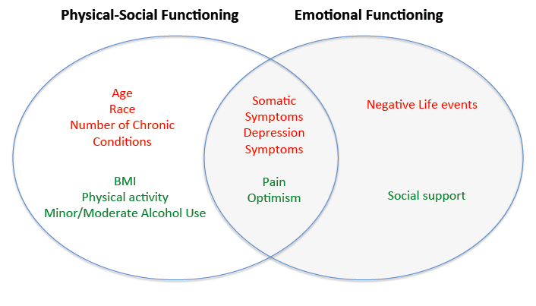
Supplementary Figure 1. Overlap of statistically significant predictors of Physical-Social and Emotional Functioning trajectories. Predictors in red significantly decrease likelihood of being in a higher-functioning trajectory in at least one estimated model (compared to Low Maintainer reference category). Predictors in green significantly increase likelihood of being in a higher functioning trajectory in at least one estimated model (compared to Low Maintainer reference category).

