Supplementary Online Content: Appendix B

A Morandi, D Davis, J Taylor, G Bellelli, B Olofsson, S Kreisel, A Teodorczuk, B Kamholz, W Hasemann, J Young, M Agar, S.E.J.A. de Roji, Meagher D, M Trabucchi, AM MacLullich. Variation in Clinical Practice among Experts in Europe: Results from a Survey of the European Delirium Association

Appendix B.1. First line pharmacological management of hyperactive delirium.

Appendix B.2. Starting dose haloperidol for hyperactive delirium

Appendix B.3. Starting dose risperidone for hyperactive delirium

Appendix B.4. ECG monitoring after an antipsychotic is started

Appendix B.5. Duration of pharmacological treatment for hyperactive delirium

Appendix B.6. Barriers to improving the detection of delirium

Appendix B.7. Barriers to improving the management of delirium

Appendix B.8. Comparison between delirium experts and non experts on the management of hyperactive and hypoactive delirium. We defined experts in delirium management as those responders who: (1) scored ≥8/10 in the self-report question: “How would you rate your knowledge of delirium”; and (2) gave a response of "more than sufficient" to the question "How much training you have received on delirium management."

This supplementary material has been provided by the authors to give readers additional
information about their work. It was last updated on May 15th, 2013.
Appendix B.1: First line pharmacological management in hyperactive delirium

Appendix B.2. Starting dose haloperidol for hyperactive delirium

Appendix B.3. Starting dose risperidone for hyperactive delirium

Appendix B.4. ECG monitoring after an antipsychotic is started

Appendix B.5: Duration of pharmacological treatment for hyperactive delirium

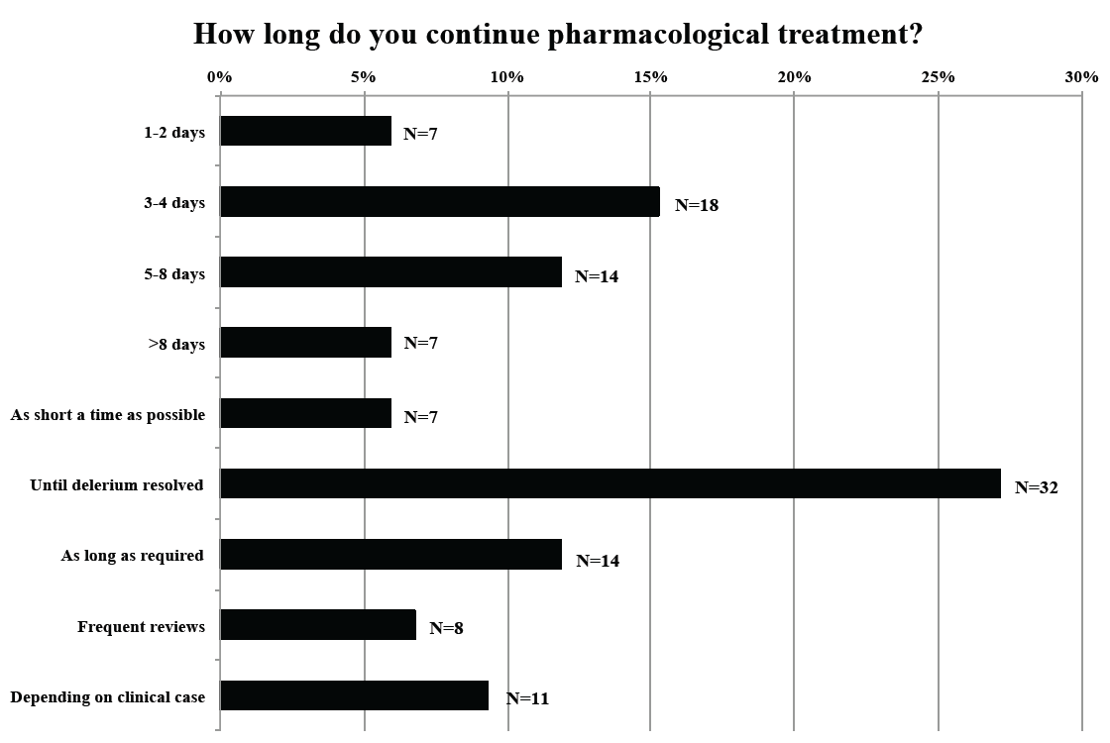

Appendix B.6. Barriers to improving the detection of delirium

Appendix B.7. Barriers to improving the management of delirium

Appendix B.6: Comparison between delirium experts and non experts
Variable | Delirium experts  N (%) | Delirium non experts  N (%) | Chi squared | P value
Routine assessment for delirium in the daily practice | 59 (95%) | 81 (92%) | 0.277 | 0.673
Pharmacological as the first approach for the management of hyperactive delirium | 7 (11.2%) | 6 (6.8%) | 0.441 | 0.506
Non pharmacological as the first approach for the management of hyperactive delirium | 16 (25.8%) | 28 (31.8%) | 0.377 | 0.539
Non pharmacological as the first approach for the management of hypoactive delirium | 46 (74.2%) | 52 (61.2%) | 2.179 | 0.018
Haloperidol as the first line pharmacological management of agitation in hyperactive delirium | 53 (91.4%) | 63 (76.8%) | 6.606 | 0.010
Oral route for the haloperidol use | 52 (83.9%) | 64 (75.3%) | 1.111 | 0.291
Routinely evaluation of the QTc interval on the ECG before initiating medication | 39 (63.9%) | 52 (59.8%) | 0.116 | 0.733

