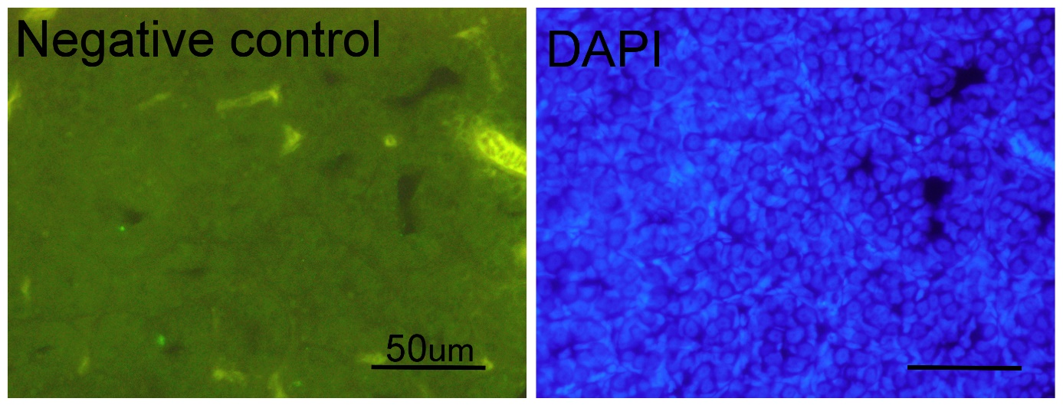
Supplementary Figure: Negative control.

Supplemental Video 1. Motile sperm differentiated in vitro in adherent culture.
Testicular cells dissociated from vitrified whole testis of juvenile G. caerulescens were cultured. The movie was recorded on day 21. Bar = 50 μm.

Supplemental Video 2. Motile sperm differentiated in vitro in suspension culture.
Testicular cells dissociated from vitrified whole testis of juvenile G. caerulescens were cultured. The movie was recorded on day 21. Bar = 50 μm.

