Supplementary Material

Geographic range and conservation of the Cipo Canastero Asthenes luizae, an endemic furnariid of Brazilian sky islands

GUILHERME H. S. FREITAS, LÍLIAN M. COSTA, ANDERSON V. CHAVES, MARCELO F. VASCONCELOS, LEONARDO C. RIBEIRO, JULIANO C. SILVA, RONEY A. SOUZA, FABRÍCIO R. SANTOS and MARCOS RODRIGUES

Contents
Appendix S1. Results: Detailed description of the new records and absence localities of Cipo Canastero.
Table S1. Records of Cipo Canastero in the Espinhaço Range, state of Minas Gerais, south-eastern Brazil.
Figure S1. Elevation map of the southern Espinhaço Range with Cipo Canastero records and the topographic profile.
Figure S2. Histogram of the elevations of the recorded locations of Cipo Canastero.
Figure S3. New and known records of Cipo Canastero in the Serra do Cipó region, south-eastern Brazil.
Figure S4. New and known records of Cipo Canastero in the Diamantina Plateau region, south-eastern Brazil.
Figure S5. New and known records of Cipo Canastero north of the Minas Gerais region (the border with the state of Bahia is indicated), south-eastern Brazil
Figure S6. Cipo Canastero distribution predicted from species distribution modelling (MaxEnt cloglog output) derived from 71 points of presence and 22 environmental variables

Appendix S1. Results: Detailed description of the new records and absence localities of Cipo Canastero.
In the Serra do Cipó South sky island, where only one record was available in the literature, we obtained many new records distributed throughout the area (Figs. S3 and 2A-C). The Cipo Canastero range extends southward to Serra Altamira and Serra da Matinha, occurring in an isolated rocky outcrop of the latter, which constitutes the southernmost boundary of the distribution. In Serra do Lobo, an isolated portion of eastern Serra do Cipó South, we recorded the easternmost population in the Serra do Cipó region (Figs. 2B-C). In Serra do Cipó North, we obtained new records mostly in the southern part of the sky island, at Serra do Breu and the headwaters of Curral Queimado stream. In the Diamantina Plateau sky island (Fig. S4), we recorded the species at Serra dos Ferreiras (Fig. 2G), at the northern limit of this important geographic unit, and near Diamantina city (W.N. Alves pers. comm.). In the Itambé-Gavião sky island (Fig. S4), we obtained a new record at Serra do Gavião (Fig. 2D). We also recorded the species for the first time in the Ambrósio sky island (Fig. S4), which is the easternmost locality of the South sector of the Cipo Canastero distribution (Fig. 2D-E). In the North sector (Fig. S5), we recorded the species for the first time in an isolated geographic unit, the Serra Branca, which is a unique sky island in this sector within a conservation unit. Finally, we obtained new records at Serra da Formosa (Fig. 2H).
Cipo Canastero was not recorded on many mountains that were adjacent to others where there are records. At the southern limit, the species was not recorded in the Quadrilátero Ferrífero region, e.g., in Serra do Caraça (studied since 1996 by MFV), Serra da Cambota (fieldwork conducted in September 2006 by MFV and in May 2011 by AVC, GHSF and MFV), and Serra da Piedade (fieldwork conducted in March 2014 by GHSF and since 1996 by MFV), which is c. 20 km from Serra do Cipo South (Fig. 2A). Towards the west, we did not record the species in Serra do Cabral (sampled in November 2006 by MFV and in October 2012 by AVC, GHSF and LMC), which is separated by c. 25 km from the Diamantina Plateau by the Curimataí and Jequitaí River valley. Between Botumirim and Serra Branca, there are some seemingly suitable campos rupestres where the species was not recorded: Morro do Chapéu (sampled in March 2012 by AVC, GHSF and LMC) and Parque Estadual de Grão Mogol (sampled in January 2007 by MFV and in February 2012 by AVC, GHSF, and LMC). Towards the north of Serra da Formosa, it was not recorded in Serra do Pau D’Arco (sampled in September 2001, December 2006, and December 2008 by MFV and in January 2011 by AVC and MFV). To the northwest, it was not recorded in Parque Estadual Caminho dos Gerais (sampled in June 2009 by GHSF).
Table S1. Records of Cipo Canastero in the Espinhaço Range, state of Minas Gerais, south-eastern Brazil. The localities are coded as follows: letters (A-I) indicate the sky islands identified in this study: A) Serra do Cipó South, B) Serra do Cipó North, C) Diamantina Plateau, D) Itambé-Gavião, E) Serra do Ambrósio, F) Itacambira, G) Botumirim, H) Serra Branca, and I) Serra da Formosa. Roman numerals indicate the overall locations (i.e., a mountain or a microrregion; see Figs. S3-5), and Arabic numerals identify individual records at the same location. Locality names are followed by synonyms in brackets (when available) and the municipality. Coordinates are provided in decimal degrees (datum WGS84) and elevation in metres. The sources include the literature references, museum acronyms (DZUFMG – Centro de Coleções Taxonômicas of the Universidade Federal de Minas Gerais, Belo Horizonte; MCNA – Museu de Ciências Naturais of the Pontifícia Universidade Católica, Belo Horizonte; MHNT – Museu de História Natural of Taubaté, Taubaté; MZUSP – Museu de Zoologia da Universidade de São Paulo, São Paulo), and the initials of the authors. The date is the month and year of the record, or, when an area was sampled across many years, we refer to it as the time since the first year of record.
Locality | Latitude | Longitude | Elevation | Source | Date
A.I. Serra do Bicudo (Serra da Matinha), Itabira | -19.567719 | -43.537236 | 1452 | JCS | Jan 2016
A.II.1. Pico Montes Claros, Nova União | -19.541580 | -43.543920 | 1657 | GHSF, RAS, DZUFMG, Costa et al. (2019) | Jul 2017
A.II.2. Pico Montes Claros, Nova União | -19.540111 | -43.544639 | 1627 | GHSF, RAS, DZUFMG | Jul 2017
A.III.1. Serra Caixa D’Água, High Ribeirão da Prata, Nova União | -19.540033 | -43.576583 | 1620 | GHSF, RAS | Jul 2017
A.III.2. Serra Caixa D’Água, High Ribeirão da Prata, Taquaraçu de Minas | -19.539175 | -43.580711 | 1596 | GHSF, RAS | Jul 2017
A.IV.1. Serra da Mutuca, Jaboticatubas | -19.503142 | -43.554156 | 1530 | GHSF, RAS | Jul 2017
A.IV.2. Serra da Mutuca, Jaboticatubas | -19.501203 | -43.555293 | 1557 | GHSF, RAS | Jul 2017
A.IV.3. Serra da Mutuca, Nova União | -19.497642 | -43.558494 | 1629 | GHSF, RAS | Jul 2017
A.IV.4. Serra da Mutuca, Jaboticatubas | -19.493210 | -43.553868 | 1626 | GHSF, RAS | Jul 2017
A.IV.5. Serra da Mutuca, Nova União | -19.492620 | -43.564798 | 1542 | GHSF, LCR | Feb 2010
A.IV.6. Serra da Mutuca, Jaboticatubas | -19.489462 | -43.557731 | 1659 | GHSF, RAS | Jul 2017
A.IV.7. Serra da Mutuca, Jaboticatubas | -19.483703 | -43.553864 | 1514 | GHSF, LCR | Feb 2010
A.IV.8. Serra da Mutuca, Jaboticatubas | -19.482065 | -43.553405 | 1516 | GHSF, LCR | Feb 2010
A.IV.9. Serra da Mutuca, Jaboticatubas | -19.481586 | -43.566631 | 1539 | GHSF, LCR | Feb 2010
A.IV.10. Serra da Mutuca, Jaboticatubas | -19.476542 | -43.558756 | 1537 | GHSF, LCR | Feb 2010
A.IV.11. Serra da Mutuca, Jaboticatubas | -19.465961 | -43.560036 | 1497 | GHSF, LCR, C.L. Silva | Sep 2015
A.V.1. Serra da Lagoa Dourada, Jaboticatubas | -19.498300 | -43.583899 | 1596 | GHSF, LCR | Feb 2010
A.V.2. Serra da Lagoa Dourada, Jaboticatubas | -19.496518 | -43.589859 | 1551 | GHSF, LCR | Feb 2010
A.V.3. Serra da Lagoa Dourada, Jaboticatubas | -19.496208 | -43.583849 | 1608 | GHSF, LCR | Feb 2010
A.V.4. Serra da Lagoa Dourada, Jaboticatubas | -19.494600 | -43.592040 | 1581 | GHSF, LCR | Feb 2010
A.V.5. Serra da Lagoa Dourada, Jaboticatubas | -19.491719 | -43.582381 | 1589 | GHSF, LCR | Feb 2010
A.V.6. Serra da Lagoa Dourada, Jaboticatubas | -19.491270 | -43.580745 | 1485 | GHSF, LCR | Feb 2010
A.V.7. High Jaboticatubas Stream, Jaboticatubas | -19.481502 | -43.576389 | 1394 | GHSF, LCR | Feb 2010
A.VI. High (east) Bandeirinha Stream, Jaboticatubas | -19.482126 | -43.526088 | 1476 | GHSF, LCR | Feb 2010
A.VII.1. Serra da Farofa, Jaboticatubas | -19.413585 | -43.527932 | 1442 | GHSF, LCR, AVC | Sep 2009
A.VII.2. Serra da Farofa, Jaboticatubas | -19.412584 | -43.529628 | 1436 | GHSF, LCR | Feb 2010
A.VII.3. Serra da Farofa, Jaboticatubas | -19.394480 | -43.550494 | 1363 | Cordeiro et al. (1998), GHSF, LCR | 20/11/1997, 13/03/2009
A.VIII.1. High Preto de Itambé River, Itambé do Mato Dentro | -19.406000 | -43.485864 | 1705 | JCS | Apr 2017
A.VIII.2. High Entancado Stream, Itambé do Mato Dentro | -19.394033 | -43.488000 | 1619 | GHSF, LMC, C.L. Silva | Mar 2011
A.VIII.3. High Entancado Stream, Itambé do Mato Dentro | -19.360613 | -43.491688 | 1519 | GHSF | Feb 2008
A.VIII.4. High Entancado Stream, Itambé do Mato Dentro | -19.359253 | -43.485456 | 1505 | GHSF, C.L. Silva | Dec 2006
A.VIII.5. High Peixe River, Itambé do Mato Dentro | -19.352663 | -43.498682 | 1444 | GHSF | Apr 2007
A.VIII.6. High Peixe River, Itambé do Mato Dentro | -19.352603 | -43.496177 | 1500 | GHSF, LCR | Mar 2009
A.IX.1. Travessão, Itambé do Mato Dentro | -19.345004 | -43.508165 | 1310 | GHSF, LMC, C.L. Silva | Mar 2011
A.IX.2. Travessão, Jaboticatubas | -19.336459 | -43.521476 | 1134 | GHSF, LCR | Mar 2009
A.IX.3. Travessão, Santana do Riacho | -19.330904 | -43.518759 | 1100 | Andrade et al. (1998), GHSF | Apr 2007
A.X. Serra do Lobo, Itabira | -19.435242 | -43.391242 | 1419 | JCS | Dec 2016
B.I.1. Alto da Boa Vista, Santana do Riacho | -19.314426 | -43.582822 | 1350 | GHSF, LMC | since 2005
B.I.2. Alto da Boa Vista, Santana do Riacho | -19.297503 | -43.587639 | 1305 | GHSF, LMC, Costa et al. (2019) | since 2005
B.I.3. Alto da Boa Vista, Santana do Riacho | -19.289409 | -43.587972 | 1260 | Pearman (1990), Vielliard (1990), Melo-Júnior et al. (2001), Vasconcelos et al. (2008), Gomes & Rodrigues (2010), Costa & Rodrigues (2012), Costa et al. (2019) DZUFMG, MZUSP | May 2005
B.II.1. Alto do Palácio, Santana do Riacho | -19.285163 | -43.537890 | 1500 | GHSF, LMC, Costa et al. (2019) | Since 2009
B.II.2. Alto do Palácio, Santana do Riacho | -19.279424 | -43.535615 | 1440 | GHSF, LMC, Costa et al. (2019) | Since 2009
B.II.3. Alto do Palácio, Santana do Riacho | -19.271941 | -43.535124 | 1405 | GHSF, LMC, Costa et al. (2019) | Since 2009
B.III.1. Salitreiro, Morro do Pilar | -19.302091 | -43.501818 | 1345 | GHSF, LMC | Aug 2010
B.III.2. Salitreiro, Morro do Pilar | -19.301389 | -43.482222 | 1363 | GHSF, LMC, DZUFMG | Apr 2011
B.IV. High Preto River, Alto do Palácio , Morro do Pilar | -19.248467 | -43.505264 | 1250 | Rodrigues et al. (2011), GHSF, LMC | Mar 2010
B.V. High Curral Queimado stream, Santana do Riacho | -19.201111 | -43.648556 | 1260 | LCR, C.L. Silva | Jun 2018
B.VI. Cachoeira Ribeirão do Campo, Serra do Intendente, Conceição do Mato Dentro | -19.095812 | -43.554553 | 1110 | Cordeiro et al. (1998) | Apr 1998
B.VII.1. Lapinha, Santana do Riacho | -19.115165 | -43.670170 | 1158 | GHSF, LMC | Jun 2007
B.VII.2. Lapinha, Santana do Riacho | -19.111365 | -43.671015 | 1209 | GHSF, LMC | Feb 2011
B.VII.3. Pico da Lapinha, Serra do Breu, Santana do Riacho | -19.102604 | -43.673538 | 1545 | LCR | Dec 1899
B.VII.4. Serra do Breu, Santana do Riacho | -19.087935 | -43.657568 | 1485 | GHSF, LMC | Since 2009
B.VII.5. Serra do Breu, Santana do Riacho | -19.085086 | -43.670685 | 1610 | GHSF, LMC | Since 2009
B.VII.6. Serra do Breu, Santana do Riacho | -19.082739 | -43.661691 | 1542 | GHSF, LCR | Since 2009
B.VII.7. Serra do Breu, Santana do Riacho | -19.082478 | -43.659183 | 1499 | GHSF, LMC, Costa et al. (2019) | Since 2009
B.VII.8. Serra do Breu, Santana do Riacho | -19.079248 | -43.664899 | 1647 | GHSF, LMC | Since 2009
B.VIII. Brumas do Espinhaço, Santana do Riacho | -19.040308 | -43.719772 | 1250 | Vasconcelos (2008) | Jan 2005
B.IX.1. Campo Alegre, Serra Talhada, Santana de Pirapama | -18.802906 | -43.880272 | 1140 | Cordeiro et al. (1998) | Feb 1998
B.IX.2. High Passagem stream, Fechados, Santana de Pirapama | -18.781111 | -43.854722 | 1307 | AVC, GHSF, DZUFMG | Feb 2012
B.IX.3. High Passagem stream, Fechados, Santana de Pirapama | -18.778889 | -43.855000 | 1292 | AVC, GHSF, DZUFMG | Feb 2012
C.I. Serra do Barro Preto, Gouveia | -18.615371 | -43.899174 | 1300 | Vasconcelos et al. (2008b), DZUFMG | Sep 2006
C.II. Ribeirão da Areia, Diamantina | -18.161448 | -43.701431 | 1100 | Alves (2015) | Dec 2015
C.III.1. Serra do Galho, PN das Sempre-vivas, Buenópolis | -17.960828 | -43.807827 | 1300 | Vasconcelos et al. (2008a) | Oct 2008
C.III.2. Várzea do Rio Preto, Parque Nacional das Sempre-Vivas, Buenópolis | -17.926667 | -43.813333 | 1250 | AVC, GHSF, DZUFMG | Feb 2012
C.III.3. Várzea do Rio Preto, Parque Nacional das Sempre-Vivas, Buenópolis | -17.918056 | -43.833056 | 1316 | MFV, D. Hoffmann | Sep 2018
C.III.4. Morro da Torre (Landinho), Parque Nacional das Sempre-Vivas, Bocaiúva | -17.895000 | -43.769167 | 1421 | AVC, GHSF, DZUFMG, MCNA | Feb 2012
C.III.5. Morro da Torre (Landinho), Parque Nacional das Sempre-Vivas, Bocaiúva | -17.894722 | -43.767500 | 1404 | AVC, GHSF, DZUFMG | Feb 2012
C.IV.1. Fazenda Álamo, Serra dos Ferreiras, Olhos D'água | -17.554510 | -43.736605 | 1122 | AVC, GHSF | Feb 2012
C.IV.2. Fazenda Álamo, Serra dos Ferreiras, Olhos D'água | -17.553611 | -43.734444 | 1145 | AVC, GHSF, DZUFMG | Feb 2012
C.IV.3. Fazenda Álamo, Serra dos Ferreiras, Olhos D'água | -17.552490 | -43.735143 | 1147 | AVC, GHSF | Feb 2012
D.I. Três Barras, Serro | -18.508562 | -43.441684 | 1252 | Vasconcelos et al. (2008b), DZUFMG | Apr 2004
D.II.1. Capivari, Serro | -18.442778 | -43.395278 | 1350 | AVC, GHSF, LMC, DZUFMG | Apr 2011
D.II.2. Capivari, Serro | -18.441763 | -43.416789 | 1235 | Cordeiro et al. (1998) | Jan 1998
D.III.1. Capivari, Serro | -18.404535 | -43.373123 | 1380 | Vasconcelos (2002) | Dec 2000
D.III.2. Pico do Itambé, Serro | -18.399108 | -43.348294 | 2002 | GHSF, LCR, C.L. Silva, JCS | 15/01/2014, May 2014
D.III.3. High Matinha stream, Serra do Itambé, Serra Azul de Minas | -18.364444 | -43.317500 | 1564 | GHSF, LCR, C.L. Silva, DZUFMG | Jan 2014
D.III.4. High Matinha stream, Serra do Itambé, Serro | -18.361667 | -43.318611 | 1540 | GHSF, LCR, C.L. Silva, DZUFMG | Jan 2014
D.IV. High Taipeiro stream, Serra do Gavião, Rio Vermelho | -18.301111 | -43.258333 | 1560 | AVC, GHSF, LMC, DZUFMG | Apr 2011
D.V.1. Parque Estadual do Rio Preto, São Gonçalo do Rio Preto | -18.225703 | -43.351592 | 1550 | Bencke et al. (2006) | ?
D.V.2. Dois Irmãos, Parque Estadual do Rio Preto, São Gonçalo do Rio Preto | -18.207734 | -43.310964 | 1790 | MFV | May 2004
E.I.1. Serra do Ambrósio, Rio Vermelho | -18.075833 | -43.074722 | 1226 | AVC, GHSF, DZUFMG | Oct 2011
E.I.2. Serra do Ambrósio, Rio Vermelho | -18.073611 | -43.072500 | 1324 | AVC, GHSF, DZUFMG | Oct 2011
F.I. Serra Resplandecente, Itacambira | -17.005494 | -43.343399 | 1300 | Vasconcelos and D’Angelo-Neto (2007), Vasconcelos et al. (2008), DZUFMG | Sep 2003
G.I.1. Campina do Bananal (Serra da Canastra), Botumirim | -16.847992 | -43.035673 | 1270 | Vasconcelos et al. (2002, 2008), Vasconcelos and D’Angelo-Neto (2007), DZUFMG, MHNT | Mar 2000
G.I.2. Campina do Bananal (Serra da Canastra), Botumirim | -16.841389 | -43.053889 | 1346 | MFV | Jan 2002
H.I. Gerais de Santana, Serra Branca, Parque Estadual Serra Nova e Talhado, Porteirinha | -15.721944 | -42.820278 | 1285 | AVC, MFV | Jan 2011
I.I.1. Serra da Formosa, Monte Azul | -15.237222 | -42.822778 | 1697 | MFV | Dec 2007
I.I.2. Serra da Formosa, Monte Azul | -15.233056 | -42.818333 | 1484 | Vasconcelos 2008, AVC, GHSF, LMC, DZUFMG | Feb 2012

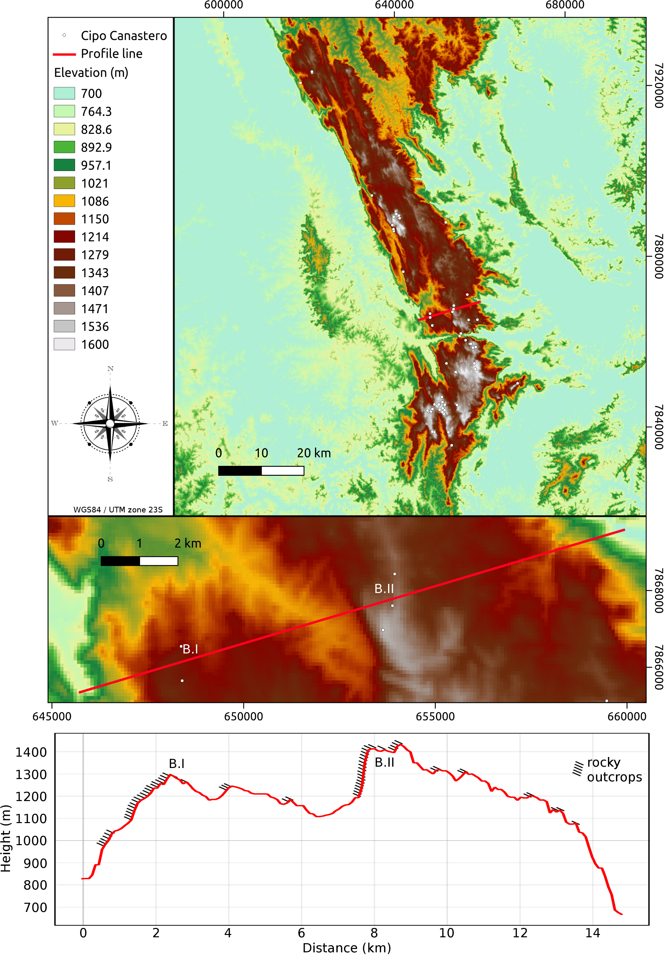Figure S1. Elevation map of the southern Espinhaço Range with Cipo Canastero records (above) and the topographic profile (below) of a transect (straight red line in the maps above) in the Cipo Canastero sky island of Serra do Cipó North. In the profile, we highlight the rocky outcrop distribution, which is mainly along the dissected slopes facing west, as well as the Cipo Canastero subpopulations (B.I and B.II) restricted to areas with the highest prevalence of rocky outcrops at the summits. The locality codes are the same as in Table S1.

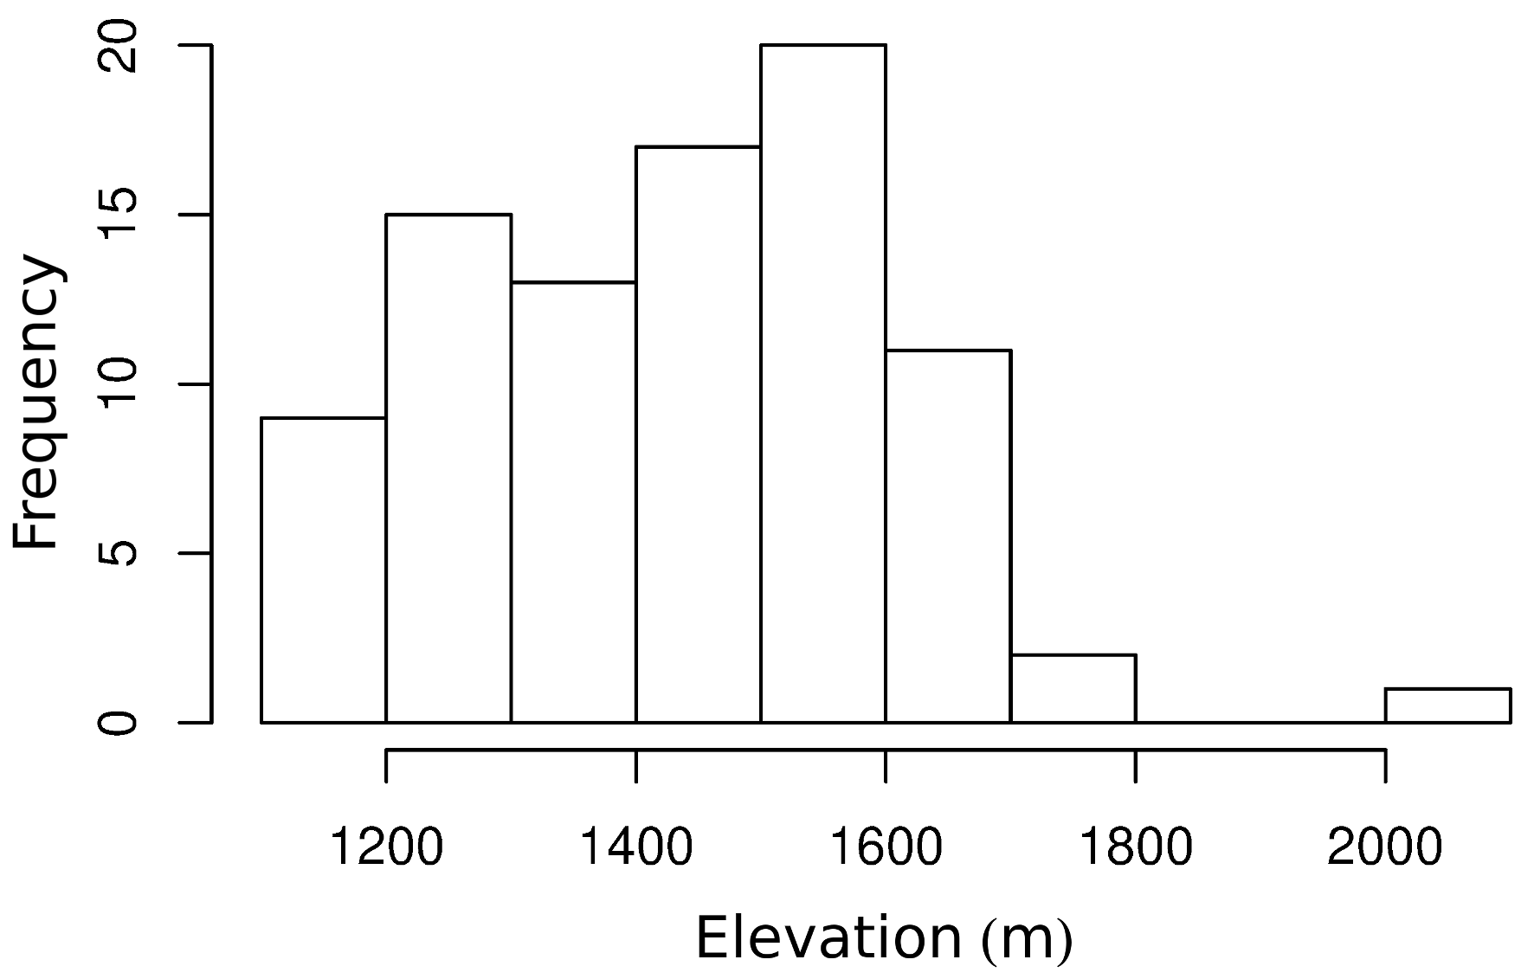
Figure S2. Histogram of the elevations of the recorded locations (n = 88; Table S1) of Cipo Canastero, a sky island species endemic to the Espinhaço Range, southeastern Brazil.
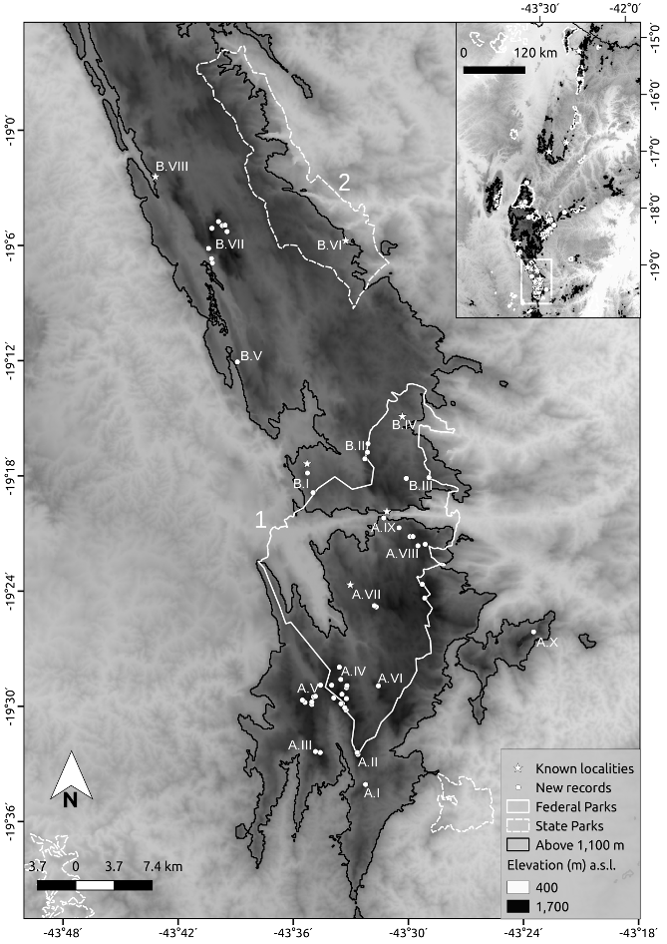
Figure S3. New (white circles) and known (stars) records of Cipo Canastero in the Serra do Cipó region, southeastern Brazil. Close-up view of the southern part of the South sector of the species distribution in the Espinhaço Range (overall view in inset map and Fig. 1), including the sky-islands Serra do Cipó South (A) and Serra do Cipó North (B). The localities are coded according to Table S1. Areas above 1,100 m are outlined (black line). Conservation units of integral protection (available at http://idesisema.meioambiente.mg.gov.br) are represented at the federal level (continuous white line) and at the state level (dashed white line): 1- Parque Nacional da Serra do Cipó; 2- Parque Estadual Serra do Intendente.
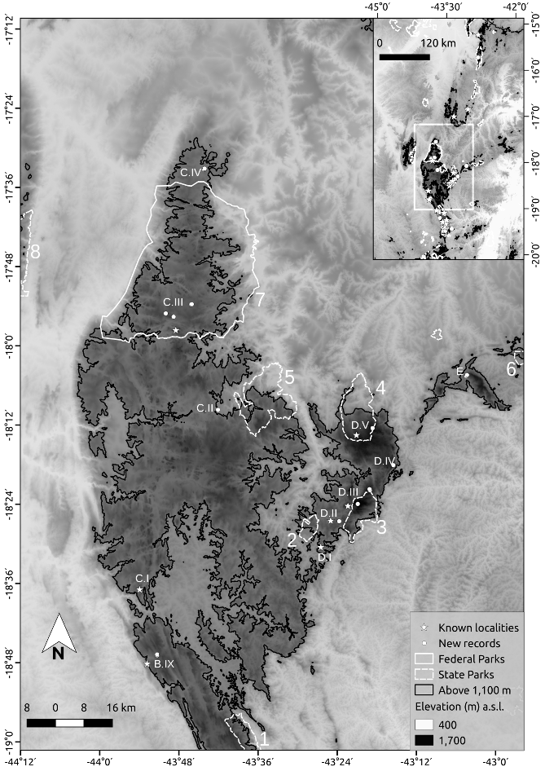
Figure S4. New (white circles) and known (stars) records of Cipo Canastero in the Diamantina Plateau region, southeastern Brazil. Close-up view of the northern part of the South sector of the species distribution in the Espinhaço Range (overall view in the inset map and Fig. 1), including the sky islands: Serra do Cipó North (B), Diamantina Plateau (C), Itambé-Gavião (D), and Serra do Ambrósio (E). The localities are coded according to Table S1. Areas above 1,100 m are outlined (black line).Conservation units of integral protection (available at http://idesisema.meioambiente.mg.gov.br) are represented at the federal level (continuous white line) and at the state level (dashed white line): 1- Parque Estadual Serra do Intendente, 2- Monumento Natural Estadual Varzea do Lageado e Serra do Raio, 3- Parque Estadual do Pico do Itambé, 4- Parque Estadual do Rio Preto, 5- Parque Estadual do Biribiri, 6- Parque Estadual da Serra Negra, 7- Parque Nacional das Sempre-Vivas, 8- Parque Estadual da Serra do Cabral.
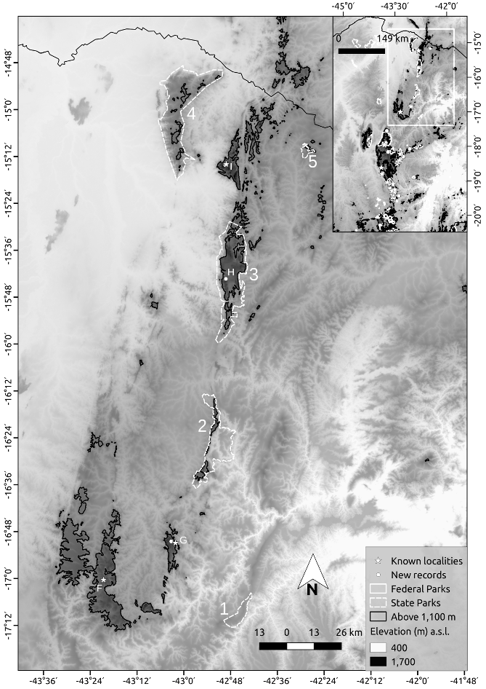
Figure S5. New (white circles) and known (stars) records of Cipo Canastero north of the Minas Gerais region (the border with the state of Bahia is indicated), southeastern Brazil. Close-up view of the Central and North sectors of the species distribution in the Espinhaço Range (overall view in the inset map and Fig. 1), including the sky islands: Itacambira (F), Botumirim (G), Serra Branca (H), and Serra da Formosa (I). The localities are coded according to Table S1. Areas above 1,100 m are outlined (black line). Conservation units of integral protection (available at http://idesisema.meioambiente.mg.gov.br) are represented at the state level (dashed white line): 1- Estação Ecológica de Acauã, 2- Parque Estadual de Grão Mogol, 3- Parque Estadual Serra Nova e Talhado, 4- Parque Estadual Caminho dos Gerais, 5- Parque Estadual de Montezuma.
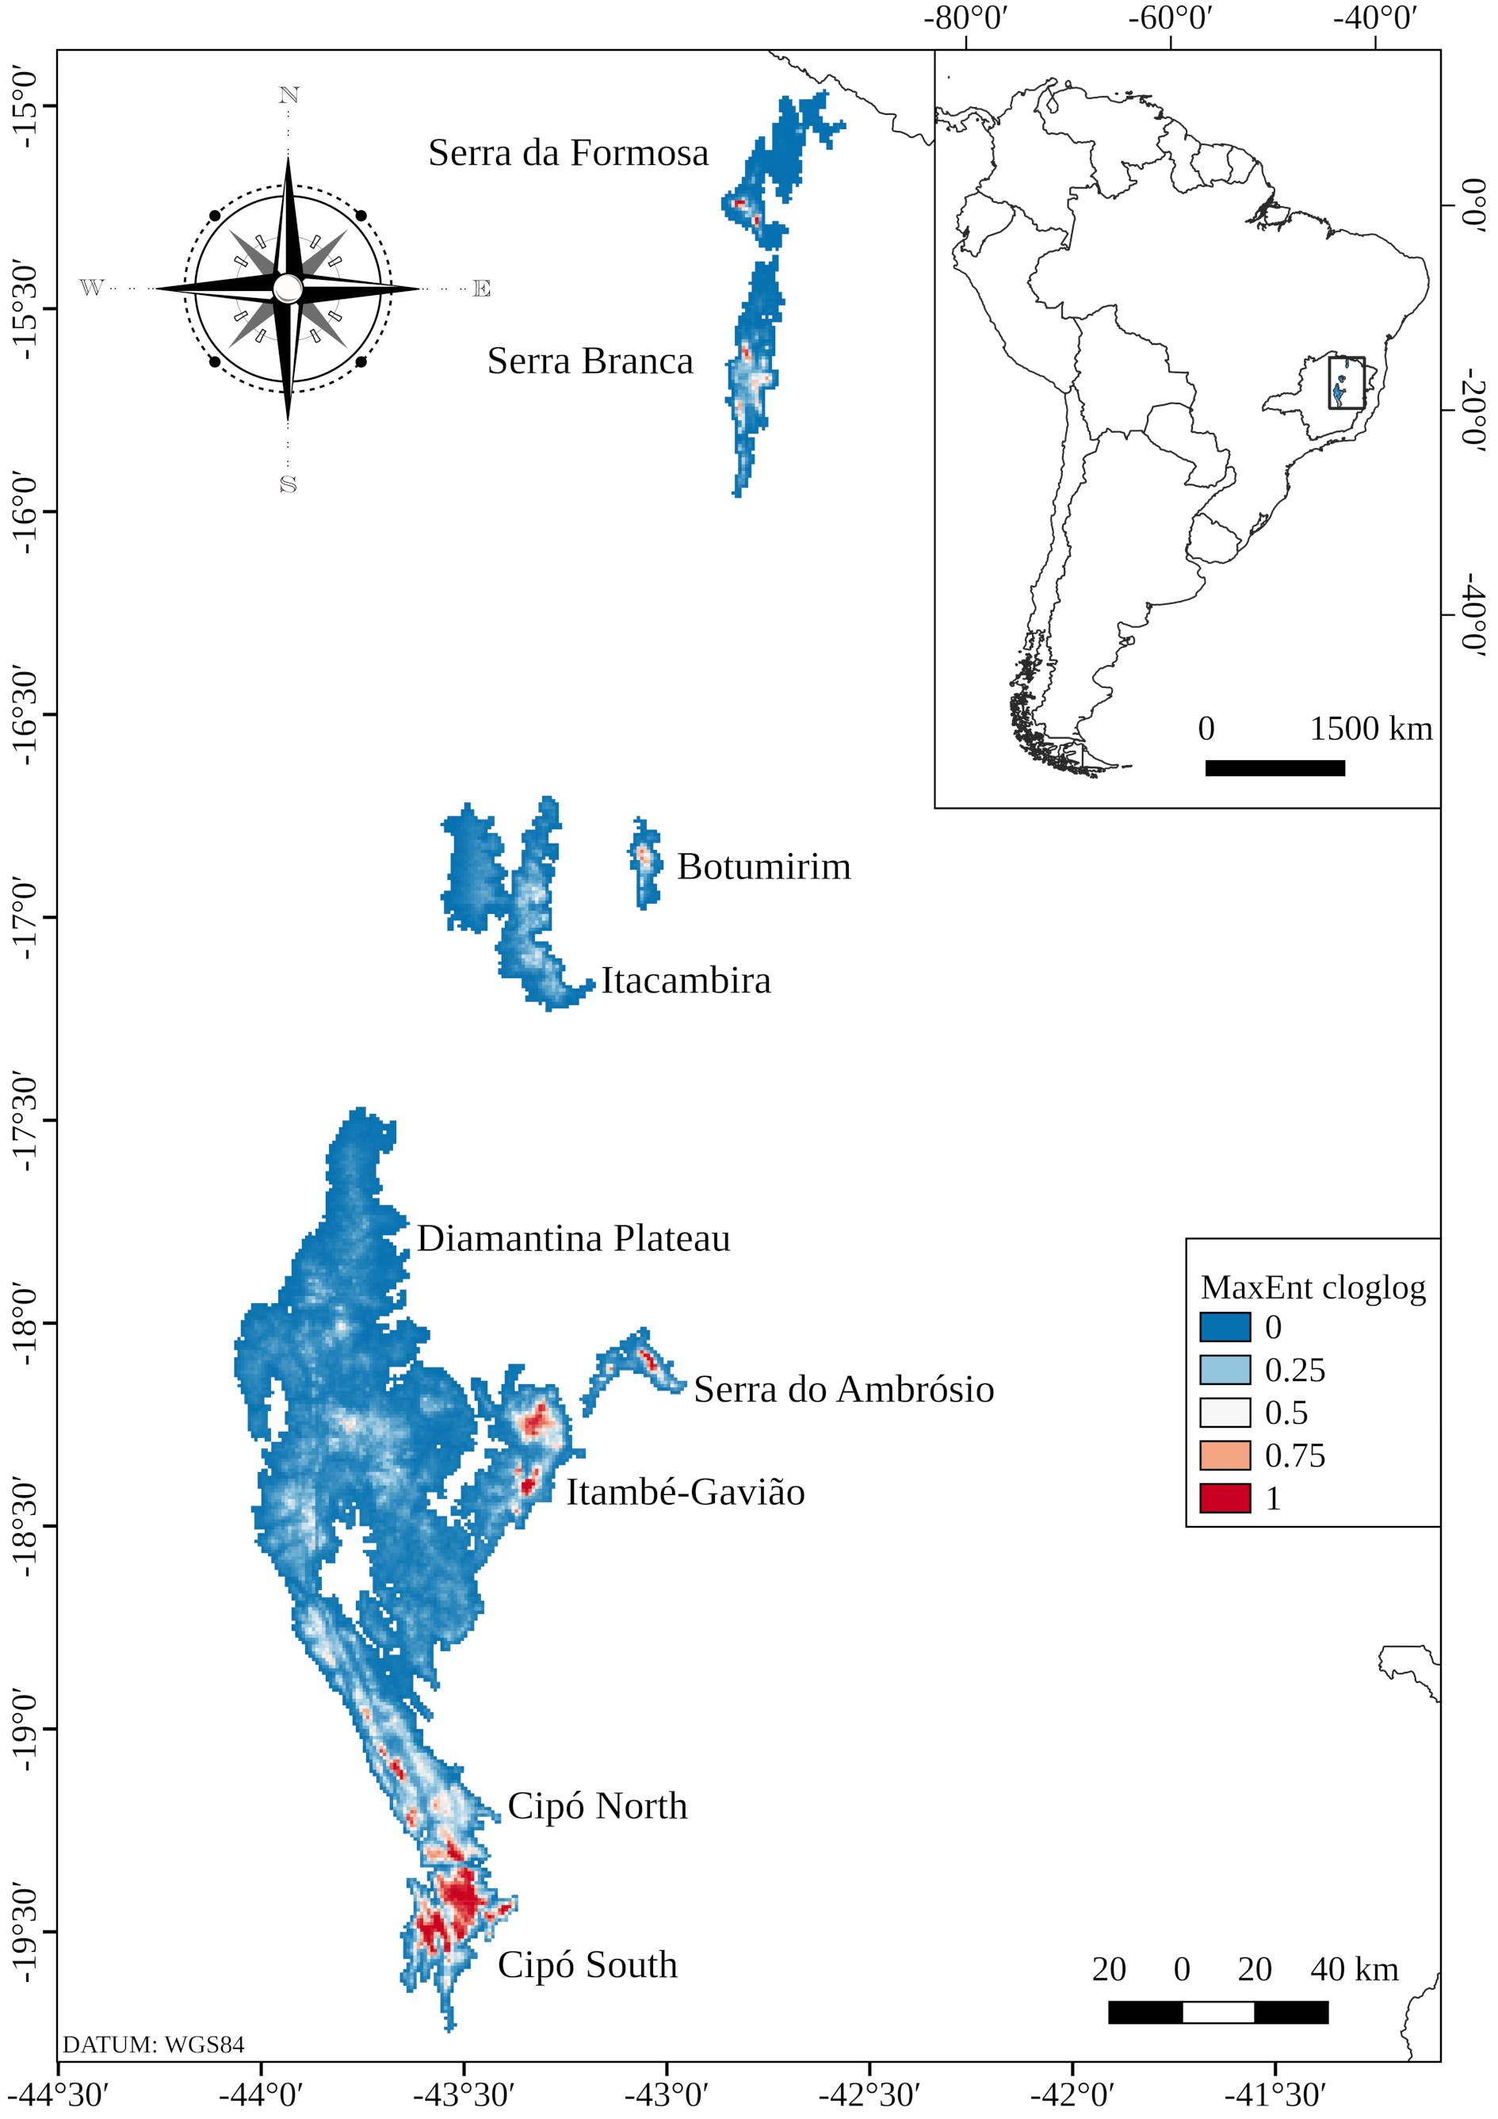
Figure S6. Cipo Canastero distribution predicted from species distribution modelling (MaxEnt cloglog output) derived from 71 points of presence and 22 environmental variables. See Fig. 3 for a binary map.

