Supplementary Material

Distribution of a habitat specialist: Mopane woodland structure determines occurrence of Near Threatened Lilian’s Lovebird Agapornis lilianae

TIWONGE I. MZUMARA, ROWAN O. MARTIN, HEMANT TRIPATHI, CHAONA PHIRI and ARJUN AMAR
Contents
Figure S1. Study design.
Figure S2. Relationship between PC1 and measures of tree ‘size’, mean and maximum dbh and height.
Figure S3. Mopane trees fallen after being burned at the root.
Table S1. Variables used in the analysis.
Table S2. Variables used in the PCA construction.
Table S3: Plausible models testing the association between the presence of Lilian's lovebirds and various habitat and environmental parameters.
Table S4. Parameter estimates and 95% Confidence intervals for the top three variables with AICc difference of less than 2. Estimates were generated using the MuMIn package (Barton 2013).
Table S5. Sampling squares where Lilian’s Lovebirds were recorded during the survey.
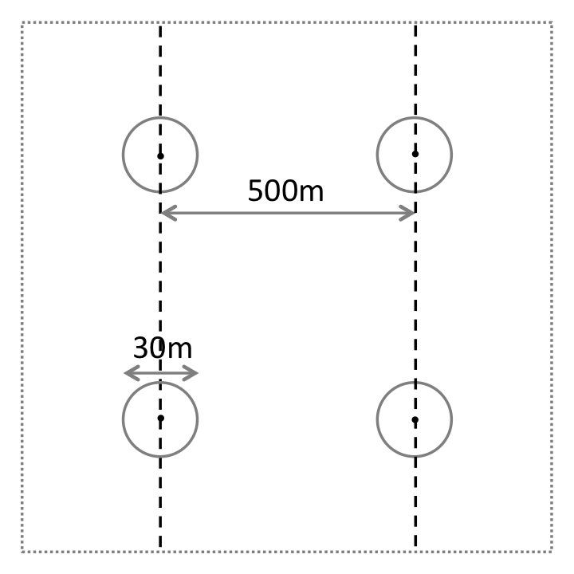
Figure S1. Study design. Sampling square was 1 km x 1 km, two plots were located along each transect, 250m from the end of each 1-km transect i.e. 500 m apart. Transects run across the square and were 500 m apart. The four circular plots have a radius of 15 m.

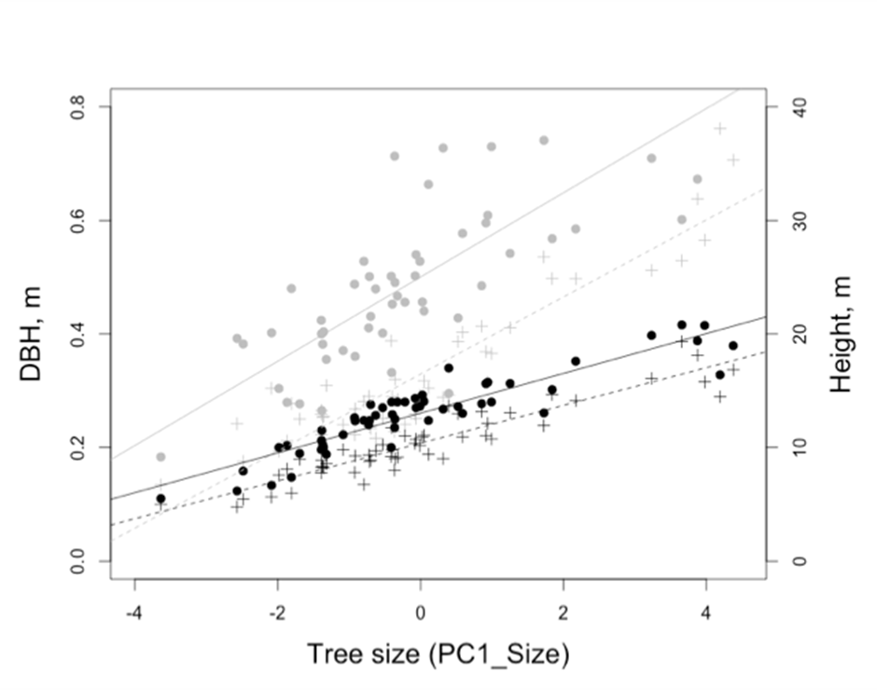
Figure S2. Relationship between PC1 and measures of tree ‘size’, mean and maximum dbh and height.

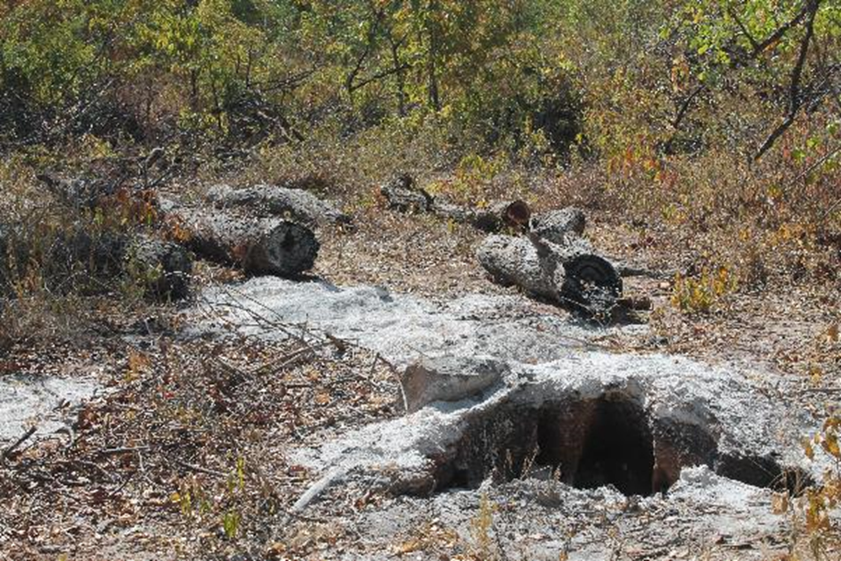
Figure S3. Mopane trees fallen after being burned at the root.

Table S1. Variables used in the analysis.
Variable | Description
Elevation | Elevation recorded using GPS (metres above sea level)
MeanDBH | Mean of the Mean dbh of Mopane trees in each plot in a sampled square (metres)
MaxDBH | Mean of the Maximum dbh of Mopane trees in each plot in a sampled square (metres)
MeanHgt | Mean of the mean height of Mopane trees in each plot in a sampled square (metres)
MaxHgt | Mean of the Maximum height of Mopane trees in each plot in a sampled square (metres)
MaxNoMop | Maximum number of Mopane trees (>0.1m dbh) in each plot
MeanMop | Mean number of Mopane trees (>0.1m dbh) in each plot
MeanOther | Mean number of other (non-Mopane) trees (>0.1m dbh) in each plot
meanTTrees | Mean of the total number of all trees (>0.1m dbh) in each plot

Table S2. Variables used in the PCA construction.
Variable | Eigen values | % explanation
PC1Size | 1.8362 | 42%
PC2Mopane | 1.5380 | 29%
PC3Other | 1.1116 | 15%

Table S3. Plausible models testing the association between the presence of Lilian's lovebirds and various habitat and environmental parameters.
Model Discription | Df | ∆ AICc | AICc weight
PCA Size | 2 | 0 | 0.317
PCA Size + PCA Mopane | 3 | 1.24 | 0.17
PCA Size + PCA Other trees | 3 | 1.49 | 0.151
PCA Size + Elevation | 3 | 2.13 | 0.109
PCA Size +PCA Mopane + PCA Other Trees | 4 | 2.74 | 0.08
PCA Size + PCA Mopane + Elevation | 4 | 3.16 | 0.065
PCA Size + PCA Other trees + Elevation | 4 | 3.29 | 0.061
PCA Size +PCA Mopane + PCA Other Trees+ Elevation | 5 | 3.84 | 0.046

Table S4. Parameter estimates and 95% Confidence intervals for the top three variables with AICc difference of less than 2. Estimates were generated using the MuMIn package (Barton 2013).
 |  | confidence Interval
Variable | Parameter estimate | 0.025 | 0.975 | Relative Importance
PCA Mopane Size | 1.0223 | 0.3978784 | 1.6467151 | 1
PCA Mopane Density | 0.2667 | -0.2722225 | 0.8057108 | 0.27
PCA Other Tree Density | -0.2843 | -0.96271 | 0.3940785 | 0.24

Table S5. Sampling squares where Lilian’s Lovebirds were recorded during the survey.
Square | lat | long_ | Elevation | MopDescription
D11S1 | -15.6018 | 29.7708 | 339.5137 | Cathedral Mopane
D11S2 | -15.5995 | 29.79115 | 359.3781 | Cathedral Mopane
D12S2 | -15.5593 | 29.72457 | 382.0468 | Cathedral Mopane
P2D10S1 | -12.9234 | 32.04191 | 556.8739 | Degraded Mopane
P2D10S2 | -12.883 | 32.01931 | 539.8154 | Cathedral Mopane
P2D10S3 | -13.0948 | 31.89741 | 528.9733 | Degraded Mopane
P2D12S1 | -12.0992 | 32.47207 | 614.386 | Degraded Mopane
P2D13S1 | -11.8682 | 32.43751 | 599.9202 | Cathedral Mopane
P2D13S2 | -11.9152 | 32.40935 | 599.196 | Cathedral Mopane
P2D1S1 | -14.2099 | 30.62586 | 443.0349 | Cathedral Mopane
P2D2S1 | -14.1954 | 30.63865 | 454.8366 | Cathedral Mopane
P2D2S2 | -14.2369 | 30.60442 | 435.3586 | Mixed Mopane
P2D3S1 | -14.1639 | 30.62865 | 435.5966 | Degraded Mopane
P2D5S1 | -13.1161 | 31.78596 | 510.0022 | Degraded Mopane
P2D5S2 | -13.1602 | 31.76057 | 533.3138 | Cathedral Mopane
P2D6S1 | -13.0794 | 31.78463 | 522.1318 | Degraded Mopane
P2D6S2 | -13.16 | 31.70915 | 530.7375 | Degraded Mopane
P2D9S2 | -13.0272 | 31.92675 | 533.1633 | Cathedral Mopane
D12S1 | -15.5593 | 29.72457 | 382.0468 | Cathedral Mopane
P2D7S2 | -12.9237 | 32.04657 | 561.8122 | Mopane

