Supplementary Material
Using camera traps to examine distribution and occupancy trends of ground-dwelling rainforest birds in north-eastern Madagascar
ASIA J. MURPHY, ZACH J. FARRIS, SARAH KARPANTY, MARCELLA J. KELLY, KATHLEEN A. MILES, FÉLIX RATELOLAHY, RAYMOND P. RAHARINIAINA and CHRISTOPHER D. GOLDEN
Contents
Appendix S1. Survey details for the 15 photographic surveys across seven sites (camera-trapping grids), including repeated surveys of three sites, ranked from least degraded (S01) to most degraded (S07) using a maximum-likelihood estimated (MLE) principal components analysis (PCA) of the landscape-level and station-level habitat data collected at each site (Farris et al. 2015b).
Appendix S2. Bi-plot from maximum likelihood estimated principle components analysis of landscape and microhabitat-level habitat data used (Farris 2014) to classify seven sites surveyed across the Makira-Masoala landscape (2008-2013) into three forest types: intact, intermediate, and degraded.
Appendix S3. List of 20 covariates used in landscape single-season occupancy analyses of seven ground-dwelling forest bird species in northeastern Madagascar (2008-2013).
Appendix S4. Total captures, trap success, number of sites detected, and IUCN status for all forest bird species captured during photographic surveys at the seven study sites in the Masoala-Makira protected area complex, northeastern Madagascar between 2008-2013.
Appendix S5. Representative camera trap photographs of the seven forest bird species analysed.
Appendix S6A. Competing (ΔQAIC ≤ 2.0) landscape occupancy models from single-season occupancy analyses for seven native forest bird species across the Masoala-Makira protected area complex, northeastern Madagascar (2008-2013).
Appendix S6B. Competing (ΔAIC ≤ 2.0) multi-season occupancy models from multi-season occupancy analyses for seven native forest bird species at S02 and S05 (2008-2013).
Appendix S6C. Competing (ΔQAIC ≤ 2.0) landscape occupancy models and yearly estimates of occupancy (ψ) and detection (p) from single-season occupancy analyses for three native forest bird species at S03 (2009 and 2013).

Appendix S1. Survey details for the 15 photographic surveys across seven sites (camera-trapping grids), including repeated surveys of three sites, ranked from least degraded (S01) to most degraded (S07) using a maximum-likelihood estimated (MLE) principal components analysis (PCA) of the landscape-level and station-level habitat data collected at each site (Farris et al. 2015b). Photographic surveys occurred from 2008 to 2013 across the Masoala-Makira landscape, northeastern Madagascar. Number of bird species detected includes exotic species (domestic chicken and helmeted guineafowl).
Study Site (Survey Dates and Season)¹ | # of Camera Stations | Total # of Trap Nights | Elevation (m) | # of Species Detected
S01 (March – May 2009; HW) | 20 | 989 | 1000-1400 | 12
S02 (September – November 2008; CW) | 20 | 1315 | 360-703 | 12
S02 (September – November 2010; HD) | 25 | 1230 | 349-680 | 10
S02 (August – October 2011; CW) | 24 | 1383 | 349-689 | 9
S02 (July – October 2012; CW) | 24 | 1536 | 340-680 | 8
S02 (September – October 2013; CW) | 24 | 1198 | 371-706 | 10
S03 (August – October 2009; CW) | 19 | 1067 | 380-550 | 9
S03 (January – February 2013; HD) | 30 | 933 | 377-556 | 9
S03 (March – April 2013; HW) | 25 | 678 | 453-580 | 9
S04 (June – August 2011; CW) | 23 | 1462 | 21-385 | 8
S05 (March – May 2011; HW) | 24 | 1509 | 324-786 | 9
S05 (June – July 2012; CW) | 24 | 1015 | 324-786 | 10
S05 (November 2013 – January 2014; HD) | 24 | 1188 | 317-786 | 9
S06 (November 2009 – January 2010; HD) | 18 | 881 | 580-820 | 8
S07 (December 2010 – February 2011; HD) | 24 | 1570 | 93-507 | 12
¹ Season survey was conducted: CW (cold-wet; June-September), HD (hot-dry; October-January) and HW (hot-wet; February-May).

Appendix S2. Bi-plot from maximum likelihood estimated principle components analysis of landscape and microhabitat-level habitat data used (Farris 2014) to classify seven sites surveyed across the Makira-Masoala landscape (2008-2013) into three forest types: intact, intermediate, and degraded. Site grouping is shown via the black circles. Two sites were classified as intact, three sites as intermediate, and two as degraded.
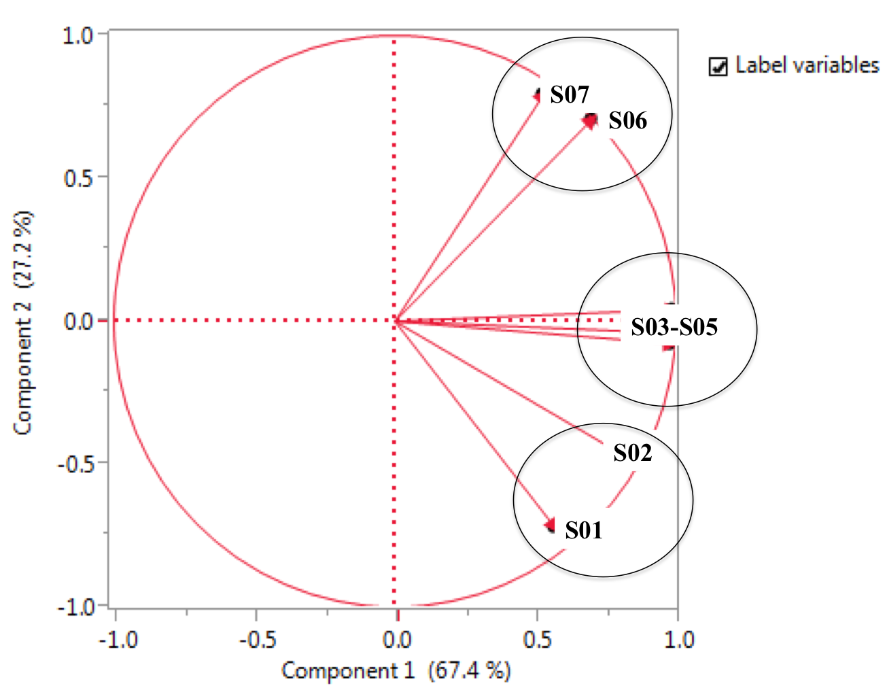
Appendix S3. List of 20 covariates used in landscape single-season occupancy analyses of seven ground-dwelling forest bird species in northeastern Madagascar (2008-2013). Covariates include landscape-level and station-level habitat characteristics, the trap success rates (TS) of humans and native/exotic carnivores, and the season that the survey was conducted. ψ indicates we tested the covariate effect on occupancy probability only, p indicates we tested the covariates effect on detection probability only, ψ/p indicates we tested the covariates effect on occupancy and detection probability, and +/- indicates the direction of the hypothesized relationship. Species abbreviations are as follows: Madagascar Magpie-robin (MMR), Red-breasted Coua (RBC), Scaly Ground-roller (SGR), Madagascar Crested Ibis (MCI), and Madagascar Wood-rail (MWR).
 |  | MMR | RFC | RBC | SGR | MCI | MWR | MTD
Habitat | Distance to Forest Edge (km) | ψ+ | ψ+ | ψ+ | ψ+ | ψ+ | ψ+ | ψ+
 | % Rainforest Cover | ψ+ | ψ+ | ψ+ | ψ+ | ψ+ | ψ+ | ψ+
 | Total # of Habitat Patches | ψ- | ψ- | ψ- | ψ- | ψ- | ψ- | ψ-
 | Avg. Canopy Height (m) |  |  |  | ψ+ | ψ+
 | Tree Density (stems $≥$ 5cm/ha) | ψ+ |  |  |  | ψ- |  | ψ+
 | Basal Area (stems $≥$ 5cm, m²/ha) |  |  |  | ψ+ | ψ+
 | Total Understory Cover (%) | ψ+ |  | ψ+ | ψ+
 | Trail Width (m) | p+ | p+ | p+ | p+ | p+ | p+ | p+
 | Trail Type | p+ | p+ | p+ | p+ | p+ | p+ | p+
 | Station-level Habitat Characterization (S03-only) | ψ- | ψ- | ψ- | ψ- | ψ- | ψ- | ψ-
Trap Success (TS) | Human TS | ψ-/p- | ψ-/p- | ψ-/p- | ψ-/p- | ψ-/p- | ψ-/p- | ψ-/p-
 | Fosa TS |  | ψ+/p- | ψ+/p- | ψ+/p- | ψ+/p- | ψ+/p- | ψ+/p-
 | Spotted Fanaloka TS |  |  |  | ψ+/p- | ψ+/p- | ψ+/p-
 | Falanouc TS |  |  | ψ+/p- | ψ+/p- | ψ+/p- | ψ+/p-
 | Small Carnivore TS¹ | ψ+/p- | ψ+/p- | ψ+/p- | ψ+/p- |  | ψ+/p- | ψ+/p-
 | Feral Cat TS | ψ-/p- | ψ-/p- | ψ-/p- | ψ-/p- | ψ-/p- | ψ-/p- | ψ-/p-
 | Small Indian Civet TS |  | ψ-/p- | ψ-/p- | ψ-/p- | ψ-/p- | ψ-/p- | ψ-/p-
 | Bush Pig TS | ψ-/p- |  |  | ψ-/p- | ψ-/p-
 | Zebu TS | ψ-/p- | ψ-/p- | ψ-/p- | ψ-/p- | ψ-/p- | ψ-/p- | ψ-/p-
Survey | Season | p+ | p+ | p+ | p+ | p+ | p+ | p+
¹ Small carnivore TS is the sum of the trap successes of three small carnivore species detected across the Masoala-Makira landscape: ring-tailed vontisra (Galidia elegans), broad-striped vontsira (Galidictis fasciata), and brown-tailed vontsira (Salanoia concolor).

Appendix S4. Total captures, trap success, number of sites detected, and IUCN status for all forest bird species captured during photographic surveys at the seven study sites in the Masoala-Makira protected area complex, northeastern Madagascar between 2008-2013.
Common Name | Scientific Name | Total # of Captures | Overall TS¹ | # of Sites Detected | IUCN Status²
Red-breasted Coua | Coua serriana | 1,329 | 7.36 | 7 | LC
Madagascar Wood-rail | Mentocrex kioloides | 616 | 3.41 | 7 | LC
Madagascar Turtle-dove | Nesoenas picturatus | 510 | 2.82 | 7 | LC
Scaly Ground-roller | Geobiastes squamiger | 487 | 2.70 | 6 | VU
Madagascar Magpie-robin | Copsychus albospecularis | 439 | 2.43 | 7 | LC
Madagascar Crested Ibis | Lophotibis cristata | 343 | 1.90 | 6 | NT
Red-fronted Coua | Coua reynaudii | 125 | 0.69 | 7 | LC
Pitta-like Ground-roller | Atelornis pittoides | 25 | 0.14 | 2 | LC
White-throated Rail | Dryolimnas cuvieri | 13 | 0.07 | 2 | LC
Crossley's Babbler | Mystacornis crossleyi | 11 | 0.06 | 3 | LC
Domestic Chicken | Gallus gallus domesticus | 8 | 0.04 | 1 | LC
Helmeted Guineafowl | Numida meleagris | 8 | 0.04 | 3 | LC
Madagascar Scops-owl | Otus rutilus | 8 | 0.04 | 3 | LC
Blue Coua | Coua caerulea | 7 | 0.04 | 3 | LC
Helmet Vanga | Euryceros prevostii | 7 | 0.04 | 1 | VU
Madagascar Coucal | Centropus toulou | 5 | 0.03 | 3 | LC
Madagascar Sparrowhawk | Accipiter madagascariensis | 4 | 0.02 | 1 | NT
Frances's Sparrowhawk | Accipiter francesiae | 3 | 0.02 | 3 | LC
Brown Mesite | Mesitornis unicolor | 2 | 0.01 | 1 | VU
Rufous-headed Ground-roller | Atelornis crossleyi | 1 | 0.01 | 1 | NT
Madagascar Buzzard | Buteo brachypterus | 1 | 0.01 | 1 | LC
Ashy Cuckooshrike | Coracina cinerea | 1 | 0.01 | 1 | LC
Madagascar Yellowbrow | Crossleyia xanthophrys | 1 | 0.01 | 1 | NT
Madagascar Serpent-eagle | Eutriorchis astur | 1 | 0.01 | 1 | EN
Bernier's Vanga | Oriolia bernieri | 1 | 0.01 | 1 | VU
White-throated Oxylabes | Oxylabes madagascariensis | 1 | 0.01 | 1 | LC
Madagascar Harrier-hawk | Polyboroides radiatus | 1 | 0.01 | 1 | LC
Madagascar Paradise-flycatcher | Terpsiphone mutata | 1 | 0.01 | 1 | LC
Unidentified |  | 124 | 0.69
OVERALL |  | 4,083 | 22.61
¹ Overall TS (trapping success) estimated by dividing total number of independent photographic capture events of the species by the total number of trap nights from 2008-2013 and then multiplying by 100.
² IUCN status: LC = least concern; NT = near threatened; VU = vulnerable; EN = endangered (IUCN, 2014).

Appendix S5. Representative camera trap photographs of the seven forest bird species analysed: (A) Madagascar Crested Ibis (Lophotibis cristata; MCI), (B) Madagascar Turtle-dove (Nesoenas picturatus; MTD), (C) Madagascar Magpie-robin (female on the left and male on the right; Copsychus albospecularis; MMR), (D) Madagascar Wood-rail (Mentocrex kioloides; MWR), (E) Scaly Ground-roller (Geobiastes squamiger; SGR), (F) Red-fronted Coua (Coua reynaudii; RFC) and (G) Red-breasted Coua (C. serriana; RBC). Pictures are cropped for better viewing.
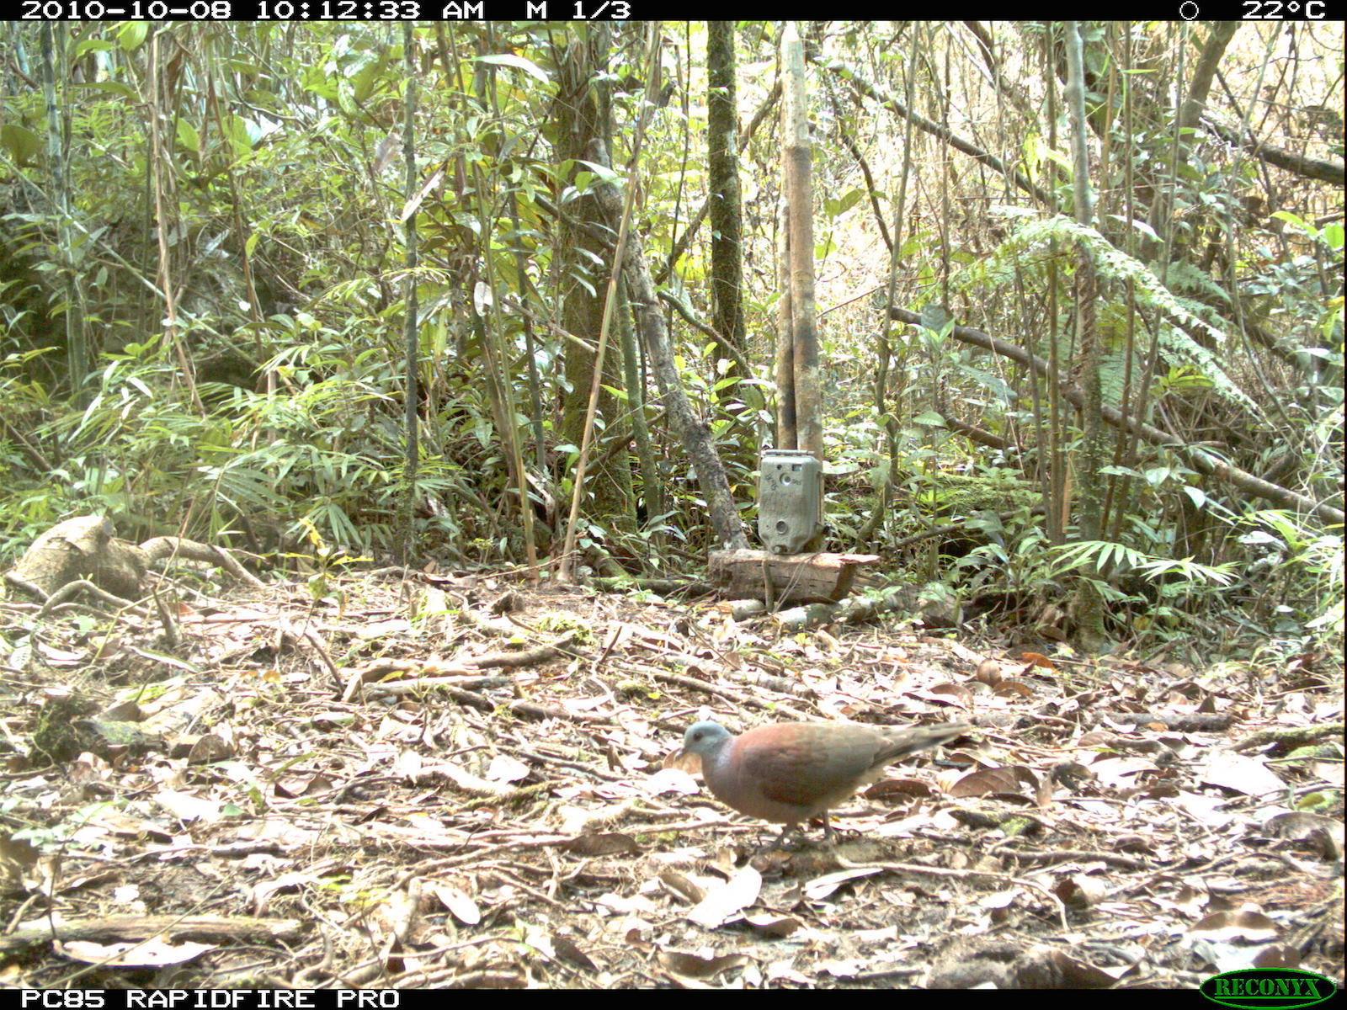
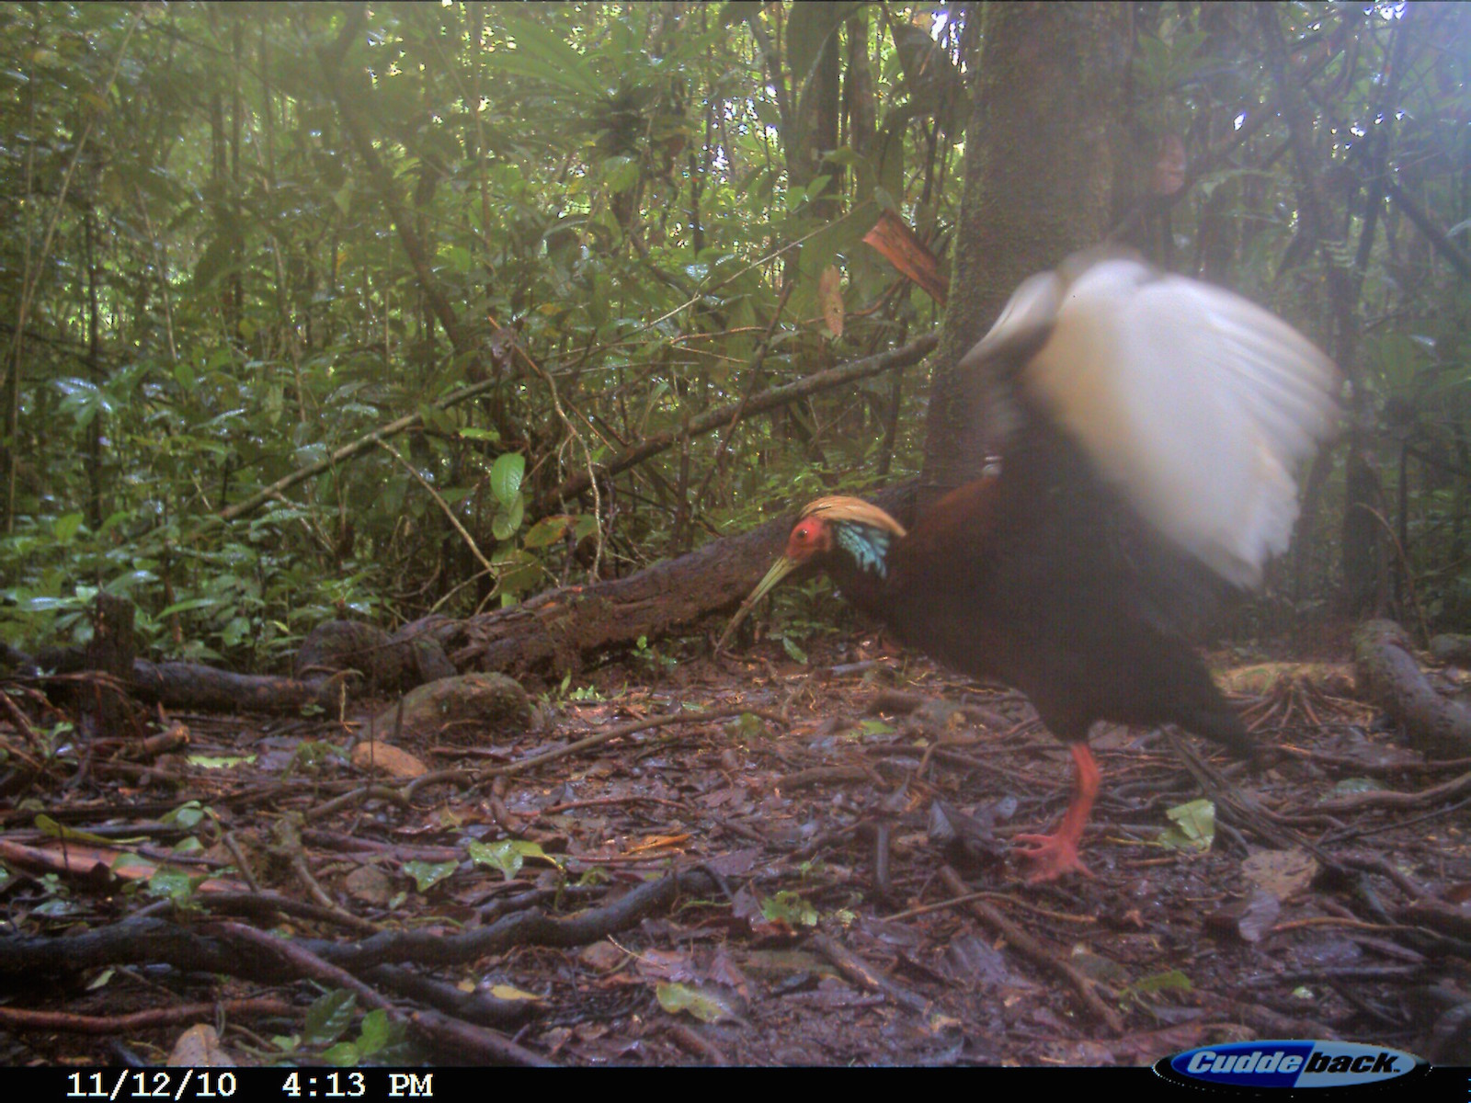

C) Madagascar Magpie-robin (MMR)
B) Madagascar Turtle-dove (MTD)
A) Madagascar Crested Ibis (MCI)

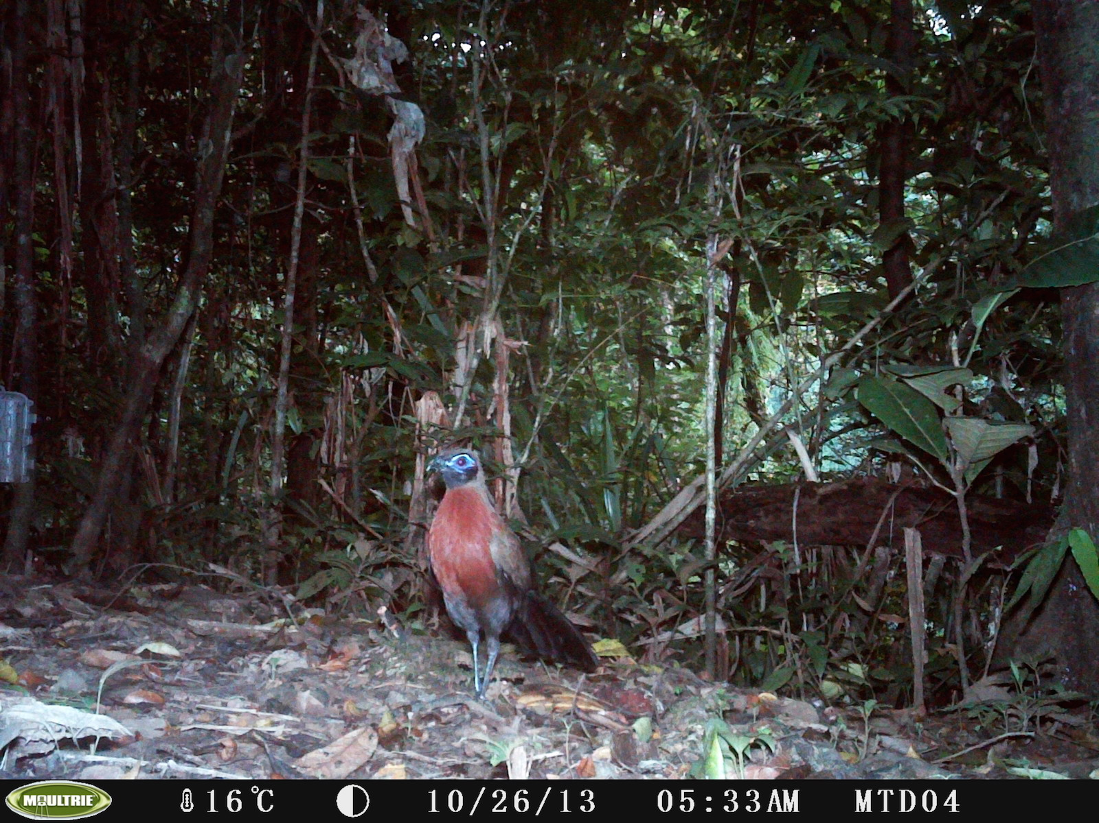
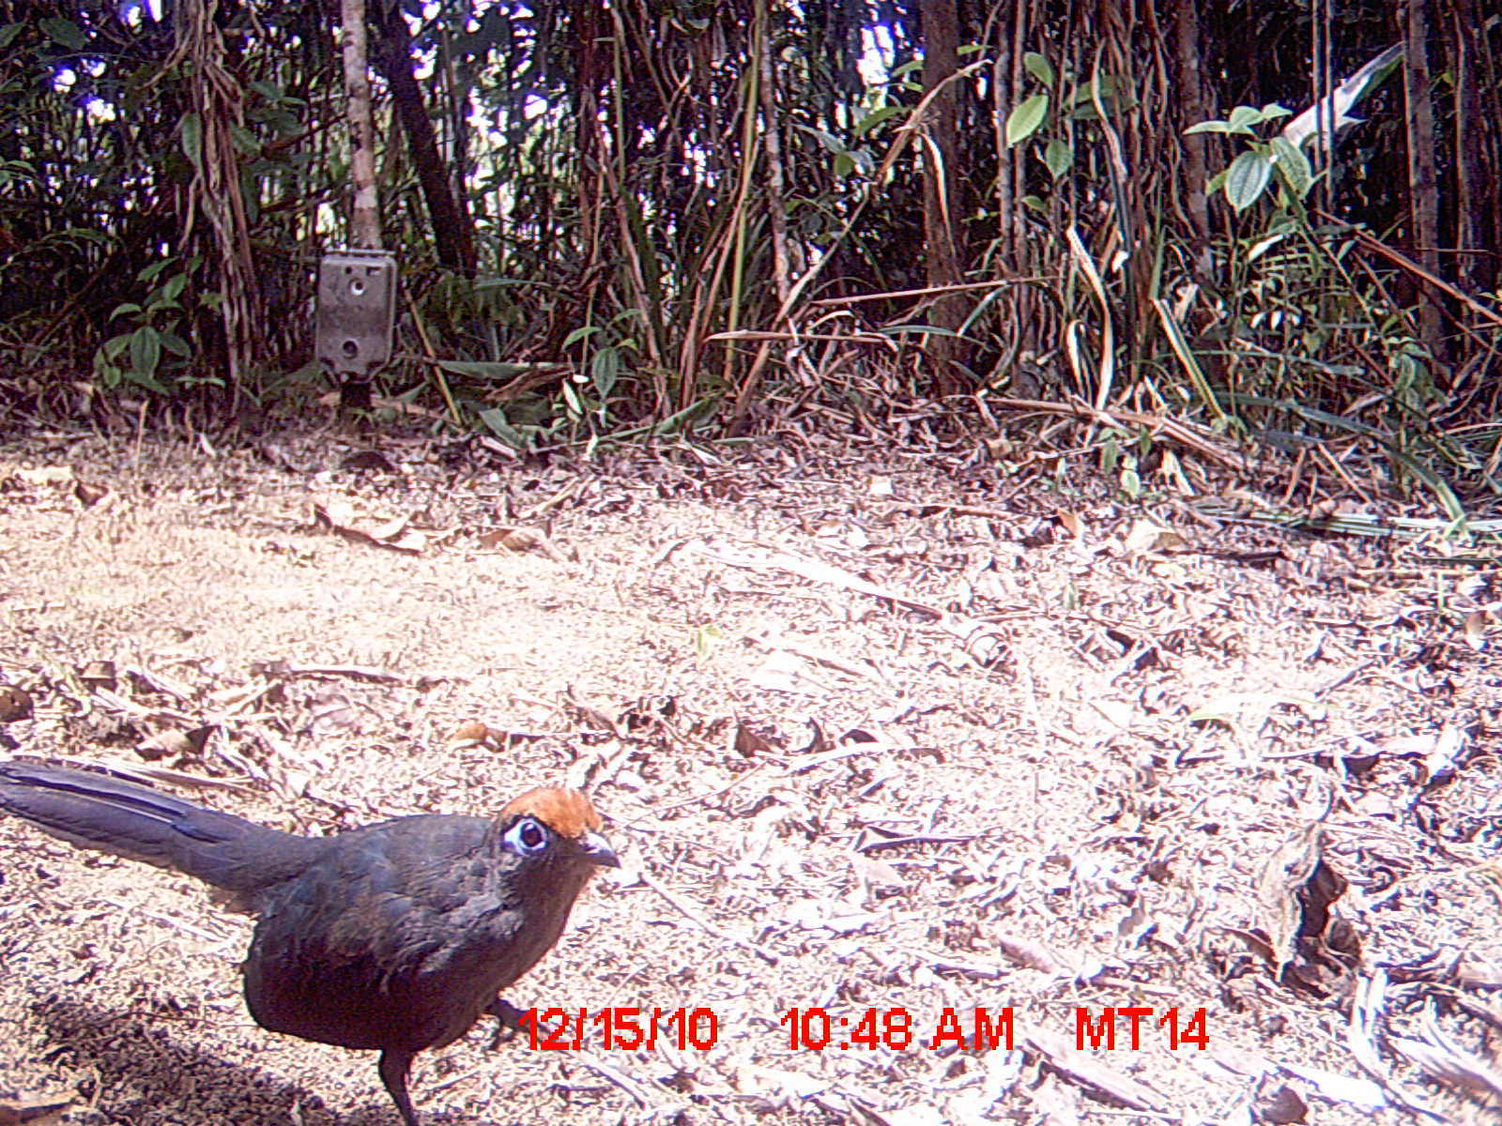
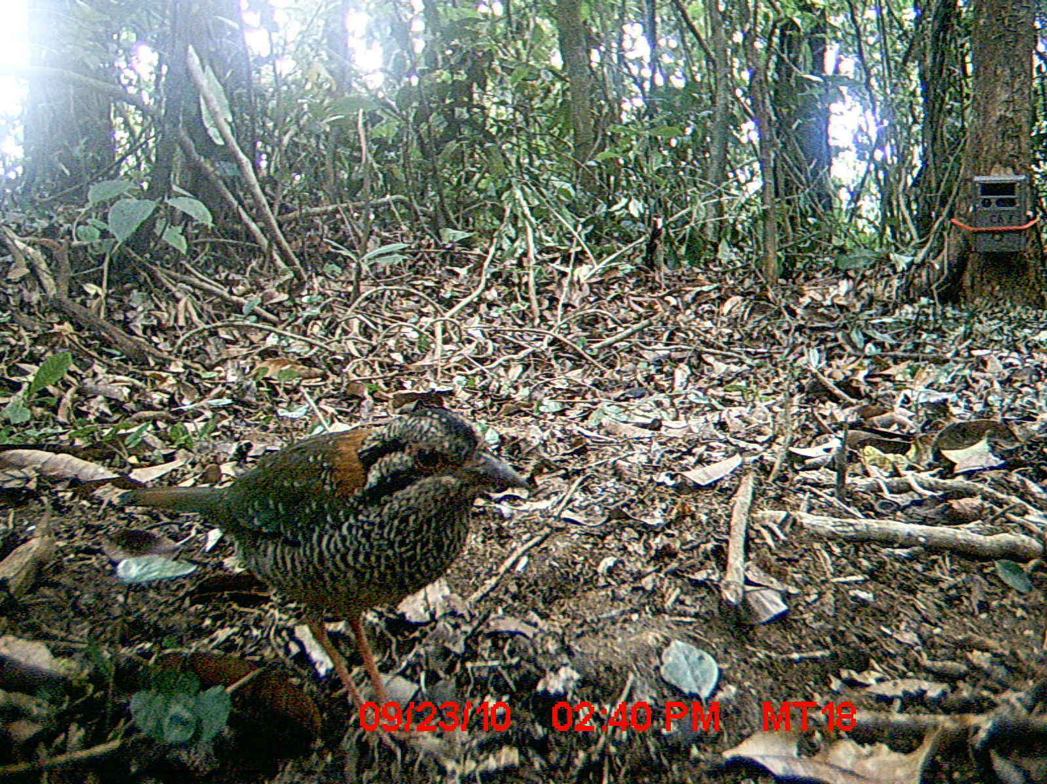
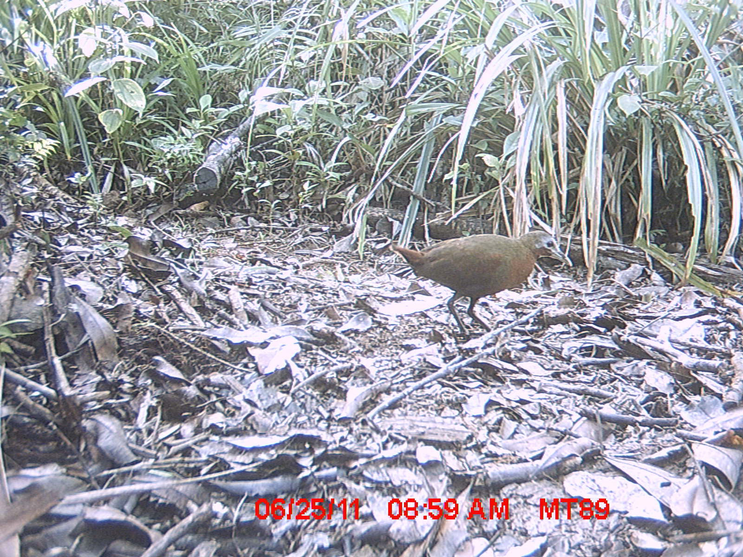
G) Red-breasted Coua (RBC)
F) Red-fronted Coua (RFC)
E) Scaly Ground-roller (SGR)
D) Madagascar Wood-rail (MWR)

Appendix S6A. Competing (ΔQAIC ≤ 2.0) landscape occupancy models from single-season occupancy analyses for seven native forest bird species across the Masoala-Makira protected area complex, northeastern Madagascar (2008-2013). Included is model weight (w_{i}) and likelihood, number of parameters included in the model (k), and the estimated overdispersion value (ĉ) from the goodness of fit (GOF) test run in PRESENCE. Covariates with strongly supported relationships with occupancy (ψ) and/or detection (p), as determined by confidence intervals on normalized beta values that do not overlap zero, are denoted positive ⁽⁺⁾ /negative ⁽⁻⁾. Red-fronted Coua and Madagascar Turtle-dove models are not shown due to overdispersion.
Species | Model¹ | ΔQAIC | w_{i} | Likelihood | k | Deviance | ĉ
Madagascar Magpie-robin | ψ(%rf⁽⁺⁾ + smallcarnTS⁽⁺⁾), p(survey + trailtype⁽⁺⁾ + bpTS⁽⁻⁾) | 0.00 | 0.49 | 1.00 | 13 | 742.39 | 1.84
 | ψ(%rf⁽⁺⁾), p(survey + trailtype⁽⁺⁾ + bpTS⁽⁻⁾) | 0.88 | 0.32 | 0.64 | 12 | 747.68
Red-breasted Coua | ψ(totpatches⁽⁺⁾), p(survey + egTS + fsTS⁽⁻⁾+ viTS⁽⁺⁾) | 0.00 | 0.66 | 1.00 | 13 | 1084.54 | 1.18
 | ψ(totpatches⁽⁺⁾ + %rf), p(survey + egTS + fsTS⁽⁻⁾+ viTS⁽⁺⁾) | 1.56 | 0.30 | 0.46 | 14 | 1084.03
Scaly Ground-roller | ψ(ffTS + %rf), p(fsTS⁽⁻⁾) | 0.00 | 0.17 | 1.00 | 5 | 423.67 | 2.67
 | ψ(ffTS), p(fsTS⁽⁻⁾) | 0.60 | 0.12 | 0.74 | 4 | 430.60
 | ψ(ffTS + %rf), p(fsTS⁽⁻⁾ + smallcarnTS) | 0.67 | 0.12 | 0.72 | 6 | 420.12
 | ψ(%rf),p(fsTS⁽⁻⁾) | 1.10 | 0.10 | 0.58 | 4 | 431.93
 | ψ(ffTS),p(.) | 1.36 | 0.09 | 0.51 | 3 | 437.96
Madagascar Crested Ibis | ψ(totpatches⁽⁺⁾ + ffTS), p(fsTS⁽⁻⁾ + ffTS⁽⁺⁾) | 0.00 | 0.90 | 1.00 | 6 | 344.22 | 1.08
Madagascar Wood-rail | ψ(totpatches⁽⁺⁾), p(survey + ffTS + season⁽⁻⁾) | 0.00 | 0.46 | 1.00 | 12 | 674.71 | 1.13
 | ψ(totpatches⁽⁺⁾ + ffTS), p(survey + ffTS + season⁽⁻⁾) | 0.58 | 0.34 | 0.75 | 13 | 673.10
 | ψ(totpatches⁽⁺⁾), p(survey + ffTS + season⁽⁻⁾ + smallcarnTS) | 1.74 | 0.19 | 0.42 | 13 | 674.41
¹ Description of covariates included in models: %rf = percent of landscape consisting of rainforest; smallcarnTS = combined trap success of three small endemic carnivores: ring-tailed (Galidia elegans), brown-tailed (Salanoia concolor) and broad-striped (Galidictis fasciata) vontsiras; survey = detection varies by survey occasion; trailtype = type of trail cameras were placed on, arranged by width (human = 1, game = 2, no trail = 3); bpTS = trap success of domestic livestock, zebu (Bos primigenius); distedge = distance (km) from an individual camera station to the forest edge; totpatches = total number of rainforest, degraded, and matrix habitat patches within the camera trap grid buffer; egTS = trap success of an endemic, medium-sized carnivore, the falanouc (Eupleres goudotii); fsTS = trap success of the exotic Felis sp.; viTS = trap success of the exotic small Indian civet (Viverricula indica); ffTS = trap success of an endemic, medium-sized carnivore, the spotted fanaloka (Fossa fossana); season = season camera trap survey occurred in (cold-wet = 1, hot-dry = 2, hot-wet = 3).

Appendix S6B. Competing (ΔAIC ≤ 2.0) multi-season occupancy models from multi-season occupancy analyses for seven native forest bird species at S02 and S05 (2008-2013). Included are model weight (w_{i}), model likelihood, and number of parameters included in the model (k). Estimated parameters include occupancy (ψ), colonization (γ), extinction (ε), and detection (p). ‘Year/survey’ indicates parameter varied by year or survey occasion and 0/1 indicates parameter was fixed at that value. Red-fronted Coua and Madagascar Turtle-dove (S02 and S05), Madagascar Crested Ibis and Madagascar Wood-rail (S05) models are not shown due to estimated overdispersion (ĉ > 3.0) or model non-convergence.
Site | Species | Model | ΔAIC | w_{i} | Likelihood | k | Deviance
S02 | Madagascar Magpie-robin | ψ, γ(0), ε(.), p(survey) | 0.00 | 0.79 | 1.00 | 41 | 347.52
 | Red-breasted Coua | ψ, γ(year), ε(year), p(year) | 0.00 | 1.00 | 1.00 | 14 | 727.11
 | Scaly Ground-roller | ψ, γ(.), ε(.), p(year) | 0.00 | 0.71 | 1.00 | 8 | 407.49
 | Madagascar Crested Ibis | ψ, γ(.), ε(.), p(.) | 0.00 | 0.60 | 1.00 | 4 | 491.89
 | Madagascar Wood-rail | ψ, γ(.), ε(.), p(survey) | 0.00 | 0.64 | 1.00 | 41 | 513.68
 |  | ψ, γ(.), ε(year), p(survey) | 1.29 | 0.34 | 0.52 | 44 | 508.97
S05 | Madagascar Magpie-robin | ψ, γ(0), ε(.), p(.) | 0.00 | 0.53 | 1.00 | 4 | 134.29
 |  | ψ, γ(0), ε(year), p(.) | 1.41 | 0.26 | 0.49 | 5 | 133.70
 |  | ψ, γ(0), ε(.), p(year) | 1.78 | 0.22 | 0.41 | 6 | 132.07
 | Red-breasted Coua | ψ, γ(.), ε(.), p(.) | 0.00 | 0.37 | 1.00 | 4 | 409.21
 |  | ψ, γ(.), ε(.), p(year) | 0.83 | 0.24 | 0.66 | 6 | 406.04
 |  | ψ, γ(year), ε(.), p(.) | 0.88 | 0.24 | 0.64 | 5 | 408.09
 |  | ψ, γ(.), ε(year), p(.) | 1.86 | 0.15 | 0.40 | 5 | 409.07
 | Scaly Ground-roller | ψ, γ(.), ε(1), p(year) | 0.00 | 0.43 | 1.00 | 6 | 156.66
 |  | ψ, γ(.), ε(.), p(.) | 0.09 | 0.41 | 0.96 | 4 | 160.75
 |  | ψ, γ(year), ε(1), p(year) | 1.86 | 0.17 | 0.39 | 7 | 156.52

Appendix S6C. Competing (ΔQAIC ≤ 2.0) landscape occupancy models and yearly estimates of occupancy (ψ) and detection (p) from single-season occupancy analyses for three native forest bird species at S03 (2009 and 2013). Included is model weight (w_{i}), model likelihood, number of parameters included in the model (k), and the estimated ĉ from the goodness of fit (GOF) test run in PRESENCE. Covariates with strongly supported relationships with occupancy and/or detection, as determined by confidence intervals on normalized betas that did not overlap 1, are denoted positive ⁽⁺⁾ /negative ⁽⁻⁾. Madagascar Magpie-robin and Madagascar Turtle-dove models are not shown due to estimated overdispersion.
Species | Model¹ | ΔQAIC | w_{i} | Likelihood | k | Deviance | ĉ | 2009 ψ (SE) | 2013 ψ (SE)
Red-breasted Coua | ψ(SHC⁽⁻⁾), p(fsTS) | 0.00 | 0.86 | 1.00 | 4 | 143.41 | 1.08 | 0.72 (0.12) | 0.51 (0.13)
Scaly Ground-roller | ψ(distedge), p(survey) | 0.00 | 0.32 | 1.00 | 10 | 132.53 | 1.00 | 0.58 (0.17) | 0.59 (0.17)
 | ψ(distedge + fsTS), p(survey) | 0.96 | 0.20 | 0.62 | 11 | 131.49
 | ψ(fsTS), p(survey) | 1.26 | 0.17 | 0.53 | 10 | 133.79
 | ψ(.), p(survey) | 1.33 | 0.17 | 0.51 | 9 | 135.86
Madagascar Wood-rail | ψ(cancov), p(.) | 0.00 | 0.18 | 1.00 | 3 | 58.30 | 1.77 | 0.14 (0.07) | 0.20 (0.10)
 | ψ(cancov), p(humanTS⁽⁻⁾) | 0.41 | 0.14 | 0.81 | 4 | 55.48
 | ψ(humanTS), p(.) | 0.72 | 0.12 | 0.70 | 3 | 59.58
 | ψ(.), p(humanTS⁽⁻⁾) | 1.11 | 0.10 | 0.57 | 3 | 60.26

¹ Description of covariates included in models: SHC = station-level habitat characterization based on camera station location (a qualitative assessment; primary rainforest = 1, secondary forest = 2 and savoka (heavily degraded) = 3); fsTS = trap success of the exotic Felis sp.; cancov = percent canopy cover at the camera station; distedge = distance (km) from an individual camera station to the forest edge; survey = detection varies by survey occasion; humanTS = trap success of humans (excluding researchers).

