Appendix G
To spatially estimate little bustard density and habitat variables by geostatistical modelling, the experimental semivariograms were computed and analysed. Fig. G.1 presents some examples of semivariograms for both little bustard density and habitat variables. In both cases, the diagrams pertain to sites “Cuba” and “Airoso”. The semivariograms show a clear spatial dependence, with a small nugget and larger range parameter in both sites. ). In “Cuba”, the range parameters are 5.032 km and 4.396 km, respectively for little bustard density and Rainfed. In “Airoso”, these parameters are closer from each other, being given by 4.298 km and 4.811 km. The Moran's I Index values reveal that the p-values are statistically significant and the z-scores are all positive (Table G.1).

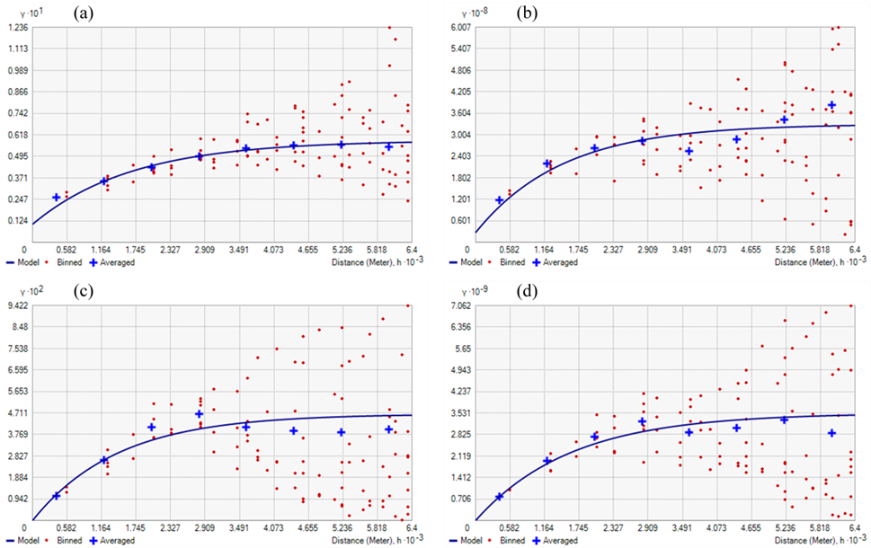

Figure G.1 Experimental omnidirectional semivariograms. The upper plots pertain to site “Cuba” in 2010 and describe the Little bustard (a) and Rainfed (b); the lower plots refer to site “Airoso” in 2007 and also represent the Little bustard (c) and Rainfed (d).

Table G. 1 Spatial autocorrelation values assessed by the Global Moran’s I statistic, based on locations and values of the explanatory variables land use/cover (Rainfed and Permanent crops) and response variable (Little bustard), pertaining to the sites “Cuba” and “Airoso”.
Site | Variable | Year | Moran's Index | z-score | p-value | Variance
Cuba | Little bustard | 2003 | 0.085080 | 15.447061 | 0.000000 | 0.000034
 | Little bustard | 2006 | 0.074648 | 13.652956 | 0.000000 | 0.000034
 | Little bustard | 2010 | 0.085996 | 15.575682 | 0.000000 | 0.000034
 | Rainfed | 2003 | 0.121967 | 22.186422 | 0.000000 | 0.000034
 | Rainfed | 2006 | 0.086139 | 15.849545 | 0.000000 | 0.000034
 | Rainfed | 2010 | 0.127811 | 23.451603 | 0.000000 | 0.000034
Airoso | Little bustard | 2004 | 0.125089 | 14.302362 | 0.000000 | 0.000088
 | Little bustard | 2007 | 0.168549 | 18.987366 | 0.000000 | 0.000088
 | Little bustard | 2010 | 0.271102 | 29.864246 | 0.000000 | 0.000088
 | Rainfed | 2004 | 0.136008 | 15.449600 | 0.000000 | 0.000088
 | Rainfed | 2007 | 0.181356 | 20.269311 | 0.000000 | 0.000088
 | Rainfed | 2010 | 0.222054 | 24.600382 | 0.000000 | 0.000088
 | Permanent crops | 2004 | 0.127850 | 14.788010 | 0.000000 | 0.000088
 | Permanent crops | 2007 | 0.138653 | 15.745170 | 0.000000 | 0.000088
 | Permanent crops | 2010 | 0.217051 | 24.053983 | 0.000000 | 0.000088

