Appendix S1
1. Regional characterization
Fieldwork was carried out during the national breeding census in Alentejo (Project LIFE02NAT/P/8476: Conservation of the little bustard in Alentejo), which is the most important region for the species in Portugal, concentrating most of the national breeding population (Silva et al. 2010) (Fig. A.1). The census consisted in estimating the breeding male abundances at a network of sampling points for a total of 81 sites (Fig. 1A), previously selected in accordance with the following criteria: (1) within steppic Important Bird Areas (IBA; Costa et al. 2003) and (2) random sites with an area of approximately 2500 ha within quadrates of a 10 km×10km UTM grid that represent over 40% of potential area for the little bustard (i.e. agricultural or pastoral land use), based on the Land Cover Corine 2000 land use map. These sites contain pertinent gradients of the landscape, considering the environmental changes (agricultural intensification, afforestation, road network and power lines installation) fundamental when it comes to the comprehension of the little bustard’s population responses. Simple and double circuit transmission power lines were studied, covering different voltages: 150, 220 and 400 kV. The height of the towers varied approximately between 30 and 60m high.
2. Little bustard counts
Little bustard censuses were based on breeding male estimates, since females and non-breeding males are not conspicuous enough to be detected in workable numbers (e.g. Silva et al. 2010). Fieldwork was planned in advance with the aid of topographic maps 1:25,000, to ensure a network of sampling points spaced by 600m between them, along dirt tracks, avoiding the proximity of inhabited houses and paved roads, ensuring distances of at least 300 m from these structures (Fig. 1A). The counts were carried out during the first three hours after sunrise and the last two before sunset (Jiguet and Bretagnolle 2001), the periods where most breeding males are active and conspicuous. Males were counted at each sampling point for a period of approximately 5min within a buffer of 250 m (study units). Sampling points were carefully accessed by car to ensure that males were detected in case they were flushed.
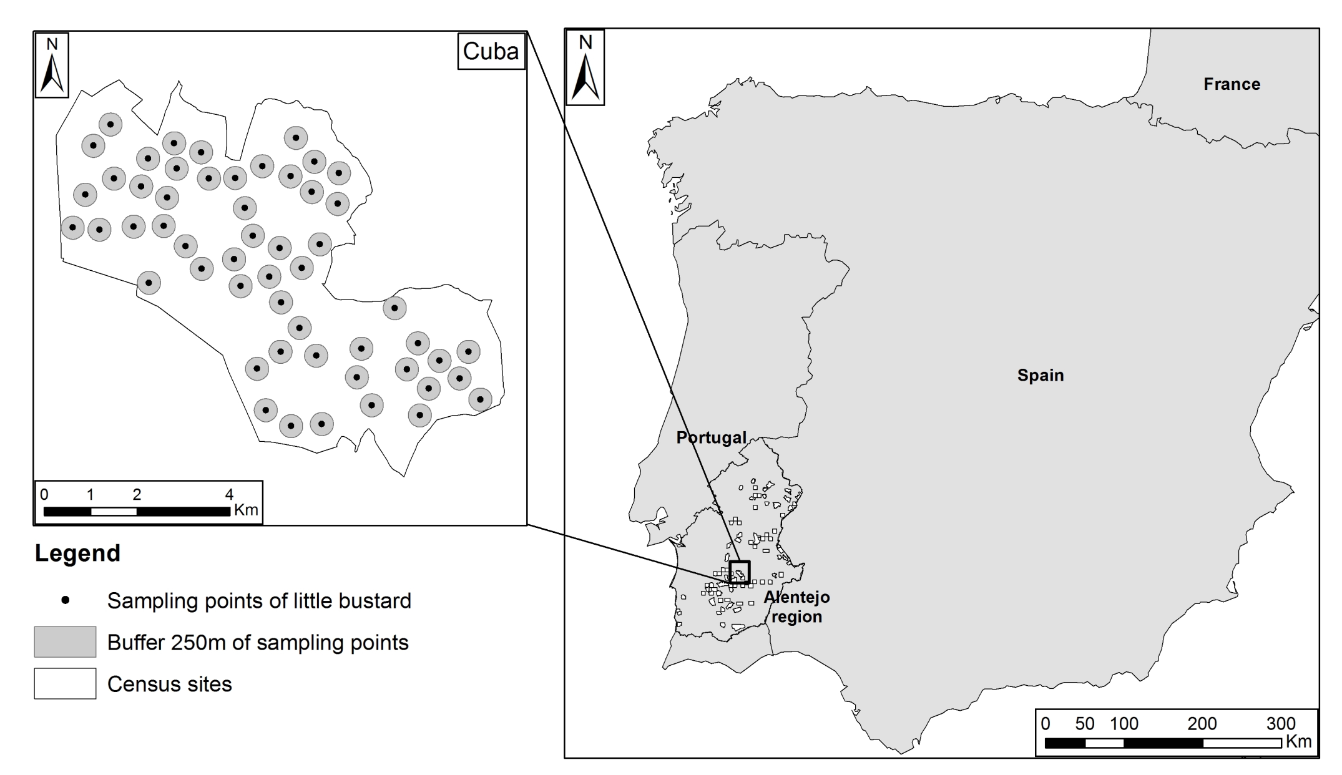
Fig. A.1 Example of the distribution of sampling points for the “Cuba” site.

3. Little bustard spatial autocorrelation
Table A. 1. Little bustard males’ abundance has a defined spatial pattern, with positive autocorrelation at shorter distances and a mostly negative autocorrelation at longer distances. The spatial analyses were carried out using SAM (Rangel et al. 2010).
D.Class | Count | DistCntr | Moran's I | P | I (max) | I/I(max)
1 | 115866 | 3842.652 | 0.196 | 0.005 | 0.679 | 0.289
2 | 115506 | 11527.96 | 0.003 | 0.523 | 0.454 | 0.006
3 | 178556 | 19213.26 | -0.013 | 0.01 | 0.421 | -0.031
4 | 149936 | 26898.57 | -0.054 | 0.005 | 0.436 | -0.125
5 | 153724 | 34583.87 | -0.03 | 0.005 | 0.705 | -0.043
6 | 137014 | 42269.18 | -0.072 | 0.005 | 0.867 | -0.083
7 | 133424 | 49954.48 | -0.037 | 0.005 | 0.679 | -0.055
8 | 160814 | 57639.78 | -0.035 | 0.005 | 0.491 | -0.071
9 | 168848 | 65325.09 | 0.098 | 0.005 | 0.426 | 0.23
10 | 166908 | 73010.39 | 0.019 | 0.005 | 0.475 | 0.04
11 | 127926 | 80695.7 | -0.027 | 0.005 | 0.497 | -0.054
12 | 119760 | 88381 | -0.016 | 0.005 | 0.313 | -0.051
13 | 75160 | 96066.31 | -0.007 | 0.126 | 0.315 | -0.023
14 | 68128 | 103751.6 | -0.003 | 0.533 | 0.52 | -0.006
15 | 65476 | 111436.9 | -0.057 | 0.005 | 0.639 | -0.089
16 | 22214 | 119122.2 | 0.007 | 0.327 | 1.149 | 0.006
17 | 3996 | 126807.5 | 0.07 | 0.035 | 1.909 | 0.037
18 | 6748 | 134492.8 | 0.053 | 0.01 | 0.906 | 0.059
19 | 4132 | 142178.1 | -0.13 | 0.005 | 1.978 | -0.065

References
Costa, L.T., Nunes, M. Geraldes, P. and Costa, H. (2003) Zonas Importantes para as Aves em Portugal. Sociedade Portuguesa para o Estudo das Aves.
Jiguet, F. and Bretagnolle, V. (2001) Courtship behaviour in a lekking species: individual variations and settlement tactics in male little bustard. Behavioural processes 55: 107–118.
Silva, J.P., Santos, M., Queirós, L., Leitão, D., Moreira, F., Pinto, M., Leqoc, M. and Cabral, J.A. (2010) Estimating the influence of overhead transmission power lines and landscape context on the density of little bustard Tetrax tetrax breeding populations. Ecological Modelling 221: 1954–1963.
Rangel, T.F.L.V.B, Diniz-Filho, J.A.F and Bini, L.M. (2010) SAM: a comprehensive application for Spatial Analysis in Macroecology. Ecography 33:46-50.

