Supplementary Material
Diclofenac is toxic to the Steppe Eagle Aquila nipalensis: widening the diversity of raptors threatened by NSAID misuse in South Asia
ANIL K. SHARMA, MOHINI SAINI, SHAMBHU D. SINGH, VIBHU PRAKASH, ASIT DAS, BHARATHI DASAN R., SHAILEY PANDEY, DAULA L. BOHARA, TOBY H. GALLIGAN, RHYS. E. GREEN, DIETMAR KNOPP and RICHARD J. CUTHBERT

Contents
Figure S1.

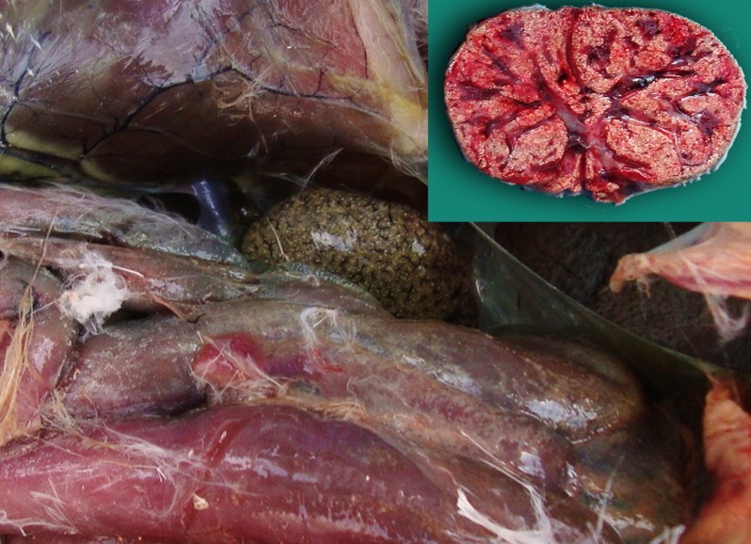

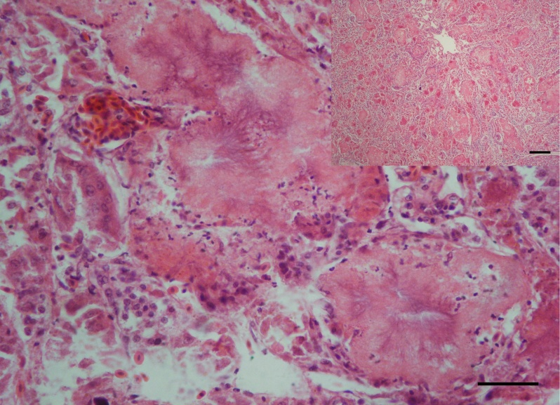

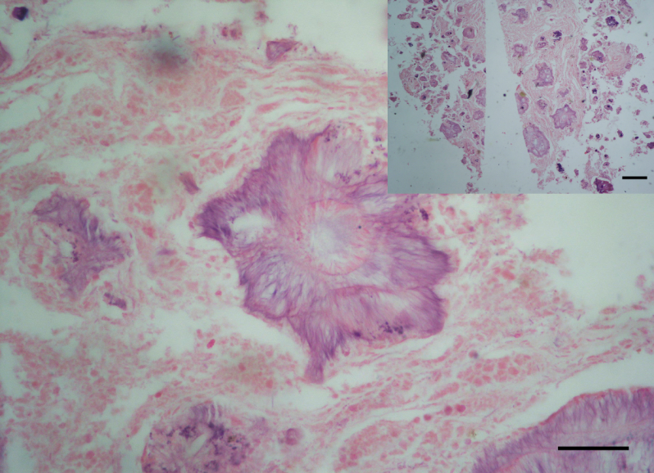

Figure 1. A) Highly enlarged kidney with distended tubules in a Steppe Eagle. Inset: Cut section of kidney revealed diffuse deposition of gritty, chalky white urates in the parenchyma in steppe eagle, B) Section of affected kidney of Steppe Eagle showing highly dilated renal tubules, necrosis of tubular epithelium, and lumen filled with eosinophilic amorphous material with radiating urate crystals at the centre. HE staining (Bar, 50 µm). Inset: Overview of the lesion. HE staining (Bar 200µm), C) Section of thickened synovial membrane of knee joint of Steppe Eagle affected with articular gout containing large disc-like urate crystals with radiating periphery. HE staining. Bar, 50 µm. Inset: overview of the lesion. HE staining (Bar 200 µm).
B

