Supplementary Materials

Simulation of Datasets

Datasets were simulated using MPLUS Monte Carlo procedures.

The following general model was used in data simulations:

$$\operatorname{logit}\left(OUTCOME\right)= β_{0}+β_{1}TX+β_{2}BTL+β_{3}∆T+β_{4}(BTL*TX)$$

$$∆T=γ_{0}+γ_{1}TX+γ_{2}BTL+γ_{3}(BTL*TX)$$

Where: TX = treatment (0=control, 1 = intervention)
BTL = baseline target level
ΔT = change in target
OUTCOME = Binary outcome (0 = below threshold, 1 = above threshold)

OUTCOME was assigned a logistic distribution
BTL and ΔT were modeled as continuous variables

Parameters were selected such that mediation (β₃) and moderation of intervention impact on the mediator (γ₃) were statistically significant. In some cases this required increasing the size of the simulated dataset. The following parameters were used in the population models for the eight simulations:

 | Compensatory | Rich get richer | Crossover | Iatrogenic
Sample size | 500 | 650 | 600 | 2100
$$β_{0}$$ | -1.55 | -1.55 | -1.55 | -1.55
$$β_{1}$$ | 0 | 0 | 0 | 0
$β_{2}$* | 0/-1.5 | 0/-1.5 | 0/-1.0 | 0/-1.5
$$β_{3}$$ | 0.25 | .25 | .25 | .15
$$β_{4}$$ | 0 | 0 | 0 | 0
$$γ_{0}$$ | 0.5 | 0.5 | 0.5 | 0.5
$$γ_{1}$$ | 0 | 0 | 0 | 0
$γ_{2}$* | 0 | 0 | 0 | 0
$$γ_{3}$$ | 2.50 | -2.5 | -2.5 | -2.5
BTL mean | -0.6 | 0.6 | 0.0 | 0.6
BTL SD | .25 | .25 | .25 | .25
*Setting these parameters to zero leads to stable control event rate. Setting β₂ to a nonzero value leads to control event rates that vary over baseline target levels.

Calculating Effect Size Indicators from BTMM Model Parameters

Model parameters can be used to estimate predicted log odds of exceeding the prevention threshold for intervention and control groups. The log odds estimates will vary across baseline target levels for the intervention group, and will either be constant for the control group or also vary across baseline target levels, depending on the data simulation. These log odds can then be converted to probabilities that index event rates for each group (EER and CER), where these rates vary across baseline target levels.

For intervention group (coded as 1):

$$\operatorname{logit}\left(OUTCOME\right)= β_{0}+β_{1}TX+β_{2}BTL+β_{3}(γ_{0}+γ_{1}TX+γ_{2}BTL+γ_{3}(BTL*TX))+β_{4}(BTL*TX)$$

For stable CER: TX = 1; β₁, β₂, β₄, γ₁, γ₂ were set to zero to simplify models, so
$$Logodds= β_{0}+{(β}_{3}*(γ_{0}+\left(γ_{3}*BTL\right)))$$
$$odds= {EXP(β}_{0}+{(β}_{3}*(γ_{0}+\left(γ_{3}*BTL\right))))$$
$$EER=\frac{odds}{(1+odds)}$$

For variable CER: TX = 1; β₁, β₄, γ₁, γ₂ set to zero; β₂ is set to moderate, so
$$Logodds= β_{0}+(β_{2}*BTL)+{(β}_{3}*(γ_{0}+\left(γ_{3}*BTL\right)))$$
$$odds= {EXP(β}_{0}+\left(β_{2}*BTL\right)+{(β}_{3}*(γ_{0}+\left(γ_{3}*BTL\right))))$$
$$EER=\frac{odds}{(1+odds)}$$
For control group (coded as 0):
For stable CER: TX = 0; β₁, β₂, β₄, γ₁, γ₂ set to zero, so
$$Logodds= β_{0}+(β_{3}* γ_{0})$$
$$odds= {EXP(β}_{0}+{(β}_{3}*γ_{0}))$$
$$CER=\frac{odds}{(1+odds)}$$

For variable CER: TX = 0; β₁, β₄, γ₁, γ₂ set to zero; β₂ is set to moderate, so
$$Logodds= β_{0}+\left(β_{3}*γ_{0}\right)+(β_{2}*BTL)$$
$$odds= {EXP(β}_{0}+\left(β_{3}*γ_{0}\right)+(β_{2}*BTL))$$
$$CER=\frac{odds}{(1+odds)}$$

MPLUS Programming Code for Monte Carlo Simulations

The following code was used to simulate datasets for the compensatory model with stable CER:

TITLE:
MONTECARLO SIMULATION OF BTMM WITH BINARY OUTCOME
COMPENSATORY EFFECT(STRONGER MODERATION STRONGER B N=500)
PEER VARYING

MONTECARLO:
NAMES = OUTCOME TX MED BT;
NOBSERVATIONS = 500;
NREPS = 1;
SAVE = MC_COMPEN_STABLPEER_SMSB_N300.dat;
CUTPOINTS = TX(0);
GENERATE = OUTCOME(1 L);
CATEGORICAL = OUTCOME;
MODEL POPULATION:
TX@1;
[TX@0];
MED@1;
[MED@0.0];
BT@0.0625;
[BT@-0.6];
TX WITH BT@0;
OUTCOME ON MED@0.25;
OUTCOME ON TX@0.;
OUTCOME ON BT@0.00;
[outcome$1@-1.55];
GAMMA1 | MED ON TX;
[GAMMA1@0.00];
GAMMA1 ON BT@2.5; !interaction effect parameter
GAMMA1 @ 0;
MED ON BT@0;

ANALYSIS:
TYPE = RANDOM;
ESTIMATOR = MLR;
INTEGRATION = MONTECARLO;

MODEL:
OUTCOME ON MED*.25 (B);
MED ON BT*.2;
MED ON TX*1;

Code for the model with variable CER was identical, with one exception:

OUTCOME ON BT@-1.50;
Analysis of Simulated Data, and Calculation of Effect Indexes

Models with Stable CER

The following MPLUS program code was used to model BTMM effects for the simulated dataset involving compensatory effects with stable control event rates.

The MODEL CONSTRAINT option was used to calculate CER, ARR and RRR along with their 95% confidence bounds for each point on the continuum of the baseline target levels. MPLUS provides graphs of these values using the LOOP and PLOT options, and lets the user save all the estimated data points for those graphs, providing specific estimates to any level of precision.

TITLE:
Analysis of BTMM simulation example (MLR)
COMPENSATORY MODEL
STABLE CER
GRAPHING CER EER ARR RRR

DATA:
FILE = MC_COMPEN_STABLPEER_SMSB_N300.dat;

VARIABLE:
NAMES = outcome med tx bt;
USEVARIABLES = OUTCOME med tx bt
btxtx
;
CATEGORICAL ARE outcome;

DEFINE:
btxtx = bt*tx;

ANALYSIS:
ESTIMATOR = mlr;
PROCESSORS = 2;

MODEL:
outcome ON TX*0 (B1)
MED*.15(B2)
BT*0 (B3);

[OUTCOME$1*-1.55] (A1);

med ON TX*0 (GAMMA1)
BT*0 (GAMMA2)
BTXTX*.1 (GAMMA3);
[MED*.489] (A2);

MODEL CONSTRAINT:
PLOT(CER, EER, ARR, RR, NNT);
LOOP(BASELINE_TARGET,-1.1,-0.1, .01);

CER =
EXP(A1 + (B2*A2))/
(1 + EXP(A1 + (B2*A2)));

EER =
EXP(A1 + (B2*(A2+(GAMMA3*BASELINE_TARGET))))/
(1+ EXP(A1 + (B2*(A2+(GAMMA3*BASELINE_TARGET)))));

ARR = CER - EER;

RRR = ARR/CER;

PLOT: TYPE = PLOT2;
OUTPUT: TECH8; STAND;

Models with variable CER:

MPLUS code was identical, except for calculation of EER and CER, which included the parameter for BTL association with outcome:

CER =
EXP(A1 + (B2*A2) + B3*BASELINE_TARGET)/
(1 + EXP(A1 + (B2*A2) + B3*BASELINE_TARGET));

EER =
EXP(A1 + (B3*BASELINE_TARGET) + (B2*(A2+(GAMMA3*BASELINE_TARGET))))/
(1+ EXP(A1 + (B3*BASELINE_TARGET) + (B2*(A2+(GAMMA3*BASELINE_TARGET)))));

Plots for Rich-get-richer, Crossover, and Iatrogenic effects

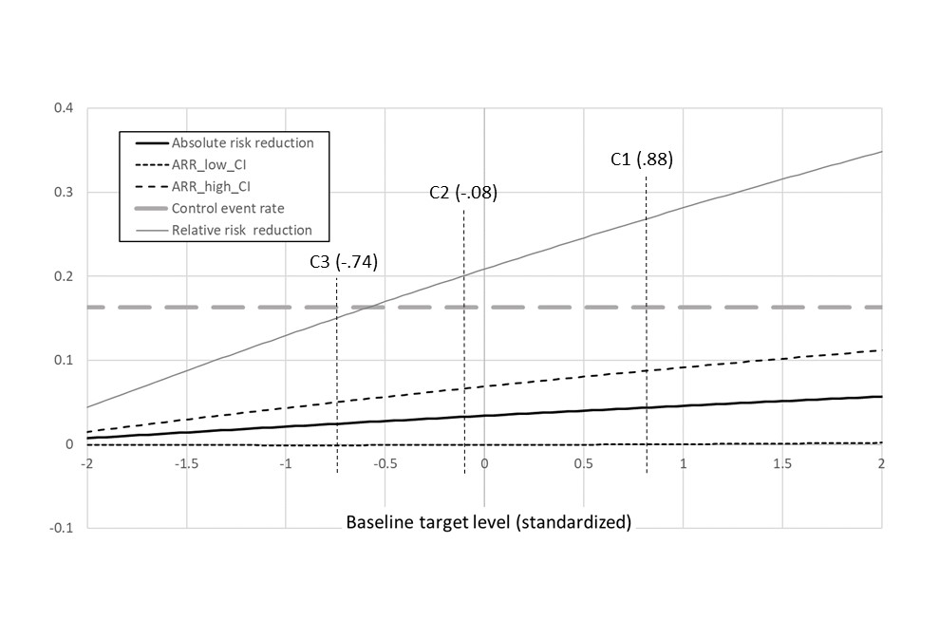
Figure SM1. Effect indicators for RICH-GET-RICHER effect with stable control event rate
SM1a. Absolute and relative risk reduction

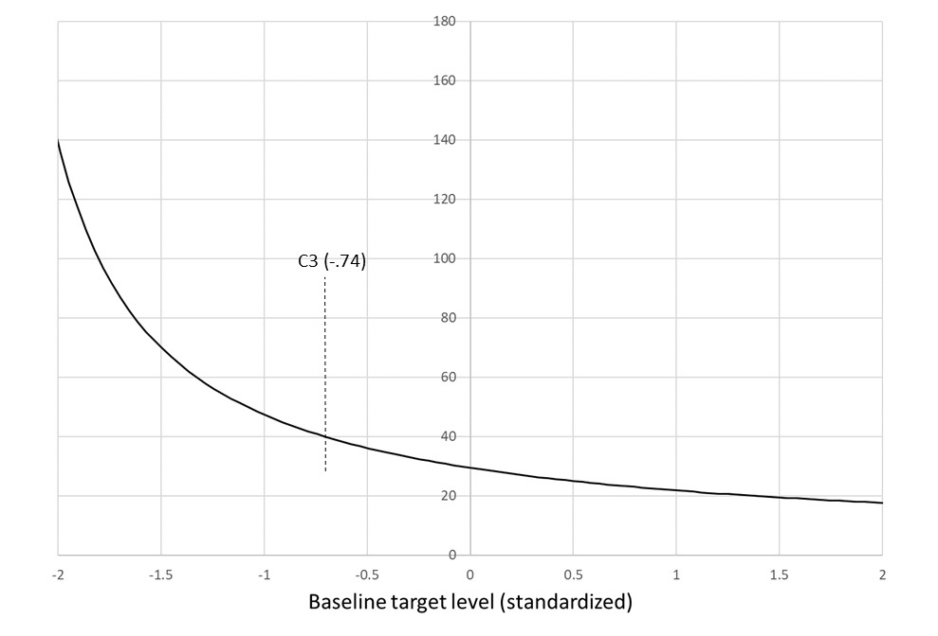
SM1b. Number needed to treat

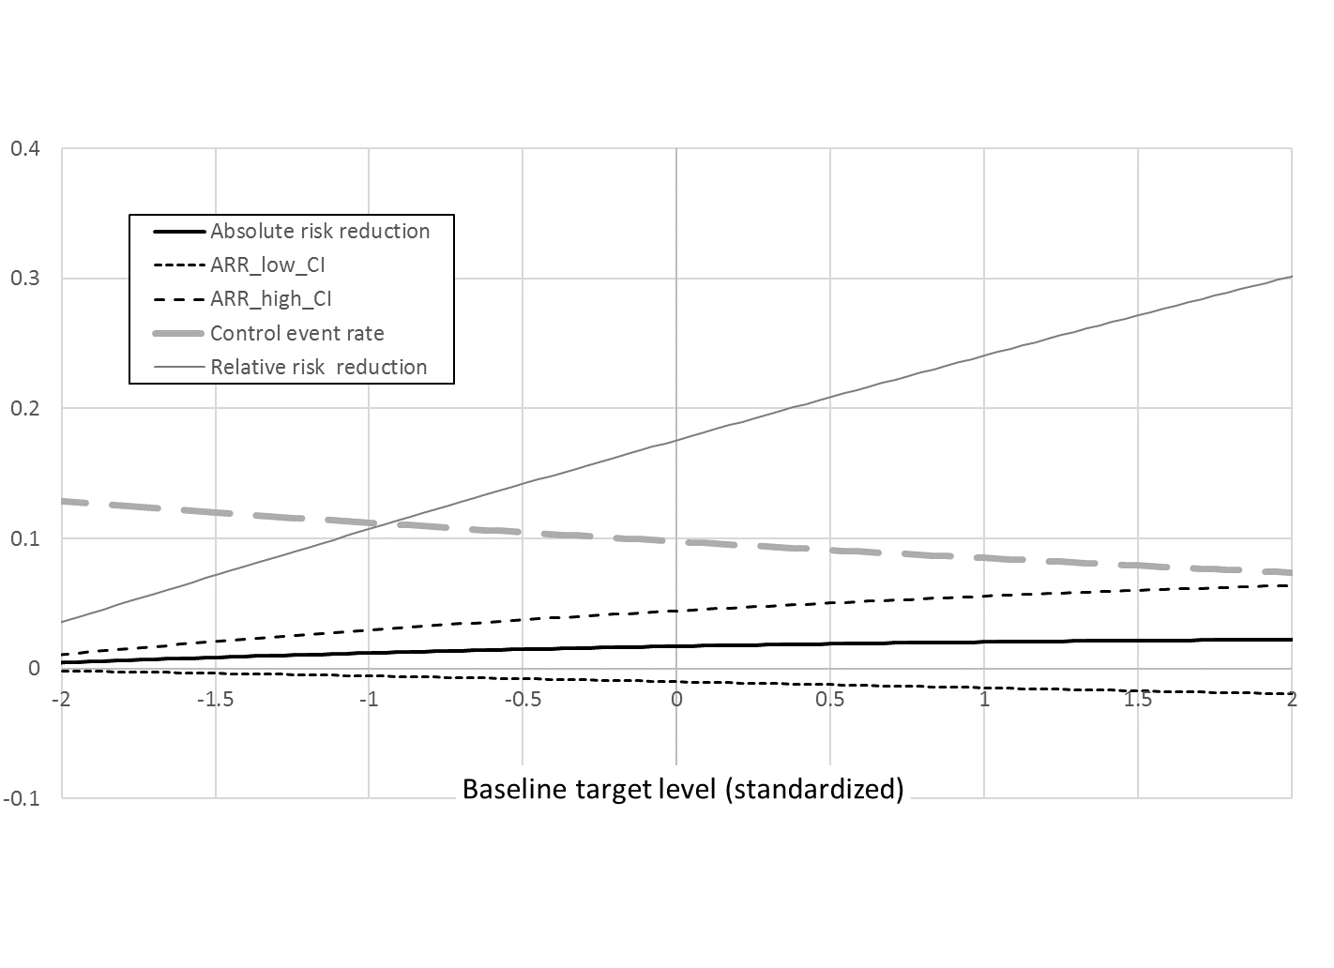
Figure SM2. Effect indicators for RICH-GET-RICHER effect with variable control event rate
SM2a. Absolute and relative risk reduction

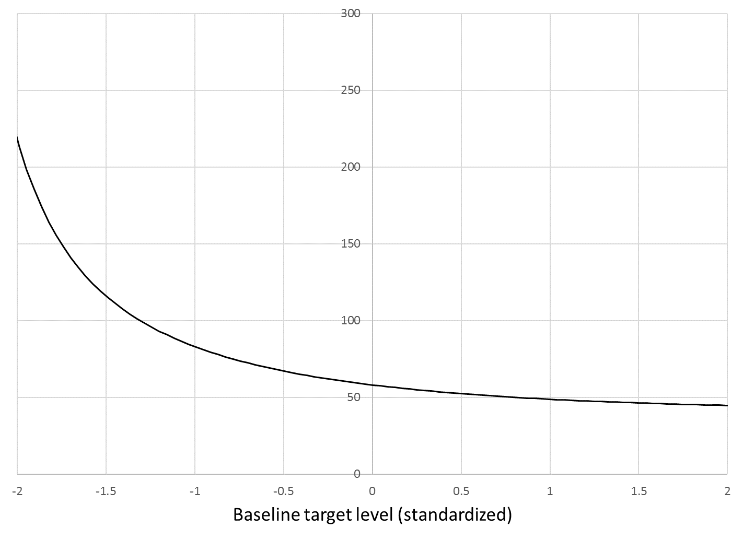
SM2b. Number needed to treat

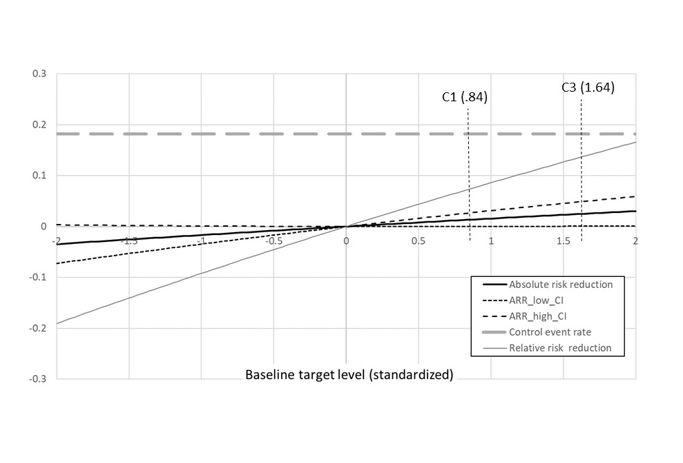
Figure SM3. Effect indicators for CROSSOVER effect with stable control event rate
SM3a. Absolute and relative risk reduction

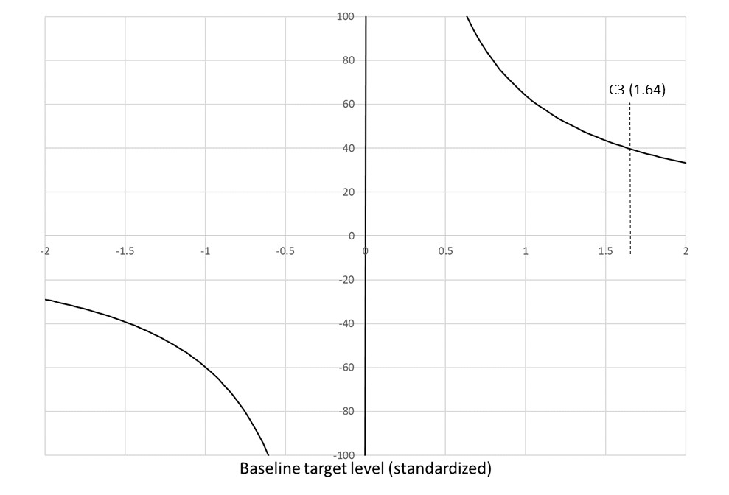
SM3b. Number needed to treat

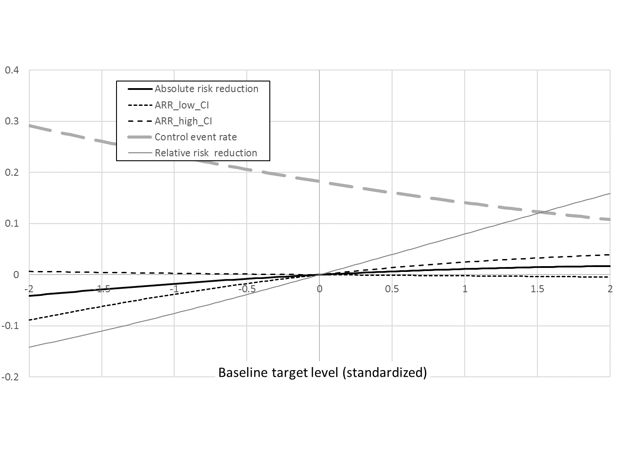
Figure SM4. Effect indicators for CROSSOVER effect with variable control event rate
SM4a. Absolute and relative risk reduction

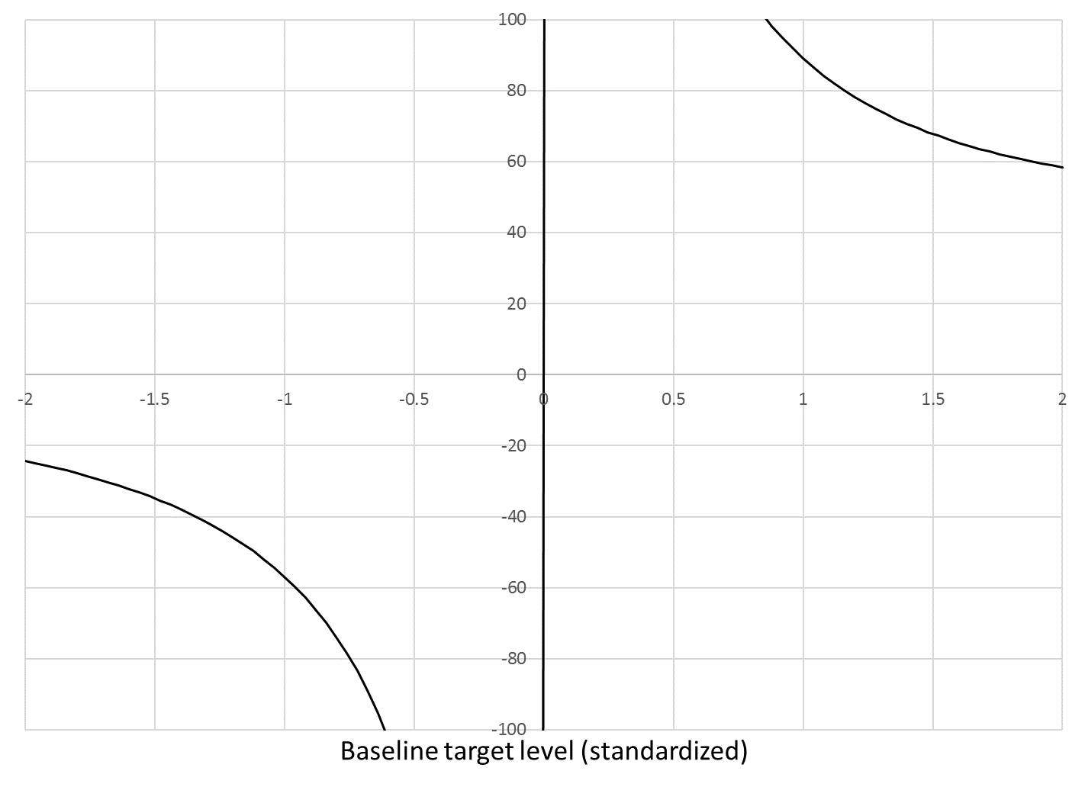
SM4b. Number needed to treat

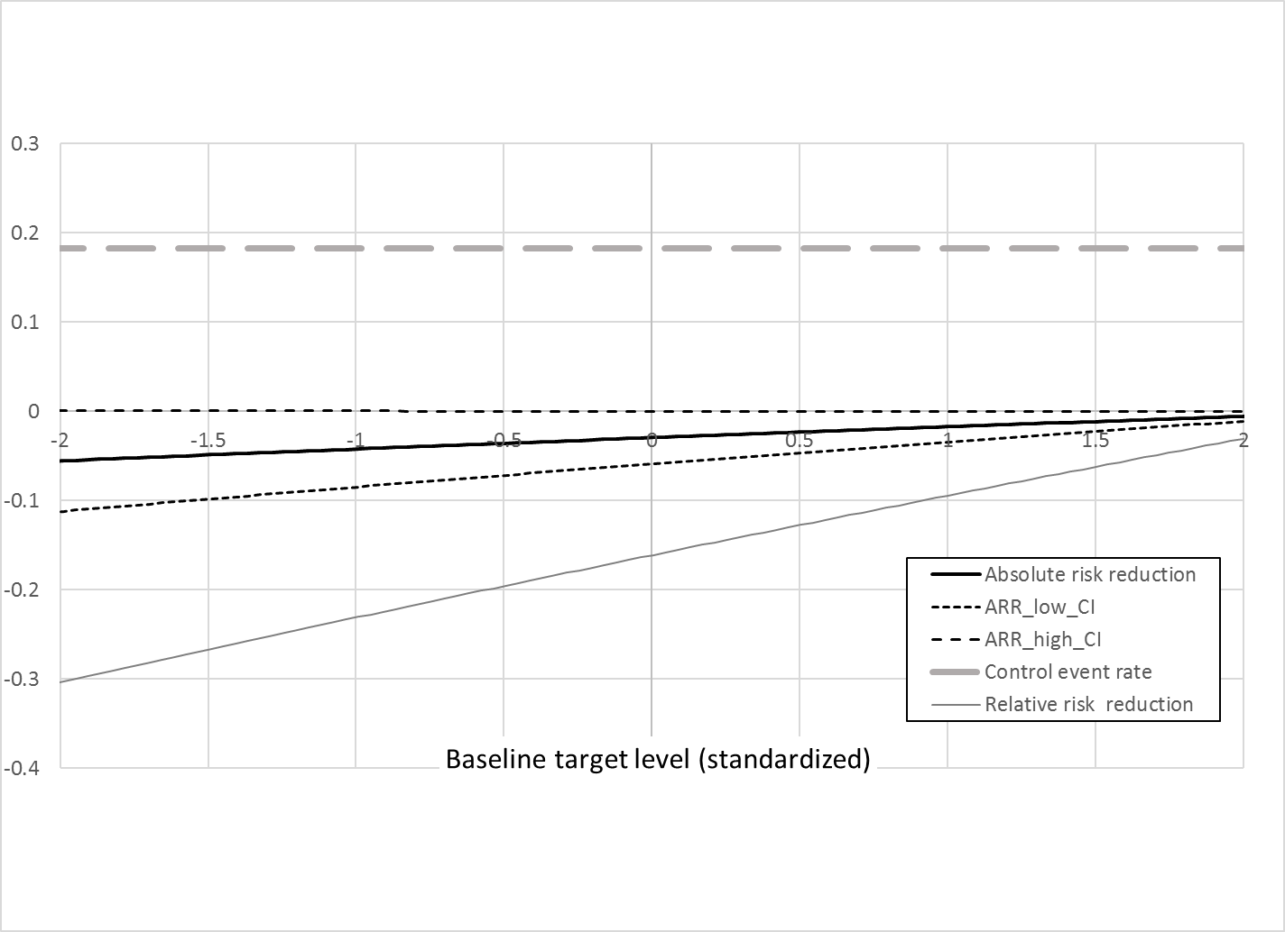
Figure SM5. Effect indicators for IATROGENIC effect with stable control event rate
SM5a. Absolute and relative risk reduction

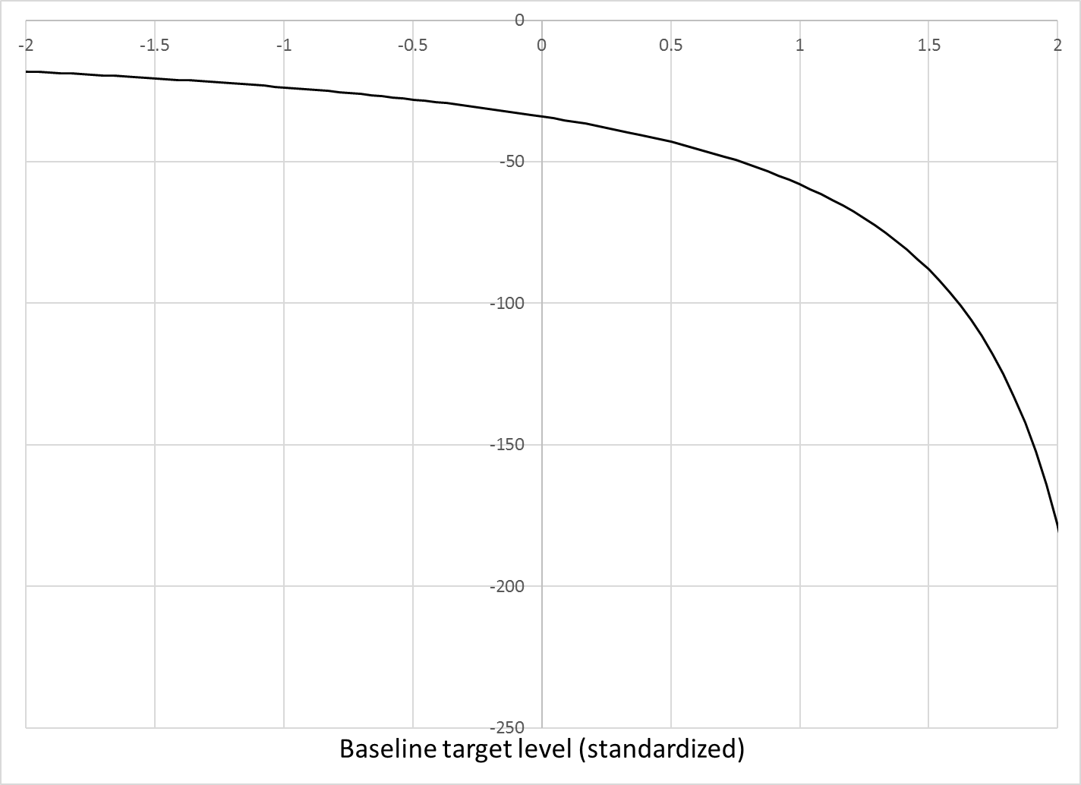
SM5b. Number needed to treat

Figure SM6. Effect indicators for IATROGENIC effect with variable control event rate
SM6a. Absolute risk reduction (relative risk reduction values too large to graph)
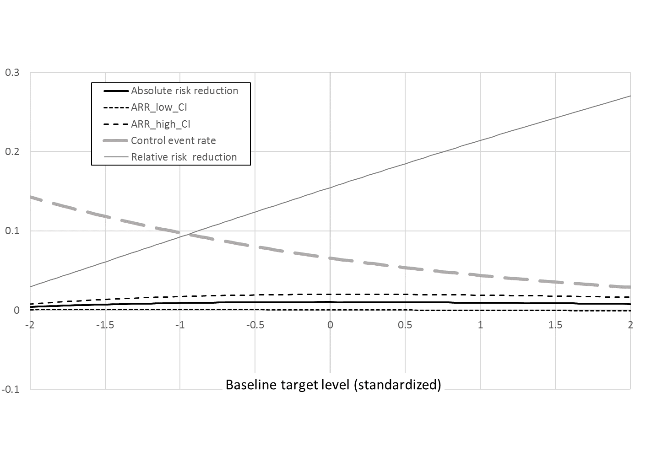

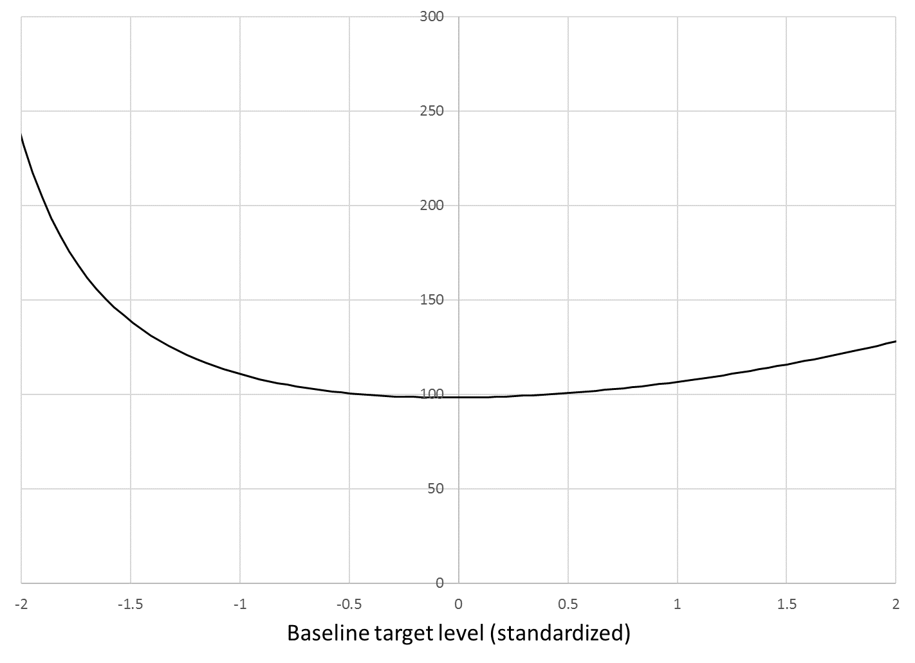

SM6b. Number needed to treat

