Supplementary Material

Figure S.1. Correspondence of Pyrosequencing and Array Quantification of NR3C1

We observed adequate correspondence between values estimated through pyrosequencing and the 450k array, with minimal differences between measurements for each of the three overlapping sites. Given the low variability of the promoter region, and many sites quantified at 0% methylation, the correlations between methods were small. For CpG 3 (cg04111177), the correlation was between pyrosequencing and the array values was significant (r = 0.26, p < 0.05), but for CpG 6 (cg15910486) and CpG 7 (cg15645634) the correlations were nonsignificant (r = 0.19, p = 0.12; r = -0.09, p = 0.45).

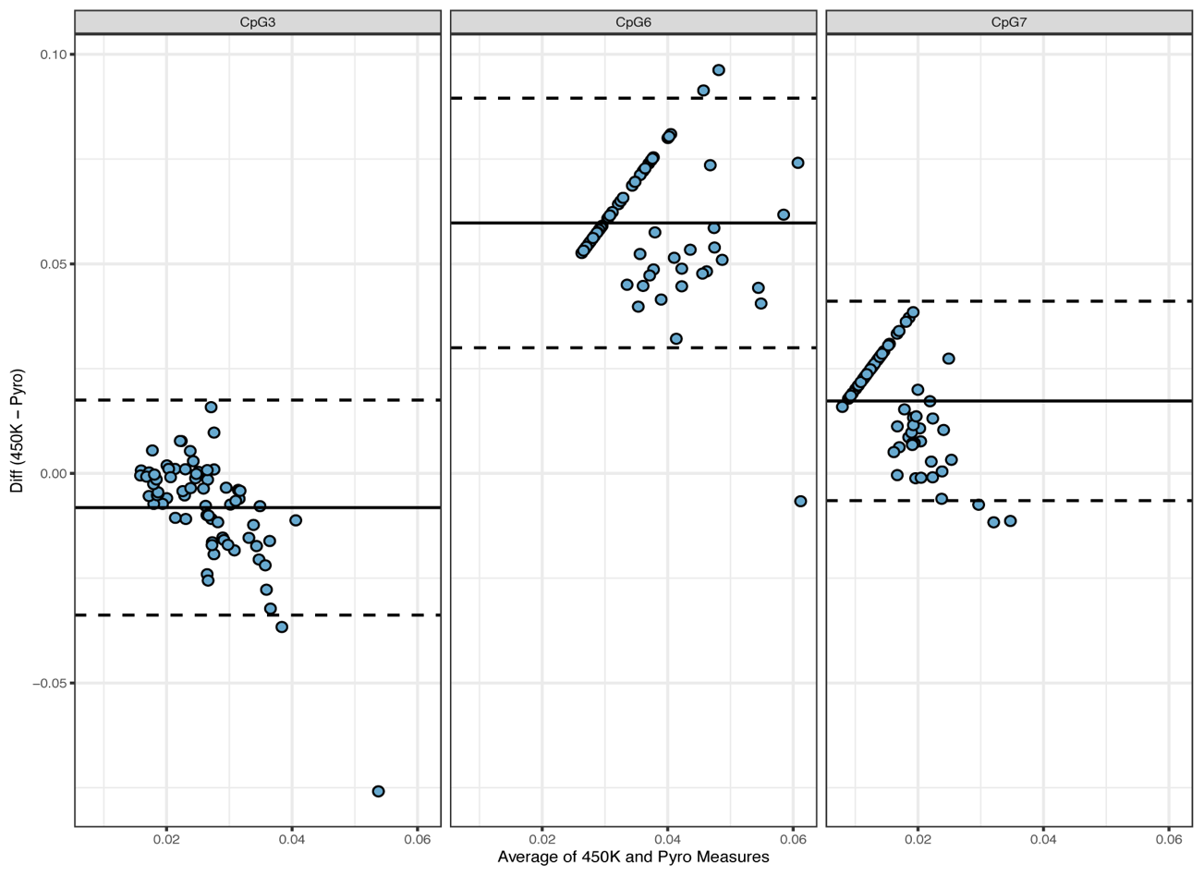

Table S.1. Results for Models Testing Interactions Between Genotype and Contact and Infant Distress on DNAm

BDNF cg07238832 | Estimate | Std. Error | t value | Pr(>|t|)
Intercept | 0.21 | 0.70 | 0.30 | 0.76
Contact | 0.41 | 0.76 | 0.54 | 0.59
BDNF A carrier | 0.68 | 0.71 | 0.97 | 0.34
Sex | 0.02 | 0.13 | 0.14 | 0.89
Race | 0.02 | 0.14 | 0.18 | 0.86
Age | 0.04 | 0.15 | 0.25 | 0.81
Contact*BDNF A carrier | -0.07 | 0.16 | -0.44 | 0.66
Contact*Sex | -0.12 | 0.17 | -0.72 | 0.47
Contact*Race | -0.06 | 0.16 | -0.36 | 0.72
Contact*Age | -0.05 | 0.16 | -0.30 | 0.77
BDNF A carrier*Sex | -0.06 | 0.18 | -0.33 | 0.75
BDNF A carrier*Race | 0.32 | 0.17 | 1.83 | 0.07
BDNF A carrier*Age | -0.23 | 0.15 | -1.53 | 0.13
Intercept | 0.53 | 0.52 | 1.01 | 0.31
Distress | 0.47 | 0.23 | 2.05 | 0.04
BDNF A carrier | 0.53 | 0.71 | 0.75 | 0.46
Sex | -0.03 | 0.10 | -0.26 | 0.80
Race | 0.02 | 0.10 | 0.19 | 0.85
Age | -0.02 | 0.10 | -0.15 | 0.88
Distress*BDNF A carrier | -0.03 | 0.05 | -0.52 | 0.60
Distress*Sex | -0.01 | 0.05 | -0.24 | 0.81
Distress*Race | 0.00 | 0.05 | 0.04 | 0.97
Distress*Age | -0.10 | 0.05 | -2.12 | 0.04
BDNF A carrier*Sex | -0.15 | 0.17 | -0.89 | 0.38
BDNF A carrier*Race | 0.32 | 0.18 | 1.83 | 0.07
BDNF A carrier*Age | -0.18 | 0.15 | -1.21 | 0.23
BDNF cg10635145
Intercept | -0.34 | 0.42 | -0.80 | 0.43
Contact | 0.09 | 0.46 | 0.20 | 0.85
BDNF A carrier | 0.06 | 0.43 | 0.13 | 0.90
Sex | -0.10 | 0.08 | -1.34 | 0.18
Race | 0.06 | 0.08 | 0.78 | 0.44
Age | 0.02 | 0.09 | 0.19 | 0.85
Contact*BDNF A carrier | -0.03 | 0.10 | -0.35 | 0.73
Contact*Sex | 0.10 | 0.10 | 1.01 | 0.32
Contact*Race | -0.01 | 0.10 | -0.13 | 0.90
Contact*Age | -0.03 | 0.09 | -0.31 | 0.75
BDNF A carrier*Sex | -0.37 | 0.11 | -3.53 | 0.00
BDNF A carrier*Race | 0.29 | 0.10 | 2.77 | 0.01
BDNF A carrier*Age | -0.07 | 0.09 | -0.79 | 0.43
Intercept | -0.22 | 0.32 | -0.68 | 0.50
Distress | 0.02 | 0.14 | 0.17 | 0.87
BDNF A carrier | 0.07 | 0.43 | 0.16 | 0.88
Sex | -0.06 | 0.06 | -0.92 | 0.36
Race | 0.04 | 0.06 | 0.72 | 0.47
Age | -0.01 | 0.06 | -0.17 | 0.86
Distress*BDNF A carrier | 0.02 | 0.03 | 0.51 | 0.61
Distress*Sex | -0.01 | 0.03 | -0.42 | 0.67
Distress*Race | 0.00 | 0.03 | 0.03 | 0.98
Distress*Age | 0.00 | 0.03 | -0.16 | 0.87
BDNF A carrier*Sex | -0.36 | 0.11 | -3.43 | 0.00
BDNF A carrier*Race | 0.32 | 0.11 | 2.94 | 0.00
BDNF A carrier*Age | -0.09 | 0.09 | -0.93 | 0.35
OXTR cg17036624
Intercept | 0.95 | 0.47 | 2.00 | 0.05
Contact | -0.15 | 0.52 | -0.30 | 0.77
BDNF A carrier | -0.19 | 0.54 | -0.35 | 0.73
Sex | 0.02 | 0.08 | 0.26 | 0.80
Race | -0.05 | 0.09 | -0.60 | 0.55
Age | 0.00 | 0.10 | 0.00 | 1.00
Contact*OXTR A carrier | -0.02 | 0.12 | -0.20 | 0.84
Contact*Sex | -0.10 | 0.11 | -0.88 | 0.38
Contact*Race | -0.04 | 0.11 | -0.34 | 0.73
Contact*Age | 0.04 | 0.11 | 0.38 | 0.70
OXTR A carrier*Sex | -0.21 | 0.12 | -1.67 | 0.10
OXTR A carrier*Race | 0.14 | 0.13 | 1.09 | 0.28
OXTR A carrier*Age | 0.01 | 0.11 | 0.11 | 0.91
Intercept | 0.80 | 0.29 | 2.81 | 0.01
Distress | -0.05 | 0.15 | -0.32 | 0.75
BDNF A carrier | -0.28 | 0.57 | -0.50 | 0.62
Sex | -0.04 | 0.06 | -0.69 | 0.49
Race | -0.06 | 0.06 | -0.98 | 0.33
Age | 0.03 | 0.06 | 0.57 | 0.57
Distress*OXTR A carrier | -0.02 | 0.04 | -0.59 | 0.56
Distress*Sex | 0.03 | 0.04 | 0.83 | 0.41
Distress*Race | -0.01 | 0.03 | -0.25 | 0.81
Distress*Age | 0.01 | 0.03 | 0.31 | 0.76
OXTR A carrier*Sex | -0.19 | 0.13 | -1.49 | 0.14
OXTR A carrier*Race | 0.10 | 0.14 | 0.72 | 0.47
OXTR A carrier*Age | 0.03 | 0.12 | 0.27 | 0.79

Table S.2. Details on Individual CpGs Found within DMRs
CpG | Estimate | False Discovery Rate | Gene | Pr(>|t|) | Chromosome | Position | Difference | Location Relative to TSS
cg05655707 | 0.0086 | 0.0000 | LDHAL6A | 2E-12 | chr11 | 18477254 | 0.0040 | ICshore
cg06588556 | 0.0543 | 0.0000 | LDHAL6A | 1E-12 | chr11 | 18477299 | 0.0364 | HC
cg06888460 | 0.0525 | 0.0000 | LDHAL6A | 1E-12 | chr11 | 18477303 | 0.0376 | HC
cg07915343 | 0.0361 | 0.0000 | LDHAL6A | 8E-13 | chr11 | 18477680 | 0.0210 | HC
cg15463284 | 0.0455 | 0.0000 | LDHAL6A | 4E-13 | chr11 | 18477534 | 0.0311 | HC
cg18888461 | 0.0444 | 0.0000 | LDHAL6A | 7E-13 | chr11 | 18477379 | 0.0283 | HC
cg23797887 | 0.0324 | 0.0000 | LDHAL6A | 2E-12 | chr11 | 18477753 | 0.0179 | HC
cg24440827 | -0.0011 | 0.0000 | LDHAL6A | 1E-08 | chr11 | 18478135 | -0.0016 | ICshore
cg26740318 | 0.0301 | 0.0000 | LDHAL6A | 4E-12 | chr11 | 18477153 | 0.0199 | ICshore
cg06080014 | -0.0607 | 0.0901 |  | 2E-04 | chr16 | 84822990 | -0.0458 | IC
cg06927361 | -0.0423 | 0.0913 |  | 2E-04 | chr16 | 84823224 | -0.0338 | IC
cg00588198 | 0.0530 | 0.0001 |  | 1E-08 | chr6 | 29648452 | 0.0567 | ICshore
cg02157626 | 0.0636 | 0.0000 |  | 7E-09 | chr6 | 29648736 | 0.0647 | HC
cg03198009 | 0.0648 | 0.0000 |  | 8E-09 | chr6 | 29648604 | 0.0685 | ICshore
cg03449857 | 0.0720 | 0.0000 |  | 7E-09 | chr6 | 29648623 | 0.0744 | ICshore
cg04071440 | 0.0200 | 0.0001 |  | 4E-08 | chr6 | 29648275 | 0.0210 | ICshore
cg07134666 | 0.0456 | 0.0001 |  | 2E-08 | chr6 | 29648400 | 0.0479 | ICshore
cg08022281 | 0.0371 | 0.0001 |  | 2E-08 | chr6 | 29648345 | 0.0366 | ICshore
cg08041448 | 0.0859 | 0.0000 |  | 1E-08 | chr6 | 29648901 | 0.0898 | HC
cg10648573 | 0.0430 | 0.0001 |  | 2E-08 | chr6 | 29648348 | 0.0435 | ICshore
cg11383134 | 0.0789 | 0.0000 |  | 8E-09 | chr6 | 29648590 | 0.0802 | ICshore
cg11747594 | 0.0167 | 0.0002 |  | 5E-08 | chr6 | 29648225 | 0.0198 | ICshore
cg12644888 | 0.0377 | 0.0001 |  | 2E-08 | chr6 | 29648360 | 0.0401 | ICshore
cg13835168 | 0.0765 | 0.0000 |  | 7E-09 | chr6 | 29648756 | 0.0820 | HC
cg15570656 | 0.0841 | 0.0000 |  | 7E-09 | chr6 | 29648628 | 0.0862 | ICshore
cg15708526 | 0.0325 | 0.0001 |  | 4E-08 | chr6 | 29648271 | 0.0346 | ICshore
cg16885113 | 0.0386 | 0.0000 |  | 1E-08 | chr6 | 29648507 | 0.0395 | ICshore
cg19636627 | 0.0697 | 0.0002 |  | 6E-08 | chr6 | 29649084 | 0.0685 | HC
cg20228636 | 0.0895 | 0.0000 |  | 1E-08 | chr6 | 29648525 | 0.0898 | ICshore
cg22494932 | 0.0344 | 0.0001 |  | 2E-08 | chr6 | 29648379 | 0.0343 | ICshore
cg24100841 | 0.0617 | 0.0001 |  | 3E-08 | chr6 | 29649024 | 0.0664 | HC
cg25699073 | 0.0367 | 0.0001 |  | 2E-08 | chr6 | 29648381 | 0.0374 | ICshore
cg25978138 | 0.0271 | 0.0002 |  | 8E-08 | chr6 | 29648161 | 0.0285 | ICshore
cg01341801 | -0.1275 | 0.0131 | HLA-DRB5 | 1E-05 | chr6 | 32489203 | -0.1352 | LC
cg05938207 | 0.0518 | 0.0623 | HLA-DRB5 | 1E-04 | chr6 | 32489750 | 0.0455 | HC
cg08188015 | -0.0490 | 0.0248 | HLA-DRB5 | 3E-05 | chr6 | 32489553 | -0.0563 | ICshore
cg13972202 | 0.0743 | 0.0786 | HLA-DRB5 | 2E-04 | chr6 | 32489801 | 0.0737 | HC
cg18816397 | -0.0529 | 0.0250 | HLA-DRB5 | 3E-05 | chr6 | 32489555 | -0.0546 | ICshore
cg05779406 | 0.0862 | 0.0059 | ZFAND2A | 5E-06 | chr7 | 1198841 | 0.0722 | HC
cg07092213 | 0.0160 | 0.0545 | ZFAND2A | 9E-05 | chr7 | 1199455 | 0.0121 | HC
cg12950816 | 0.0745 | 0.0051 | ZFAND2A | 4E-06 | chr7 | 1198977 | 0.0659 | HC
cg15112475 | 0.0273 | 0.0105 | ZFAND2A | 1E-05 | chr7 | 1198522 | 0.0257 | ICshore
cg16145915 | 0.0265 | 0.0079 | ZFAND2A | 6E-06 | chr7 | 1198662 | 0.0231 | HC
cg18765753 | 0.0310 | 0.0053 | ZFAND2A | 4E-06 | chr7 | 1198926 | 0.0239 | HC

Note. Difference = difference between high and low contact groups.

Supplementary Table 3. Results for Main Effects and Interaction Models Testing Associations Between Contact and Epigenetic Age Deviation.
Main Effects Model | Estimate | Std. Error | t value | Pr(>|t|)
Intercept | 0.59 | 0.44 | 1.36 | 0.18
Contact | 0.17 | 0.15 | 1.10 | 0.27
Distress | 0.01 | 0.05 | 0.28 | 0.78
Sex | 0.04 | 0.15 | 0.26 | 0.79
Race | -0.05 | 0.15 | -0.33 | 0.74
Years Education | -0.04 | 0.03 | -1.50 | 0.14
Interaction Model
Intercept | 1.35 | 0.70 | 1.92 | 0.06
Contact | -1.15 | 0.94 | -1.22 | 0.23
Distress | 0.33 | 0.26 | 1.27 | 0.21
Sex | 0.31 | 0.23 | 1.35 | 0.18
Race | 0.09 | 0.22 | 0.40 | 0.69
Years Education | -0.10 | 0.04 | -2.35 | 0.02
Contact*Distress | 0.23 | 0.10 | 2.41 | 0.02
Distress*Sex | -0.07 | 0.10 | -0.66 | 0.51
Contact*Sex | -0.41 | 0.32 | -1.31 | 0.19
Distress*Race | 0.03 | 0.09 | 0.29 | 0.77
Contact*Race | -0.22 | 0.33 | -0.66 | 0.51
Distress*Years Education | -0.03 | 0.02 | -1.63 | 0.11
Contact*Years Education | 0.10 | 0.06 | 1.79 | 0.08

