Supplementary Figure S.1.
(a) Longitudinal life stress event data in the Raine Study (by number)
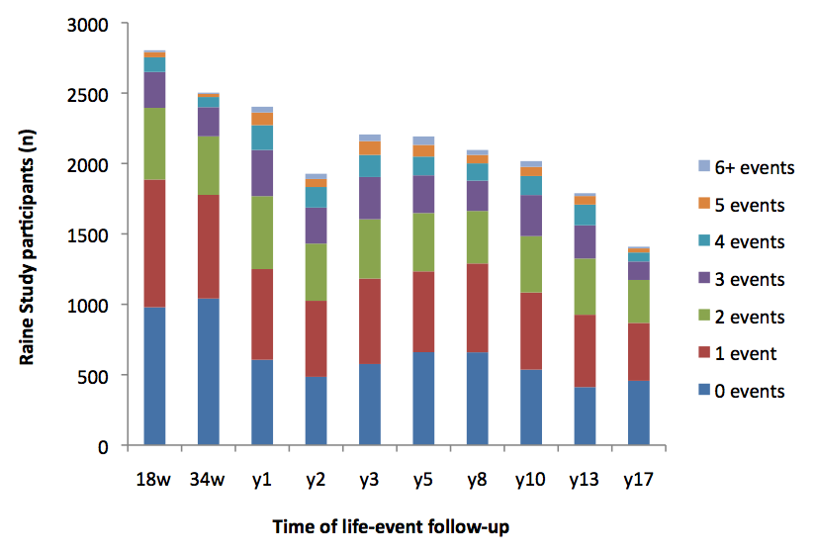
(b) Longitudinal life stress event data in the Raine Study (by percentage)
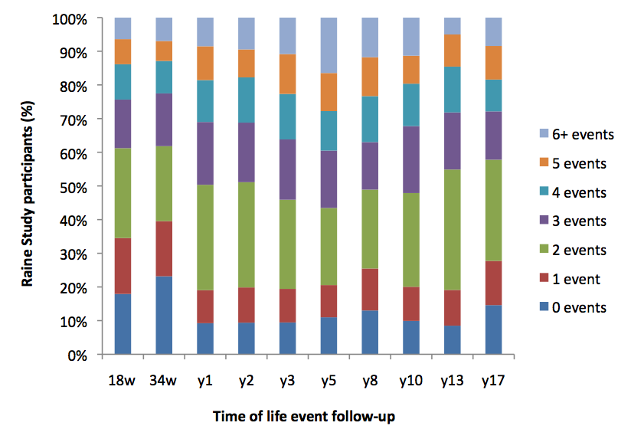
NOTE: The timepoints of 18w and 34w refer to the prenatal follow-ups and y1-y17 refer to the postnatal follow-ups. y2 was not a complete follow-up, therefore numbers are lower than y1 and y3.

