Supplemental Tables and Figures
Antarctic Science

Toxic cyanobacteria in meltwater ponds on the Antarctic Peninsula:
A pyrosequencing approach

J Kleinteich^{1,2}, F Hildebrand^{3,4}, SA Wood^{5,6}, S Cires^{7,8}, R Agha⁷, A Quesada⁷,
D Pearce^{9,10,11}, P Convey^{9,12}, FC Küpper^{13,14}, DR Dietrich¹*
¹ Human and Environmental Toxicology, University of Konstanz, 78457 Konstanz, Germany; ² CIP, Institute of Chemistry B6, University of Liège, B-4000 Liège, Belgium; ³ European Molecular Biology Laboratory, Meyerhofstrasse 1, 69117 Heidelberg, Germany; ⁴ Department of Bioscience Engineering, Vrije Universiteit Brussel, Pleinlaan 2, 1050 Brussels, Belgium; ⁵ Cawthron Institute, Nelson 7042, New Zealand; ⁶ University of Waikato, Hamilton 2001, New Zealand; ⁷ Departamento de Biología, Universidad Autónoma de Madrid, E-28049 Madrid, Spain; ⁸ School of Marine and Tropical Biology, James Cook University, Townsville, Queensland, 4811, Australia; ⁹ British Antarctic Survey, Natural Environment Research Council, High Cross, Madingley Road, Cambridge CB3 0ET, United Kingdom; ¹⁰ Faculty of Health and Life Sciences, University of Northumbria, Newcastle Upon Tyne, NE1 8ST, United Kingdom; ¹¹ University Centre in Svalbard, N-9171 Longyearbyen, Norway; ¹² New Zealand Antarctic; ¹³Scottish Association for Marine Science, Oban, Argyll PA37 1QA, Scotland, United Kingdom; ¹⁴ Oceanlab, University of Aberdeen, Main Street, Newburgh, AB41 6AA, Scotland, United Kingdom
*corresponding author: Daniel.Dietrich@uni-konstanz.de

Figure S1: Photographic images of mats sampled.
(A) Panorama and (B) detail of mats on Anchorage Island. (C) Cyanobacterial mat habitat on Lagoon Island as well as details of mats (D) LA2 (note gas bubbles on mat surface) and (E) LA6 (note shoe tips for scale). (F) The microscale layering of sample AN1 (scale bare 5 mm).
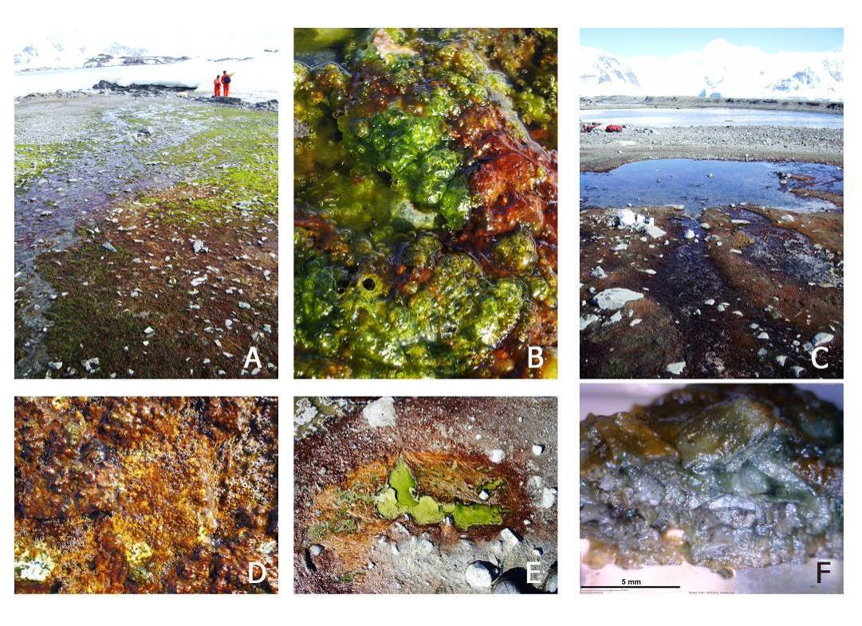

Figure S2: Phylogenetic tree based on Operational Taxonomic Units detected by 454 Next Generation Sequencing.
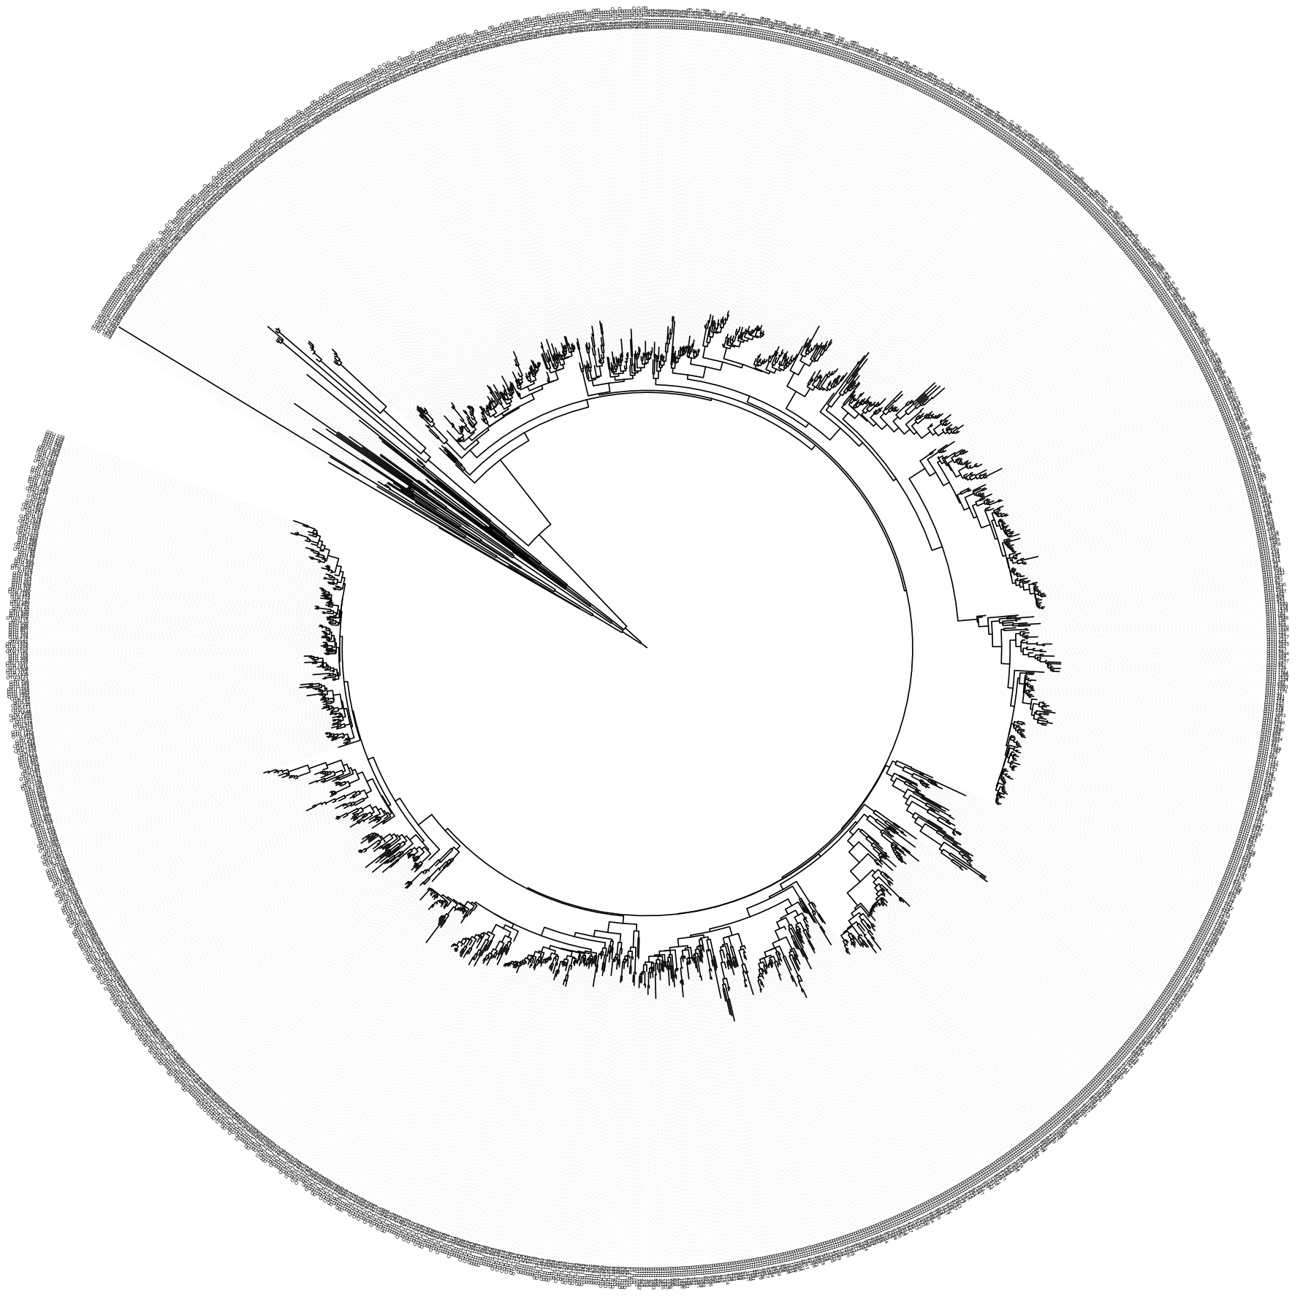
Fasta formatted OTU’s were aligned using Clustal Omega (Sievers et al. 2011) default options and fasttree2 (Price et al. 2010) to build the actual tree with parameters “-nt -gamma -no2nd -fastest -spr 4”. This tree is based on short reads and thus less reliable than a tree based on full length 16S sequences. The tree can be downloaded separately for full resolution.

Figure S3: Temperature records for two cyanobacterial mats.
Water temperature was recorded from the end of December 2010 to the end of January 2011 in two separate cyanobacterial mats at “East Beach” (Rothera) (blue and red).
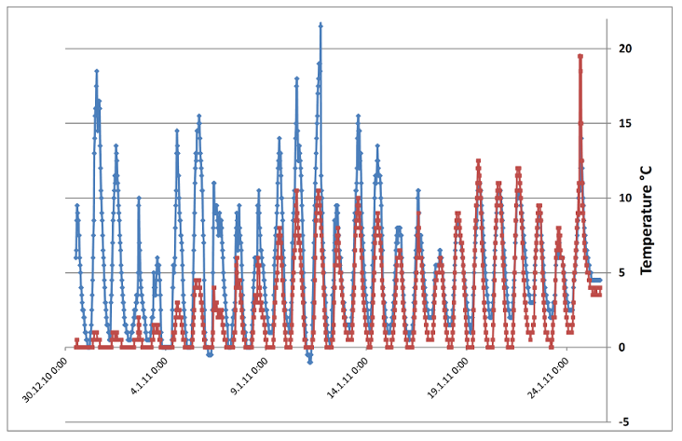

Figure S4: Cyanobacterial Operational Taxonomic Units abundance based on 454 sequencing data compared across samples. Samples from Rothera Point (RO), Lagoon (LA), Léonie (LE), and Lagoon (LA) Island.
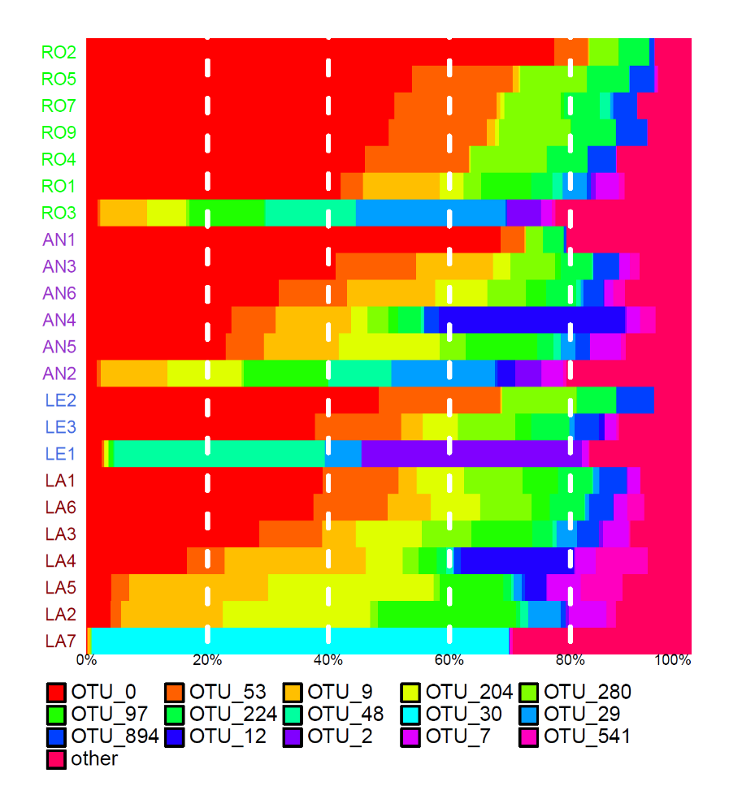

Figure S5: Non-metric Multidimensional Scaling (NMDS) graph of sequences obtained from 454 next generation sequencing on the level of Operational Taxonimic Units. Samples from Rothera Point (RO), Lagoon (LA), Léonie (LE), and Lagoon (LA) Island ordinated using a 2-dimensional NMDS based on intersample Bray –Curtis distances on OTU level.
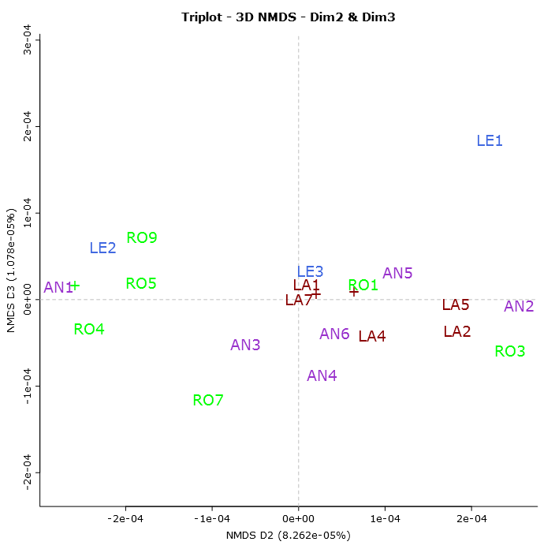

Table S1: Samples from additional polar microbial mats in which CYN has been measured. All names are unofficial but in some cases used in scientific literature. In bold font those that produced problems in the extractions and were not analyzed.
Pond name /  mat name | Location | coordinates | Date of collection | Habitat type
Pink mat | Taconite Inlet /Arctic | 82º 51’N  78º 13’W | 19/7/2001 | stream
Black mat | Taconite Inlet/Arctic | 82º 51’N  78º 13’W | 20/7/2001 | stream
Son of skua spa | Cape Evans/Antarctica | 77º 38’S  166º 24’E | 20/1/2006 | pond
Skua spa | Cape Evans/Antarctica | 77º 38’S | 20/1/2006 | pond
Lift off pond | Cape Evans/Antarctica | 166º 24’E | 20/1/2006 | pond
Snow bridge | Cape Evans/Antarctica | 77º 38’S | 20/1/2006 | pond
Skua spa 2 | Cape Evans/Antarctica | 166º 24’E | 20/1/2006 | pond
Buena Vista | Cape Evans/Antarctica | 77º 38’S | 20/1/2006 | pond
Casten pond | Iceshelf close to Bratina Island/Antarctica | 78º0’S  165º 33’E | 17/1/2006 | pond
Fog Horne | Iceshelf close to Bratina Island/Antarctica | 78º0’S  165º 33’E | 17/1/2006 | pond
Cripple pond | Iceshelf close to Bratina Island/Antarctica | 78º0’S  165º 33’E | 17/1/2006 | pond
P70 pond | Iceshelf close to Bratina Island/Antarctica | 78º0’S  165º 33’E | 17/1/2006 | pond
Creek pond | Iceshelf close to Bratina Island/Antarctica | 78º0’S  165º 33’E | 17/1/2006 | pond
Petreles stream | Byers Peninsula, Livingston Island/Antarctica | 62º 38’S  61º 05’W | 25/1/2002 | stream
South west wetland | Byers Peninsula, Livingston Island/Antarctica | 62º 38’S  61º 05’W | 4/1/2002 | wet area
Triangular pond | Byers Peninsula, Livingston Island/Antarctica | 62º 38’S  61º 05’W | 15/1/2002 | pond
Campamento mat | Byers Peninsula, Livingston Island/Antarctica | 62º 38’S  61º 05’W | 2/1/2002 | wet area
Orange mat | Byers Peninsula, Livingston Island/Antarctica | 62º 38’S  61º 05’W | 15/1/2002 | pond
Somero pond | Byers Peninsula, Livingston Island/Antarctica | 62º 38’S  61º 05’W | 18/11/2001 | pond
Purple mat | Byers Peninsula, Livingston Island/Antarctica | 62º 38’S  61º 05’W | 27/1/2002 | wet area
Limopolar watershed | Byers Peninsula, Livingston Island/Antarctica | 62º 38’S  61º 05’W | 2/1/2009 | wet area
South west pond 2 | Byers Peninsula, Livingston Island/Antarctica | 62º 38’S  61º 05’W | 20/1/2009 | wet area
Pond 2 | Mars Oasis, Alexander Island/Antarctica | 71º52’S  68º15’W | 14/12/2008 | pond
Pond 5 | Ares Oasis, Alexander Island/Antarctica | 71º50’S  68º13’W | 13/12/2008 | pond
Pond 7 | Ares Oasis, Alexander Island/Antarctica | 71º50’S  68º13’W | 13/12/2008 | pond
Pond M3 | Mars Oasis, Alexander Island/Antarctica | 71º52’S  68º15’W | 14/12/2008 | pond
Pond 1 | Ares Oasis, Alexander Island/Antarctica | 71º50’S  68º13’W | 9/12/2008 | pond
Pond M1 | Mars Oasis, Alexander Island/Antarctica | 71º52’S  68º15’W | 14/12/2008 | pond
Pond M3-2 | Mars Oasis, Alexander Island/Antarctica | 71º52’S  68º15’W | 10/12/2008 | pond
Pond 8 | Ares Oasis, Alexander Island/Antarctica | 71º50’S  68º13’W | 13/12/2008 | pond
Boeckella Pond | Bahia Esperanza/Antarctica | 63º23’S  56º59’W | 21/1/2004 | pond
Ward Hunt lake | Ward Hunt Island/Arctic | 83º04’N  74º08’W | 2/8/2001 | pond
Orange mat | Ward Hunt Island/Arctic | 83º04’N  74º08’W | 6/7/2009 | pond
Antoniades pond | Ward Hunt Island/Arctic | 83º04’N  74º08’W | 3/7/2009 | pond
Meretta Lake | Resolute Bay/Arctic | 74º41N  94º52’W | 18/7/2009 | pond
Antoniades pond-2 | Ward Hunt Island/Arctic | 83º04’N  74º08’W | 3/7/2009 | pond
PCSP Pond | Resolute Bay/Arctic | 74º41N  94º52’W | 20/7/2009 | pond
Meteo mat | Ward Hunt Island/Arctic | 83º04’N  74º08’W | 5/7/2009 | pond
Lake A/Nostoc colony | Ward Hunt Island/Arctic | 83º04’N  74º08’W | 7/7/2009 | pond

Table S2: Primer used in this study.

Primer | Target gene | Sequence | T_{m} | Reference
27F | 16S rRNA | AGAGTTTGATCCTGGCTCAG | 50°C* / 61°C | Jungblut & Neilan 2006
359F | 16S rRNA | GGGGAATYTTCCGCAATGGG | sequencing only | modified after Nuebel et al. 1997
781R | 16S rRNA | GACTACWGGGGTATCTAATCCCWTT | sequencing only | modified after Nuebel et al. 1997
809R | 16S rRNA | GCTTCGGCACGGCTCGGGTCGATA | 50°C* | Jungblut & Neilan 2006
CY-ARISA-F | 16S rRNA | FAM-GYCAYRCCCGAAGTCRTTAC | 50°C* | Wood et al. 2008
23S30R | 23S rRNA | CHTCGCCTCTGTGTGCCWAGGT | 61°C / 50°C* | Wood et al. 2008
mcyA-F | mcyA | AAAAGTGTTTTATTAGCGGCTCAT | 53°C | Hisbergues et al. 2003
mcyA-R | mcyA | AAAATTAAAAGCCGTATCAAA | 53°C | Hisbergues et al. 2003
FAA | mcyA | CTATGTTATTTATACATCAGG | 43°C* | Neilan et al. 1999
RAA | mcyA | CTCAGCTTAACTTGATTATC | 43°C* | Neilan et al. 1999
MTF mod | mcyA | GCNGGDGGRGCNTAYGTNCC | 55.5°C | modified after Neilan et al. 1999
MTR mod | mcyA | CCNCGAAATYTTRACYTG | 55.5°C | modified after Neilan et al. 1999
HEPF | mcyE | TTTGGGGTTAACTTTTTTGGGCATAGTC | 46°C | Jungblut & Neilan 2006
HEPR | mcyE | AATTCTTGAGGCTGTAAATCGGGTTT | 46°C | Jungblut & Neilan 2006
DKF | PKS | GTGCCGGTNCCRTGNGYYTC | 61.5°C | Moffitt & Neilan 2003
DKR | PKS | GCGATGGAYCCNCARCARMG | 61.5°C | Moffitt & Neilan 2003
abcs F | mcyH | CAAACTCCATTTTTTCAACA | 50°C | Kaebernick et al. 2001
abcs R | mcyH | GGTGAAGTAGTAGTCATCGT | 50°C | Kaebernick et al. 2001
cyrA360F | cyrA | CGCACTGCCTCTGGCACCAA | sequencing only | this study
cyrA1422R | cyrA | TCGAAGCACCACACCCCACT | sequencing only | this study
CYLATF | cyrA | ATTGTAAATAGCTGGAATGAGTGG | 57°C | Ralf Kellmann et al. 2006
CYLATR | cyrA | TTAGGGAAGTAATCTTCACAG | 57°C | Ralf Kellmann et al. 2006
JKcyrA1f | cyrA-B | TGTGAAAACGCCGCTCTTTG | 64°C | this study
JKcyrB1r | cyrA-B | TTATGCAASATMGCCCCAGT | 64°C | this study
Cyl M13 | cyrB | GGCAAATTGTGATAGCCACGAGC | 62°C | Schembri et al. 2001
Cyl M14 | cyrB | GATGGAACATCGCTCACTGGTG | 62°C | Schembri et al. 2001
Cyl sulfF | cyrJ | ACTTCTCTCCTTTCCCTATC | 60°C | Mihali et al. 2008
Cyl namR | cyrJ | GAGTGAAAATGCGTAGAACTTG | 60°C | Mihali et al. 2008
sxtaF | sxtA | GCGTACATCCAAGCTGGACTCG | 68.5°C | Ballot et al. 2010
sxtaR | sxtA | GTAGTCCAGCTAAGGCACTTGC | 68.5°C | Ballot et al. 2010
sxtAF | sxtA | GATGACGGAGTATTTGAAGC | 60°C | Al-Tebrineh et al. 2010
sxtAR | sxtA | CTGCATCTTCTGGACGGTAA | 60°C | Al-Tebrineh et al. 2010
*PCR using Fermentas Master Mix, all other reactions using Phusion polymerase
Table S3: Accession numbers of sequences derived in this study from mcy and cyr genes.

Sample | Gene | Accession  number | First annotated hit  in NCBI database | Accession no.  of BLAST  match | Length (bp) | Similarity
20.1.11-006 | mcyA | KF029612 | amino acid adenylation domain of Nostoc punctiforme | CP001037.1 | 791 | 79 %
20.1.11-001 | mcyA | KF029613 | amino acid adenylation domain of Nostoc punctiforme | CP001037.1 | 827 | 80 %
10.1.11-006 | cyrAB | KF029610 | CYN biosynthetic gene cluster of Oscillatoria sp. | FJ418586 | 2220 | 95 %
10.1.11-006 | cyrJ | KF029611 | CYN biosynthetic gene cluster of Oscillatoria sp. | FJ418586 | 584 | 93 %

Table S4: Spearman regression test of Operational Taxonomic Unit abundance (cyanobacteria only) correlated to microcystin concentration. Only OTU’s with a p-value <0.05 are listed.
Rank | Feature name | p-value | q-value | Rho | FeatureSum (%) | Class | order | family | genus
1 | OTU_1061 | 5,58E-05 | 0,005077 | 0,751459 | 0,177565 | Synechococcophycideae | Pseudanabaenales | Pseudanabaenaceae | ?
2 | OTU_883 | 0,000771 | 0,035066 | 0,662699 | 0,136436 | Synechococcophycideae | Pseudanabaenales | Pseudanabaenaceae | ?
3 | OTU_894 | 0,007742 | 0,169424 | 0,547207 | 2,525143 | Synechococcophycideae | Pseudanabaenales | Pseudanabaenaceae | Leptolyngbya
4 | OTU_280 | 0,008473 | 0,169424 | 0,54177 | 5,690793 | Synechococcophycideae | Pseudanabaenales | Pseudanabaenaceae | Leptolyngbya
5 | OTU_53 | 0,010766 | 0,169424 | 0,52694 | 8,69801 | Synechococcophycideae | Pseudanabaenales | Pseudanabaenaceae | Leptolyngbya
6 | OTU_224 | 0,011171 | 0,169424 | 0,524598 | 3,776777 | Synechococcophycideae | Pseudanabaenales | Pseudanabaenaceae | Leptolyngbya
7 | OTU_71 | 0,016694 | 0,21702 | -0,49815 | 0,376132 | Oscillatoriophycideae | Oscillatoriales | Phormidiaceae | Phormidium
8 | OTU_1028 | 0,025888 | 0,294481 | 0,467013 | 0,014614 | Oscillatoriophycideae | Oscillatoriales | Phormidiaceae | ?
9 | OTU_1152 | 0,040582 | 0,409127 | 0,432326 | 0,01835 | Synechococcophycideae | Pseudanabaenales | Pseudanabaenaceae | Leptolyngbya
10 | OTU_1197 | 0,053036 | 0,409127 | 0,410136 | 0,201459 | Synechococcophycideae | Pseudanabaenales | Pseudanabaenaceae | Leptolyngbya

References
Al-Tebrineh, J., Mihali, T.K., Pomati, F. & Neilan, B.A. 2010. Detection of saxitoxin-producing cyanobacteria and Anabaena circinalis in environmental water blooms by quantitative PCR. Applied and Environmental Microbiology, 76, 7836–7842.
Ballot, A., Fastner, J. & Wiedner, C. 2010. Paralytic shellfish poisoning toxin-producing cyanobacterium Aphanizomenon gracile in northeast Germany. Applied and Environmental Microbiology, 76, 1173–1180.
Hisbergues, M., Christiansen, G., Rouhiainen, L., Sivonen, K. & Börner, T. 2003. PCR-based identification of microcystin-producing genotypes of different cyanobacterial genera. Archives of Microbiology, 180, 402–410.
Jungblut, A.D. & Neilan, B.A. 2006. Molecular identification and evolution of the cyclic peptide hepatotoxins, microcystin and nodularin, synthetase genes in three orders of cyanobacteria. Archives of Microbiology, 185, 107–114.
Kaebernick, M., Rohrlack, T., Christoffersen, K. & Neilan, B.A. 2001. A spontaneous mutant of microcystin biosynthesis: genetic characterization and effect on Daphnia. Environmental Microbiology, 3, 669–679.
Kellmann, R., Mills, T. & Neilan, B.A. 2006. Functional modeling and phylogenetic distribution of putative cylindrospermopsin biosynthesis enzymes. Journal of Molecular Evolution, 62, 267–280.
Mihali, T.K., Kellmann, R., Muenchhoff, J., Barrow, D., Neilan, B.A., Biosynthesis, C. & Barrow, K.D. 2008. Characterization of the gene cluster responsible for cylindrospermopsin biosynthesis. Applied and Environmental Microbiology, 74, 716–722.
Moffitt, M.C. & Neilan, B.A. 2003. Evolutionary affiliations within the superfamily of ketosynthases reflect complex pathway associations. Journal of Molecular Evolution, 56, 446–457.
Neilan, B.A., Dittmann, E., Rouhiainen, L., Bass, R.A., Schaub, V., Sivonen, K. & Borner, T. 1999. Nonribosomal Peptide Synthesis and Toxigenicity of Cyanobacteria. Journal Of Bacteriology, 181, 4089–4097.
Nuebel, U., Garcia-Pichel, F. & Muyzer, G. 1997. PCR primers to amplify 16S rRNA genes from cyanobacteria. Applied and Environmental Microbiology, 63, 3327–3332.
Price, M.N., Dehal, P.S. & Arkin, A.P. 2010. FastTree 2--approximately maximum-likelihood trees for large alignments. Poon, A.F.Y., ed. PloS one, 5, e9490.
Schembri, M.A., Neilan, B.A. & Saint, C.P. 2001. Identification of genes implicated in toxin production in the cyanobacterium Cylindrospermopsis raciborskii. Environmental Toxicology, 16, 413–421.
Sievers, F., Wilm, A., Dineen, D., Gibson, T.J., Karplus, K., Li, W., Lopez, R., et al. 2011. Fast, scalable generation of high-quality protein multiple sequence alignments using Clustal Omega. Molecular Systems Biology, 7, 539.
Wood, S., Rueckert, A., Cowan, D. & Cary, S. 2008. Sources of edaphic cyanobacterial diversity in the Dry Valleys of Eastern Antarctica. The ISME Journal, 2, 308–320.

