Technical Appendix A
Direct comparison between Bayesian inference and least squares for model calibration

To justify the argument that least squares algorithm is inappropriate for calibration of the transmission mode proposed by Regan et al (2016), and that the Bayesian approach can improve the model calibration, we perform the following simulations.

To be fair for the comparison between the two methods, here we use exactly the same model and the same ten parameters and priors (i.e., fitting constraint for the 10 parameters given in Table 2 of Regan et al (2016)). Following the assumption of Poisson noise made by Regan et al (2016), we assume Poisson likelihood function to capture the variation in the monthly cases. We sample Bayesian posterior distributions of the model parameters using Monte Carlo Markov Chain simulations (for details of the method see Appendix B). The results are shown in the panel A of the following figure. For the convenience of comparison, the corresponding distributions of the ten model parameters from Regan et al (2016) are shown in the panel B of the figure. To make the comparison easy the following table (similar to table 2 of Regan et al) is also given. It is obvious from the figure that the Bayesian inference generates much better results for the posterior distributions of model parameters.

Table Description, fitting constraints (priors) and estimates of model parameters
Parameter | Description | prior | 95% (PI) | Median[95% CI]
N | Effective population size | U[1000,10000] | [1038,2445]] | 1332[1022,2090]
λ | “Force of infection“  (transmission rate) | U[0.01,0.50] | [0.108,0.276] | 0.129[0.085,0.201]
ζ (σ) | Rate of removal from E to Ip (O) (per day) | U[1/18,1/10] | [0.056,0.1] | 0.067[0.056,0.098]
κ (γ₁) | Rate of removal from Ip(O) to IS/IA (D/A) (per day) | U[1/18,1/10] | [0.056,0.1] | 0.064[0.056,0.096]
γ (γ₂) | Rate of removal from IS/IA (D/A) to R (per day) | U[1/11,1/3] | [0.91,0.333] | 0.149[0.0920,0.323]
p_{S} | Proportion of cases that are symptomatic | U[0.5,1.0] | [0.5,0.867] | 0.62[0.5,0.95]
p_{I} | Proportion immune | U[0.1,0.5] | [0.169,0.5] | 0.34[0.11,0.5]
E_{initial} (E0) | Initial number in E | U[1,20] | [1,13.379] | 2.66[1.05,7.59]
I_{P,initial} (I_{O0}) | Initial number in I_{P}(I_{O}) | U[1,20] | [1,10.403] | 1.93[1.03,5.31]
I_{S,initial (}I_{S0)} | Initial number in I_{S} | U[1,20] | [1,20] | 8.53[1.17,19.26]
R₀ | Basic reproductive number | – | [1.71,3.67] | 2.21[1.61,3.00]
Here U stands for the uniform distribution. PI stands for plausible intervals and CI stands for credible intervals. The symbols or description within brackets are that used in this study.

- Bayesian inference
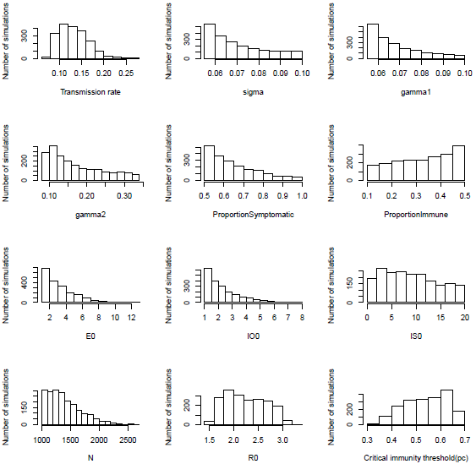

- Least Squares
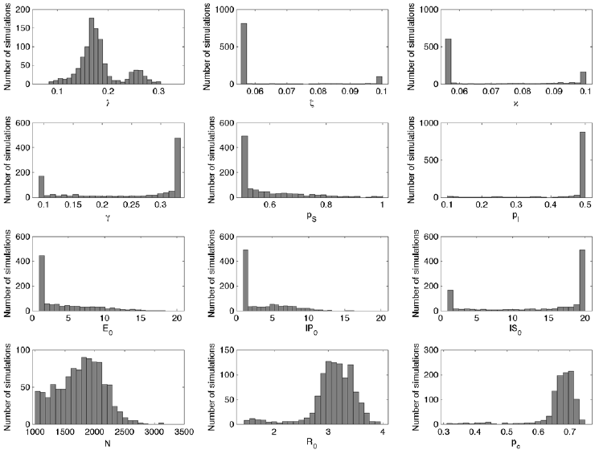

Figure Posterior distributions of model parameters obtained by A) Bayesian inference and B) least squares algorithm.

