*Epidemiology and Infection*

“*Salmonella* source attribution in a subtropical state of Australia: capturing environmental reservoirs of infection”

E. J. Fearnley, A. Lal, J. Bates, R. Stafford, M.D. Kirk, K. Glass

**Supplementary Material**

*Selection of postcodes for inclusion*

To ensure a sufficient number of *Salmonella* isolates from nuts, we expanded our geographic range to include samples from the following postcodes across the Queensland border in New South Wales: 2477, 2478, 2479, 2480, 2481,1 2482, 2484, 2486, 2487, 2650.

*Prevalence Assumptions*

Where possible, we based our prevalence assumptions on Queensland data; where such data were not available, we used Australian data. Estimates of prevalence on eggs have been highly varied, and we followed our earlier work [1], in assuming fairly low prevalence of *Salmonella* on eggs of 1%, with a wide interval about this to reflect uncertainty.

The data underlying these assumptions are listed below:

|  |  |  |  |  |  |  |
| --- | --- | --- | --- | --- | --- | --- |
|  | **Year;**  **state** | **Sample** | **Positive** | **Prevalence**  **(95% CI)** | **Study Details** | **Reference** |
| **Bovine** | 2000-2005;  multiple | 9,055 | 40 | 0.44% (0.3, 0.6) | Bull/Cow carcass samples from slaughter | [2] |
| **Chicken** | 2007-2008;  Queensland | 150 | 66 | 44% (36, 52) | Carcass samples from processing plants | [3] |
| **Nuts** | 2012;  multiple | 915 | 1 | 0.1%  (0.0, 0.6) | Survey of retail pre-packaged nuts | [4] |
| **Ovine** | 2000-2005;  multiple | 13,059 | 93 | 0.71%  (0.6, 0.9) | Sheep carcass samples from slaughter | [2] |
| **Porcine** | 2000-2006;  multiple | 7,038 | 132 | 1.88%  (1.57, 2.22) | Export pork samples tested through routine monitoring | [5] |

**References**

[1] Glass K, Fearnley E, Hocking H, et al. Bayesian source attribution of salmonellosis in South Australia. *Risk analysis*. Mar 2016; 36(3):561-570.

[2] Jordan, D. and S. Morris, *Analysis of ESAM data. Final report*, 2006, Meat & Livestock Australia (MLA): Sydney.

[3] FSANZ and the South Australian Research and Development Institute, *Baseline survey on the prevalence and concentration of Salmonella and Campylobacter in chicken meat on-farm and at primary processing* in *Proposal P282: Primary Production and Processing Standard for Poultry Meat* 2010: Canberra.

[4] NSW Food Authority. Report on the prevalence of *Salmonella* and *E.coli* in ready to eat nuts and nut products sold in Australia, online available at

<http://www.foodauthority.nsw.gov.au/_Documents/scienceandtechnical/national_nut_survey.pdf> (accessed February 2018)

[5] Hamilton, D.R., P. Smith, and A. Pointon, *National Salmonella and E. coli Monitoring (ESAM) data from Australian pig carcases from 2000 to 2006*.

**Table S1**: Samples included in each non-human source as extracted from Queensland pathology data

|  |  |
| --- | --- |
| **Source** | **Sample details** |
| Bovine | beef, beef carcass, beef ground, beef meat, beef meat meal, beef meat patty, beef pattie, beef product, beef raw, beef trim, bovine, calf, cattle, corned beef, cow, meat(beef), raw beef, silverside. |
| Chicken | bottom chicken, breast fillet, breeder hen, chicken; chicken balls, chicken breast, chicken burger, chicken caecum, chicken chow me, chicken crumbed chicken lasagne, chicken manure, chicken mcwrap, chicken meat, chicken mince, chicken nuggets, chicken patty, chicken pieces, chicken product, chicken raw, chicken rissole, chicken shed; chicken thigh, chicken whole, chicken wrap, crumbed chicken, hen meat, minced chicken, minced hen meat, raw chicken, whole chicken. |
| Egg | Chicken egg, egg, egg pulp, egg wash, egg whole, egg mayo sandwich, eggs, egg shed, raw egg, raw egg pulp, whole egg pulp, whole eggs. |
| Nuts | Almond, cashew, chestnut, mac nut, macadamia, macadamia nut, macadamia kernel, macadamia raw, nuts, nut kernel, pecan, pecan nuts, peanuts, raw macadamia, raw nuts, raw pecan. |
| Ovine | Lamb, lamb carcass, mutton, mutton carcass, ovine, sheep, sheep carcass, raw mutton. |
| Porcine | Pepperoni, bacon burger, baked ham, boar, boar meat, boar carcass, ham, kabana, pig, pig carcass, pig offal, piglet , pig snout, porcine, pork, pork carcass, pork food meal, pork mince, pork offal, raw pork, salami, wild boar, wild pig meat. |

**Table S2**: Number of *Salmonella* isolates per source for the 20 most common serotypes isolated from humans in Queensland, 2000-2011.

|  |  |  |  |  |  |  |  |
| --- | --- | --- | --- | --- | --- | --- | --- |
| **Serotype** | **Human** | **Bovine** | **Chicken** | **Eggs** | **Nuts** | **Ovine** | **Porcine** |
| Saintpaul | 2534 | 13 | 3 | 3 | 13 | 6 | 0 |
| Virchow PT 8 | 2070 | 13 | 16 | 0 | 16 | 0 | 2 |
| Birkenhead | 1544 | 0 | 0 | 0 | 33 | 0 | 0 |
| Aberdeen | 1264 | 8 | 0 | 0 | 69 | 1 | 0 |
| Typhimurium PT 135a | 1087 | 10 | 8 | 3 | 21 | 1 | 1 |
| Hvittingfoss | 994 | 2 | 0 | 0 | 18 | 0 | 0 |
| Typhimurium PT 170 | 985 | 6 | 5 | 3 | 0 | 2 | 0 |
| Typhimurium PT 135 | 944 | 7 | 2 | 1 | 25 | 2 | 2 |
| Waycross | 847 | 1 | 0 | 0 | 20 | 3 | 0 |
| Chester | 832 | 12 | 10 | 0 | 9 | 5 | 1 |
| Typhimurium PT 197 | 755 | 8 | 3 | 2 | 1 | 0 | 0 |
| Muenchen | 669 | 13 | 1 | 1 | 10 | 3 | 4 |
| Typhimurium PT 9 | 644 | 12 | 3 | 0 | 1 | 1 | 0 |
| Subspecies IIIb* | 485 | 0 | 0 | 0 | 2 | 1 | 0 |
| Anatum | 399 | 16 | 3 | 9 | 15 | 3 | 7 |
| Subspecies I | 386 | 11 | 8 | 4 | 4 | 0 | 5 |
| Mgulani* | 379 | 0 | 0 | 0 | 2 | 0 | 0 |
| Potsdam | 354 | 2 | 0 | 0 | 26 | 2 | 0 |
| Zanzibar | 354 | 17 | 1 | 0 | 21 | 0 | 2 |
| Virchow PT 34 | 341 | 1 | 5 | 0 | 8 | 0 | 0 |

PT= phage type

*= Serotype not included in source attribution model due to fewer than 10 isolates from non-human sources in dataset.

**Figure S1:** Annual salmonellosis incidence per 100,000 in Queensland, 2000-2011  
a) compared to national trends   
b) Typhimurium versus non-Typhimurium

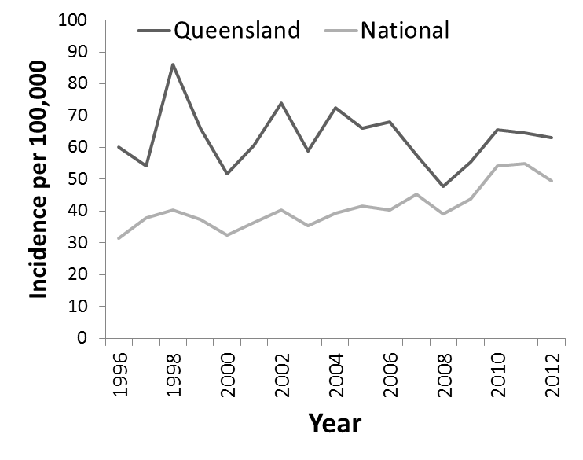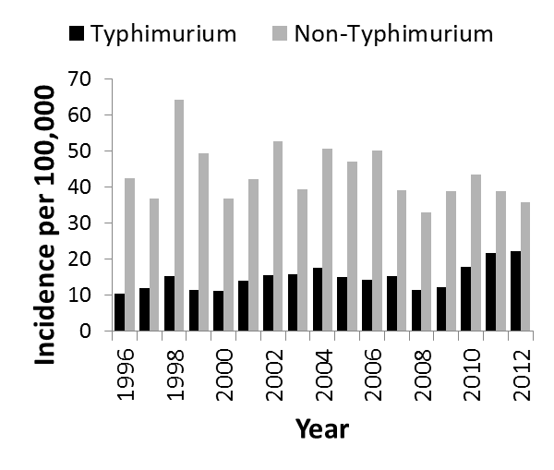

**Figure S2:** Annual age group specific incidence rates per 100,000 for five main non-Typhimurium *Salmonella* serotypes in Queensland, 2000-2011

