Epidemiology and Infection

Interactive effects of age and respiratory virus on severe lower respiratory infection - Supplementary Material

N. Prasad, A. A. Trenholme, Q. S. Huang, M.G. Thompson, N. Pierse, MA. Widdowson, T. Wood, R. Seeds, S. Taylor, C.C. Grant, E. C. Newbern, SHIVERS team

Supplementary Text S1: Additional information on laboratory testing methods as part of the Southern Hemisphere Influenza Vaccine Effectiveness Research and Surveillance project
Two major public hospitals, the Auckland and Counties Manakau District Health Board hospitals (ADHB and CMDHB), served the central, eastern, and southern Auckland region in 2012-2016 and were the study sites of the SHIVERS surveillance. The performance of hospital assays from clinician ordered tests were compared to CDC’s real-time RT-PCR as a gold standard. Only results from assays with a sensitivity greater than 80% and a specificity greater than 95% were included in the SHIVERS study dataset.
Supplementary Table S1: Performance of hospital assays (clinician ordered tests) in detecting different respiratory viruses 2012-2016
Virus type | Auckland hospital assay |  |  | Counties Manukau hospital assay
 | Sensitivity (95% CI) | Specificity (95% CI) |  | Sensitivity (95% CI) | Specificity (95% CI)
Flu | 96.49 (94.74-97.67) | 99.75 (99.52-99.87) |  | 97.82 (96.43-98.67) | 99.50 (99.29-99.65)
RSV | 95.74 (93.84-97.08) | 99.61 (99.32-99.78) |  | 91.38 (88.95-93.32) | 98.18 (97.47-98.69)
RV | 94.79 (92.48-96.42) | 99.86 (99.58-99.95) |  | ------------------------ | 85.71 (60.06-95.99)
ADV | 87.87 (83.45-91.23) | 99.65 (99.39-99.80) |  | 69.87 (64.56-74.70) | 97.89 (97.14-98.44)

Supplementary Text S2: Acute lower respiratory tract infections discharge diagnosis - ICD-10 codes.

J09 - Influenza due to certain identified influenza viruses
J10 - Influenza due to other identified influenza virus
J11 - Influenza due to unidentified influenza virus
J12 - Viral pneumonia, not elsewhere classified
J13 - Pneumonia due to Streptococcus pneumoniae
J14 - Pneumonia due to Hemophilus influenzae
J15 - Bacterial pneumonia, not elsewhere classified
J16 - Pneumonia due to other infectious organisms, not elsewhere classified
J17 - Pneumonia in diseases classified elsewhere
J18 - Pneumonia, unspecified organism
J20 - Acute bronchitis
J21 - Acute bronchiolitis
J22 - Unspecified acute lower respiratory infection

Supplementary Table S2: Comparison of demographics and clinical outcomes among children tested for influenza, RSV, RV, ADV and non-tested children aged <2 years hospitalised with acute lower respiratory infections in Auckland, New Zealand 2012-2015
 | Tested ALRI hospitalisations |  |  |  | Non-tested ALRI hospitalisations
 | n |  | (column %) |  | n | (column %)
Total | 1780 |  | (100.0) |  | 469 | (100.0)
Age
0 - 2 months |  | 352 |  | (19.8) | 111 | (23.7)
3 - 5 months |  | 368 |  | (20.7) | 98 | (20.9)
6 - 11 months |  | 601 |  | (33.8) | 164 | (35.0)
12 - 23 months |  | 459 |  | (25.8) | 96 | (20.5)
Ethnicity
Maori |  | 513 |  | (28.8) | 132 | (28.1)
Pacific |  | 896 |  | (50.3) | 230 | (49.0)
European, Asian, and Other |  | 371 |  | (20.8) | 107 | (22.8)
Sex
Male |  | 1082 |  | (60.8) | 263 | (56.1)
Household deprivation
NZ dep 1-6 (Least deprived) |  | 359 |  | (20.2) | 102 | (21.8)
NZ dep 7-8 |  | 282 |  | (15.8) | 50 | (10.7)
NZ dep 9-10 (Most deprived) |  | 1139 |  | (63.9) | 317 | (67.6)
ICU Admission |  | 228 |  | (12.8) | 74 | (15.8)
Hospital length of stay – mean (range) |  | 3 |  | (1-27) | 3 | (1-29)

Supplementary Table S3: Sources and definitions of covariates used in models
Variable | Definition | Source | Completeness
Age | Age in months at time of hospital event - calculated from date of birth and date of event | SHIVERS case report form (CRF), New Zealand (NZ) Ministry of Health (MoH) National Hospitalization (NMDS) data collections.ª | All patients
Sex | Male or Female | SHIVERS CRF, NZ MoH National Hospitalization (NMDS) data collections | All patients
Ethnicity | Prioritized ethnicity - Maori, Pacific, Asian, European, and Other. (European and Other ethnicity combined for the current analysis). | SHIVERS case report form (CRF), National Hospitalization (NMDS) data collections | All patients
Neighborhood socio-economic status (NZ Deprivation score)^{b} | NZ Deprivation 2013 (NZDep) Index of Deprivation - combines census data relating to income, home ownership, employment, qualifications, family structure, housing, access to transport and communications to create a deprivation score for each meshblock in New Zealand. Meshblocks are the smallest geographical area defined by Statistics New Zealand, with a population of around 60–110 people.  NZDep2013 groups deprivation scores into deciles, where 1 represents the areas with the least deprived scores and 10 the areas with the most deprived scores. A value of 10 therefore indicates that a meshblock is in the most deprived 10% of areas in New Zealand.  Deciles (1-10) are converted to an NZDep2013 score (1-5) which were used for the current analysis. | NZ MoH National Hospitalization (NMDS) data collections | All patients
Current influenza vaccination | Had an influenza vaccination in the last 12 months | Self-report SHIVERS CRF, NZ MoH National Immunization Register ^{c} | All consented patients. 9% of hospitalizations with unknown/missing vaccination record.
Pre-term birth | <37 weeks of gestational age - determined from gestational age at birth | SHIVERS CRF, NZ MoH National Maternity collections ^{d} | All patients
Low birth weight | <2500 grams - determined from birth weight | SHIVERS CRF, NZ MoH National Maternity collections ^{d} | All patients
Asthma | Does the patient have asthma (based on medical report) | SHIVERS CRF – hospital medical records | All consented patients
Other lung condition | Does the patient have another lung condition (based on medical report) | SHIVERS CRF – hospital medical records | All consented patients
Prior respiratory hospitalization beyond last 14 days | Flag patients with primary respiratory discharge diagnoses (J ICD-codes) before the 14 days preceding the hospitalization. Data from 2004-2016. For children aged <2 years, only applicable from 2009/2010). Emergency visits and non-admitted cases excluded. | NZ MoH National Hospitalization (NMDS) data collections | All patients
Congenital heart conditions | Does the patient have a congenital heart condition (based on medical report) | SHIVERS CRF – hospital medical records | All consented patients
Immunodeficiency | Does the patient have any immune condition (based on medical report) | SHIVERS CRF – hospital medical records | All consented patients
Renal or hepatic disease | Does the patient have any renal or hepatic condition (based on medical report) | SHIVERS CRF – hospital medical records | All consented patients

ª New Zealand Ministry of Health. National collections and surveys. Available at: http://www.health.govt.nz/nz-health-statistics/national-collections-and-surveys/collections.
^{b} Salmond C, Crampton P, King P, Waldegrave C. NZiDep: a New Zealand index of socioeconomic deprivation for individuals. Social science & medicine 2006; 62:1474-85.
^{c} New Zealand Ministry of Health. National Immunication Register. Availabe at: http://www.health.govt.nz/our-work/preventative-health-wellness/immunisation/national-immunisation-register.
^{d.} New Zealand Ministry of Health. National Maternity collections. Available at: http://www.health.govt.nz/nz-health-statistics/national-collections-and-surveys/collections/national-maternity-collection.

Supplementary Table S4: Association of intensive care unit admission and prolonged hospital stay with age and virus among children aged <2 years hospitalized with acute lower respiratory infection in Auckland, New Zealand 2012-2015– including influenza vaccination
 | ICU Admission |  |  |  | Prolonged hospital stay
 | RR | (95% CI) | P-value |  | RR | (95% CI) | P-value
Main effects
Demographics
Age in months | 0.95 | (0.92-0.99) | 0.016 |  | 0.96 | (0.96-0.97 | 0.000
European/ Asian/ Other | ref
Maori | 1.41 | (0.98-2.04) | 0.063 |  | 1.06 | (0.95-1.18 | 0.317
Pacific | 1.07 | (0.73-1.57) | 0.745 |  | 1.01 | (0.90-1.13 | 0.894
Nz dep 1-6 (High socio-economic area) ª | 0.87 | (0.59-1.27) | 0.459 |  | 1.06 | (0.93-1.20 | 0.382
Nz dep 7-8 | ref
Nz dep 9-10 (Low socio-economic area) | 0.50 | (0.36-0.70) | 0.000 |  | 0.96 | (0.86-1.06 | 0.402
Current influenza vaccine | 1.46 | (0.80-2.68) | 0.220 |  | 1.30 | (1.03-1.64 | 0.029
Underlying conditions
Premature birth and/or low birth weight ^{b} | 1.84 | (1.40-2.42) | 0.000 |  | 1.15 | (1.04-1.26 | 0.004
Chronic respiratory (asthma, other lung disease, and/or prior respiratory hospitalization) | 1.58 | (1.21-2.07) | 0.001 |  | 1.17 | (1.08-1.27 | 0.000
Other underlying condition (Congenital cardiovascular, immune, renal, hepatic) | 2.08 | (1.34-3.23) | 0.001 |  | 1.70 | (1.38-2.09 | 0.000
Viral Infection
Influenza | 0.42 | (0.15-1.13) | 0.084 |  | 0.76 | (0.62-0.94 | 0.011
RSV | 1.47 | (0.93-2.32) | 0.101 |  | 1.01 | (0.93-1.10 | 0.846
Rhinovirus | 0.88 | (0.66-1.18) | 0.394 |  | 0.83 | (0.76-0.91 | 0.000
Adenovirus | 1.50 | (1.09-2.07) | 0.012 |  | 0.99 | (0.79-1.24 | 0.937
Interactive effects
Influenza and age in months (multiplicative) | 1.07 | (0.98-1.16) | 0.137 |  | 1.04 | (1.02-1.06 | 0.000
Influenza and age in months  (additive [RERI]) | 0.05 | (0.01-0.10) | 0.014
RSV and age in months (multiplicative) | 0.92 | (0.86-0.97) | 0.005
RSV and age in months (additive [RERI]) | -0.14 | (-0.28-0.01) | 0.063
Adenovirus and age in months (multiplicative) |  |  |  |  | 1.02 | (1.00-1.04 | 0.041
Adenovirus and age in months (additive [RERI])
Abbreviations: ICU = Intensive care unit; RR =risk ratio; RERI =relative excess risk owing to interaction; RSV = respiratory syncytial virus
ª Socio-economic status ascertained from New Zealand Deprivation score (2013).
^{b} Preterm birth defined as <37 weeks of gestational age. Low birth weight defined as birth weight <2500 grams.
Supplementary Figure S1: Proportion of ICU by hospital length of stay in days among children <2 years with an acute lower respiratory tract infection (ALRI), 2012-2015 winter seasons, Auckland, New Zealand
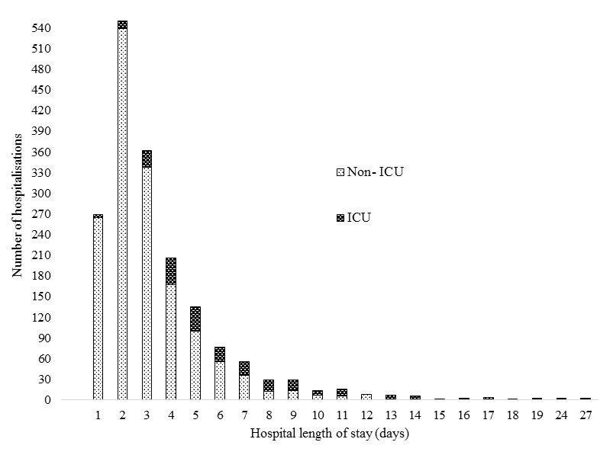

Supplementary Table S5. Unadjusted association of Intensive care unit admission and prolonged hospital stay with age and virus among children aged <2 years hospitalized with acute lower respiratory infection in Auckland, New Zealand 2012-2015
 | ICU Admission |  |  |  | Prolonged hospital stay
 | RR | (95% CI) | P-value |  | RR | (95% CI) | P-value
Main effects
Demographics
Age in months | 0.96 | (0.93-0.98) | 0.0008 |  | 0.99 | (0.97-0.99) | 0.0000
Male | 1.15 | (0.89-1.48) | 0.2891 |  | 1.00 | (0.93-1.09) | 0.9073
European/ Asian /Other | ref |  |  |  | ref
Maori | 1.13 | (0.81-1.56) | 0.4720 |  | 1.02 | (0.91-1.14) | 0.7500
Pacific | 0.76 | (0.55-1.04) | 0.0840 |  | 0.95 | (0.86-1.05) | 0.3230
Nz dep 1-6 (High socio-economic area) ª | 0.96 | (0.68-1.36) | 0.8120 |  | 1.10 | (0.96-1.25) | 0.1650
Nz dep 7-8
Nz dep 9-10 (Low socio-economic area) | 0.60 | (0.44-0.82) | 0.0010 |  | 0.98 | (0.89-1.09) | 0.7290
Underlying conditions
Premature birth and/or low birth weight ^{b} | 1.91 | (1.48-2.47) | 0.0000 |  | 1.21 | (1.11-1.33) | 0.0000
Chronic respiratory (asthma, other lung disease, and/or prior respiratory hospitalization) | 1.69 | (1.32-2.15) | 0.0000 |  | 1.18 | (1.09-1.27) | 0.0000
Other underlying condition (Congenital cardiovascular, immune, renal, hepatic) | 2.26 | (1.58-3.22) | 0.0000 |  | 1.70 | (1.42-2.20) | 0.0000
Viral Infection
Influenza | 0.61 | (0.39-0.96) | 0.0322 |  | 0.99 | (0.87-1.13) | 0.8593
RSV | 0.88 | (0.68-1.12) | 0.2960 |  | 1.04 | (0.97-1.12) | 0.2779
Rhinovirus | 1.02 | (0.77-1.34) | 0.9107 |  | 0.88 | (0.81-0.95) | 0.0021
Adenovirus | 1.28 | (0.95-1.72) | 0.1106 |  | 1.15 | (1.03-1.29) | 0.0122
Multiple viruses | 0.96 | (0.70-1.32) | 0.7832 |  | 1.04 | (0.94-1.14) | 0.4510
Interactive effects
Influenza and age in months (multiplicative) | 1.08 | (1.00-1.17) | 0.0380 |  | 1.03 | (1.01-1.05) | 0.0030
Influenza and age in months (additive [RERI]) | 0.06 | (0.03-0.09) | 0.0000
RSV and age in months (multiplicative) | 0.92 | (0.87-0.97) | 0.0040 |  | 0.99 | (0.97-1.00) | 0.0510
RSV and age in months (additive [RERI]) | -0.12 | (-0.24-0.00) | 0.0430
RV and age in months (multiplicative) | 1.00 | (0.94-1.07) | 0.9470 |  | 0.99 | (0.98-1.01) | 0.4130
RV and age in months (additive [RERI]) | 0.00 | (-0.08-0.08) | 0.9330
Adenovirus and age in months (multiplicative) | 1.03 | (0.96-1.10) | 0.4180 |  | 1.02 | (0.99-1.04) | 0.1520
Adenovirus and age in months (additive [RERI]) | 0.02 | (-0.07-0.11) | 0.6150
Abbreviations: ICU = Intensive care unit; RR =risk ratio; RERI =relative excess risk owing to interaction; RSV = respiratory syncytial virus
Supplementary Figure S2: Percentage (%) RSV positive in ICU by age in months among hospitalizations in children <2 years with an acute lower respiratory tract infection (ALRI), 2012-2015 winter seasons, Auckland, New Zealand
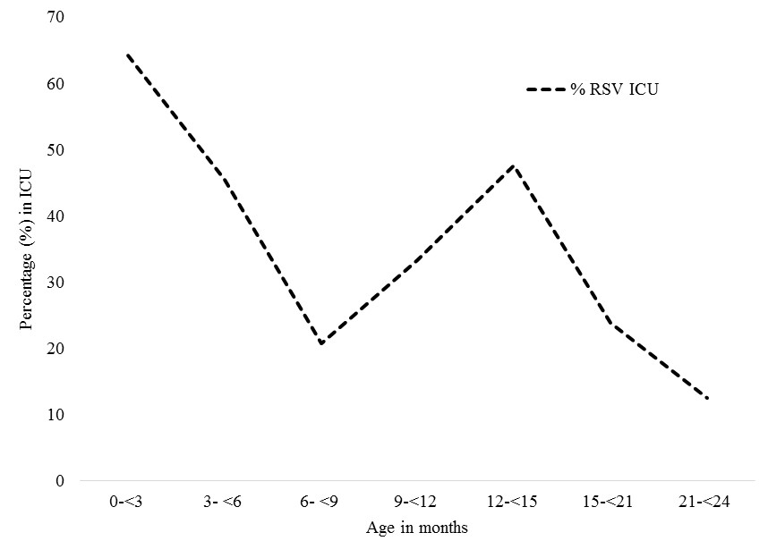

Supplementary Figure S3: Percentage (%) influenza positive in ICU by age in months among hospitalizations in children <2 years with an acute lower respiratory tract infection (ALRI), 2012-2015 winter seasons, Auckland, New Zealand
