Epidemiology and Infection
Dynamic Transmission Modelling to Address Infant Pneumococcal Conjugate Vaccine Schedule Modifications in The United Kingdom

M. WASSERMAN¹, A. LUCAS², D. JONES³, M. WILSON², B. HILTON⁴, A. VYSE³, H. MADHAVA³, A. BROGAN⁵, M. SLACK⁶, R. FARKOUH⁴
¹ Pfizer Inc., New York, NY, USA
²RTI Health Solutions, Research Triangle Park, NC, USA
³ Pfizer Ltd., UK
⁴ Pfizer Inc., Collegeville, PA, USA
⁵ RTI Health Solutions, Manchester, UK
⁶ School of Medicine, Griffith University, Australia

SUPPLEMENTARY MATERIAL

Other Parameters in the Model
Table S1 shows the birth rate, general mortality rate, and non-invasive pneumococcal disease multipliers used in the model.

Table S1. Epidemiological Parameters
Parameter | Value |  |  | Source
Birth rate | 12 per 100000 per year |  |  | [1]
General mortality rate
< 1 year old | 3.86 per 1000 per year |  |  | [2]
1 to < 2 years old | 0.15 per 1000 per year
2-4 years old | 0.15 per 1000 per year
5-17 years old | 0.15 per 1000 per year
18-34 years old | 0.42 per 1000 per year
35-49 years old | 1.46 per 1000 per year
50-64 years old | 5.00 per 1000 per year
65+ years old | 43.20 per 1000 per year
Ageing rate | Inverse of duration of time spent in age group |  |  | Calculated
Non-IPD multipliers | CAP | Otitis media
 |  | Mild | Moderate/severe
0 to < 2 years old | 7.1 | 146.0 | 10.6 | Estimated using IPD data [3, 4] and CAP and otitis media data [5, 6]
2-4 years old | 22.4 | 601.5 | 33.5
5-17 years old | 14.0 | 618.2 | 39.7
18-34 years old | 16.7 | N/A | N/A
35-49 years old | 17.6 | N/A | N/A
50-64 years old | 21.6 | N/A | N/A
65+ years old | 38.6 | N/A | N/A
CAP = community-acquired pneumonia; IPD = invasive pneumococcal disease; N/A = not applicable.

How Vaccine Waning Is Captured
Vaccinated individuals receive partial immunity (PI) based on the vaccine dose received. This immunity may wane over time. We capture this waning by shifting a proportion of the population over time to a no-immunity (NI) compartment.

Vaccine Effectiveness Calculations
To calculate vaccine effectiveness against invasive pneumococcal disease (IPD) (VE_{OI}) for each serotype group and dose number combination, we use the individual mean estimates for VE_{OI} for each serotype group and then multiply this base VE_{OI} by a multiplier depending on the serotype group.
Estimates of vaccine effectiveness against carriage (VE_{c}) are limited in the published literature, but recent models have assumed a value of about 50% as VE_{c} for all PCV13-covered serotypes after booster dose [7-9]. Our model allows VE_{c} to vary by serotype group. Previous studies have suggested that VE_{c} varies by serotype [10]. Allowing VE_{c} to vary by serotype group lets the model identify the best-fit to IPD incidence for each serotype group and dose combination. Using the vaccine effectiveness equation presented in the Methods section, we impose an upper bound (equal to VE_{OI}) for VE_{c}. We then calculate VE_{i} using VE_{OI} and VE_{c}.

Adherence Calculations
From the National Health Service, we know the average proportion of infants getting the complete pneumococcal vaccine primary series by age 1 year as well as the proportion of children who received the complete primary series plus the booster by age 2 years [11]. In the model, this coverage, or “adherence,” to the vaccine series is translated into the three probabilities associated with receiving each dose in the 2+1 vaccination schedule. The coverage data do not explicitly provide these adherence probabilities. To estimate them, we assume the adherence to the first dose is the same as the second dose. Similarly, we assume an adherence probability equal to the two priming doses for the booster dose.
For these values, we use the adherence levels from the most recent year of observed data, since adherence has plateaued in recent years. However, we initiated the model using the first year of observed data (2007) to mimic the catch-up campaign for PCV7 in the UK. This catch-up campaign vaccinated a high proportion of individuals younger than 2 years in just a few months. From documentation of the catch-up campaign, we approximated this proportion by assuming, at the start of the PCV7 availability, that 83.7% of individuals older than 4 months and younger than 2 years received their indicated dose.

Differential Equations Describing Model

Risk of Infection Equation
Let:
- $VE_{i,j,m}^{C}$ ${VE}_{i,j,m}^{I}$ be the vaccine effectiveness against carriage and vaccine effectiveness against IPD given carriage conferred for an individual with immunity level $i∈\{NI=no immunity, PI=partial immunity\}$ and dose number $j∈\{0=NV,1,2,3\}$ for serotype group $m$;
- $τ_{m}$ be the clearance rate for individuals carrying a serotype in serotype group $m$;
- $θ_{a}$ be the age rate for age group $a$;
- $γ_{j}$ be the waning rate for individuals who received dose $j$;
- $α_{a,j,j^{*}}$ be the adherence to dose $j^{*}$ for individuals in age group $a$ and last dose number received $j$ ($α_{a,j,j^{*}}$ is 0 for individuals in an age group and dose number $j$ that is not eligible for receiving dose $j^{*}$ according to the rules governing dosing in the model);
- $r_{a,m}$ be the probability of acquiring carriage for age group $a$ given contact with a carrier of serotype group $m$;
- $δ_{a}$ be an indicator function with $δ=1$ if $a$ is the first age group and 0 otherwise;
- $κ$ be the birth rate and $μ_{a}$ be the mortality rate for age group $a$;
- $d_{a,a^{*}}$ be the rate of individuals in age group $a^{*}$ contacting individuals in age group $a$;
- $β_{m}$ be the probability of developing IPD after acquiring carriage; and
- and $S∈\{NV,V^{1},V^{2},V^{3}\}$ with $N_{a}$ = the total size of the population in age group $a$ and $N$ = the total size of the entire population in the model.
Then the rate at which carriers in serotype group $m$ and age group $a^{*}$ successfully transmit to susceptible individuals in compartments with age group $a$, immunity level $i$, and dose number $j$ is:
$λ_{a,i,j,m}=\left(1-{VE}_{i,j,m}^{C}\right)r_{a,m}d_{a,a^{*}}\left(\frac{S_{a,i,j}}{N_{a}}\right)$.

Differential Equations Governing Flow of Individuals
Then the following equations define the rate of change for each of the compartments using the parameters described above.
$$S_{a,NI,j}=κδ_{a}N+\sum_{m}{τ_{m}C_{a,NI,j,m}}+γ_{j}S_{a,PI,j}-{θ_{a}S}_{a,NI,j}+\sum_{j^{*}}{\left(1-α_{a-1,j,j^{*}}\right)θ_{a-1}S_{a-1,NI,j}}-\sum_{a^{*}}{\sum_{i^{*}}{\sum_{j^{*}}{\sum_{m}{λ_{a,NI,j,m}C_{a^{*},i^{*},j^{*},m}}}}}-μ_{a}S_{a,NI,j}$$
$$S_{a,PI,j}=\sum_{m}{τ_{m}C_{a,PI,j,m}}-γ_{j}S_{a,PI,j}-{θ_{a}S}_{a,PI,j}+\sum_{j^{*}}{(1-α_{a-1,j,j^{*}})θ_{a-1}S_{a-1,PI,j}}+\sum_{i^{*}}{\sum_{j^{*}}{{α_{a-1,j^{*},j}θ_{a-1}S}_{a-1,i^{*},j^{*}}}}-\sum_{a^{*}}{\sum_{i^{*}}{\sum_{j^{*}}{\sum_{m}{λ_{a,PI,j,m}C_{a^{*},i^{*},j^{*},m}}}}}-μ_{a}S_{a,PI,j}$$
$$C_{a,NI,j,m}=-τ_{m}C_{a,NI,j,m}+γ_{j}C_{a,PI,j,m}-{θ_{a}C}_{a,NI,j}+\sum_{j^{*}}{\left(1-α_{a-1,j,j^{*}}\right)θ_{a-1}C_{a-1,NI,j}}+\sum_{a^{*}}{\sum_{i^{*}}{\sum_{j^{*}}{\sum_{m}{λ_{a,NI,j,m}C_{a^{*},i^{*},j^{*},m}}}}}-μ_{a}C_{a,NI,j,m}$$
$$C_{a,PI,j,m}=-τ_{m}C_{a,PI,j,m}-γ_{j}C_{a,PI,j,m}-{θ_{a}C}_{a,PI,j}+\sum_{j^{*}}{(1-α_{a-1,j,j^{*}})θ_{a-1}C_{a-1,PI,j}}+\sum_{i^{*}}{\sum_{j^{*}}{{α_{a-1,j^{*},j}θ_{a-1}C}_{a-1,i^{*},j^{*}}}}+\sum_{a^{*}}{\sum_{i^{*}}{\sum_{j^{*}}{\sum_{m}{λ_{a,PI,j,m}C_{a^{*},i^{*},j^{*},m}}}}}-μ_{a}C_{a,PI,j,m}$$
$$I_{a,i,j,m}=\left(1-{VE}_{i,j,m}^{C}\right)β_{m}\sum_{a^{*}}{\sum_{i^{*}}{\sum_{j^{*}}{\sum_{m}{λ_{a,i,j,m}C_{a^{*},i^{*},j^{*},m}}}}}$$

Calibration Procedure
We began the calibration by assuming that, before the introduction of PCV7, the incidence of IPD and the prevalence of carriage throughout all age groups was in a steady state. We then used a steady state approximation to calculate the force of infection parameters for each serotype and selected age group. A steady state approximation assumes that the per-time number of carriage acquisitions equals the per-time number of carriage clearances, with no births or deaths. This calculation uses a set of linear equations and is calculated outside the model.
Using these force of infection estimates, we randomly drew parameters within certain bounds for all vaccine effectiveness and waning parameters, and ran the model forward from 2001, when the most recent estimates of IPD surveillance exist, with the dynamics of the model. The model then ran through to the last year of observed surveillance data. The calibration procedure then repeated for a given number of iterations with the goal of minimizing the sum of squared deviations of the resulting yearly IPD incidence values produced from the model with the actual IPD surveillance values.
This calibration procedure allows the force of infection parameters to be estimated not just from a steady state period, but from the two vaccine periods (PCV7 and PCV13). Implementing the calibration procedure in this way allows the model to account for serotype replacement and competition before and after a vaccination programme.
The final set of calibrated parameters, along with the initial distribution of the population in the model compartments given all parameters and model dynamics, are used to run the model “forward” (i.e., projecting into the future) to estimate the outcomes associated with the 2+1 and 1+1 schedule.

Calibration Results
The model was calibrated to fit IPD incidence across age and serotype groups. The probability of carriage acquisition per contact with a carrier was highest for age groups < 2 and 65+ years (Table S2). Additionally, this probability was highest for PCV7-covered serotypes and serotype 19A in those < 2 years and for serotype 3 and non–vaccine-type serotypes for 65+ years of age:

Table S2. Probabilities of Carriage Acquisition per Contact With a Carrier
Age (Years) | Serotype 19A | Serotype 3 | Serotypes 1, 5, 7F, 6A | PCV7-Covered Serotypes | Noncovered Serotypes
0 to < 1 | 0.030 | 0.025 | 0.027 | 0.031 | 0.027
1 to < 2 | 0.031 | 0.026 | 0.027 | 0.032 | 0.027
2-4 | 0.002 | 0.001 | 0.004 | 0.003 | 0.002
5-17 | 0.001 | 0.001 | 0.003 | 0.001 | 0.002
18-34 | 0.002 | 0.004 | 0.003 | 0.001 | 0.004
35-49 | 0.003 | 0.006 | 0.006 | 0.002 | 0.007
50-64 | 0.007 | 0.019 | 0.007 | 0.005 | 0.016
65+ | 0.114 | 0.287 | 0.191 | 0.115 | 0.280
PCV7 = 7-valent pneumococcal conjugate vaccine.
The following graphs illustrate the fit of the calibrated model compared with IPD surveillance:

Figure S1. Invasive Pneumococcal Disease Incidence per 100,000 for Ages 0 to < 2 Years by Serotype Group From 2001 to 2017: Calibrated Versus Surveillance
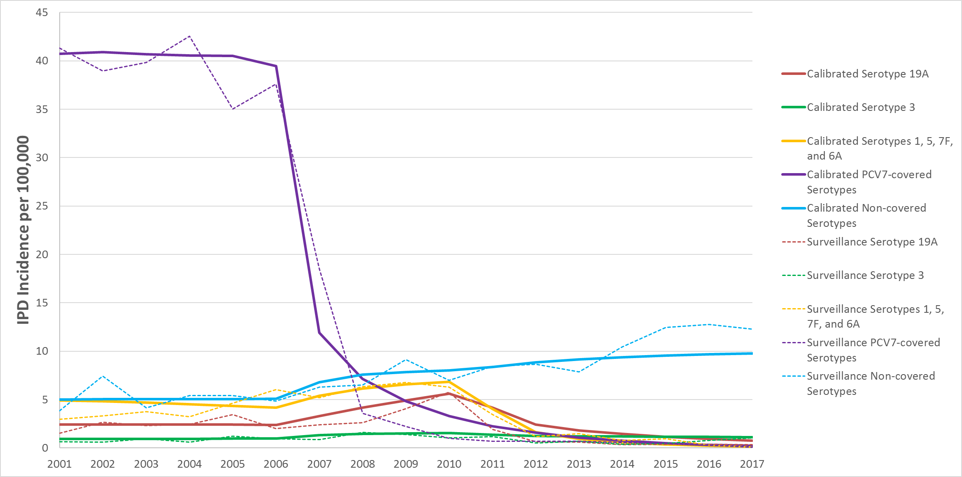
IPD = invasive pneumococcal disease; PCV7 = 7-valent pneumococcal conjugate vaccine.

Figure S2. Invasive Pneumococcal Disease Incidence per 100,000 for Ages 2 to 4 Years by Serotype Group From 2001 to 2017: Calibrated Versus Surveillance
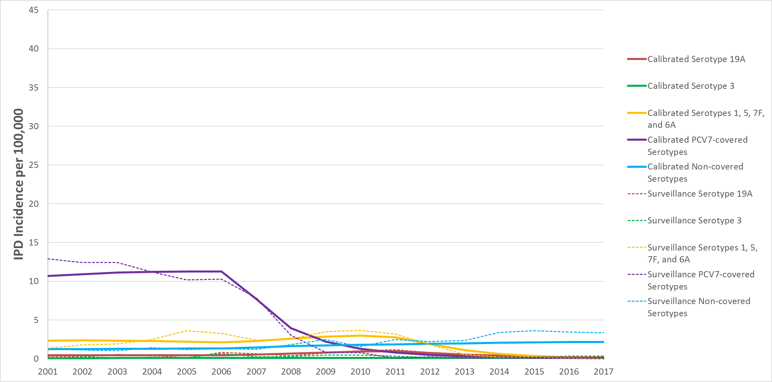
IPD = invasive pneumococcal disease; PCV7 = 7-valent pneumococcal conjugate vaccine.

Figure S3. Invasive Pneumococcal Disease Incidence per 100,000 for Ages 5 to 17 Years by Serotype Group From 2001 to 2017: Calibrated Versus Surveillance
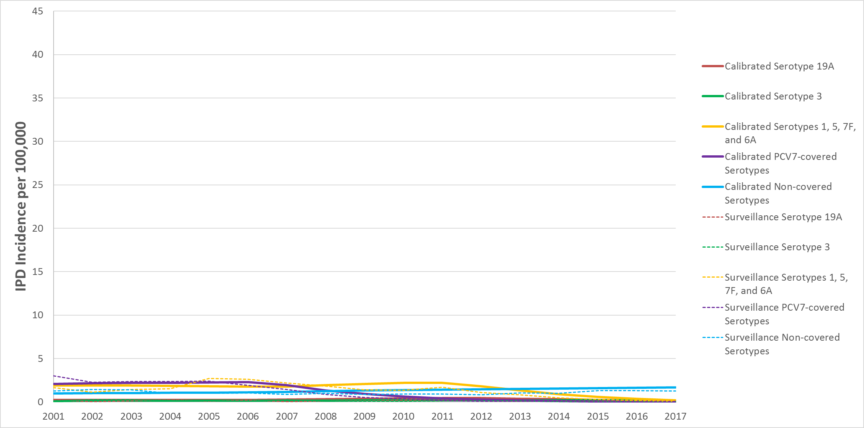
IPD = invasive pneumococcal disease; PCV7 = 7-valent pneumococcal conjugate vaccine.

Figure S4. Invasive Pneumococcal Disease Incidence per 100,000 for Ages 18 to 34 Years by Serotype Group From 2001 to 2017: Calibrated Versus Surveillance
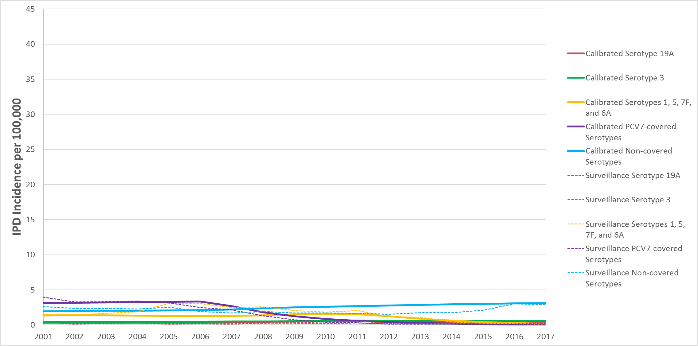
IPD = invasive pneumococcal disease; PCV7 = 7-valent pneumococcal conjugate vaccine.

Figure S5. Invasive Pneumococcal Disease Incidence per 100,000 for Ages 35 to 49 Years by Serotype Group From 2001 to 2017: Calibrated Versus Surveillance
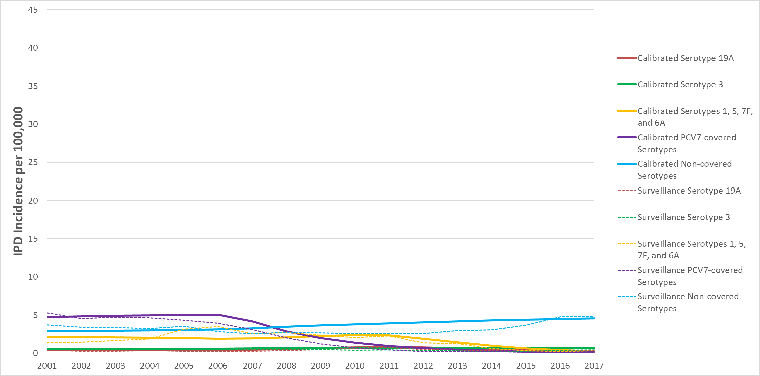
IPD = invasive pneumococcal disease; PCV7 = 7-valent pneumococcal conjugate vaccine.

Figure S6. Invasive Pneumococcal Disease Incidence per 100,000 for Ages 50 to 64 Years by Serotype Group From 2001 to 2017: Calibrated Versus Surveillance
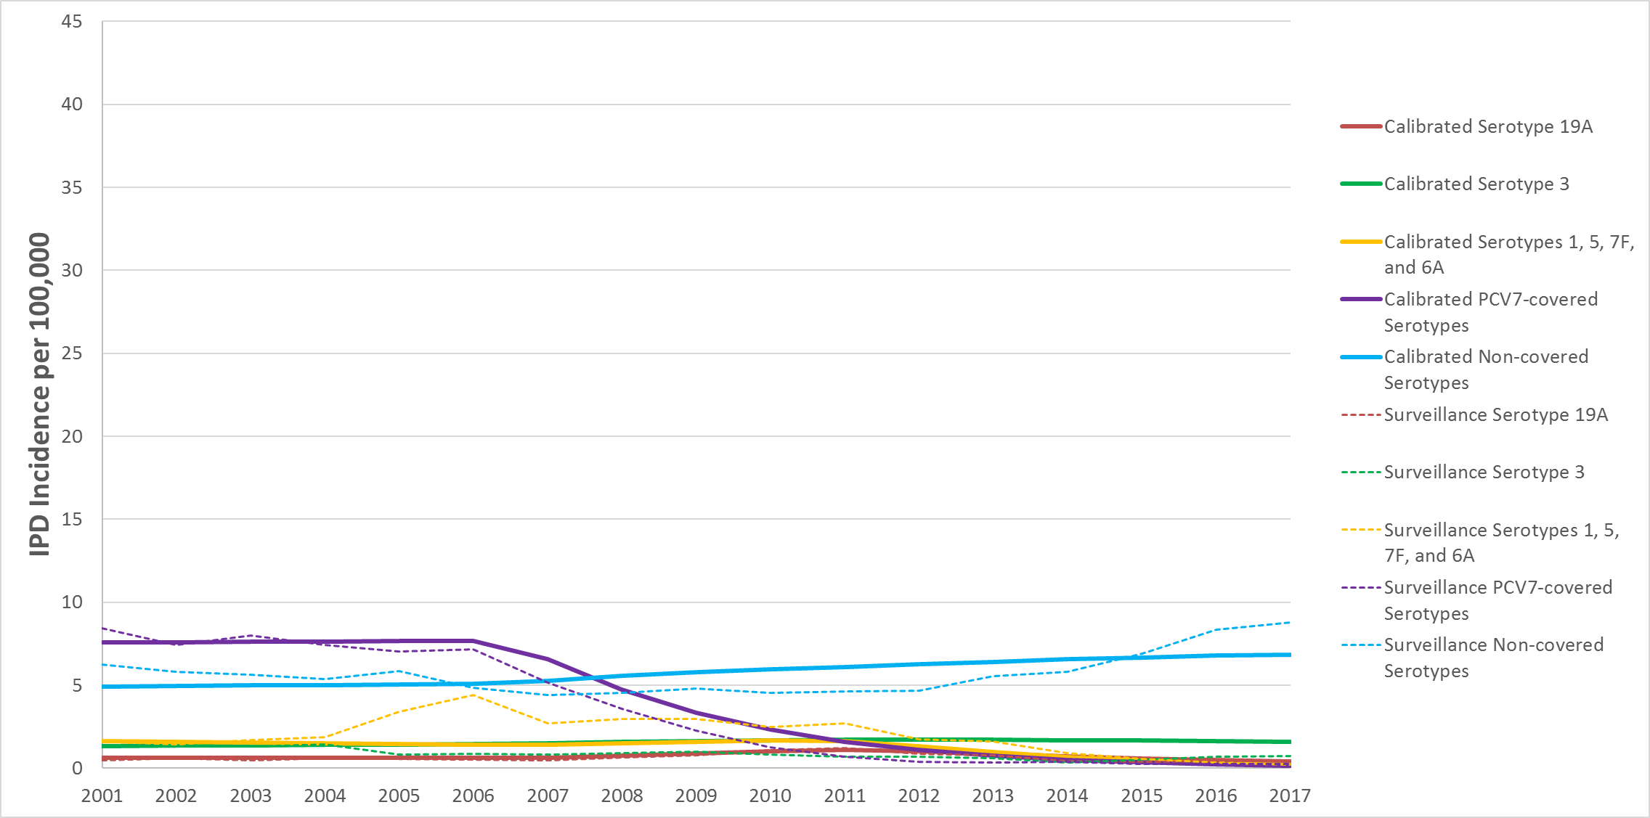
IPD = invasive pneumococcal disease; PCV7 = 7-valent pneumococcal conjugate vaccine.

Figure S7. Invasive Pneumococcal Disease Incidence per 100,000 for Ages 65+ Years by Serotype Group From 2001 to 2017: Calibrated Versus Surveillance
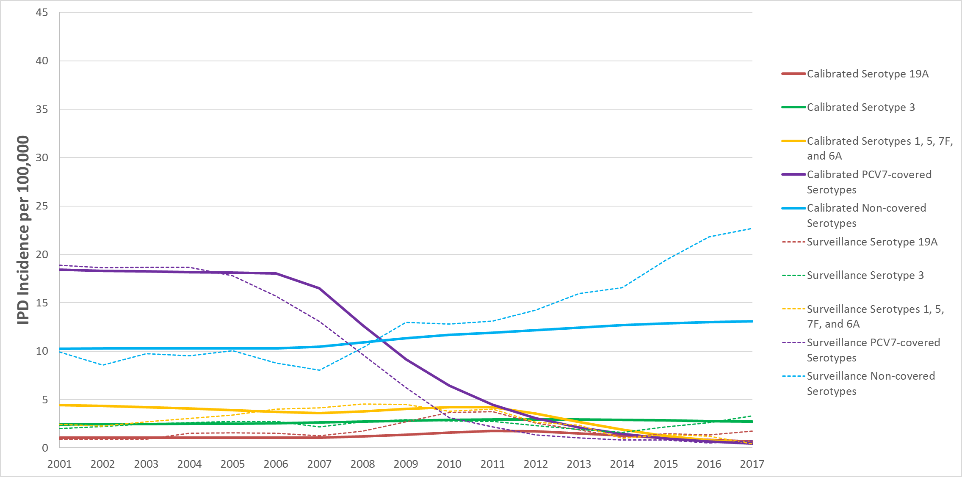
IPD = invasive pneumococcal disease; PCV7 = 7-valent pneumococcal conjugate vaccine.

References
(1) World Bank. World development indicators. 2018.
(2) Office of National Statistics. Death registrations summary statistics, England and Wales. 2015.
(3) Collins S, et al. Trends in invasive pneumococcal disease over time: England and Wales 2000/01 to 2014/15. In: 10th International Symposium on Pneumococci and Pneumococcal Diseases. Glasgow, Scotland, 2016.
(4) Waight PA, et al. Effect of the 13-valent pneumococcal conjugate vaccine on invasive pneumococcal disease in England and Wales 4 years after its introduction: an observational cohort study. The Lancet Infectious Diseases 2015; 15: 535-543.
(5) NHS Digital. Hospital admitted patient care activity, 2015-16. National Health Service; 9 November 2016.
(6) University College London. THIN database -- a collaboration between In Practice Systems (INPS) and IMS Health. 14 April 2015.
(7) Bottomley C, et al. A mathematical model of serotype replacement in pneumococcal carriage following vaccination. Journal of the Royal Society, Interface 2013; 10: 20130786.
(8) Choi YH, et al. Mathematical modelling long-term effects of replacing Prevnar7 with Prevnar13 on invasive pneumococcal diseases in England and Wales. PLOS One 2012; 7: e39927.
(9) Van Effelterre T, et al. A dynamic model of pneumococcal infection in the United States: implications for prevention through vaccination. Vaccine 2010; 28: 3650-3660.
(10) Dagan R, et al. Modeling pneumococcal nasopharyngeal acquisition as a function of anticapsular serum antibody concentrations after pneumococcal conjugate vaccine administration. Vaccine 2016; 34: 4313-4320.
(11) NHS Digital. Childhood vaccination coverage statistics, England, 2016-17. National Health Service; 20 September 2017.

