Epidemiology and Infection
Probable transmission routes of the influenza virus in a nosocomial outbreak
S. XIAO*, J. W. TANG, D. S. HUI, H. LEI, H. YU, Y. LI

Supplementary Material
SI A. Parameter selection
Table S1. Parameters for the multi-zone model.
Parameter | Zone 1 | Zone 2 | Zone 3 | Zone 4 | Zone 5 | Zone 6 | Data source
Volume (m³) | 117.9 | 68.5 | 117.9 | 117.9 | 38.5 | 63.9 | [1]
Supply airflow rate (L/s) | 171 | 0 | 228 | 254 | 39 | 228 | [1]
Exhaust airflow rate (L/s) | 0 | 510 | 0 | 0 | 253 | 157 | [1]
HEPA air purifier airflow rate (L/s) | 346 | 0 | 450 | 363 | 0 | 0 | [1]
Heat gain (kW) | 2.310 | 0.900 | 2.310 | 2.158 | 0.506 | 0.840 | [1, 2]

Table S2. Surface material types and areas.
Surface | Material type | Areaª (cm²) | Data source
Clothes | Porous surfaces | 10,000 | Assumed
Bed surface |  | 18,000 | Assumed
Curtains |  | 1,000 | Assumed
Over-bed table | Non-porous surfaces | 4,800 | Assumed
Bedside table |  | 8,400 | Assumed
Cup |  | 250 | Assumed
Bed rail |  | 2,355 | Assumed
Water heater button |  | 3 | Assumed
Toilet door handle (outer) | Toilet surfaces | 47 | Assumed
Toilet door handle (inner) |  | 47 | Assumed
Toilet lid |  | 500 | Assumed
Toilet flush buttons |  | 3 | Assumed
Toilet taps |  | 3 | Assumed
Toilet sanitizer button |  | 3 | Assumed
Hand contact area | Skin | 40 | Estimated [3, 4]
Finger contact area |  | 3 | Estimated [5]
Non-mucosal regions of the head and neck |  | 1,300 | Assumed
Mucous membranes | Mucous membranes | 10 | Assumed [6]
a Surface areas are effect areas that are commonly touched and not the actual areas.

Table S3. Transfer rates between surfaces of different materials.
Donor surface | Acceptor surface | Transfer rate | Data source
Hand | Porous surface | 80% | [7]
Hand | Skin | 17% | [8]
Hand | Non-porous surface | 27% | [8]
Hand | Toilet surface | 36% | [8]
Hand | Mucous membranes | 34% | [9]
Porous surface | Hand | 3% | [10]
Skin | Hand | 17% | [8]
Non-porous surface | Hand | 29% | [8]
Toilet surface | Hand | 16% | [8]
Mucous membranes | Hand | 0% | Assumed

Table S4. First-order inactivation rates at different sites.
Site | Value | Data source
In air | 0.36/h | [11, 12]
On porous surface | 1.78/h | [13]
On skin | 55/h | [12, 14]
On non-porous surface | 0.2/h | [15]
On toilet surface | 0.05/h | [16]

Table S5. Virus sources at different sites of the index patient.
Parameter | Sites | Value | Data source
$$L_{0}$$ | In initially expired droplets | 10⁴–10⁸ TCID₅₀/mLª | [17]
$$L_{s}$$ | On skin | 1.9 × 10⁻⁷$L_{0}$ TCID₅₀/cm² | Estimated^{b}
$$L_{p}$$ | On porous surfaces | 2.3 × 10⁻⁷$L_{0}$ TCID₅₀/cm² | Estimated^{b}
$$L_{np}$$ | On non-porous surfaces | 1.0 × 10⁻⁶$L_{0}$ TCID₅₀/cm² | Estimated^{b}
a The tissue-culture infectious dose (TCID₅₀) is the quantity of virus required for a cytopathic effect in 50% of inoculated cultures [18].
b When the index patient coughed, the airborne droplets became suspended in the air and the other droplets were assumed to be uniformly deposited on a small area around him. The virus concentrations on different surfaces varied with the first-order inactivation rates of the surface materials and the largest diameter of the virus-containing droplets $d_{g}$. Here, $d_{g}$ was set to be 200 μm.

Table S6. Dose–response parameters at different exposure sites.
Parameter | Exposure site | Value | Data source
$$α_{m}$$ | Mucous membranes | 1.4 × 10⁻³/TCID₅₀ª | Estimated [12]
$$α_{r}$$ | Respiratory tract | 1.03/TCID₅₀ª | Estimated [12]
a Dose–response parameters were calculated using ID₅₀ from Spicknall et al. [12] with the equation $α=ln2/ID_{50}$[13].

Table S7. Behaviour frequencies
Behaviour | Executors | Frequency | Data source
Touching one’s own clothes | All agents | 3/h | Assumed
Touching one’s own non-mucosal regions of head and neck | All agents | 13/h | Estimated [19]
Touching one’s own mucous membranes | Nurses and the health assistant | 9/h | Estimated [20]
 | Doctors | 5/h | Estimated [20]
 | Patients, visitors and cleaning staff | 16/h | Estimated [20]
Touching one’s own bed rails | Patients | 10/day | Assumed
Touching one’s own over-bed tables | Patients | 3/day | Assumed
Touching one’s own bed surfaces | Patients | 3/h | Assumed
Touching one’s own bedside table | Patients | 3/day | Assumed
Helping index patient fetch water | Health assistant | 2.5/day | [21]
Helping index patient with urination | Health assistant | 4–7/day | [22]
Helping index patient with defecation | Health assistant | 1/3–3/day | [23]
Fetching water | Normal patients | 2.5/day | [21]
Urination | Normal patients | 4–7/day | [22]
Defecation | Normal patients | 1/3–3/day | [23]
Visiting patients | Visitors | 1/day | Assumed
Medical examinations | Doctors | Beginning at 08:00 | Assumed
Routine rounds | Nurses | Beginning at 07:00, 11:00, 15:00, 19:00 and 23:00 ª | Assumed
Cleaning cubicles | Cleaners | Beginning at 08:00 and 18:00 | Assumed
Cleaning toilets | Cleaners | After cleaning cubicles | Assumed
a Nurses were assumed to take observations for every patient (such as pulse, temperature and blood pressure) every 4 h in the daytime, for a total of five times per day.

Table S8. Assumed sequences of touching surfaces with respect to behaviours.
Behaviour | Executors | Assumed sequence of touching surfacesª
Touching one’s own clothes | All agents | Clothes
Touching one’s own non-mucosal regions of head and neck | All agents | Non-mucosal regions of head and neck
Touching one’s own mucous membranes | All agents | Mucous membranes
Touching one’s own bed rails | Patients | Bed rails
Touching one’s own over-bed tables | Patients | Over-bed tables
Touching one’s own bed surfaces | Patients | Bed surfaces
Touching one’s own bedside table | Patients | Bedside tables
Health assistant helping index patient fetch water | Index patient | Call bell
 | Health assistant | Cup → water heater button → water heater button → cup
Health assistant helping index patient with urination/defecation | Index patient | Call bell
 | Health assistant | Toilet door handle (outer) → toilet door handle (inner) → toilet lid → toilet lid → toilet flush button → toilet tap → toilet sanitizer button → toilet door handle (inner) → toilet door handle (outer)
Fetching water | Patients (not bed-bounded) | Bed surface → bed rails → cup → water heater button → water heater button → cup → bed rails → bed surface
Urination/defecation | Patients (not bed-bounded) | Bed surface → bed rails → toilet door handle (outer) → toilet door handle (inner) → toilet lid → toilet lid → toilet flush button → toilet tap → toilet sanitizer button → toilet door handle (inner) → toilet door handle (outer) → bed rails → bed surface
Visiting patients/medical examinations/routine rounds | Visitors/doctors/nurses | Curtains → bed rails → bed surfaces → clothes → patients’ hands → clothes → bed surfaces → bed rails → curtains
Cleaning cubicles | Cleaners | Curtains → over-bed table^{b} → bedside table^{b} → curtains
Cleaning toilets | Cleaners | Toilet outside door handle → toilet inside door handle → toilet lid^{b} → toilet lid^{b} → toilet flush button^{b} → toilet inside door handle → toilet outside door handle
a HCWs’ surface touching sequences were assumed on the basis of YouTube videos of student-focused training in health care from the Arizona Medical Training Institute (AZMTI) (https://www.youtube.com/user/AZMTI).
b Underlined text denotes surfaces cleaned by the cleaning staff.

Table S9. Other parameters.
Parameter | Description | Value | Data source
$$T$$ | Computational duration | 5 days, from 27 to 31 March 2008 | Assumed [1]
$$d_{a}$$ | Largest diameter for airborne droplets | 10 μm | [17, 24]
$$d_{i}$$ | Largest diameter for inspirable droplets | 100 μm | [17]
$$d_{g}$$ | Largest diameter for virus-containing droplets | 200 μm as the baseline value; 20–200 μm for sensitivity analyses | Assumed [6]
$$p$$ | Pulmonary ventilation rate | 0.48$m^{3}/h$ | [25]
$$f_{c}$$ | Frequency of cough | 12/h | [17]
$$t_{s}$$ | Temperature of supply airflow | 21.05°C | [1]
$$N_{c}$$ | Number of droplets generated per incidence of cough | 2,000 | Estimated [26]
$$N_{ip}$$ | Number of index patients | 1 | [1]
$$N_{h}$$ | Number of health assistants | 1 | Assumed
$$N_{np}$$ | Number of normal patients at one time point | 27 | Assumed [1]
$$N_{v}$$ | Number of visitors | 0–3 for each patient | Assumed
$$N_{d}$$ | Number of doctors | 3 | Assumed
$$N_{n}$$ | Number of nurses | 3 | Assumed [27]
$$N_{cs}$$ | Number of cleaning staff | 1 | Assumed
$$η_{c}$$ | Surface cleaning efficiency | 80% | Assumed
$$P_{w}$$ | Probability of nurses and doctors washing hands after contacting a patient | 67.3% | Estimated [28]
$$η_{w}$$ | Hand-washing efficiency | 0.4 | Estimated [29]
SI B. Supplemental figure
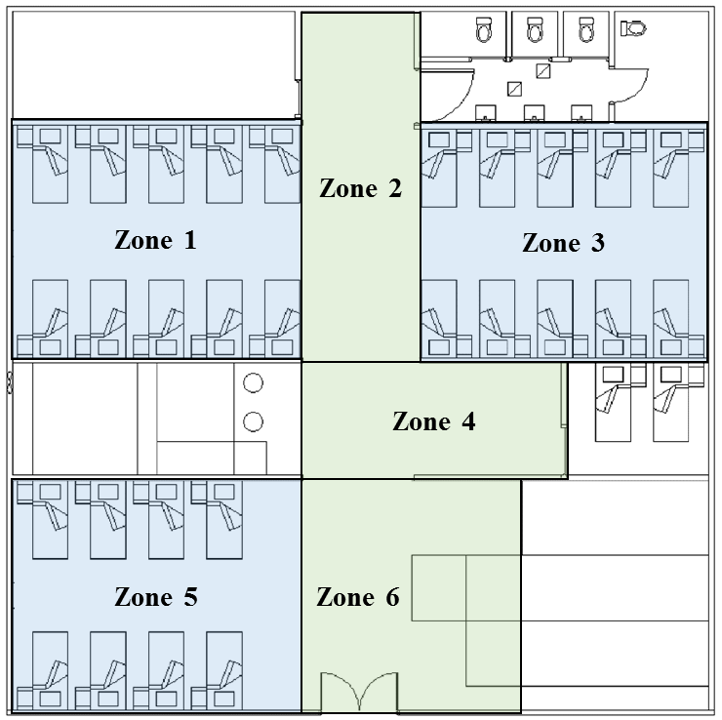
Fig. S1 Division of the outbreak ward into six zones for multi-zone modelling. The corridor was divided into three zones.

References
- Wong BCK, et al. Possible role of aerosol transmission in a hospital outbreak of influenza. Clinical Infectious Diseases. 2010; 51: 1176-1183.
- Chen C, et al. Role of two-way airflow owing to temperature difference in severe acute respiratory syndrome transmission: revisiting the largest nosocomial severe acute respiratory syndrome outbreak in Hong Kong. Journal of The Royal Society Interface. 2011; 8: 699-710.
- Lee JY, Choi JW, Kim H. Determination of hand surface area by sex and body shape using alginate. Journal of Physiological Anthropology. 2007; 26: 475-483.
- AuYeung W, Canales RA, Leckie JO. The fraction of total hand surface area involved in young children’s outdoor hand-to-object contacts. Environmental Research. 2008; 108: 294-299.
- Wiertlewski M, Hayward V. Mechanical behavior of the fingertip in the range of frequencies and displacements relevant to touch. Journal of Biomechanics. 2012; 45: 1869-1874.
- Gao X, Relative effectiveness of ventilation in community indoor environments for controlling infection (dissertation). Hong Kong, China: The University of Hong Kong, 2011.
- Mackintosh C, Hoffman P. An extended model for transfer of micro-organisms via the hands: differences between organisms and the effect of alcohol disinfection. Journal of Biomechanics. 1984; 92: 345-355.
- Lopez GU. Transfer of microorganisms from fomites to hands and risk assessment of contaminated and disinfected surfaces (dissertation). Tucson, Arizona, USA: University of Arizona, 2013.
- Rusin P, Maxwell S, Gerba C. Comparative surface-to-hand and fingertip-to-mouth transfer efficiency of gram-positive bacteria, gram-negative bacteria, and phage. Journal of Applied Microbiology. 2002; 93: 585-592.
- Lopez GU, et al. Transfer efficiency of bacteria and viruses from porous and nonporous fomites to fingers under different relative humidity conditions. Applied and Environmental Microbiology. 2013; 79: 5728-5734.
- Hemmes J, Winkler K, Kool S. Virus survival as a seasonal factor in influenza and poliomyelitis. Nature. 1960; 188: 430-431.
- Spicknall IH, et al. Informing optimal environmental influenza interventions: how the host, agent, and environment alter dominant routes of transmission. PLoS Computational Biology. 2010; 6: e1000969.
- Atkinson MP, Wein LM. Quantifying the routes of transmission for pandemic influenza. Bulletin of Mathematical Biology. 2008; 70: 820-867.
- Bean B, et al. Survival of influenza viruses on environmental surfaces. The Journal of Infectious Diseases. 1982; 146: 47-51.
- Oxford J, et al. The survival of influenza A (H1N1) pdm09 virus on 4 household surfaces. American Journal of Infection Control. 2014; 42: 423-425.
- Dublineau A, et al. Persistence of the 2009 pandemic influenza A (H1N1) virus in water and on non-porous surface. PLoS One. 2011; 6: e28043.
- Nicas M, Jones RM. Relative contributions of four exposure pathways to influenza infection risk. Risk Analysis. 2009; 29: 1292-1303.
- Cowling BJ, et al. Comparative epidemiology of pandemic and seasonal influenza A in households. The New England Journal of Medicine. 2010; 362: 2175-2184.
- Kwok YLA, Gralton J, Mclaws ML. Face touching: A frequent habit that has implications for hand hygiene. American Journal of Infection Control. 2015; 43: 112-114.
- Elder NC, et al. Hand hygiene and face touching in family medicine offices: a Cincinnati Area Research and Improvement Group (CARInG) network study. The Journal of the American Board of Family Medicine. 2014; 27: 339-346.
- How much water do people drink? (http://www.theatlantic.com/health/archive/2013/03/how-much-water-do-people-drink/273936/). Accessed 15 August 2017.
- Am I peeing too much? How to tell what’s normal from frequency to annoying late-night urges, a doctor answers all our pressing questions about going no. 1. (http://www.health.com/mind-body/am-i-peeing-too-much). Accessed 22 August 2017.
- The poop on pooping: 5 misconceptions explained. (http://www.livescience.com/45017-poop-health-misconceptions-truth.html). Accessed 22 August 2017.
- Nicas M, Nazaroff WW, Hubbard A. Toward understanding the risk of secondary airborne infection: emission of respirable pathogens. Journal of Occupational and Environmental Hygiene. 2005; 2: 143-154.
- Chen SC, Chang CF, Liao CM. Predictive models of control strategies involved in containing indoor airborne infections. Indoor Air. 2006; 16: 469-481.
- Chao C, et al. Characterization of expiration air jets and droplet size distributions immediately at the mouth opening. Journal of Aerosol Science. 2009; 40: 122-133.
- Spetz J, et al. How many nurses per patient? Measurements of nurse staffing in health services research. Health Services Research. 2008; 43: 1674-1692.
- Chau JPC, et al. An evaluation of hospital hand hygiene practice and glove use in Hong Kong. Journal of Clinical Nursing. 2011; 20: 1319-1328.
- Pittet D, et al. Bacterial contamination of the hands of hospital staff during routine patient care. Archives of Internal Medicine. 1999; 159: 821-826.

