Epidemiology and Infection
A spatial and temporal analysis of paediatric central nervous system infections from 2005 to 2015 in Ho Chi Minh City, Vietnam
N.T. Ho¹, V.M.T. Hoang², N.N.T. Le³, D.T. Nguyen⁴, A. Tran⁵, D. Kaki ⁶, P.M. Tran⁷, C.N. Thompson⁷, M.N.Q. Ngo³, K.H. Truong³, H.T. Nguyen³, T.M. Ha², C.V.V. Nguyen⁴, G.E. Thwaites^{7,8}, K.T. Thakur¹, D. Hesdorffer¹, and S. Baker^{7,8*}

Supplementary Material

Supplementary tables
Supplementary Table S1. Detailed diagnoses and ICD10 codes of central nervous system infections (CNSI) for the whole study period (2005-2015).
Diagnosis (ICD10 Code) | All CNSI patients (N = 9469) |  | Presumed bacterial CNSI (N = 5182) | Presumed non-bacterial CNSI (N=4287)
Mosquito-borne viral encephalitis (A83) | 46/9469 (0%) |  | 0/5182 (0%) | 46/4287 (1%)
- Mosquito-borne viral encephalitis (A83) | - 1/9469 (0%) |  | - 0/5182 (0%) | - 1/4287 (0%)
- Japanese encephalitis (A83.0) | - 45/9469 (0%) |  | - 0/5182 (0%) | - 45/4287 (1%)
Other viral encephalitis, not elsewhere classified (A85) | 1071/9469 (11%) |  | 0/5182 (0%) | 1071/4287 (25%)
- Other viral encephalitis, not elsewhere classified (A85) | - 70/9469 (1%) |  | - 0/5182 (0%) | - 70/4287 (2%)
- Enteroviral encephalitis (A85.0) | - 991/9469 (10%) |  | - 0/5182 (0%) | - 991/4287 (23%)
- Other specified viral encephalitis (A85.8) | - 10/9469 (0%) |  | - 0/5182 (0%) | - 10/4287 (0%)
Unspecified viral encephalitis (A86) | 137/9469 (1%) |  | 0/5182 (0%) | 137/4287 (3%)
Viral meningitis (A87) | 1241/9469 (13%) |  | 0/5182 (0%) | 1241/4287 (29%)
- Viral meningitis (A87) | - 500/9469 (5%) |  | - 0/5182 (0%) | - 500/4287 (12%)
- Enteroviral meningitis (A87.0) | - 11/9469 (0%) |  | - 0/5182 (0%) | - 11/4287 (0%)
- Other viral meningitis (A87.8) | - 4/9469 (0%) |  | - 0/5182 (0%) | - 4/4287 (0%)
- Viral meningitis, unspecified (A87.9) | - 726/9469 (8%) |  | - 0/5182 (0%) | - 726/4287 (17%)
Unspecified viral infection of central nervous system (A89) | 1/9469 (0%) |  | 0/5182 (0%) | 1/4287 (0%)
Bacterial meningitis, not elsewhere classified (G00) | 3722/9469 (39%) |  | 3722/5182 (72%) | 0/4287 (0%)
- Bacterial meningitis, not elsewhere classified (G00) | - 1433/9469 (15%) |  | - 1433/5182 (28%) | - 0/4287 (0%)
- Haemophilus meningitis (G00.0) | - 26/9469 (0%) |  | - 26/5182 (1%) | - 0/4287 (0%)
- Pneumococcal meningitis (G00.1) | - 40/9469 (0%) |  | - 40/5182 (1%) | - 0/4287 (0%)
- Streptococcal meningitis (G00.2) | - 15/9469 (0%) |  | - 15/5182 (0%) | - 0/4287 (0%)
- Staphylococcal meningitis (G00.3) | - 4/9469 (0%) |  | - 4/5182 (0%) | - 0/4287 (0%)
- Other bacterial meningitis (G00.8) | - 12/9469 (0%) |  | - 12/5182 (0%) | - 0/4287 (0%)
- Bacterial meningitis, unspecified (G00.9) | - 2192/9469 (23%) |  | - 2192/5182 (42%) | - 0/4287 (0%)
Meningitis in other infectious and parasitic diseases classified elsewhere (G02) | 1118/9469 (12%) |  | 0/5182 (0%) | 1118/4287 (26%)
- Meningitis in other infectious and parasitic diseases classified elsewhere (G02) | - 70/9469 (1%) |  | - 0/5182 (0%) | - 70/4287 (2%)
- Meningitis in viral diseases classified elsewhere (G02.0) | - 1031/9469 (11%) |  | - 0/5182 (0%) | - 1031/4287 (24%)
- Meningitis in mycoses (G02.1) | - 1/9469 (0%) |  | - 0/5182 (0%) | - 1/4287 (0%)
- Meningitis in other specified infectious and parasitic diseases classified elsewhere (G02.8) | - 16/9469 (0%) |  | - 0/5182 (0%) | - 16/4287 (0%)
Meningitis due to other and unspecified causes (G03) | 1460/9469 (15%) |  | 1460/5182 (28%) | 0/4287 (0%)
- Meningitis due to other and unspecified causes (G03) | - 1414/9469 (15%) |  | - 1414/5182 (27%) | - 0/4287 (0%)
- Nonpyogenic meningitis (G03.0) | - 17/9469 (0%) |  | - 17/5182 (0%) | - 0/4287 (0%)
- Meningitis, unspecified (G03.9) | - 29/9469 (0%) |  | - 29/5182 (1%) | - 0/4287 (0%)
Encephalitis, myelitis and encephalomyelitis (G04)# | 657/9469 (7%) |  | 0/5182 (0%) | 657/4287 (15%)
- Encephalitis, myelitis and encephalomyelitis (G04) | - 509/9469 (5%) |  | - 0/5182 (0%) | - 509/4287 (12%)
- Acute disseminated encephalitis (G04.0) | - 5/9469 (0%) |  | - 0/5182 (0%) | - 5/4287 (0%)
- Bacterial meningoencephalitis and meningomyelitis, not elsewhere classified (G04.2)* | - 9/9469 (0%) |  | - 0/5182 (0%) | - 9/4287 (0%)
- Other encephalitis, myelitis and encephalomyelitis (G04.8) | - 1/9469 (0%) |  | - 0/5182 (0%) | - 1/4287 (0%)
- Encephalitis, myelitis and encephalomyelitis, unspecified (G04.9) | - 133/9469 (1%) |  | - 0/5182 (0%) | - 133/4287 (3%)
Encephalitis, myelitis and encephalomyelitis in diseases classified elsewhere (G05) | 16/9469 (0%) |  | 0/5182 (0%) | 16/4287 (0%)
- Encephalitis, myelitis and encephalomyelitis in diseases classified elsewhere (G05) | - 4/9469 (0%) |  | - 0/5182 (0%) | - 4/4287 (0%)
- Encephalitis, myelitis and encephalomyelitis in viral diseases classified elsewhere (G05.1) | - 11/9469 (0%) |  | - 0/5182 (0%) | - 11/4287 (0%)
- Encephalitis, myelitis and encephalomyelitis in other diseases classified elsewhere (G05.8) | - 1/9469 (0%) |  | - 0/5182 (0%) | - 1/4287 (0%)
ICD10: International Classification of Disease version 10.
#ICD10 code G04 may include both bacterial and viral CNSI. Most of the ICD codes in our databases only contained general ICD codes like G04 therefore it was not straightforward how to classify G04 codes into BI or non-BI group based on the data in our databases. However, we learnt that, clinically, most of the CNSI cases coded with G04 in our three study hospitals were non-BI. Therefore, for the purpose of our analysis, all CNSI cases with ICD10 code G04 was grouped as non-BI.
*These 9 patients with G04.2 code should have been in the BI group. However, for the purpose of our analysis, we anticipated that mis-classification of these 9 patients (among 657 patients with G04 code) into non-BI group would not affect the general results and interpretation of our data.

Supplementary figures
Supplementary Figure S1. Maps of presumed bacterial central nervous system (CNS) infection incidence at district level by year
Green dots: locations of the three study hospitals. *Rural districts.
1-12: district 1-12; 13-24: district Binh Chanh, Binh Tan, Binh Thanh, Can Gio, Cu Chi, Go Vap, Hoc Mon, Nha Be, Phu Nhuan, Tan Binh, Tan Phu, Thu Duc respectively.
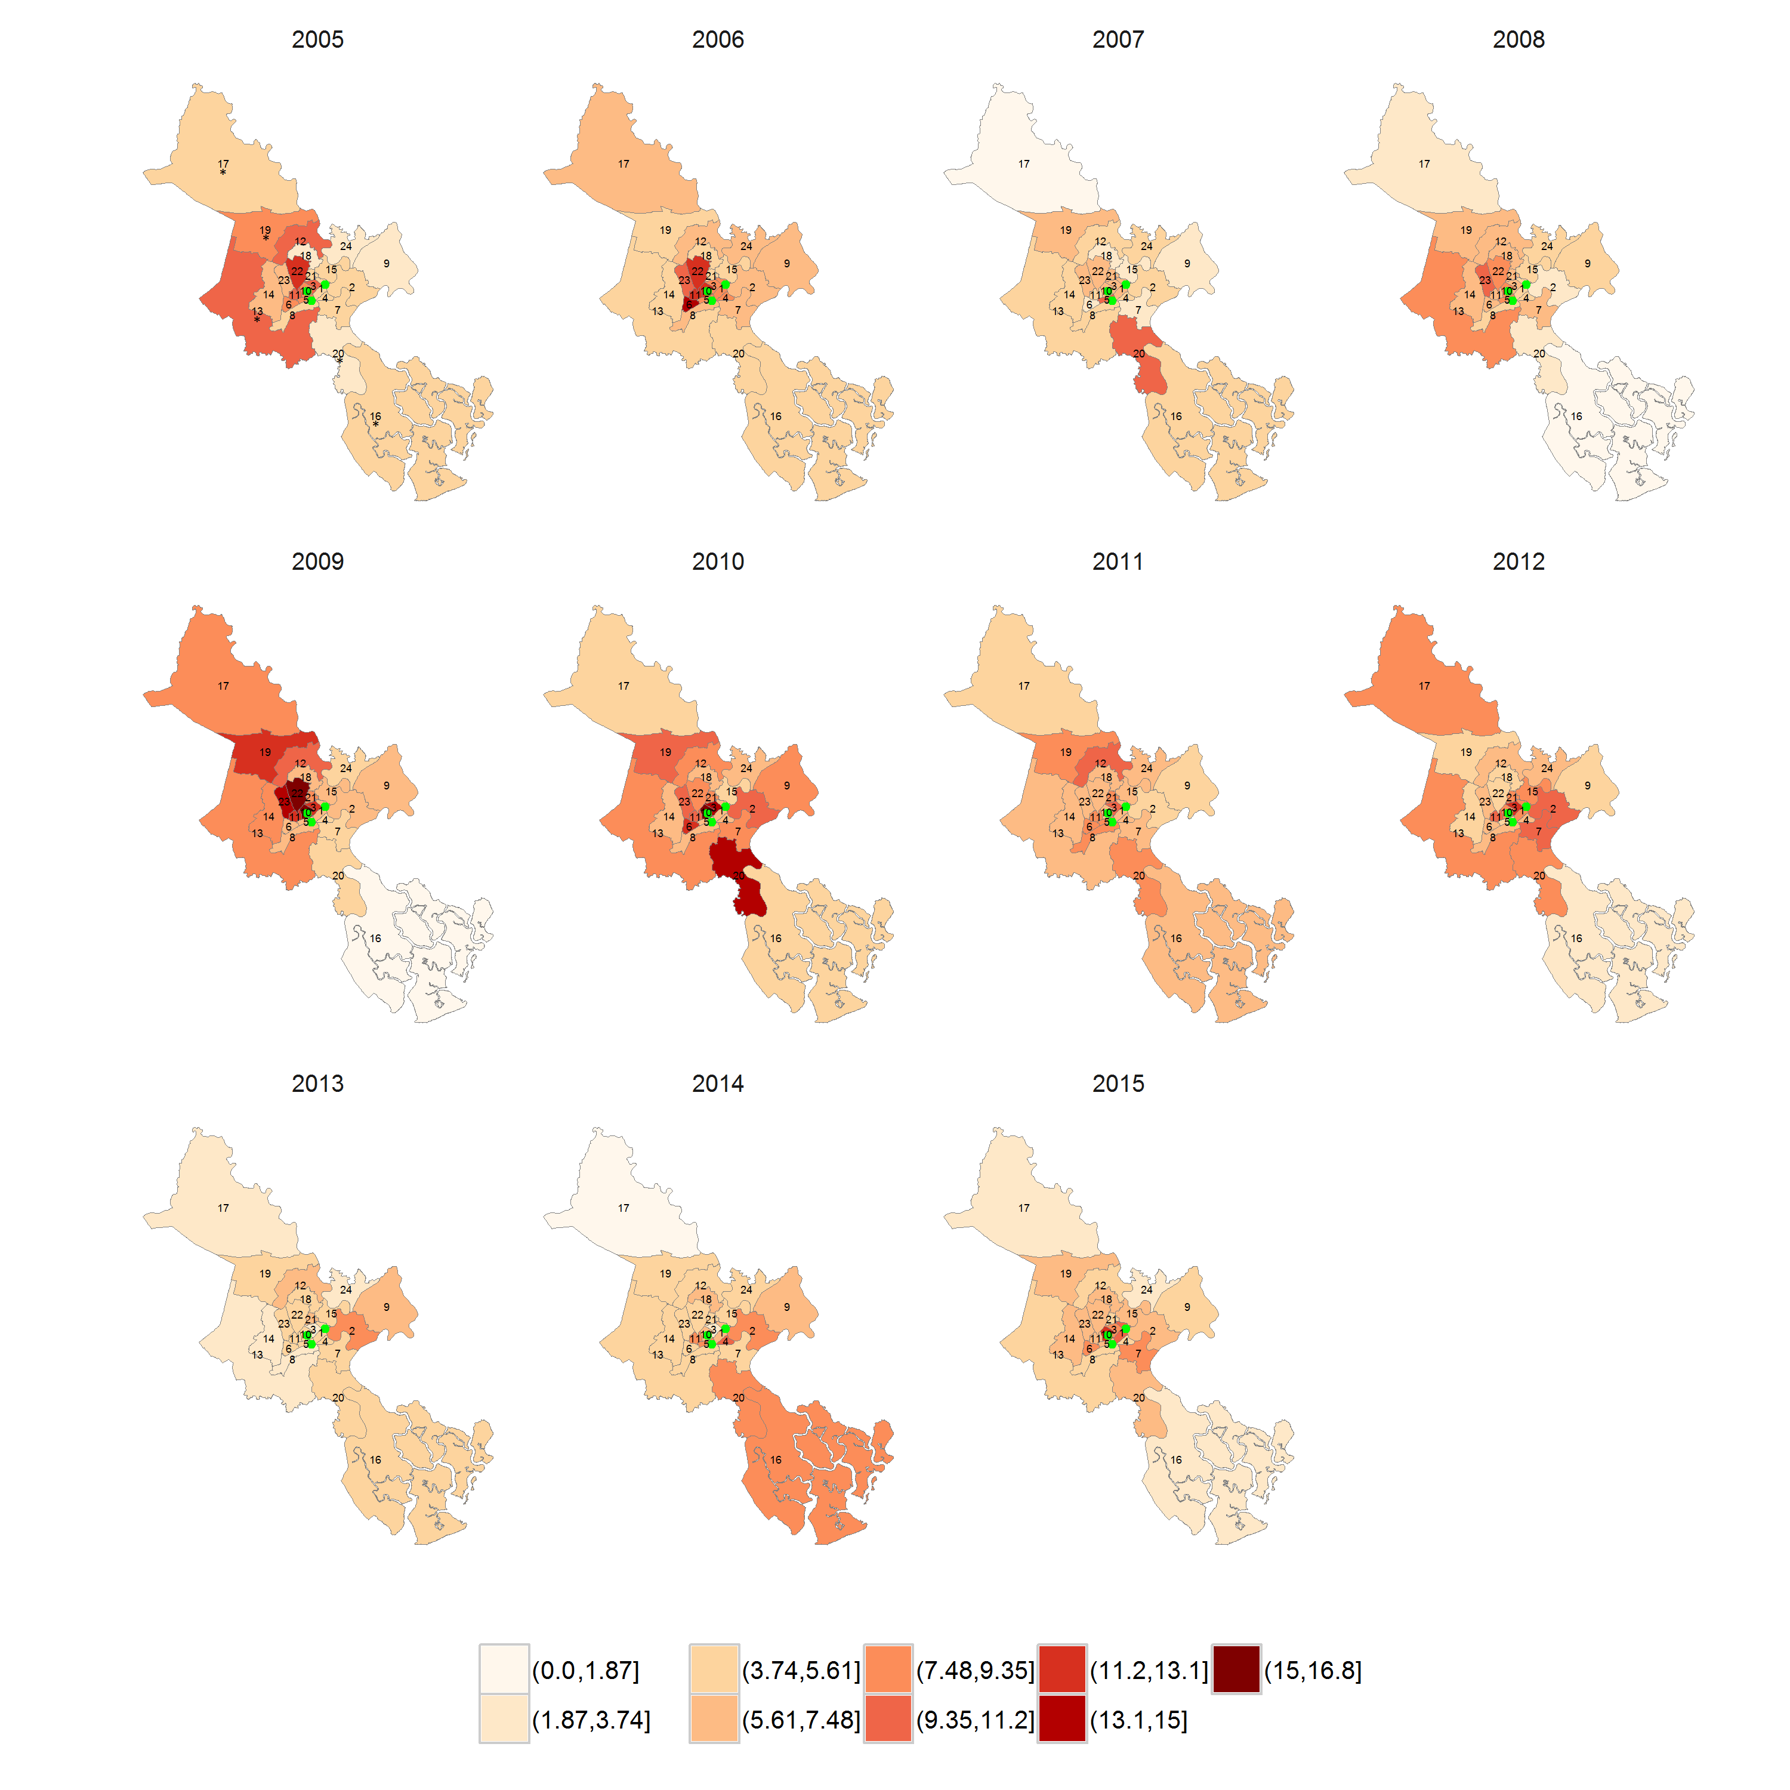

Supplementary Figure S2. Maps of presumed non-bacterial central nervous system (CNS) infection incidence at district level by year.
Green dots: locations of the three study hospitals. *Rural districts.
1-12: district 1-12; 13-24: district Binh Chanh, Binh Tan, Binh Thanh, Can Gio, Cu Chi, Go Vap, Hoc Mon, Nha Be, Phu Nhuan, Tan Binh, Tan Phu, Thu Duc respectively.
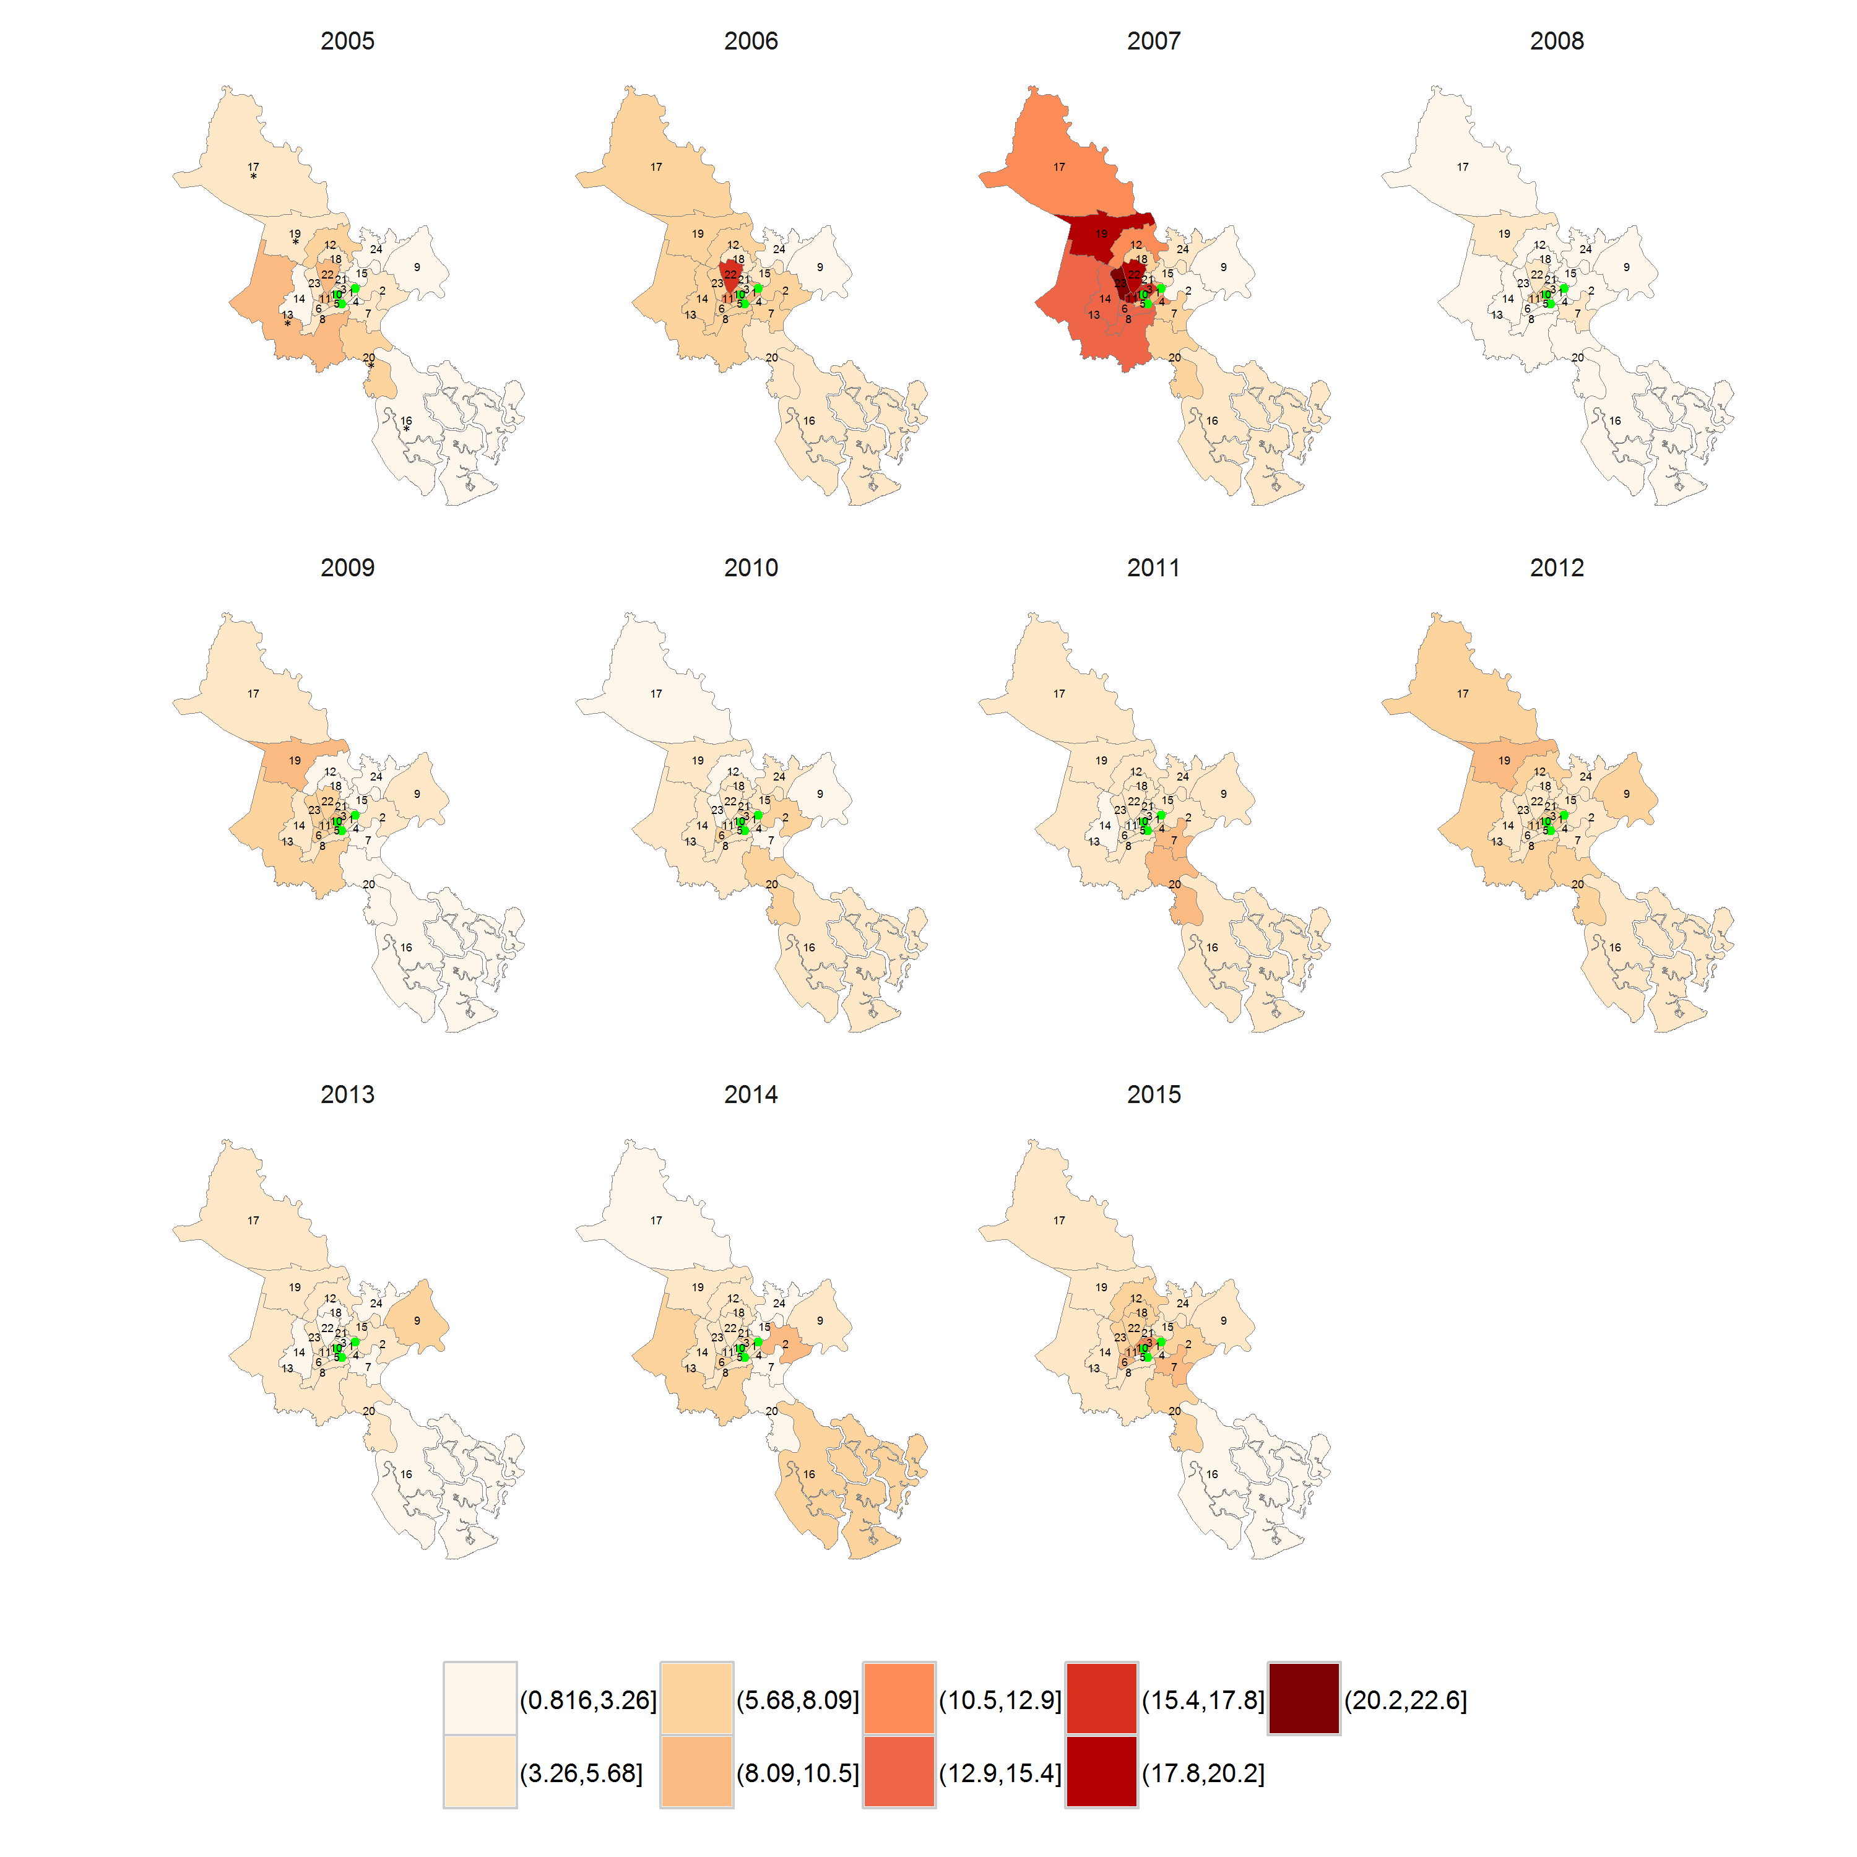
Supplementary Figure S3. Time series plots of monthly incidence of presumed bacterial central nervous system infection (BI) by district.
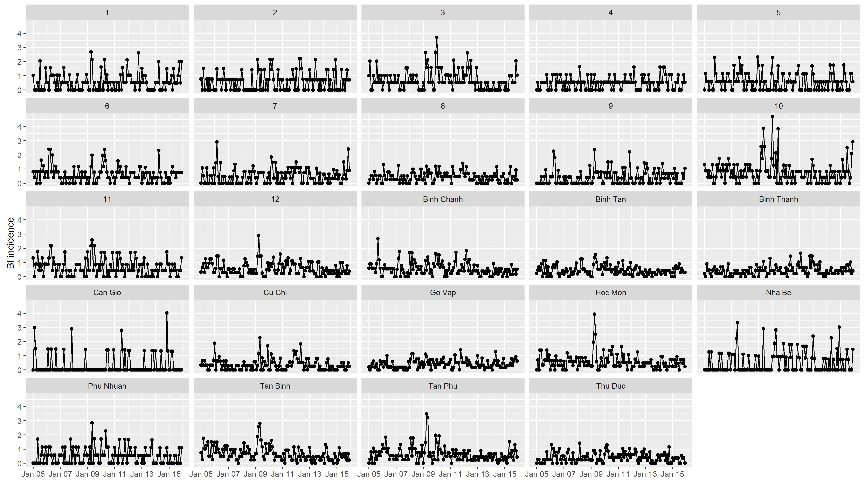

Supplementary Figure S4. Time series plots of monthly incidence of presumed non-bacterial central nervous system infection (non-BI) by district.
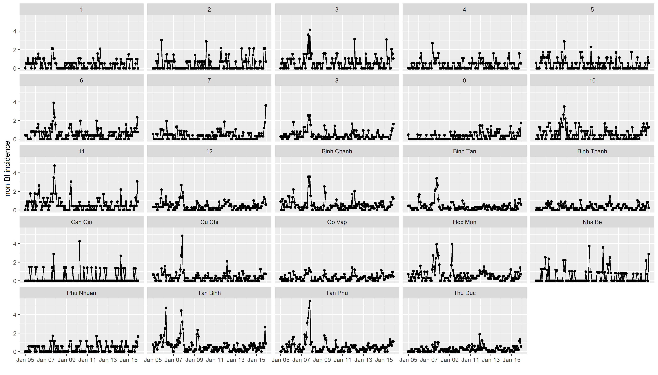

Supplementary Figure S5. Maps of district covariates and the relationship of district covariates with district incidence of presumed bacterial and viral central nervous system infection.
A: Population density (1000/km2); B: Number of pigs in herds > 2 months of age by district (average of 2008-2010); C: % area of district used as rice paddy (average of 2008-2010); D: District elevation (m).
Green dots: locations of the three study hospitals. Districts with white color had zero values.
1-12: district 1-12; 13-24: district Binh Chanh, Binh Tan, Binh Thanh, Can Gio, Cu Chi, Go Vap, Hoc Mon, Nha Be, Phu Nhuan, Tan Binh, Tan Phu, Thu Duc respectively. *Rural districts.
Table of univariate Poisson Generalized Linear Model (GLM) of presumed bacterial central nervous system infection (BI) and presumed non-BI central nervous system infection (non-BI) incidences vs. district covariates. RR: rate ratio; LL and UL: lower limit and upper limit respectively of 95% confidence interval.
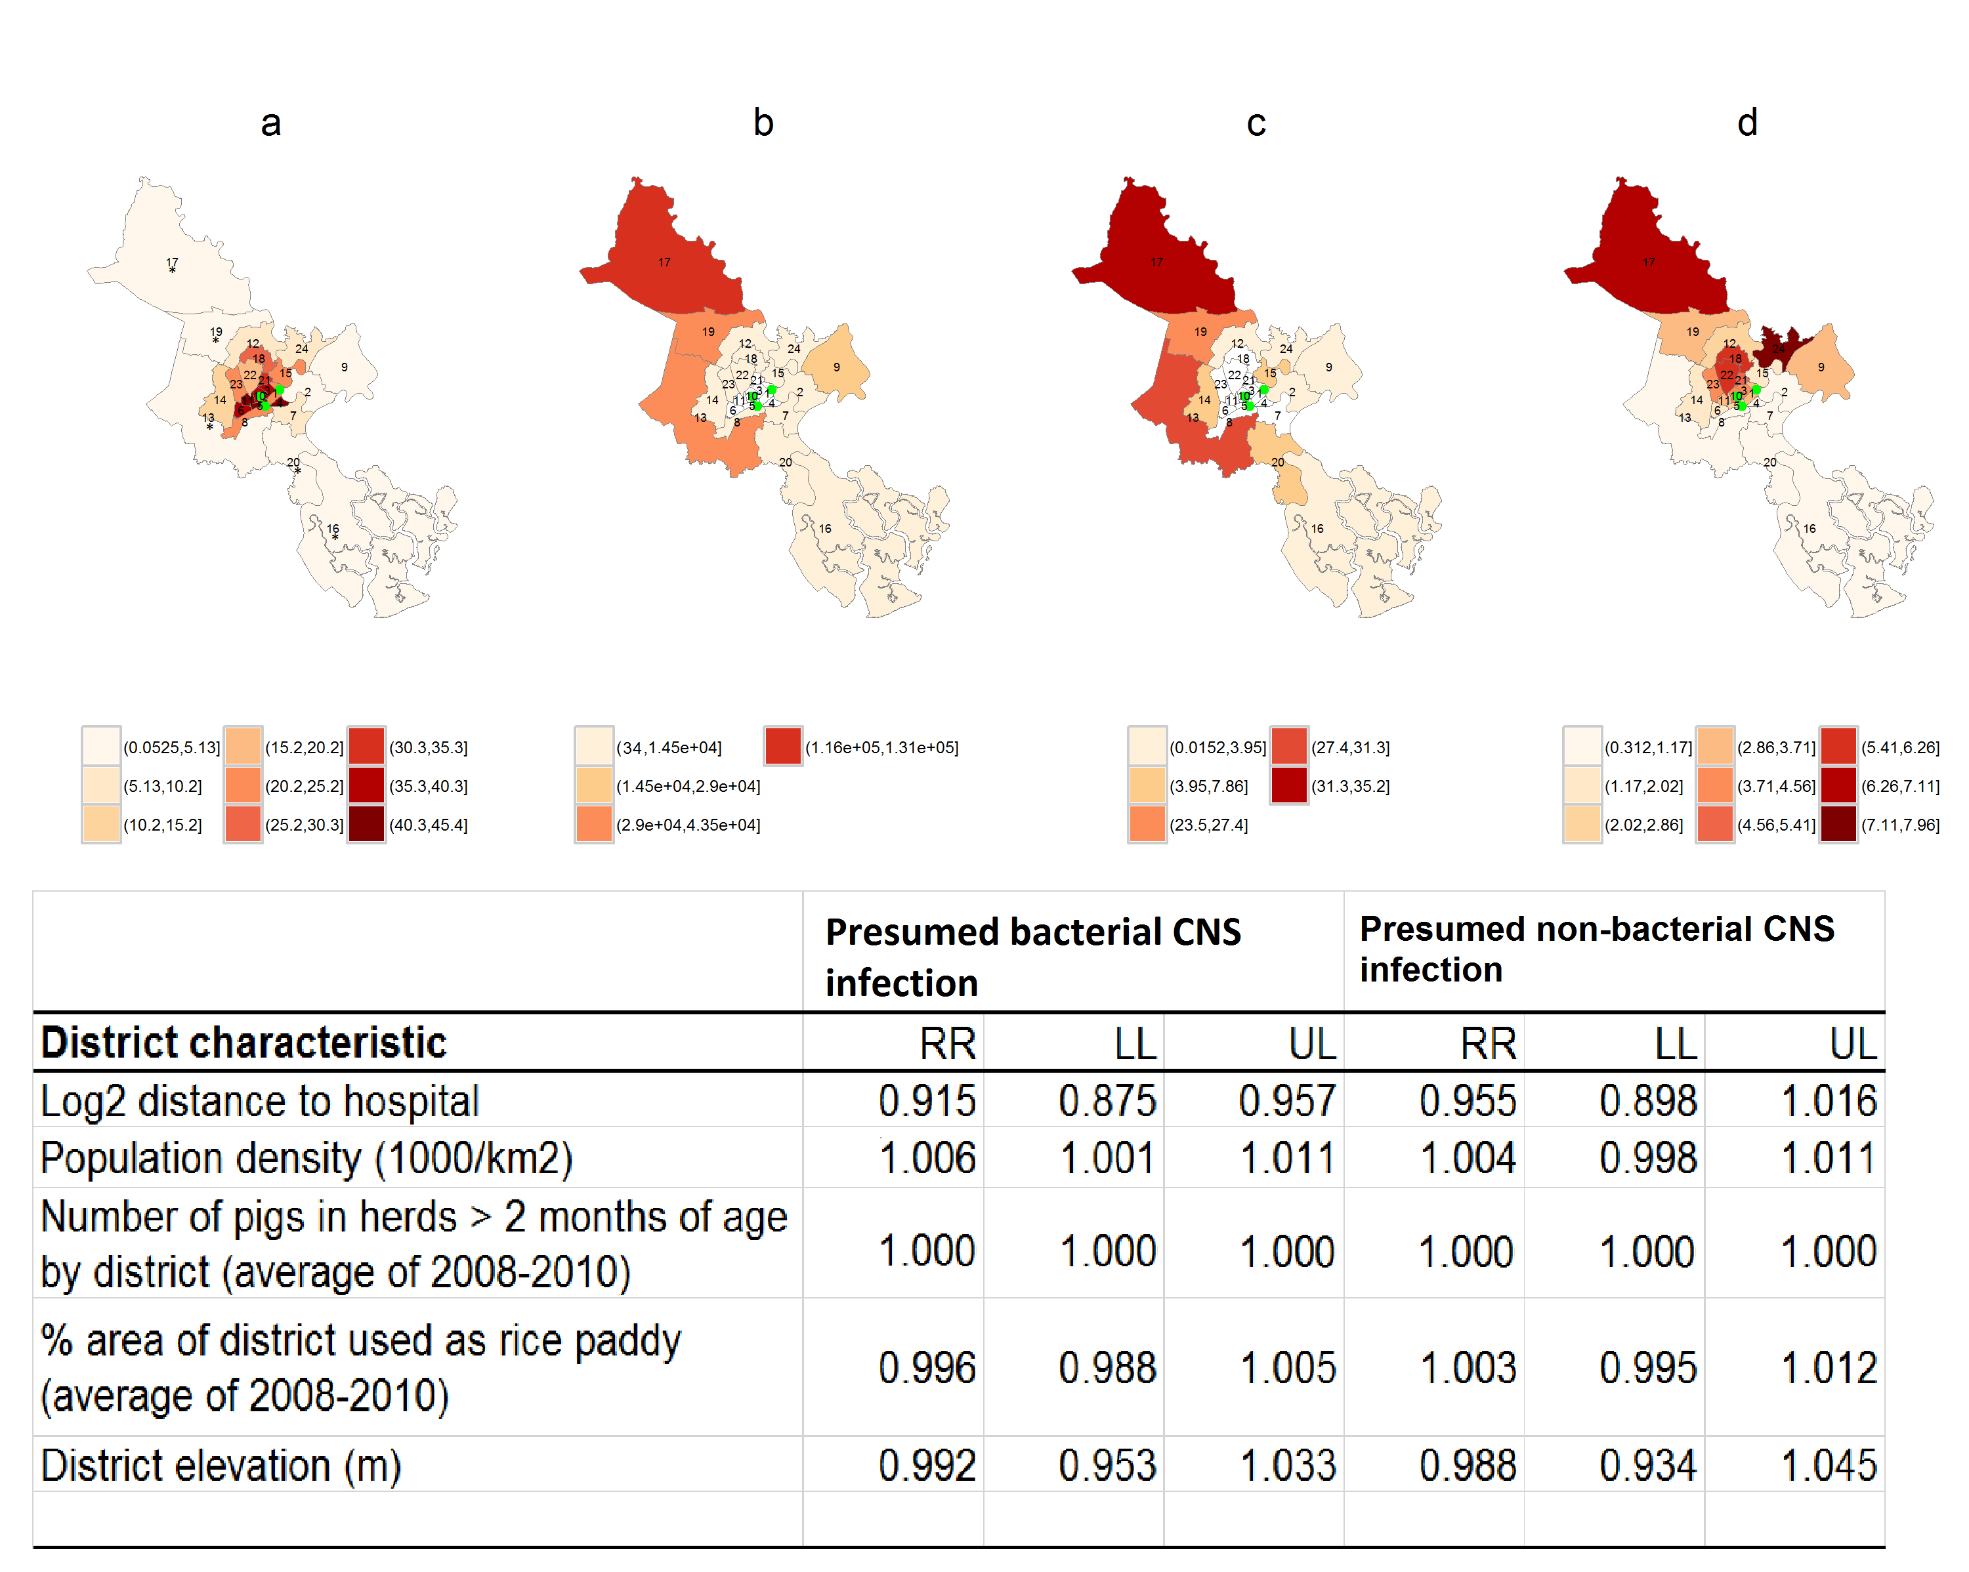

Supplementary Figure S6. Diagnostic plots for the full GAMM models of presumed bacterial and viral central nervous system infection.
Upper panel: presumed bacterial central nervous system infection (BI).
Lower panel: presumed non-bacterial central nervous system infection (non-BI ).
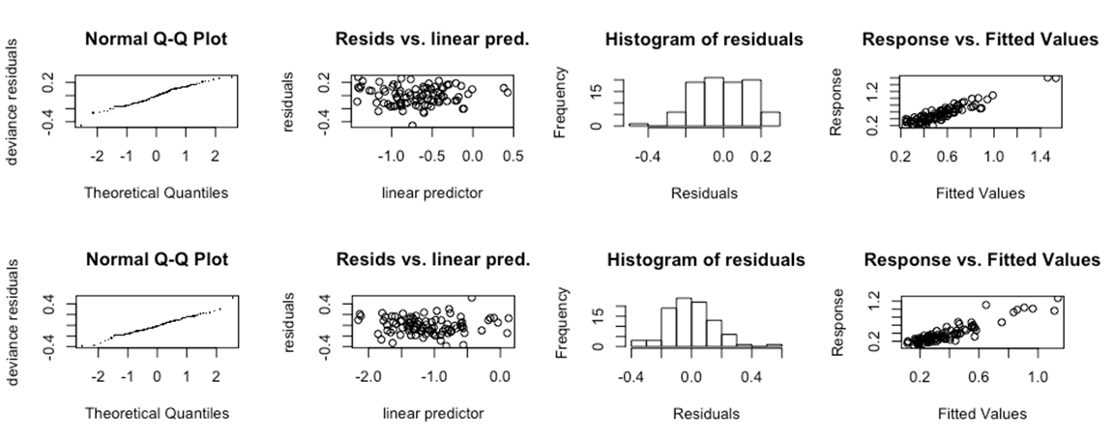

Supplementary Figure S7. Autocorrelation function (ACF) and partial autocorrelation function (PACF) of the residuals of the full GAMM models for presumed bacterial and non-bacterial central nervous system infection.
Upper panel: presumed bacterial CNS infection.
Lower panel: presumed non-bacterial CNS infection.
