Epidemiology and infection

Hepatitis C virus epidemiology among hemodialysis patients in the Middle East and North Africa: systematic syntheses, meta-analyses, and meta-regressions

Supplementary material

M. Harfouche¹, H. Chemaitelly¹, S. Mahmud¹ , K. Chaabna^{1,2}, S. P. Kouyoumjian¹, Z. Al Kanaani¹ and L. J.
Abu-Raddad^{1,2}

¹Infectious Disease Epidemiology Group, Weill Cornell Medicine-Qatar, Cornell University, Qatar Foundation - Education City, Doha, Qatar
²Department of Healthcare Policy & Research, Weill Cornell Medicine, Cornell University, New York, USA

Supplementary Table S1. Sensitivity analyses assessing the impact of our imputation method for the year of data collection variable.

A: with no imputation |  | Number of studies | Univariable analysis |  | Multivariable analysis
 |  |  | OR (95%CI) | p-value | AOR (95%CI) | p-value
Region | Fertile Crescentª | 51 | 1.0 | - | 1.0 | -
 | Egypt | 26 | 11.15 (6.49-19.16) | 0.000 | 8.29 (4.01-17.14) | 0.000
 | Gulf^{b} | 45 | 3.85 (2.43-6.10) | 0.000 | 2.37 (1.32-4.26) | 0.004
 | Horn of Africa^{c} | 6 | 2.48 (0.94-6.55) | 0.065 | 2.29 (0.90-5.83) | 0.081
 | Iran | 41 | 0.37 (0.23-0.59) | 0.000 | 0.42 (0.26-0.68) | 0.001
 | Maghreb^{d} | 29 | 2.30 (1.36-3.88) | 0.002 | 1.85 (1.00-3.40) | 0.046
 | Pakistan | 7 | 2.32 (0.93-5.74) | 0.068 | 2.97 (1.18-7.46) | 0.021
Year of data collection |  | 146 | 0.89 (0.86-0.92) | 0.000 | 0.93 (0.90-0.96) | 0.000

B: with imputed variables |  | Number of studies | Univariable analysis |  | Multivariable analysis
 |  |  | OR (95%CI) | p-value | AOR (95%CI) | p-value
Region | Fertile Crescentª | 51 | 1.0 | - | 1.0 | -
 | Egypt | 26 | 11.15 (6.49-19.16) | 0.000 | 7.43 (4.44-12.44) | 0.000
 | Gulf^{b} | 45 | 3.85 (2.43-6.10) | 0.000 | 1.77 (1.08-2.90) | 0.022
 | Horn of Africa^{c} | 6 | 2.48 (0.94-6.55) | 0.065 | 1.82 (0.74-4.46) | 0.189
 | Iran | 41 | 0.37 (0.23-0.59) | 0.000 | 0.38 (0.24-0.58) | 0.000
 | Maghreb^{d} | 29 | 2.30 (1.36-3.88) | 0.002 | 1.47 (0.89-2.43) | 0.130
 | Pakistan | 7 | 2.32 (0.93-5.74) | 0.068 | 2.47 (1.07-5.69) | 0.033
Year of data collection |  | 205 | 0.89 (0.87-0.91) | 0.000 | 0.92 (0.90-0.95) | 0.000

Other variables including “Income group” and “Sample size” were not displayed because they were not part of the multivariable regression analysis.

Supplementary Table S2. Studies reporting hepatitis C virus (HCV) antibody incidence among hemodialysis patients across the Middle East and North Africa.

First author, year of publication | Years of data collection | Population description | Sample size | HCV seroconversion risk (%) | Incidence rate (per 1,000 person-years)
Egypt (n=6)
El-Sherif, 2012 [1] | ˗ | HCV negative HD patients | 14 | 21.4 | ˗
Goher, 1998 [2] | ˗ | HD patients | 90 | 21.2 | ˗
Khodir, 2012 [3] | 2011 | HD patients | 1527 | 11.0 | ˗
Soliman, 2013 [4] | 2008 | HCV negative HD patients | 83 | 33.7 | ˗
Zahran, 2014 [5] | ˗ | HD patients | 259 | 0.0 | ˗
Zahran, 2014 [5] | ˗ | HD patients | 44 | 100 | ˗
Iraq (n=1)
Al-Rubaie, 2011 [6] | 2009 | HD patients | 57 | 40.3 | ˗
Iran (n=1)
Jabbari, 2008 [7] | 2005 | HD patients | 70 | 4.3 | ˗
Jordan (n=1)
Batieha, 2007 [8] | 2003 | HD patients | 1300 | 9.2 | ˗
Lebanon (n=6)
Abou Rached, 2016 [9] | 2010 | HD patients from Beirut | 559 | ˗ | 5.1
Abou Rached, 2016 [9] | 2010 | HD patients from Mount Lebanon | 1632 | ˗ | 2.1
Abou Rached, 2016 [9] | 2010 | HD patients from Beqaa | 394 | ˗ | 6.3
Abou Rached, 2016 [9] | 2010 | HD patients from South Lebanon | 339 | ˗ | 14.7
Abou Rached, 2016 [9] | 2010 | HD patients from North Lebanon | 757 | ˗ | 1.9
Abou Rached, 2016 [9] | 2010 | HD patients from Nabatieh | 88 | ˗ | 0.0
Libya (n=1)
Alashek, 2012 [10] | 2009 | ˗ | 1160 | 7.1 | ˗
Morocco (n=4)
Amar, 2005 [11] | ˗ | ˗ | 83 | 53.0 | ˗
Lioussfi, 2014 [12] | 2009 | HD patients | 66 | 59.1 | ˗
Lioussfi, 2014 [12] | 2009 | HD patients | 35 | 0.0 | ˗
Sekkat, 2008 [13] | 2003 | ˗ | 87 | 4.6 | ˗
Tunisia (n=1)
Ben Othman, 2004 [14] | 1998 | ˗ | 213 | 9.4 | ˗
Abbreviations: HCV = Hepatitis C virus; HD = Hemodialysis

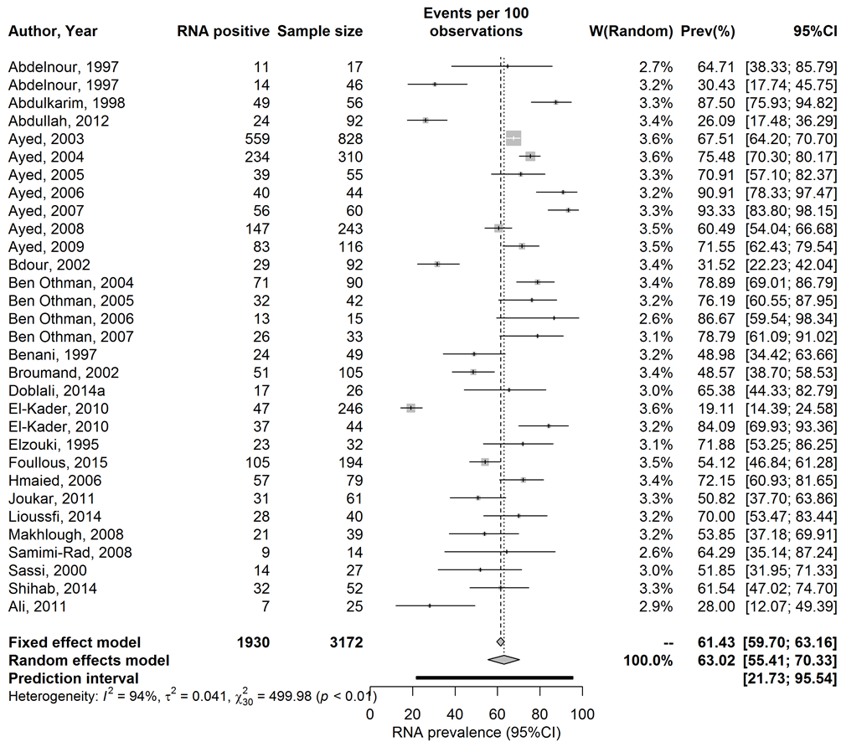
Supplementary Figure S1. Forest plot presenting the outcome for the pooled mean analysis of hepatitis C virus (HCV) viremic rate among hemodialysis patients across the Middle East and North Africa. HCV viremic rate is the prevalence of HCV chronic infection (HCV RNA positivity) among antibody positive persons.

Supplementary Figure S2. Distribution of hepatitis C virus (HCV) genotypes and subtypes among hemodialysis patients across the Middle East and North Africa. These results are pooled outcomes of 32 studies including 2093 HCV RNA positive participants. Categories are mutually exclusive. Subtype information was not available for all studies.

Supplementary Figure S3. Forest plots presenting the outcome by country for the pooled mean analysis of hepatitis C virus (HCV) prevalence among hemodialysis patients across the Middle East and North Africa.

- Algeria

- Egypt

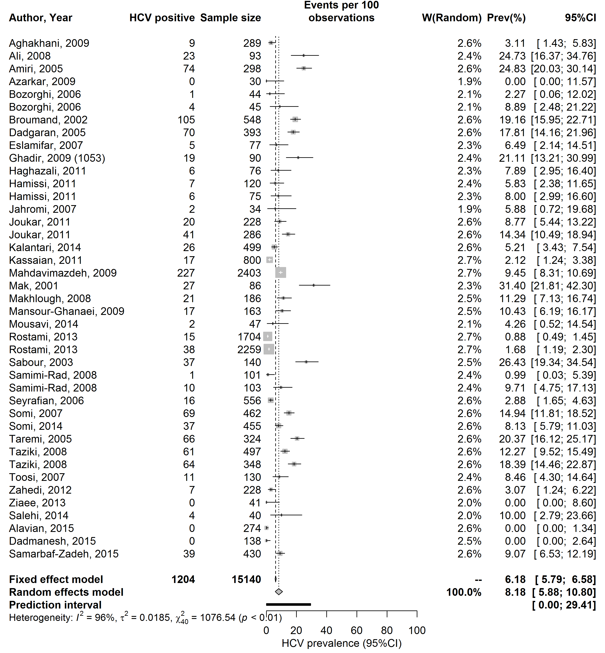
- Iran

- Iraq

- Jordan

- Kuwait

- Lebanon

- Libya

- Morocco

- Pakistan

- Palestine

- Saudi Arabia

- Sudan

- Syria

- Tunisia

- Yemen

References

(1) El‐Sherif A, et al. High false‐negative rate of anti‐HCV among Egyptian patients on regular hemodialysis. Hemodialysis International 2012; 16: 420-427.
(2) Goher SA, et al. Dialyzer reuse and hepatitis C virus in hemodialysis population in Egypt. Scientific Medical Journal 1998; 10: 43-54.
(3) Khodir SA, et al. Prevalence of HCV infections among hemodialysis patients in Al Gharbiyah Governorate, Egypt. Arab Journal of Nephrology and Transplantation 2012; 5: 145-147.
(4) Soliman AR, Momtaz Abd Elaziz M. Evaluation of an Isolation Program of Hepatitis C Virus Infected Hemodialysis Patients in Some Hemodialysis Centers in Egypt. International Scholarly Resrach Notices: Nephrology 2012; 2013.
(5) Zahran A. Prevalence of seroconversion of hepatitis C virus among hemodialysis patients in Menoufia Governorate, Egypt. Arab journal of nephrology and transplantation 2014; 7: 133-135.
(6) Al-Rubaie HM, Malik AS. Seroconversion Rate of Hepatitis C Virus Infection among Haemodialysis Patients in AL-Kadhimiya Teaching Hospital (Dialysis Unit). Iraqi Journal of Medical Sciences 2000: 343.
(7) Jabbari A, Besharat S, Khodabakshi B. Hepatitis C in hemodialysis centers of golestan province, northeast of Iran (2005). Hepatitis Monthly 2008; 8: 61-65.
(8) Batieha A, et al. Epidemiology and cost of haemodialysis in Jordan. Eastern Mediterranean Health Journal 2007; 13: 654-663.
(9) Rached AA, et al. Incidence and prevalence of hepatitis B and hepatitis C viruses in hemodialysis patients in Lebanon. World journal of nephrology 2016; 5: 101.
(10) Alashek WA, McIntyre CW, Taal MW. Hepatitis B and C infection in haemodialysis patients in Libya: prevalence, incidence and risk factors. BMC infectious diseases 2012; 12: 265.
(11) Amar Y, et al. Hepatitis C virus infection in a Moroccan hemodialysis unit: prevalence and risk factors. Gastroenterologie clinique et biologique 2004; 29: 746-747.
(12) Lioussfi Z, et al. Viral hepatitis C and B among dialysis patients at the Rabat University Hospital: prevalence and risk factors. Saudi journal of kidney diseases and transplantation : an official publication of the Saudi Center for Organ Transplantation, Saudi Arabia 2014; 25: 672-679.
(13) Sekkat S, et al. Prevalence of anti-HCV antibodies and seroconversion incidence in five haemodialysis units in Morocco. Nephrologie & therapeutique 2008; 4: 105-110.
(14) Ben Othman S, et al. High prevalence and incidence of hepatitis C virus infections among dialysis patients in the East-Centre of Tunisia. Pathologie Biologie 2004; 52: 323-327.

