Supporting Information for Identifying Transmission Routes of Streptococcus pneumoniae and Sources of Novel Acquisitions in High Transmission Communities
Benjamin M Althouse, Laura L Hammitt, Lindsay Grant, Bradley G Wagner, Raymond Reid, Francene Larzelere-Hinton, Robert Weatherholtz, Keith P Klugman, Gail L Rodgers, Katherine L O’Brien, Hao Hu.

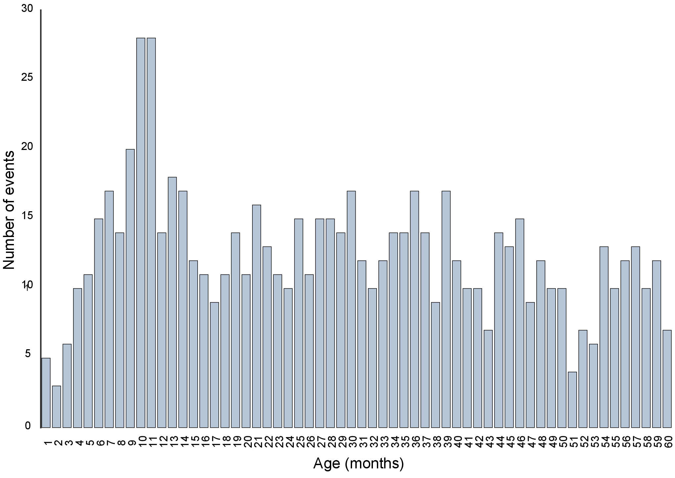
Figure S1: Numbers of events by age of child. Figure shows the number of events by month of child age. Note the peak in events at 9 to 10 months.

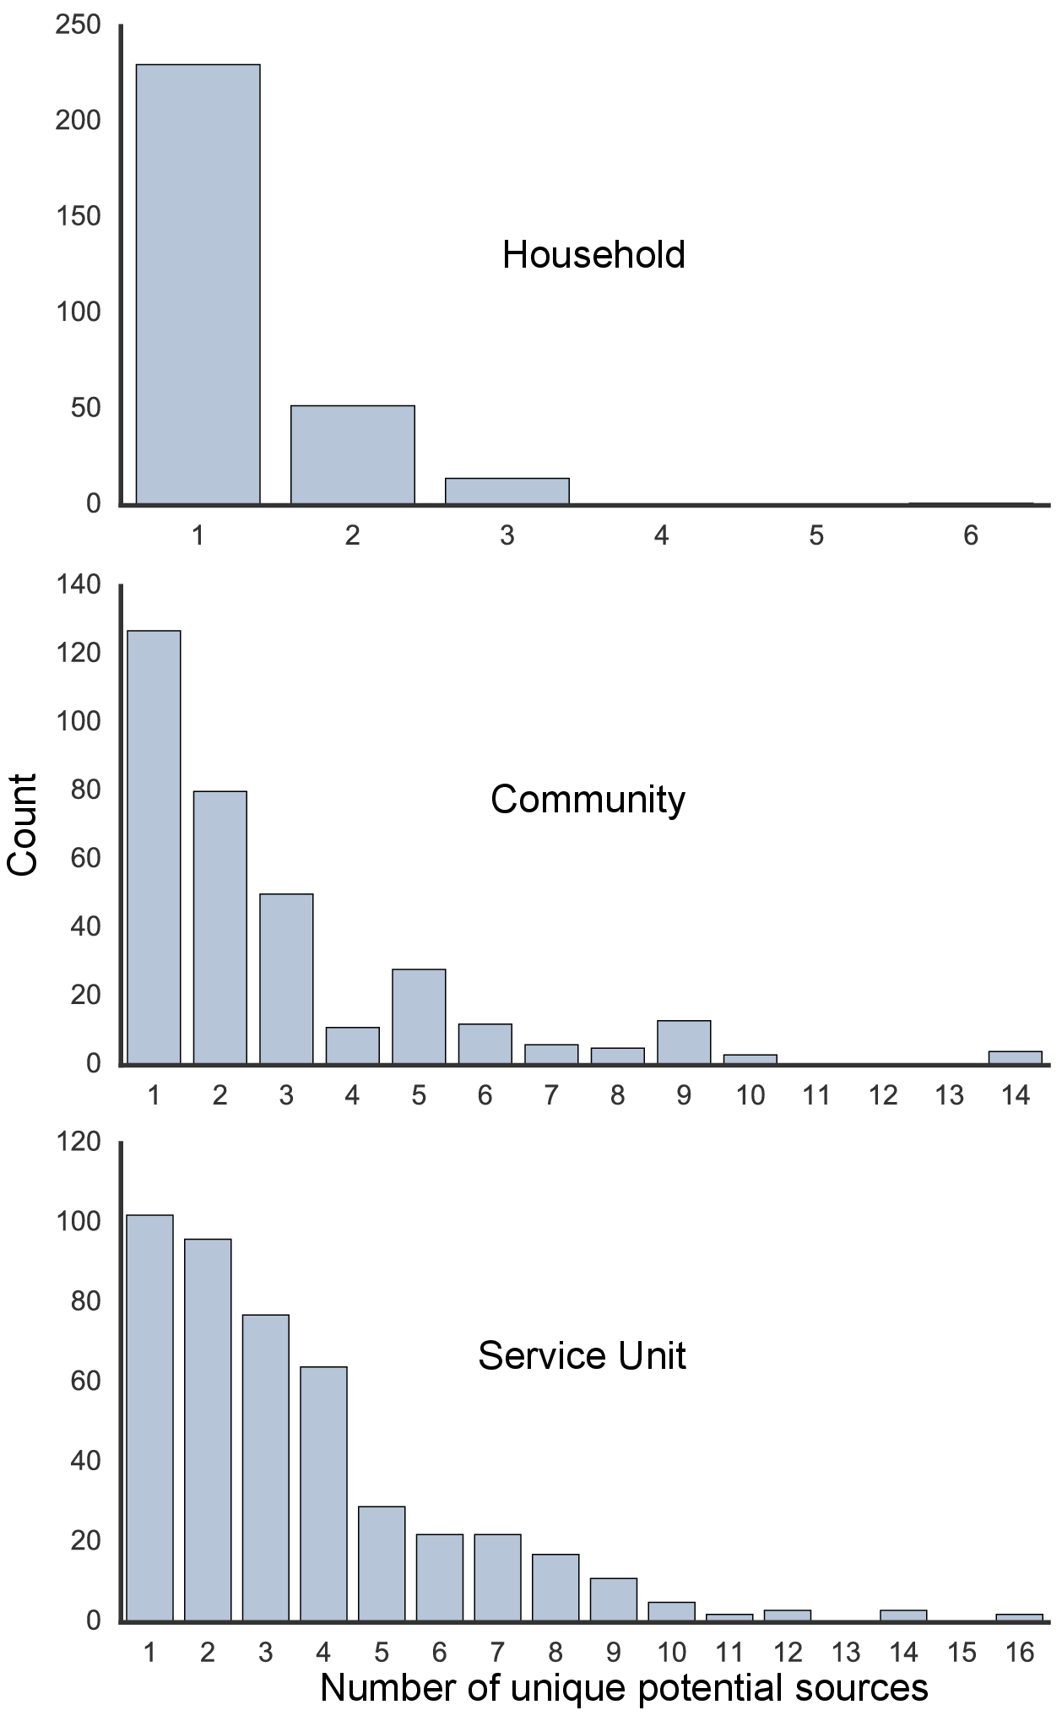
Figure S2: Counts of potential sources by geography. Figure shows the number of potential pneumococcus source for household, community, and site transmission.

