**SUPPLEMENTARY MATERIAL**

**APPENDIX 1 – DETAILS ON LABORATORY DATA**

Fingerstick whole blood was collected on dried blood spots (DBS). Six drops, corresponding to approximately 50 µL of capillary whole blood, were spotted onto filter paper card (Whatman 903™, GE Healthcare Europe GmbH, Freiburg, Germany), The filter paper was then placed onto a horizontal clean dry surface to air dry for at least 1 hour. Each dried DBS was then stored in an individual sealed plastic bag with a desiccant package at -80°C until analysis.

Screening for antibodies to HCV was performed by ELISA using the HCV 3.0 Ortho assay (Ortho-Clinical-Diagnostics, Raritan, NJ) with a sensitivity of 99.1% (95%CI 97.4 - 99.8) and a specificity of 98.2% (95%CI 94.9 - 99.6) [1]. The DBS were cut out with a punch to obtain a circle 6 mm in diameter, which was placed in 250 µl of 0.01 M sodium phosphate buffer containing 10% bovine serum albumin and 0.05% Tween 20, then incubated at room temperature for one hour in an ultrasonic cleaner. The eluted serum samples were directly used to fill the wells of ELISA microplates (200 µL per well). Subsequent steps were carried out in strict compliance with the manufacturer’s recommendations.

**APPENDIX 2 – DESCRIPTION AND CHOICE OF THE MIXTURE MODEL**

We investigated whether the distribution of the quantitative results of anti-HCV antibody tests depended on HIV serostatus, gender, blotting paper quality and year of each survey. Distribution was only associated with year of each survey. We then decided to apply a mixture model for the distributions in 2004 and 2011.

In a *c*-component mixture model, $f_{i}\left(x\right)$ is the distribution for the ith component and $p_{i}$ is the proportion of samples from the ith component. The overall density of results, $F$, is a mixture of the *c* component densities,

$$F\left(x\right)=\sum_{i}^{c}{p_{i}f_{i}(x)}.$$

Each $f_{i}\left(x\right)$ is a normal distribution with mean $μ_{i}$ and standard deviation $σ_{i}$.

The simplest model (also called a 2-component mixture model) includes two states, interpreted in this case as individuals with and individuals without HCV infection. Due to the poor fit of this simplest mixture model, we applied different mixture models with a varying number of components (from 2 to 6). The model with the lowest Bayesian information criterion was chosen and is represented in bold in Table A1.

**Table A1**. Model selection procedure for mixture models, France, 2004 and 2011.

|  |  |  |  |  |  |
| --- | --- | --- | --- | --- | --- |
| **Number of normal components in the mixture** | **2004** | |  | **2011** | |
| **AIC** | **BIC** |  | **AIC** | **BIC** |
| 2 | 1855.17 | 1878.67 |  | -223.83 | -199.53 |
| 3 | 990.33 | 1072.93 |  | -422.76 | -383.88 |
| 4 | 879.9 | 931.61 |  | -538.52 | -485.07 |
| 5 | 800.35 | 866.16 |  | -554.71 | **-486.67** |
| 6 | 753.35 | **833.26** |  | -557.14 | -474.52 |

* AIC: Akaike information criterion; BIC: Bayesian information criterion

For the year of each survey, the density functions of the components of the finite mixture models provided by the retained model are shown in Figure A1.

**Figure A1.** The density functions of the components of the finite mixture models, France, 2004 and 2011.

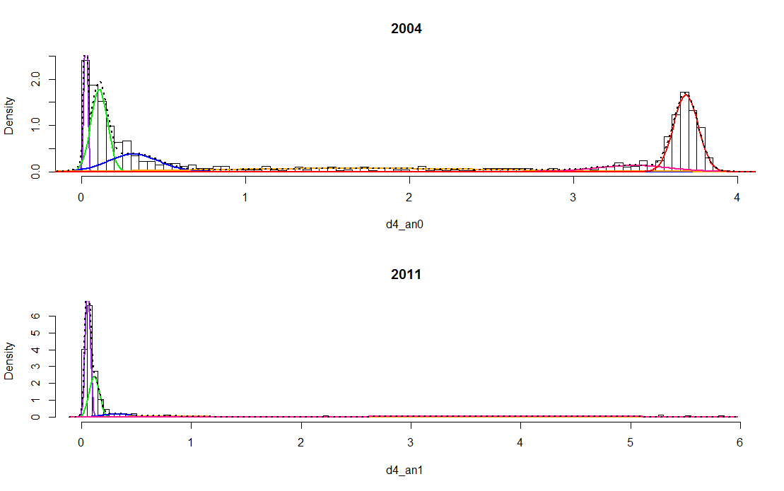

The best model was based on 6 and 5 component distributions (Table A2) in 2004 and 2011, respectively. Table A2 indicates the estimated parameters of the mixtures and our interpretation (anti-HCV status) for each component.

**Table A2**. Parameters of the final mixture models, France, 2004 and 2011.

|  |  |  |  |  |  |  |  |  |
| --- | --- | --- | --- | --- | --- | --- | --- | --- |
| **ith component (Reactivity level)** | **Anti-HCV status** | **2004** | | |  | **2011** | | |
| $$p_{i}$$ | $$μ_{i}$$ | $$σ_{i}$$ |  | $$p_{i}$$ | $$μ_{i}$$ | $$σ_{i}$$ |
| 1 | negative | 0.09 | 0.03 | 0.01 |  | 0.44 | 0.06 | 0.02 |
| 2 | negative | 0.23 | 0.11 | 0.05 |  | 0.28 | 0.12 | 0.05 |
| 3 | negative | 0.15 | 0.32 | 0.16 |  | 0.06 | 0.32 | 0.13 |
| 4 | positive | 0.15 | 1.68 | 0.85 |  | 0.05 | 0.79 | 0.29 |
| 5 | positive | 0.07 | 3.36 | 0.22 |  | 0.16 | 3.86 | 1.32 |
| 6 | positive | 0.31 | 3.68 | 0.07 |  | - | - | - |

A maximum of 6 components was chosen in order to avoid over-fitting the number of mixture model components.

HCV classification obtained from both approaches (threshold and direct methods using the above mixture model) for comparison is presented in Table A3.

**Table A3**. HCV classification according to the threshold and direct methods, France, 2004 and 2011. ANRS-Coquelicot surveys

|  |  |  |  |  |  |
| --- | --- | --- | --- | --- | --- |
| **Method** | **Threshold method** | | | | |
|  | **2004** | |  | **2011** | |
| **Direct method** | **0** | **1** |  | **0** | **1** |
| **0** | 373 | 13 |  | 747 | 8 |
| **1** | 0 | 427 |  | 9 | 478 |

0 represents the anti-HCV negative results; 1 represents the anti-HCV positive results

A discrepancy about 1.5% was observed between the two classification methods. The direct method allows us to identify anti-HCV antibodies without using the manufacturer’s cut-off value [2, 3].

**APPENDIX 3 – CONFIDENCE INTERVALS FOR PREVALENCE AND INCIDENCE**

We generated 2000 samples from the 2004-2011 combined dataset, using a 6-step process.

* Step 1: Individuals were expanded according to their sampling weights
* Step 2: A random number was assigned to each individual
* Step 3: Individuals were ordered according to the year of each survey and these random numbers
* Step 4: The first *n* individuals were selected to constitute a simple random sample. (*n = 813* for 2004 and *n=1242* for 2011).
* Step 5: Prevalence and incidence were estimated by assuming that $β$ followed a uniform distribution *U(0.01,0.03)*, $γ$ followed a binomial distribution *B(size =2063, probability =0.001)* divided by 2063, and $μ_{1}$ followed a Poisson distribution *P(7)* divided by 1000
* Step 6: 95% confidence intervals were obtained with the 2.5th and 97.5th percentiles of the distribution.

Confidence bands for prevalence are presented in Figures A2, A3, A4 and A5 according to each sub-population.



**Figure A2**. Curves represent the age-dependent HCV prevalence estimates from the logistic models among drug users in 2004 (gray) and 2011 (black) with their confidence intervals (dashed curves).



**Figure A3**. Curves represent the age-dependent HCV prevalence estimates from the logistic models in 2004 (gray) and 2011 (black) with their confidence intervals (dashed curves) among those not reporting injecting drug use (Left) and those reporting injecting drug use (Right).



**Figure A4**. Curves represent the age-dependent HCV prevalence estimates from the logistic models among those reporting active injecting drug use in 2004 (gray) and 2011 (black) with their confidence intervals (dashed curves).



**Figure A5**. Curves represent the age-dependent HCV prevalence estimates from the logistic models in 2004 (gray) and 2011 (black) with their confidence intervals (dashed curves) among HIV-negative drug users (Left) and HIV-positive drug users (Right).

References

(1) **Soulier A, et al.** Dried blood spots: a tool to ensure broad access to hepatitis C screening, diagnosis and treatment monitoring. *Journal of Infectious Diseases* 2015: jiv423.

(2) **Bollaerts K, et al.** Estimating the population prevalence and force of infection directly from antibody titres. *Statistical Modelling* 2012; **12**(5): 441-462.

(3) **Kafatos G, et al.** Is it appropriate to use fixed assay cut-offs for estimating seroprevalence? *Epidemiology and Infection* 2016; **144**(04): 887-895.