Supplementary Figure S1: 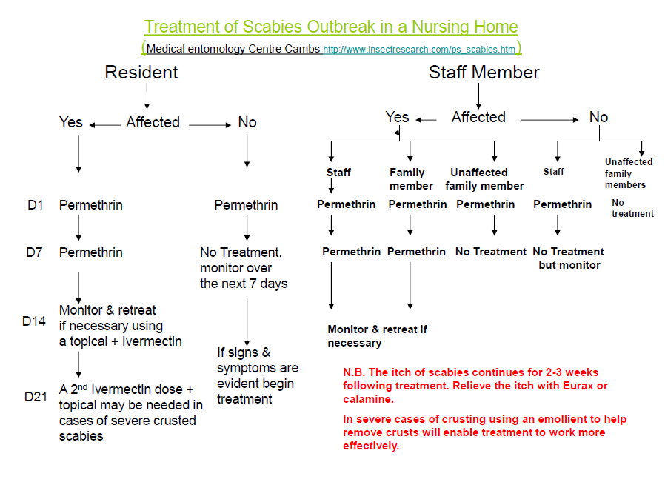
Treatment of scabies in care homes algorithm, replicated in the guidelines of 7 health protection teams. Algorithm produced by Medical Entomology Centre (Cambridge). Image taken from:
Health Protection Agency North West, The management of scabies infection in the community, 2010. (http://www.wirral.nhs.uk/document_uploads/Policies_Infection_Prevention_Control/HPAManagementofScabiesApril12.pdf) Accessed 26 January 2016.

