SUPPLEMENTARY MATERIAL

S1. Model structure and parameters
The model possesses 101 age cohorts (0, 1, 2, …, 100+). Children enter the population at 6 months of age. The flow diagram and equations of the mathematical model of transmission dynamics of varicella and zoster were depicted in Fig. S1. A more detailed description of the model can be found elsewhere [1,2]. The model parameters and Australian population characteristics are listed in Table S1. Parameters used for sensitivity analysis are summarised in Table S2.

Fig. S1. Flow chart of the transmission dynamics of varicella and zoster with and without vaccination. The mutually exclusive compartments represent the different VZV epidemiological states. Arrows represent the flow between these states. Model variables: S(a, t) = Susceptible, E(a, t) = Latent, I(a, t) = Infectious, R(a, t) = Temporary immune to zoster, Z_{S}(a, t) = Susceptible boosting, Z_{I}(a, t) = Zoster, Z_{R}(a, t) = Zoster immune, V_{TP1}(a, t) = V One-dose protected, V_{TP2}(a, t) = V Two-dose protected, V_{S1}(a, t) = V₁ Susceptible after one-dose vaccination, V_{S2}(a, t) = V₂ Susceptible after two-dose vaccination, V_{E}(a, t) = V Latent, V_{I}(a, t) = V Infectious, V_{R(}a, t) = V Immune, Z_{VS}(a, t) = V Susceptible boosting, Z_{VI}(a, t) = V Zoster, Z_{VR}(a, t) = V Zoster immune. Model parameters: F = Percent where vaccine fails completely, T = Percent temporarily protected after vaccination, λ = Force of infection, μ = Death rate, w =Waning rate from vaccine protected to vaccine susceptible, k = Proportion of temporarily protected individuals who become immune due to contact with varicella, b = Relative susceptibility of vaccinees compared to non-vaccinees, 1/σ = Duration of natural varicella latent period, 1/α = Duration of natural varicella infectious period, 1/σ_{v} = Duration of breakthrough varicella latent period, 1/α_{v} = Duration of breakthrough varicella infectious period, 1/δ = Duration of immunity to zoster after exposure to varicella, z = Percent of effective varicella contacts that boost against zoster, ρ = Rate of reactivation.
p₁(C₁+C₂η)
Susceptible
F₁
F₂
1-dose protected
2-dose protected
V₁ Susceptible
C₂T₂
w₂
C₂T₂
F₂
λ
Latent
σ
Infectious
Immune
α
Susceptible to boosting
δ
zλ
ρ
Zoster
α_{z}
Zoster
immune
b₂λ
V Latent
σ_{v}
Type equation here.
V Infectious
α_{v}
V Immune
δ_{v}
z_{v}λ
V Susceptible to boosting
ρ_{v}
V Zoster
α_{z}
V Zoster immune
Model equations:
dS(a,t)/dt = B−[λ+(C₁+ηC₂)(T₁+p₁)+ξC₂ (T₂+ p₂)+μ]S(a,t),
dE(a,t)/dt = λS(a,t)−(σ +μ)E(a,t),
dI(a,t)/dt = σE(a,t)−(α+μ)I(a,t),
dR(a,t)/dt = αI(a,t)+zλZ_{S}(a,t)−(δ+μ)R(a,t),
dV_{TP1}(a,t)/dt = (C₁T₁+ηC₂T₁)S(a,t)-(C₂T₂+w₁+k_{1λ}+μ)V_{TP1}(a,t),
dV_{TP2}(a,t)/dt = C₂T₂ ξ S(a,t) +C₂T₂(V_{TP1}(a,t) +V_{S1}(a,t))− (w₂+
k_{2λ} +μ)V_{TP2}(a,t),
dV_{S1}(a,t)/dt = p₁ (C₁+C₂η)S(a,t) + w₁V_{TP1}(a,t)- (C₂T₂+b_{1λ}
+μ)V_{S1}(a,t),
dV_{S2}(a,t)/dt = C₂p₂ ξS(a,t) + w₂V_{TP2}(a,t) - (b_{2λ}+μ)V_{S2}(a,t),
dV_{E}(a,t)/dt = b_{1λ}V_{S1}(a,t) +b_{2λ}V_{S2}(a,t) −(σ_{v} +μ)V_{E}(a,t),
dV_{I}(a,t)/dt = σ_{v}V_{E}(a,t)−(α_{v}+μ)V_{I}(a,t),
dV_{R}(a,t)/dt = k_{1λ}V_{TP1}(a,t)+ k_{2λ}V_{TP2}(a,t)+ α_{v}V_{I}(a,t)+
z_{vλ}Z_{VS}(a,t) −(δ_{v}+μ)V_{R}(a,t),
dZ_{S}(a,t)/dt = δR(a,t)−(ρ+zλ+μ)Z_{S}(a,t),
dZ_{I}(a,t)/dt = ρZ_{S}(a,t)−(α_{z}+μ)Z_{I}(a,t),
dZ_{R}(a,t)/dt = α_{z}Z_{I}(a,t)-μZ_{R}(a,t),
dZ_{VS}(a,t)/dt = δ_{v}V_{R}(a,t)−(ρ_{v}+z_{vλ}+μ)Z_{VS}(a,t),
dZ_{VI}(a,t)/dt = ρ_{v}Z_{VS}(a,t)−(α_{z}+μ)Z_{VI}(a,t),
dZ_{VR}(a,t)/dt = αzZ_{VI}(a,t)-μZ_{VR}(a,t),
where λ(a,t) = λ_{v}(a,t)+λ_{z}(t); α_{z}= α; η = (1-C₁);
ξ= C₁F₁; p₁=1-T₁-F₁; p₂=1-T₂-F₂.

w₁
k₂λ
k₁λ
V₂ Susceptible
p₂C₂ξ
Vaccinated
b₁λ
Unvaccinated
C₂T₂ξ
T₁(C₁+C₂η)

Table S1
Model parameters
Parameters | Symbol | Values |  | References
Varicella parameter
Duration of natural varicella latent period (days) | 1/σ | 14
Duration of natural varicella infectious period (days) | 1/α | 7
Duration of breakthrough varicella latent period (days) | 1/σ_{v} | 14
Duration of breakthrough varicella infectious period (days) | 1/α_{v} | 4.5
Pre-vaccination force of varicella infection by age group (per year) | λ_{v}(a,t)
0-4 |  | 0.140
5-9 |  | 0.182
10-14 |  | 0.086
15-19 |  | 0.053
20-24 |  | 0.047
25-29 |  | 0.057
30-34 |  | 0.077
35-39 |  | 0.086
40-44 |  | 0.051
45-49 |  | 0.030
50-54 |  | 0.034
55-59 |  | 0.025
60-64 |  | 0.030
65-69 |  | 0.032
70+ |  | 0.011
Force of varicella due to zoster  (per year) (λ_{z}) |  | 5.4×10⁻⁷×zoster prevalence
Zoster parameters
Average duration of immunity to zoster after varicella infection (years) | 1/δ | 24.4
Percent of effective varicella contacts that boost against zoster | z(a)
0-50 |  | 75%
60 |  | 71%
70 |  | 57%
80+ |  | 32%
Rate of reactivation by age  (per year) | ρ(a)
10 |  | 0.017
25 |  | 0.005
50 |  | 0.010
60 |  | 0.014
70 |  | 0.018
80 |  | 0.024
Vaccine efficacy parameters |  | 1-dose | 2-dose
Waning rate from vaccine protected to vaccine susceptible  (1/ year) | w | 0.027 | 0.010
Percent temporarily protected after vaccination | T | 0.840 | 0.970
Percent where vaccine fails completely | F | 0.040 | 0.020
Relative susceptibility of vaccinees compared to non-vaccinees | b | 0.900 | 0.340
Proportion of temporarily protected individuals who become immune due to contact with varicella | k | 0.182 | 0.000
Rate of varicella infectiousness of vaccinees compared to non-vaccinees | m | 0.500 | 0.500
Australian population characteristics |  | Estimate
Australian population (2010 ABS* estimate) | N | 22,342,400 |  | ABS* website
Birth rate (birth/year) (2010 ABS* estimate) | B | 297,900 |  | ABS* website
*ABS = Australian Bureau of Statistics, http://www.abs.gov.au/AUSSTATS/abs@.nsf/mf/3301.0

Table S2
Parameters for sensitivity analysis
Parameter | Symbol | Base value | Min | Max | Reference
Infant vaccine coverage (18 months) | C₁ | 0.830 | 0.700 | 0.950 | ACIR, [8,9]
Catch-up vaccination coverage (12years) | C_{R} | 0.350 | 0.300 | 0.400 | ATAGI 2007-9, [10]
Specificity of parental report for varicella infection | ψ | 0.5/0.78* | 0.3/0.63* | 0.7/0.9* | [11-13]
Sensitivity of parental report for varicella infection | φ | 0.65/0.73* | 0.5/0.58* | 0.9/0.95* | [11-13]
1-dose vaccine efficacy (VE) parameters
Immunity waning rate | w₁ | 0.027 | 0.021 | 0.085
Relative infectiousness of vaccinees | m₁ | 0.500 | 0.200 | 1.000
Vaccine efficacy | T₁ | 0.840 | 0.830 | 0.950
Relative susceptibility of vaccinees | b₁ | 0.900 | 0.500 | 1.000
Rate of vaccine protected individuals getting immune | k₁ | 0.182 | 0.000 | 1.000
Percent where vaccine fails completely | F₁ | 0.040 | 0.010 | 0.060 | [1,2,14]
2-dose VE parameters
Immunity waning rate | w₂ | 0.010 | 0.000 | 0.085
Vaccine efficacy | T₂ | 0.970 | 0.830 | 1.000
Relative susceptibility of vaccinees | b₂ | 0.340 | 0.085 | 1.000
Rate of vaccine protected individuals getting immune | k₂ | 0.000 | 0.000 | 1.000
Percent where vaccine fails completely | F₂ | 0.020 | 0.000 | 0.040 | [1,2,7,14]
*before 2015/after 2020, the value is linearly increasing between 2015 and 2020.

S2. Vaccine efficacy over time
In Fig. S2, we show the assumed proportion immune to breakthrough infection after 1 or 2 doses by time since last dose. At 10 years post vaccination, ~65% of 1-dose and 88% of 2-dose recipients are assumed protected against breakthrough infection in base-case.

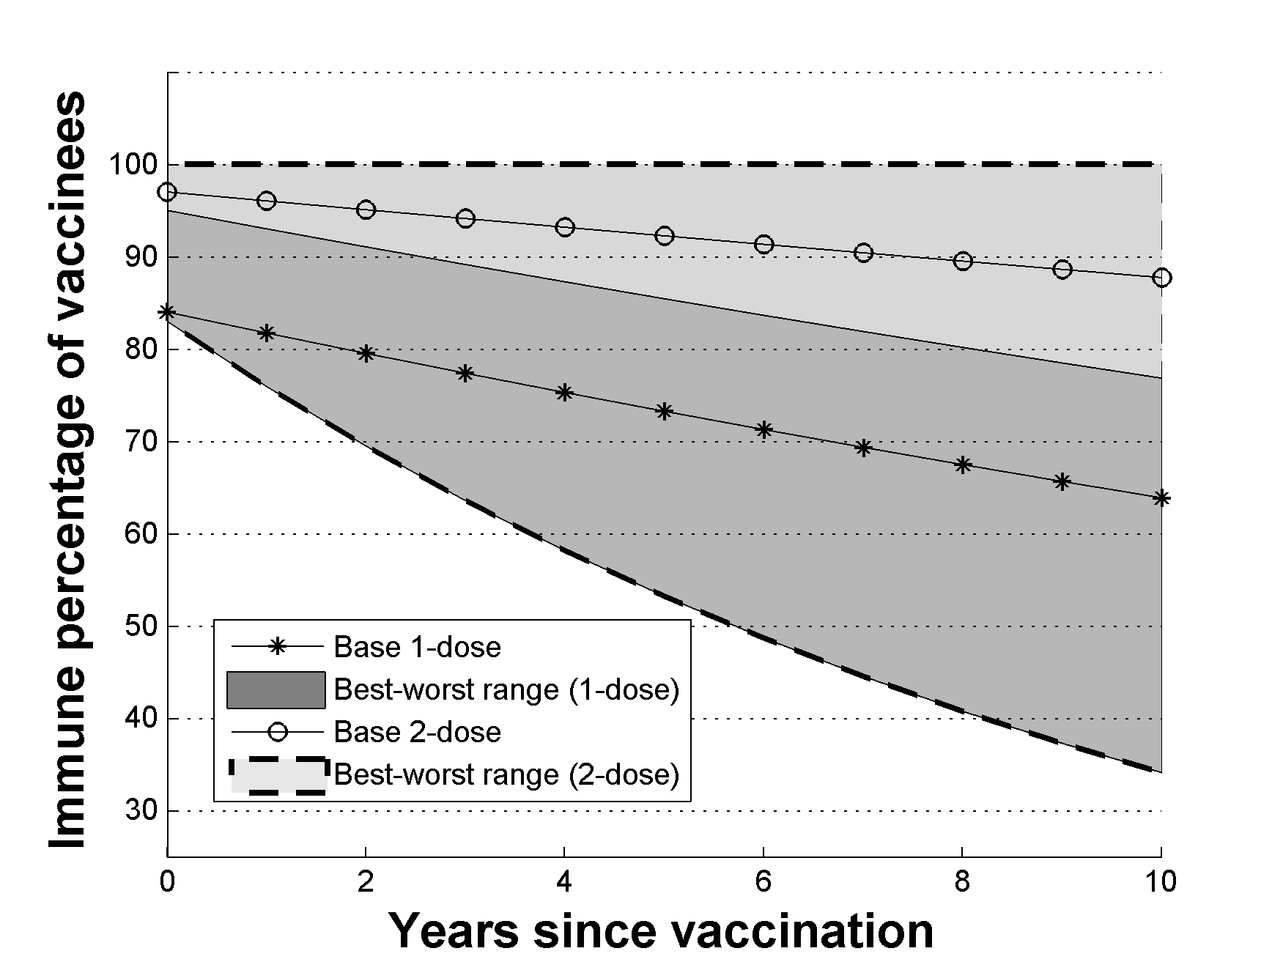
Fig. S2. Proportion of vaccinees immune by time since last infection for one-dose (circle-solid line for base-case, dashed lines for best/worst case) and two-dose recipients (star-solid line for base-case, solid lines for best/worst case).

S3. Vaccine coverage of susceptibles via catch-up
To determine the proportion (C_{s}(a,t)) of susceptible individuals who received catch-up vaccination, we assumed that parental recall of infection and immunisation could be summarised through literature-derived sensitivity (φ) and specificity (ψ) estimates, with coverage of susceptibles determined by the following formula:
C_{s}(a,t) = C(a,t) / [(1- φ)P_{i}(a,t) + ψP_{s}(a,t)],
where P_{i}(a,t) = the proportion immune (natural or vaccinated) of age a at time t; P_{s}(a,t) = the proportion susceptible of age a at time t and C(a,t) is the coverage of that age-cohort. For recall of infection, we assumed that φ = 0.65 and ψ =0.5, while for recall of vaccination status we assumed φ = 0.73 and ψ =0.78 based on US surveys [13]. From 2015 on there will be a high level of vaccine coverage within the cohort being offered catch-up vaccination. Recall of vaccination is much higher than recall of infection [11-13]. We assume a constant cohort coverage of 35% (based on school-program data from 2007-9 in Australia [10]) but assume this will decrease once vaccination occurs, falling to 19% after 2020 under base-case coverage assumptions and 15% under projected coverage assumptions. Coverage curves for these two situations are shown in Fig. S3. We also show the projected proportion of the catch-up vaccination that is provided to individuals who have already experienced natural infection or been vaccinated (wastage) in Fig. S4.

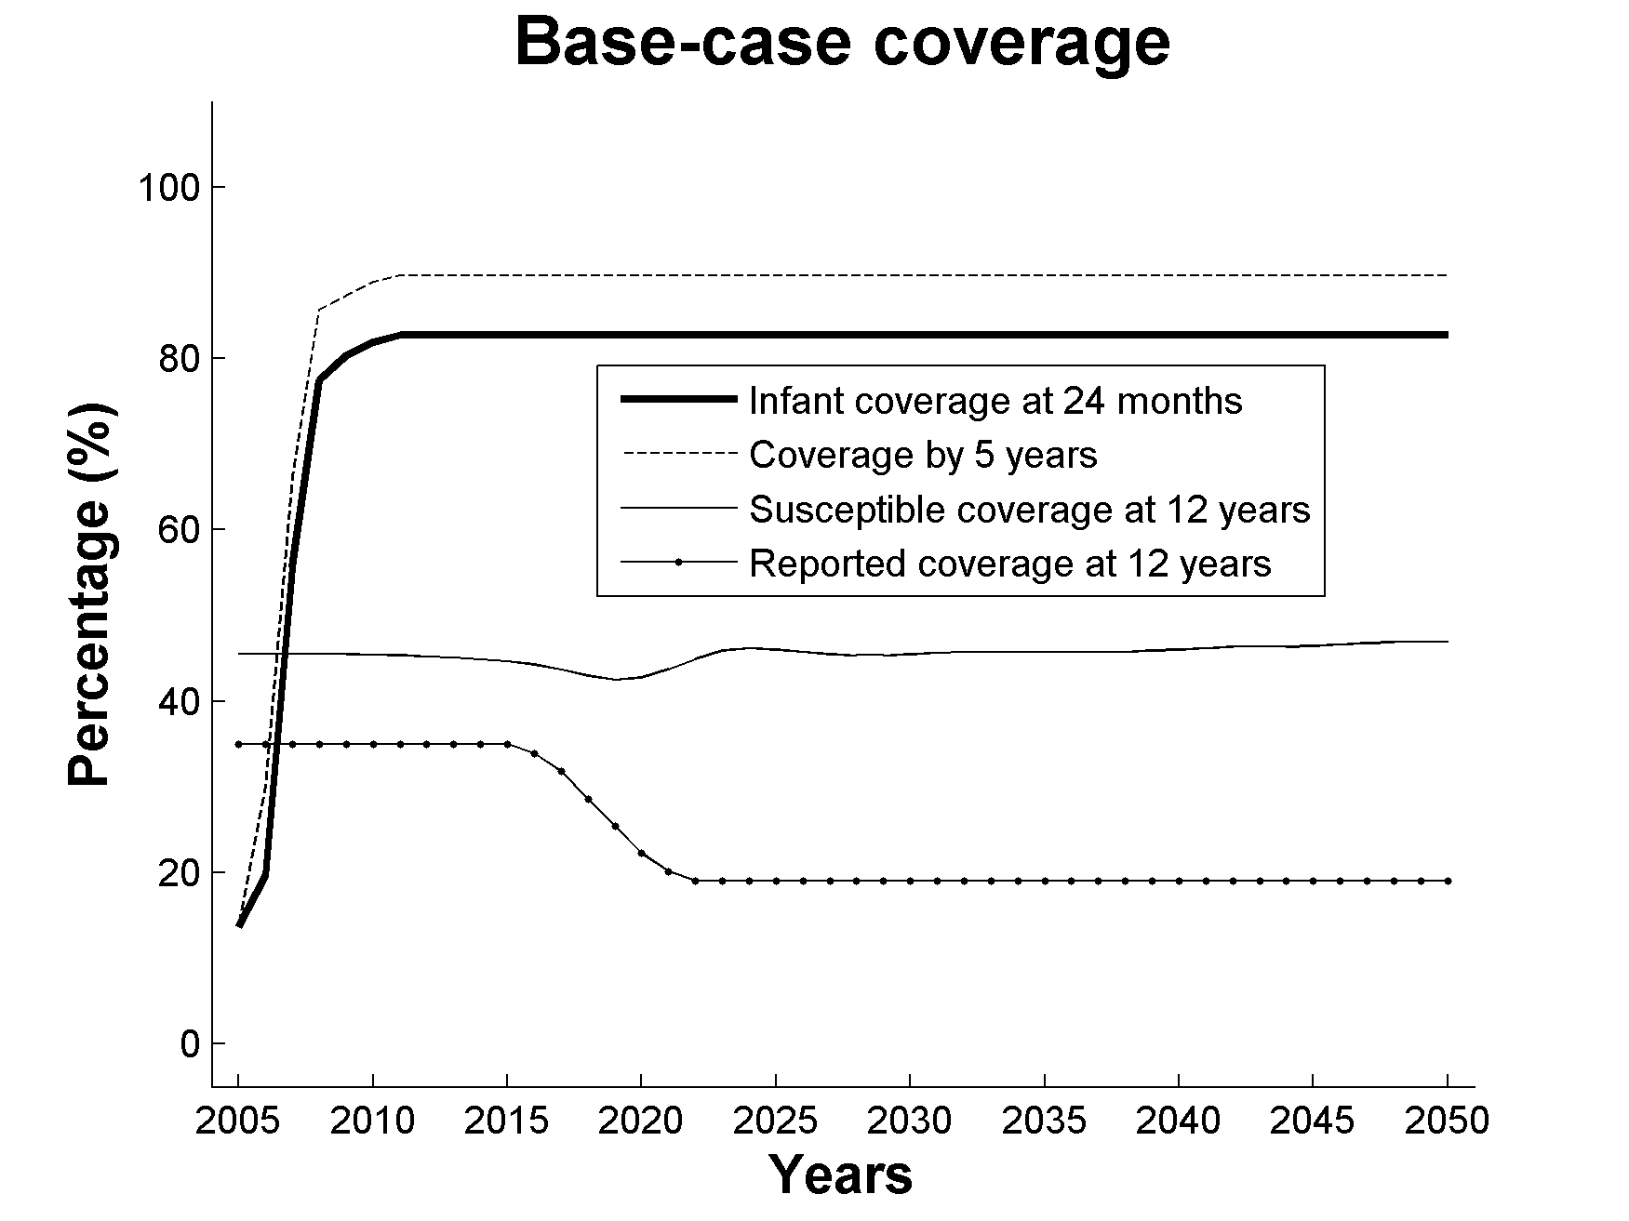  (a)  (b) | 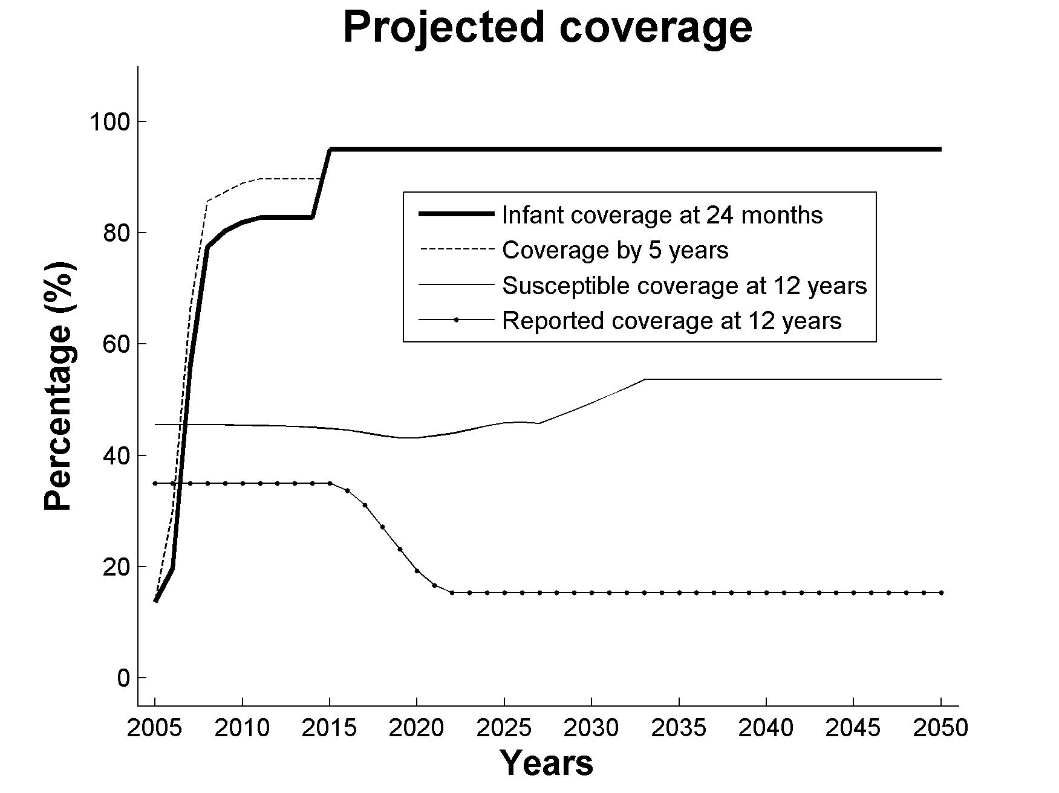
Fig. S3. Base-case coverage (a) and projected coverage (b) of varicella vaccination in Australia from 2005 to 2050.
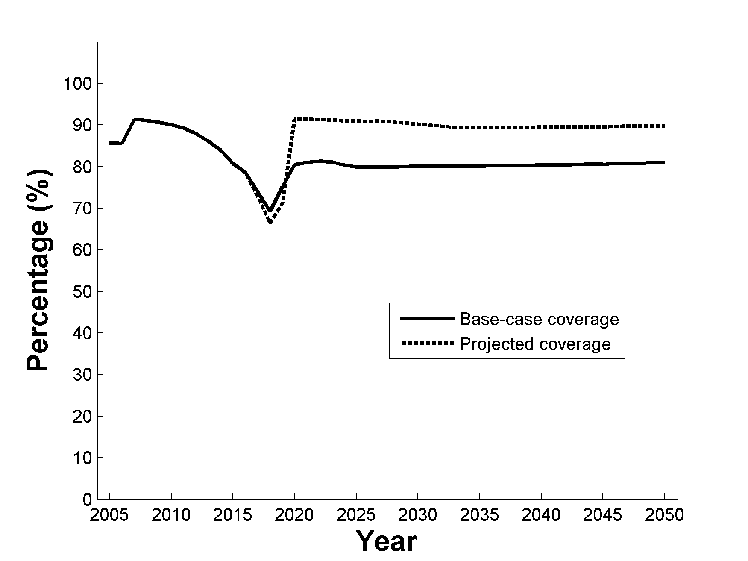
Fig. S4. Proportion of school-based catch-up doses provided to individuals with existing natural or vaccine-induced protection (wastage) under base-case and projected coverage for strategy 2

S4. Model upgrades
Our VZV model used social contact and mixing patterns from the European Commission project, POLYMOD . We used the UK portion of the survey to determine contact rates by age-group with both physical and general contacts included as separate terms. This leads to the following representation for the infectious contact matrix:
M = q₁M₁+q₂M₂,
with the matrices M₁ and M₂ representing contributions from physical and general contacts respectively and the co-efficients q₁ and q₂ the respective probabilities of infection per contact. These probabilities were estimated by fitting to age-specific pre-vaccination seroprevalence data from Australia based on the national serosurvey in 1997-99 . The two matrices are highly correlated and the estimation procedure placed almost all of the weight on physical contacts, with q₁=0.0945 as opposed to q₂ = 0.0001.
Prior to fitting and incorporation into the deterministic model we calculated the symmetrised and weighted contact rates c_{ij} in time units of years, with these elements given by
c_{ij} = 365 (m_{ij} / w_{j} + m_{ji} / w_{i}) / 2,
where w_{i} = Australian population size in age class i, obtained from Australian population data (ABS 2010) and m_{ij} are the matrix elements of M defined above.

S5. Estimates of hospitalisation rates of varicella and zoster in Australia
We used pre-vaccination data (1997/98 and 1998/99) to estimate the proportion of cases who were hospitalised (Fig. S5) and the LOS (length of stay in hospital) days (Fig. S6) for both varicella and zoster. The raw estimates are given by the black dots in these figures, while the solid curves represent the parametric fits used to represent these data in the model.
(a)
(b)
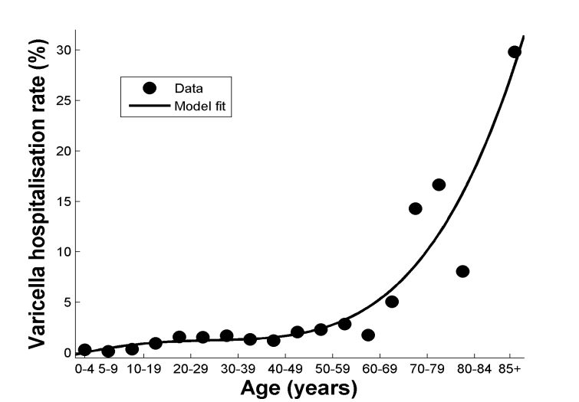 | 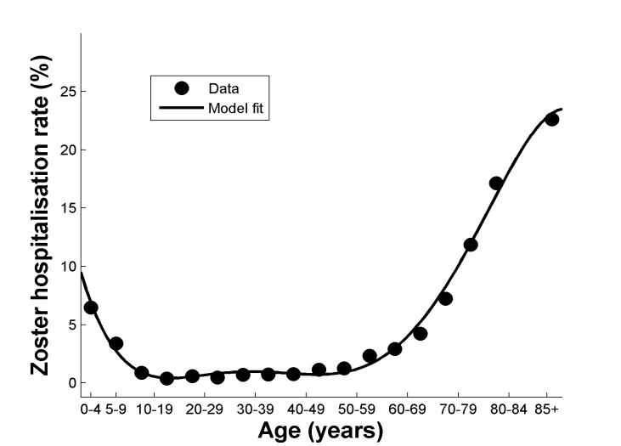
Fig. S5. Estimated age-specific varicella (a) and zoster (b) hospitalisation rates (%). Varicella hospitalisation rate (%) = (the number of varicella hospitalised cases / the number of modelled varicella infections) × 100. Zoster hospitalisation rate (%) = (the number of zoster hospitalised cases / the number of modelled zoster cases) × 100.
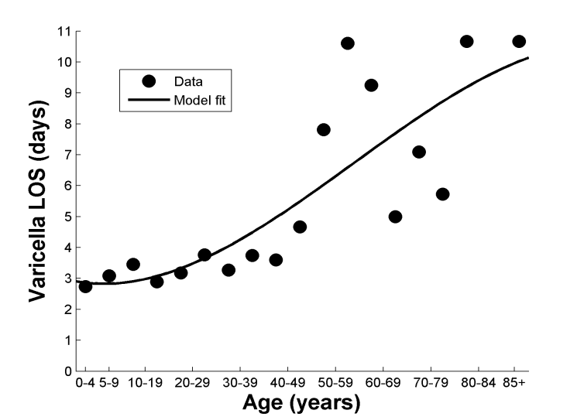  (a) | 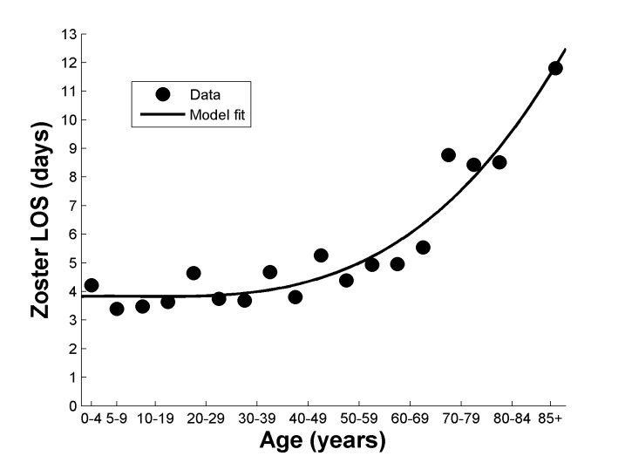  (b)
Fig. S6. Estimated age-specific varicella (a) and zoster (b) length of stay (LOS) (days) in hospital.

S6. Best-worse case analysis
In order to investigate multivariate uncertainty in one dose vaccine efficacy(VE), we chose worst and best case scenarios by setting each of the 5 key VE parameters to the most pessimistic or optimistic values simultaneously. For the worst case scenario, we set the waning rate (w₁) = 8.5% per year, the proportion initially protected (T₁) = 83%, the relative susceptibility of vaccines (b₁) = 100%, the proportion of vaccine-protected individuals that could be boosted to full immunity (k₁) = 0% and the proportion experiencing primary failure (F₁)= 6%. The corresponding figures in the best-case scenario were w₁ = 2.1% per year, T₁ = 95%, b₁ = 50%, k₁ = 100% and F₁ = 1%. The outcomes from these parameter scenarios are summarised in terms of differences in in-patient days between scenarios, with the worst-case results shown in Fig. S7 and the best-case results in Fig. S8.
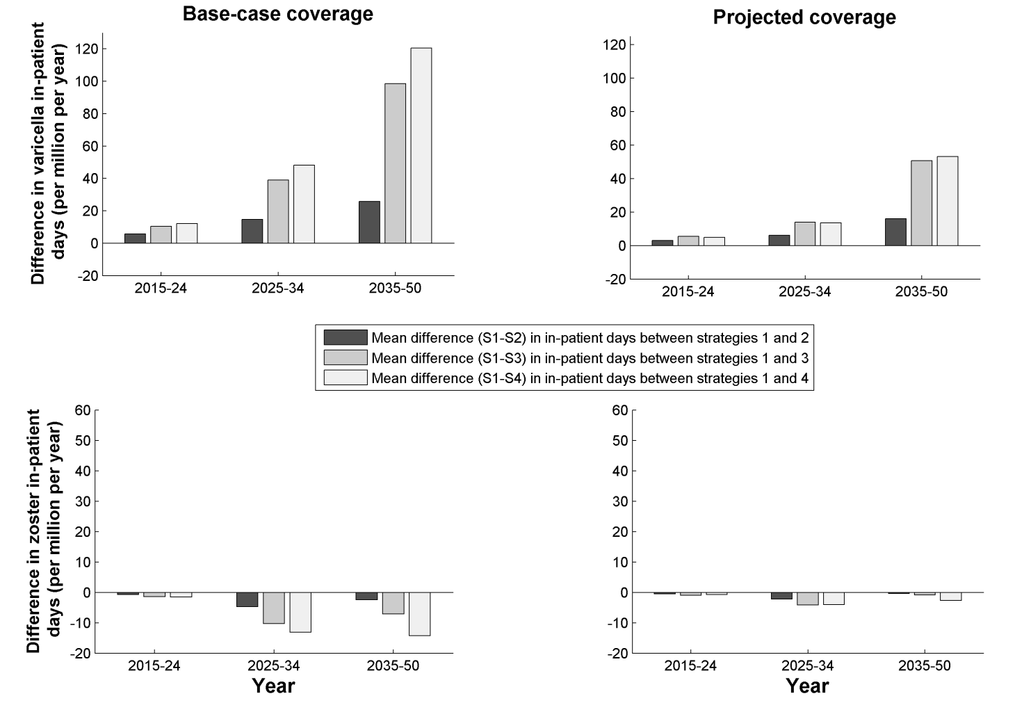 Fig. S7. (a-b) Mean annual difference in varicella morbidity (in-patient days) and (c-d) zoster morbidity between strategy 1 (S1) and alternative strategies (S2, S3 and S4) in the periods: 2015-24, 2025-34 and 2035-50 under base-case coverage (infant dose coverage 83%) and projected coverage (infant dose coverage 95%) scenarios under worst-case 1-dose VE assumptions.
(a)
(b)
(d)
(c)
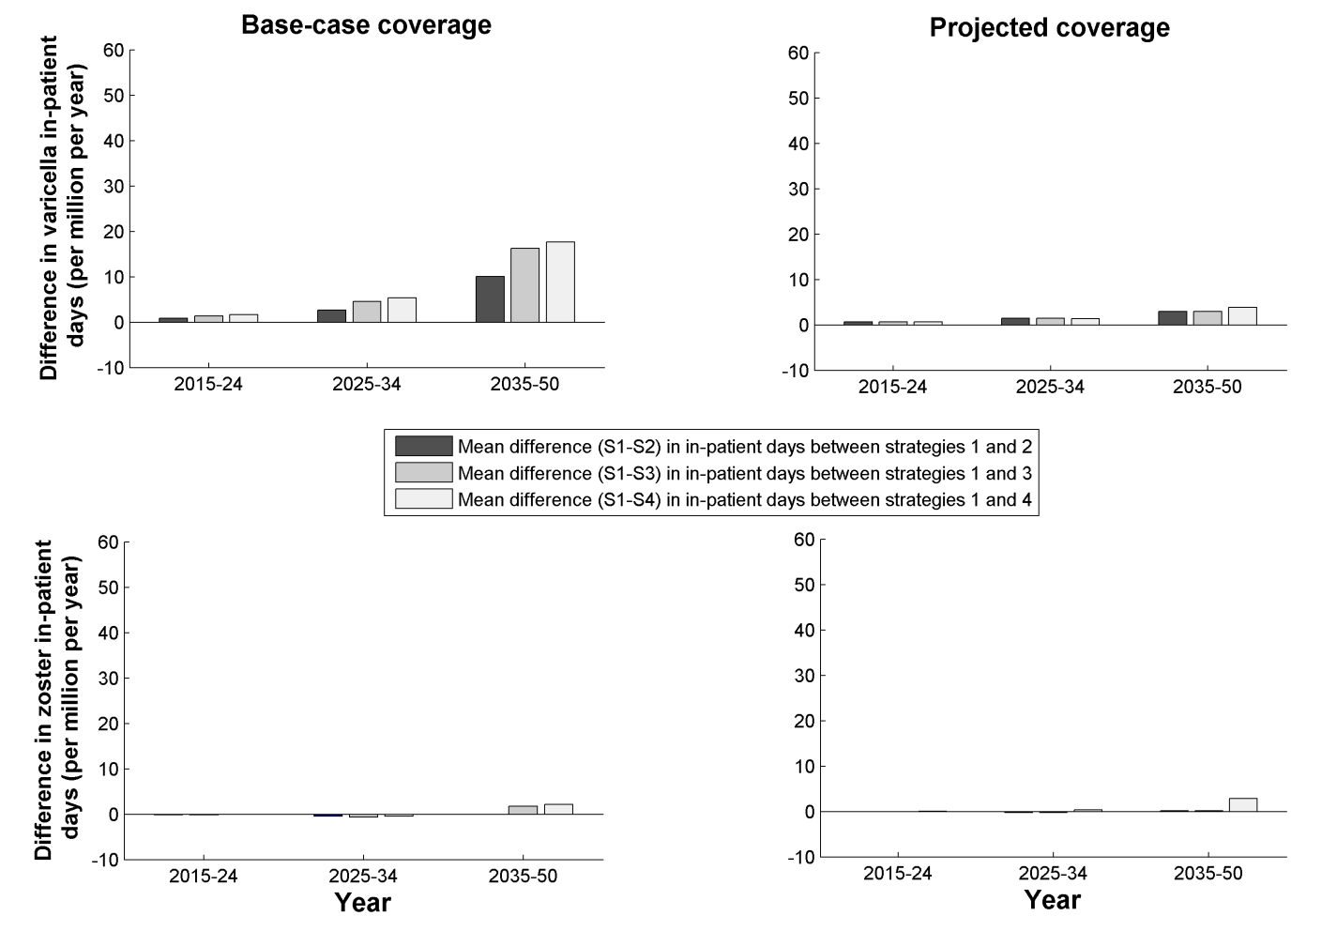 Fig. S8. (a-b) Mean annual difference in varicella morbidity (in-patient days) and (c-d) zoster morbidity between strategy 1 (S1) and alternative strategies (S2, S3 and S4) in the periods: 2015-24, 2025-34 and 2035-50 under base-case coverage (infant dose coverage 83%) and projected coverage (infant dose coverage 95%)scenarios under best-case 1-dose VE assumptions.
(a)
(b)
(c)
(d)

S7. Original zoster assumptions
In our previous paper [2], we used different assumptions for the rate of zoster reactivation and boosting by age and in Fig. S9 we compare the incidence of zoster using the old and new sets of assumptions under strategy 1. The effect of these assumptions on relative differences in zoster between strategies is even smaller, with the differences summarised in Fig. 4 in the main text changing by less than 1 day of hospitalisation per million population in any of the time periods and under both coverage situations presented.
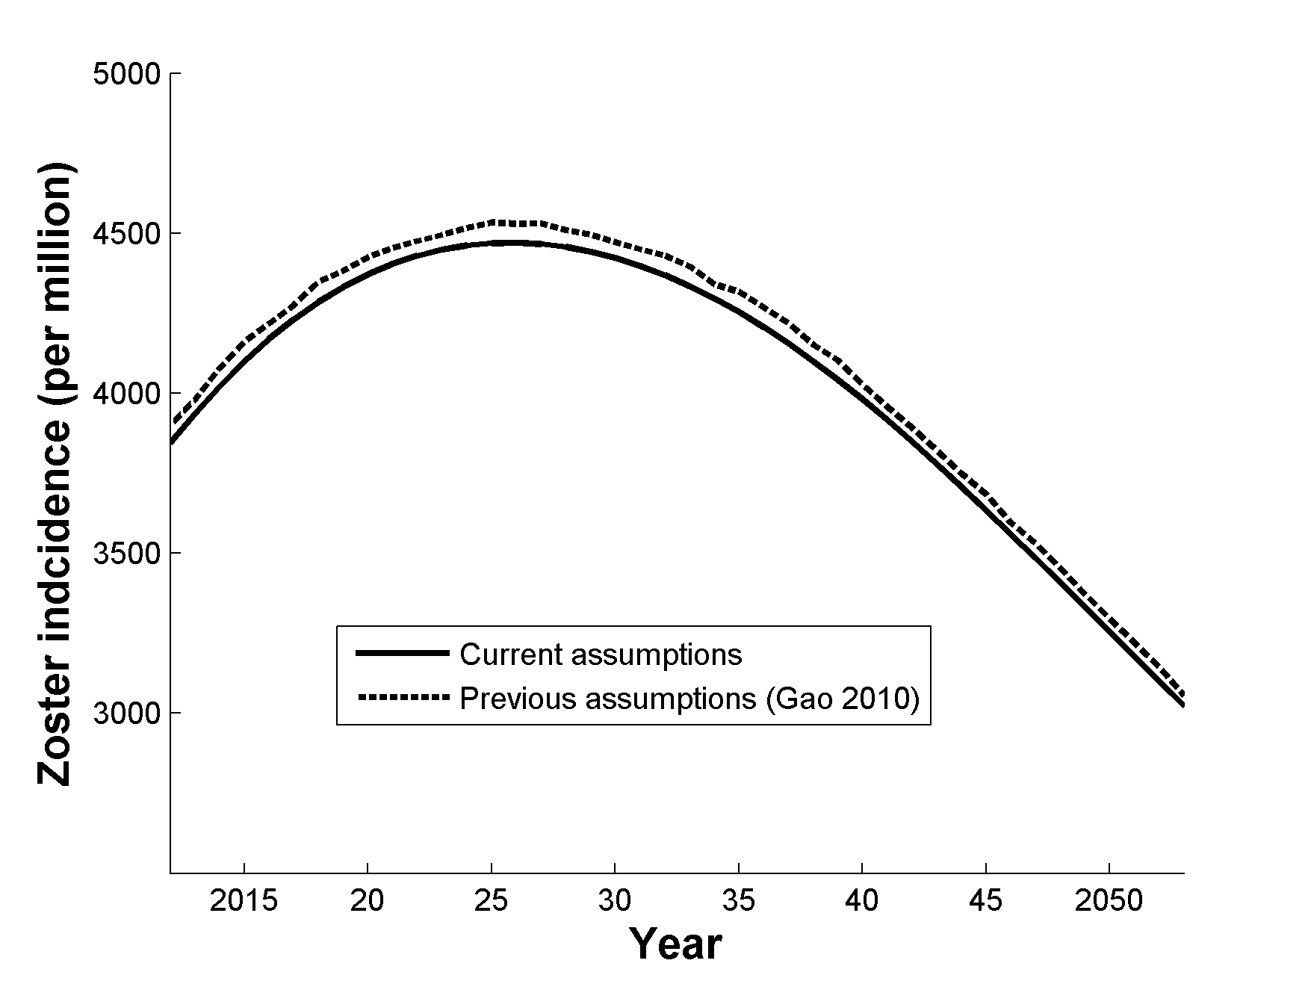
Fig. S9. Comparison between zoster incidence under current and previous assumptions [2] regarding zoster reactivation and boosting under strategy 1.

REFERENCES
[1] Brisson M, Melkonyan G, Drolet M, De Serres G, Thibeault R, De Wals P, et al. Modeling the impact of one- and two-dose varicella vaccination on the epidemiology of varicella and zoster. Vaccine 2010 Apr 26;28(19):3385-97.
[2] Gao Z, Gidding HF, Wood JG, MacIntyre CR. Modelling the impact of one-dose vs. two-dose vaccination regimens on the epidemiology of varicella zoster virus in Australia. Epidemiology and Infection 2010 Apr;18(4):457-68.
[3] Izurieta HS, Strebel PM, Blake PA. Postlicensure effectiveness of varicella vaccine during an outbreak in a child care center. Jama-Journal of the American Medical Association 1997 Nov;278(18):1495-9.
[4] Mossong J, Hens N, Jit M, Beutels P, Auranen K, Mikolajczyk R, et al. Social contacts and mixing patterns relevant to the spread of infectious diseases. PLoS Medicine 2008 Mar 25;5(3):e74
[5] Gidding HF, MacIntyre CR, Burgess MA, Gilbert GL. The seroepidemiology and transmission dynamics of varicella in Australia. Epidemiology and Infection 2003 Dec;131(3):1085-9.
[6] Brisson M, Edmunds WJ, Gay NJ, Law B, De Serres G. Analysis of varicella vaccine breakthrough rates: implications for the effectiveness of immunisation programmes. Vaccine 2000 06/15/;18(25):2775-8
[7] Kuter B, Matthews H, Shinefield H, Black S, Dennehy P, Watson B, et al. Ten year follow-up of healthy children who received one or two injections of varicella vaccine. Pediatric Infectious Disease Journal 2004 Feb;23(2):132-7.
[8] Hull B, Dey A, Mahajan D, Menzies R, McIntyre PB. Immunisation coverage annual report, 2009. Communicable Diseases Intelligence 2011 Jun;35(2):132-48.
[9] Hull BP, Mahajan D, Dey A, Menzies RI, McIntyre PB. Immunisation coverage annual report, 2008. Communicable Diseases Intelligence 2010 2010-Sep;34(3):241-58.
[10] Hull B, Dey A, Mahajan D, Campbell-Lloyd S, Menzies RI, McIntyre PB. NSW Annual Immunisation Coverage Report, 2009. New South Wales Public Health Bulletin 2010 2010;21(9-10):210-23.
[11] Holmes CN, Holmes CN. Predictive value of a history of varicella infection. Canadian Family Physician 2005 Jan;51:60-5.
[12] Karunajeewa HA, Kelly HA. Predictive value of personal recall of chicken pox infection: implications for the use of varicella vaccine. Medical Journal of Australia 2001 Feb 5;174(3):153.
[13] Dorell CG, Jain N, Yankey D, Dorell CG, Jain N, Yankey D. Validity of parent-reported vaccination status for adolescents aged 13-17 years: National Immunization Survey-Teen, 2008. Public Health Reports 2011 Jul-Aug;126 Suppl 2:60-9.
[14] Michalik DE, Steinberg SP, Larussa PS, Edwards KM, Wright PF, Arvin AM, et al. Primary vaccine failure after 1 dose of varicella vaccine in healthy children. Journal of Infectious Diseases 2008 Apr 1;197(7):944-9.

