Failure to deactivate medial prefrontal cortex in people at high risk for psychosis
Irina Falkenberg ^{a,b}* , Chris Chaddock ª , Robin M. Murray ª, Colm McDonald ^{d} , Gemma Modinos ª , Elvira Bramon ^{a,e} ,Muriel Walshe ª , Matthew Broome ^{a,c} , Philip McGuire ª , Paul Allen ª

ª Department of Psychosis Studies, Institute of Psychiatry, King’s College London, London, United Kingdom; ^{b} Department of Psychiatry and Psychotherapy, Philipps-University Marburg, Germany; ^{c} Division of Mental Health and Wellbeing, Warwick Medical School, University of Warwick, Gibbet Hill, Coventry, CV4 7AL, United Kingdom; ^{d} Department of Psychiatry, Clinical Science Institute, National University of Ireland, Galway, Galway, Ireland; ^{e} Department of Clinical Neuroscience, Institute of Psychiatry, King’s College London, London, United Kingdom

* Corresponding author: Institute of Psychiatry, King's College London, Department of Psychosis Studies (PO67), 16 De Crespigny Park, London SE5 8AF, UK, Tel: +44 (0)20 7848 0801, Fax: +44 (0)20 7848 0976, E-mail: irina.falkenberg@kcl.ac.uk

Supplementary Results

Table S1: Linear trend analysis of activation during N-back, covaried for age and IQ. Results are reported at a threshold of p <.001 uncorrected. * p ≤ 0.05 FWE
Group Effects |  | MNI coordinates
 | Side | X | Y | Z | Peak Z-score | Cluster size
UHR>FHR>CTRL
Precuneus | L | -14 | -50 | 40 | 5.38 | 1279*
Posterior cingulate | R | 22 | -66 | 4 | 4.26 | 290
Insula | L | -30 | -40 | 14 | 4.19 | 364
Hippocampus | R | 32 | -34 | -6 | 3.89 | 124
Parahippocampal gyrus | L | -28 | -58 | -4 | 3.64 | 51
Inferior temporal gyrus | R | 54 | -6 | -24 | 3.50 | 16
Lingual gyrus | L | -16 | -72 | -10 | 3.49 | 47
Superior temporal gyrus | L | -40 | -32 | 0 | 3.47 | 32
Postcentral gyrus | R | 22 | -34 | 48 | 3.40 | 23
Cingulate gyrus | L | -16 | 26 | 28 | 3.39 | 20
Superior frontal gyrus | L | -12 | 58 | 20 | 3.38 | 35
Transverse temporal gyrus | R | 58 | -22 | 10 | 3.30 | 12
Anterior cingulate | L | -16 | 36 | 12 | 3.25 | 18
CTRL>FHR>UHR
Precunues | L | -2 | -52 | 32 | 4.75 | 812*
Insula | R | 52 | -22 | 12 | 4.08 | 200

Table S2 Demographic characteristics and means and standard deviations for errors in N-Back task, including an additional sample of patients with first episode psychosis (FEP).
 | FEP (n=10) | UHR (n=17) | GHR (n=10) | Controls (n=15) | Statistic
Age
Mean (SD) | 25.5 (5.9) | 24.3 (4.2) | 40.3 (10.7) | 25.6 (4.8) | F (3, 48) = 15.5ª
Range | 18 - 35 | 20 - 34 | 26 - 59 | 19 - 35
IQ
Mean (SD) | 105.4 (10.5) | 101.7 (11.7) | 111.9 (7.5) | 123.2 (16.2) | F (3, 36) = 6.5ª
Range | 96.6 - 114.1 | 95.5 – 108.0 | 105.0 - 118.8 | 110.7 - 135.7
Gender (n female) | 3 | 5 | 5 | 5 | Χ² (3) = 4.5
Ethnicity (%) |  |  |  |  | Χ² (12) = 29.3^{b}
White | 20 | 76.5 | 100 | 66.7
Black | 40 | 11.8 | 0 | 26.7
Oriental | 0 | 11.8 | 0 | 0
Mixed | 30 | 0 | 0 | 0
Other | 10 | 0 | 0 | 6.7
Errors in N-back task (Mean ± SD)
Total | 8.7 ± 10.4 | 4.2 ± 3.8 | 1.9 ± 2.0 | 2.9 ± 3.2 | F (3, 115) = 8.1ª
Errors in Instructions | 1.0 ± 1.8 | 0.1 ± 0.2 | 0 | 0.5 ± 1.3 | F (3, 115) = 6.5ª
Errors in 0-back | 1.7 ± 2.7 | 1.0 ± 1.6 | 0.4 ± 0.9 | 0.7 ± 1.2 | F (3, 115) = 3.3^{b}
Errors in 1-back | 1.7 ± 2.0 | 0.6 ± 0.9 | 0 | 0.3 ± 0.7 | F (3, 115) = 12.4ª
Errors in 2-back | 3.9 ± 4.5 | 2.5 ± 2.3 | 1.4 ± 1.4 | 1.5 ± 1.7 | F (3, 115) = 5.1^{b}
Medication at baseline (no. of cases)
Atypical antipsychotics | 7
Missing | 3

ª p ≤ .001
^{b} p < .05

Table S3: Linear trend analysis across 4 groups in ascending/descending order of risk of transition to psychosis. Results are reported at a threshold of p <.001 uncorrected.
Group Effects |  | MNI coordinates
 | Side | X | Y | Z | Peak Z-score | Cluster size
CTRL>FHR>UHR>FEP
Middle frontal gyrus | R | 30 | -4 | 56 | 3.8 | 23
Inferior parietal lobule | L | -38 | -52 | 40 | 3.69 | 94
Thalamus | R | 8 | -4 | 2 | 3.47 | 28
FEP>UHR>FHR>CTRL
Lingual gyrus | R | 26 | -62 | -4 | 4.64 | 734
Precuneus | L | -14 | -48 | 38 | 4.49 | 149
Medial frontal gyrus | R | 2 | 54 | 20 | 4.04 | 158
Lentiform nucleus | L | -18 | -72 | -10 | 3.99 | 133
Paracentral lobule | R | 4 | -30 | 48 | 3.93 | 172
Parahippocampal gyrus | L | -26 | -42 | -14 | 3.72 | 36
Thalamus | L | -42 | -20 | 8 | 3.65 | 86
Cuneus | L | -14 | -70 | 20 | 3.5 | 70
Insula | R | 54 | -30 | 20 | 3.44 | 45
Parahippocampal gyrus | R | 26 | -42 | -12 | 3.41 | 22
Lingual gyrus | L | -12 | -60 | 2 | 3.38 | 31
Cingulate gyrus | R | 2 | -62 | 30 | 3.29 | 47

Figure S1:
Statistical parametric maps (SPMs) showing activation (yellow) and deactivation depending on risk of transition (FEP> UHR > FHR > CTRL). Plots showing contrasts estimates by group

a) in the left precuneus and
b) the right medial frontal gyrus.

Areas of significance are reported at p <.001 (uncorrected). The left side of the picture corresponds to the left side of the brain.

a)

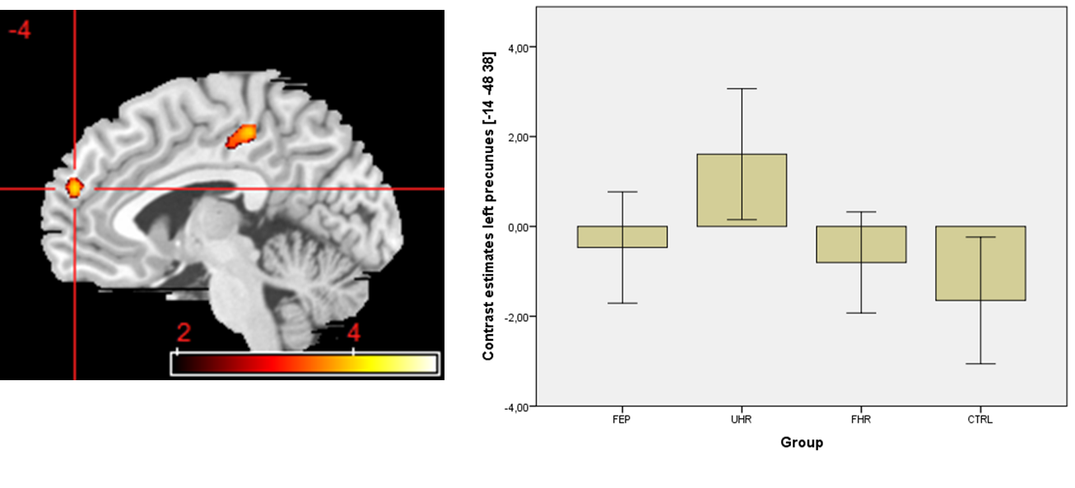

b)

