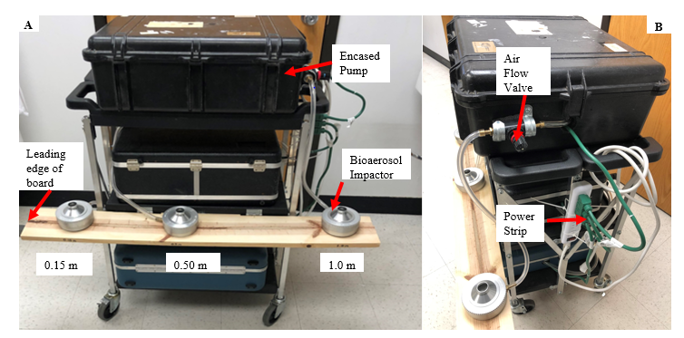

Supplemental Figure 1: Diagram of Sampling Cart: A. Three bioaerosol samplers (silver) and their distance from the toilet rim. B. Pump and flow valve to maintain constant flow rate across the three bioaerosol compactors

Patient and HCW Activity Measurements
It was hypothesized that activities in the patient room may contribute to the amount of bioaerosols in the air. To account for this, the duration and type of activities performed by healthcare workers and patient family/friends in patients’ rooms during the entire trial were recorded. Activity level was classified according to potential for bioaerosol generation. Low activity level included activities such as patient/doctor consultations and food delivery that lasted less than four minutes. Moderate activity level included extended patient consultations (over four minutes), multiple entrances and exits from the patient room, and short medical procedures under three minutes. A high level of activity was determined to be medical procedures over three minutes, patient bathing or adult diaper changing, and activities that involved cleaning the patient room. A score value was created by assigning a numerical value to the activity level from 0 to 3, where zero is no activity and three is the highest level of activity and multiplying it by the duration of the activity.
HCW Results

No association was found between activity level and culture positivity (p-value= 0.8636). There was no association observed between duration of activity and culture positivity (p-value= 0.5265). Similarly, there was no difference between the type of activity and whether the culture was positive test (p-value= 0.4339). No difference in positive culture rate was found across the three activity levels (p-value=0.6052) (Supp. Table 1).

Table 4: Healthcare Worker Activity by Culture Type

 | Positively Cultured Rooms (n=8) | Negatively Cultured Rooms (n=16) | p-value
Activity Level | N (%) |  | 0.8636
None | 2 (25%) | 6 (33%)
Low | 1 (13%) | 1 (6%)
Moderate | 2 (25%) | 2 (13%)
High | 3 (38%) | 5 (38%)
Missing | 0 | 2 (13%)
Activity Type |  |  | 0.4339
Missing | 0 | 2 (13%)
No Activity | 2 (25%) | 6 (33%)
Medical Procedure | 0 | 3 (19%)
Patient Bathing/Cleaning | 1 (13%) | 2 (13%)
Patient Consultation/Food Delivery | 2 (25%) | 1 (6%)
HCW Enters and Exits, Performing Small Tasks | 3 (38%) | 2 (13%)
 | Median (IQR)
Activity Duration (minutes) | 4.00 (0.00-14.00) | 3.50 (0.00-15.00) | 0.5265
Activity Score | 10.00 (0.00-42.00) | 5.00 (0.00-45.00) | 0.6052
Fisher Exact test used for categorical variables and Wilcoxon signed rank used for continuous variables

