Criteria | Patient Criteria Assignment
 | Positive if : | Negative if : | Excluded from analysis if :
Most-Recent Criteria | Last available VRE swab before blood culture is positive | Last available VRE swab before blood culture is negative | No VRE swab result available at any time
Table S1 : Patient Criteria Assignment

Most-Recent Criteria
 | VRE Screen + | VRE Screen -
VRE in Blood Culture | 33 | 13
No VRE in Blood Culture | 44 | 240
Data Extracted from Brasg et al(1)
 | VRE Screen + | VRE Screen -
VRE in Sterile Culture | 7 | 3
No VRE in Sterile Culture | 12 | 466
Table S2 : 2x2 diagnostic tests

Test Property | Most-Recent Criteria  (N=330) | Pooled Estimates (N=818)
Sensitivity (95% CI) | 71.7 (56.5, 84.0) | 70.9 (57.6, 81.4)*
Specificity (95% CI) | 84.5 (79.8, 88.5) | 93.5 (67.7, 99.0)*
LR+ (95% CI) | 4.73 (3.40, 6.53) | 16.6 (2.17, 67.6)
LR- (95% CI) | 0.332 (0.180, 0.487) | 0.329 (0.205, 0.491)
VRE proportion below which NPV > 90% | 26.0 (18.6, 38.2) | 26.0 (18.4, 35.2)
VRE proportion below which NPV > 95% | 14.4 (9.76, 22.6) | 14.3 (9.68, 20.5)
Table S3 : Diagnostic properties of the Most-Recent criteria, and the pooled estimates. *Cross-hair estimates (see Figure S1).

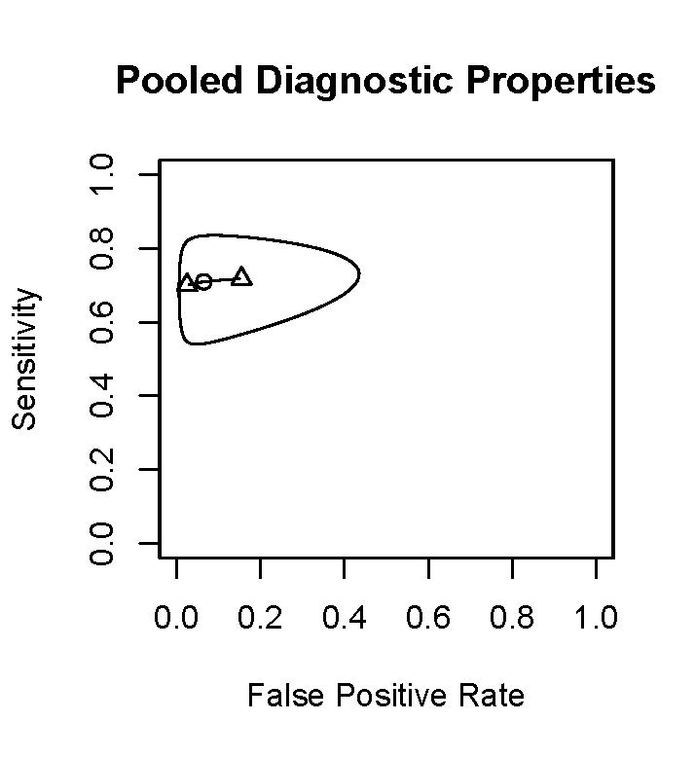
Figure S1 : Pooled diagnostic properties and 95% confidence intervals for sensitivity and false positive ratio (1-specificity) as a function of each other.

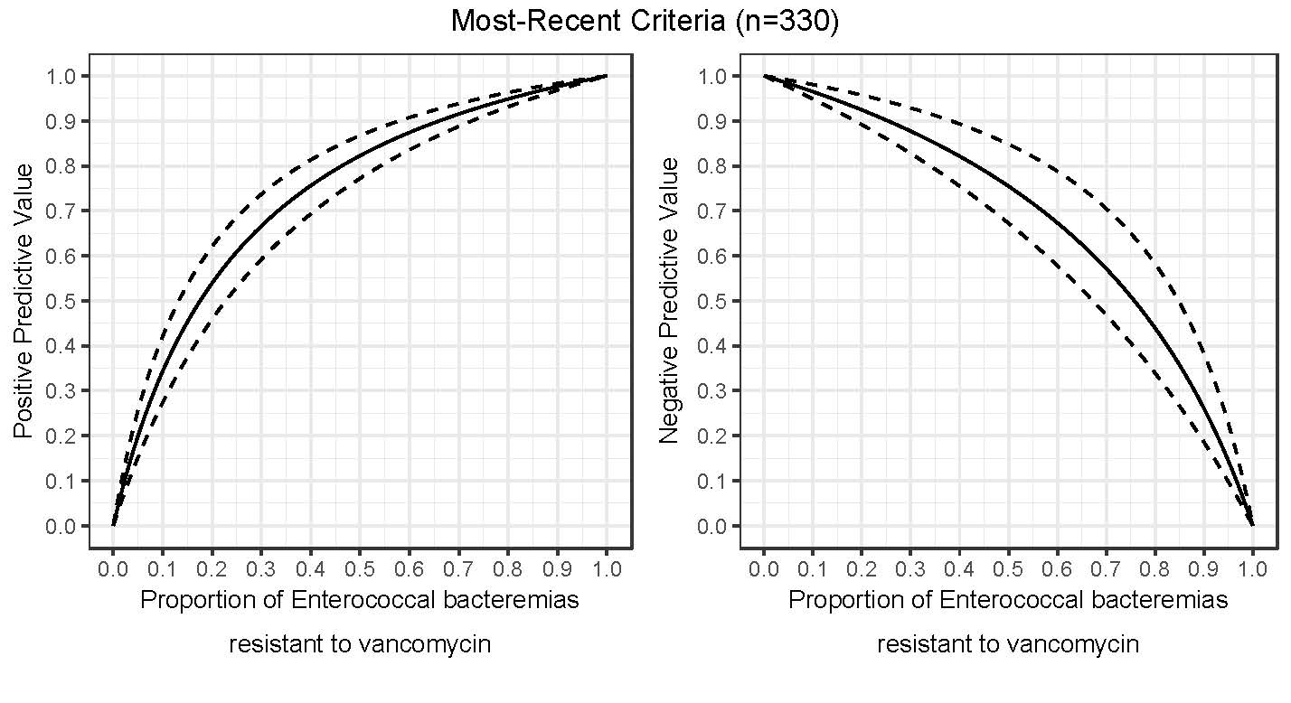
Figure S2 : Most-Recent criteria diagnostic properties
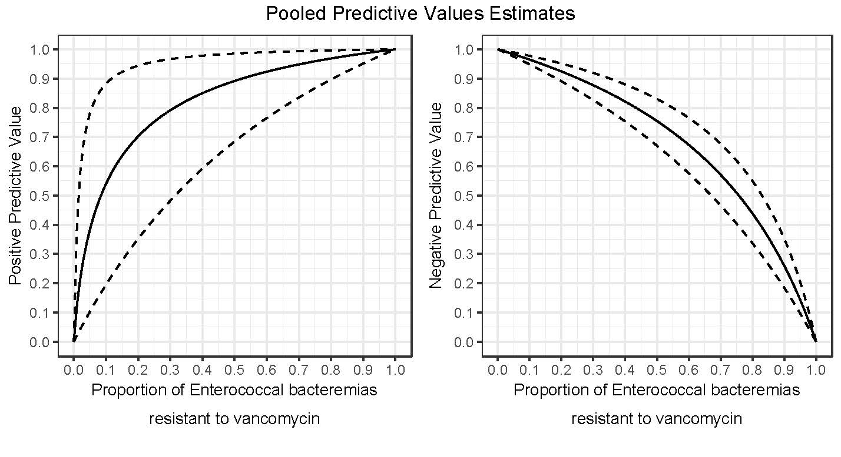
Figure S3 : Pooled criteria diagnostic properties.

References
1. Brasg I, Elligsen M, MacFadden D, Daneman N. 2017. Predictive utility of swab screening for vancomycin-resistant Enterococcus in selection of empiric antibiotics for Enterococcus sterile-site infections: a retrospective cohort study. CMAJ Open 5:E632-e637.

