SUPPLEMENTAL MATERIAL
Supplemental Figure 1: Example of a PPE-Free Zone
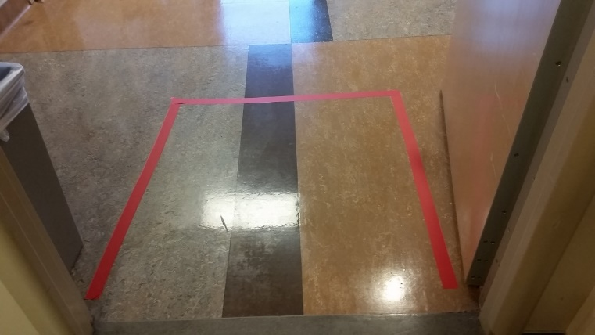

Supplemental Figure 2a: Hand Hygiene Compliance Plotted Over Study Duration

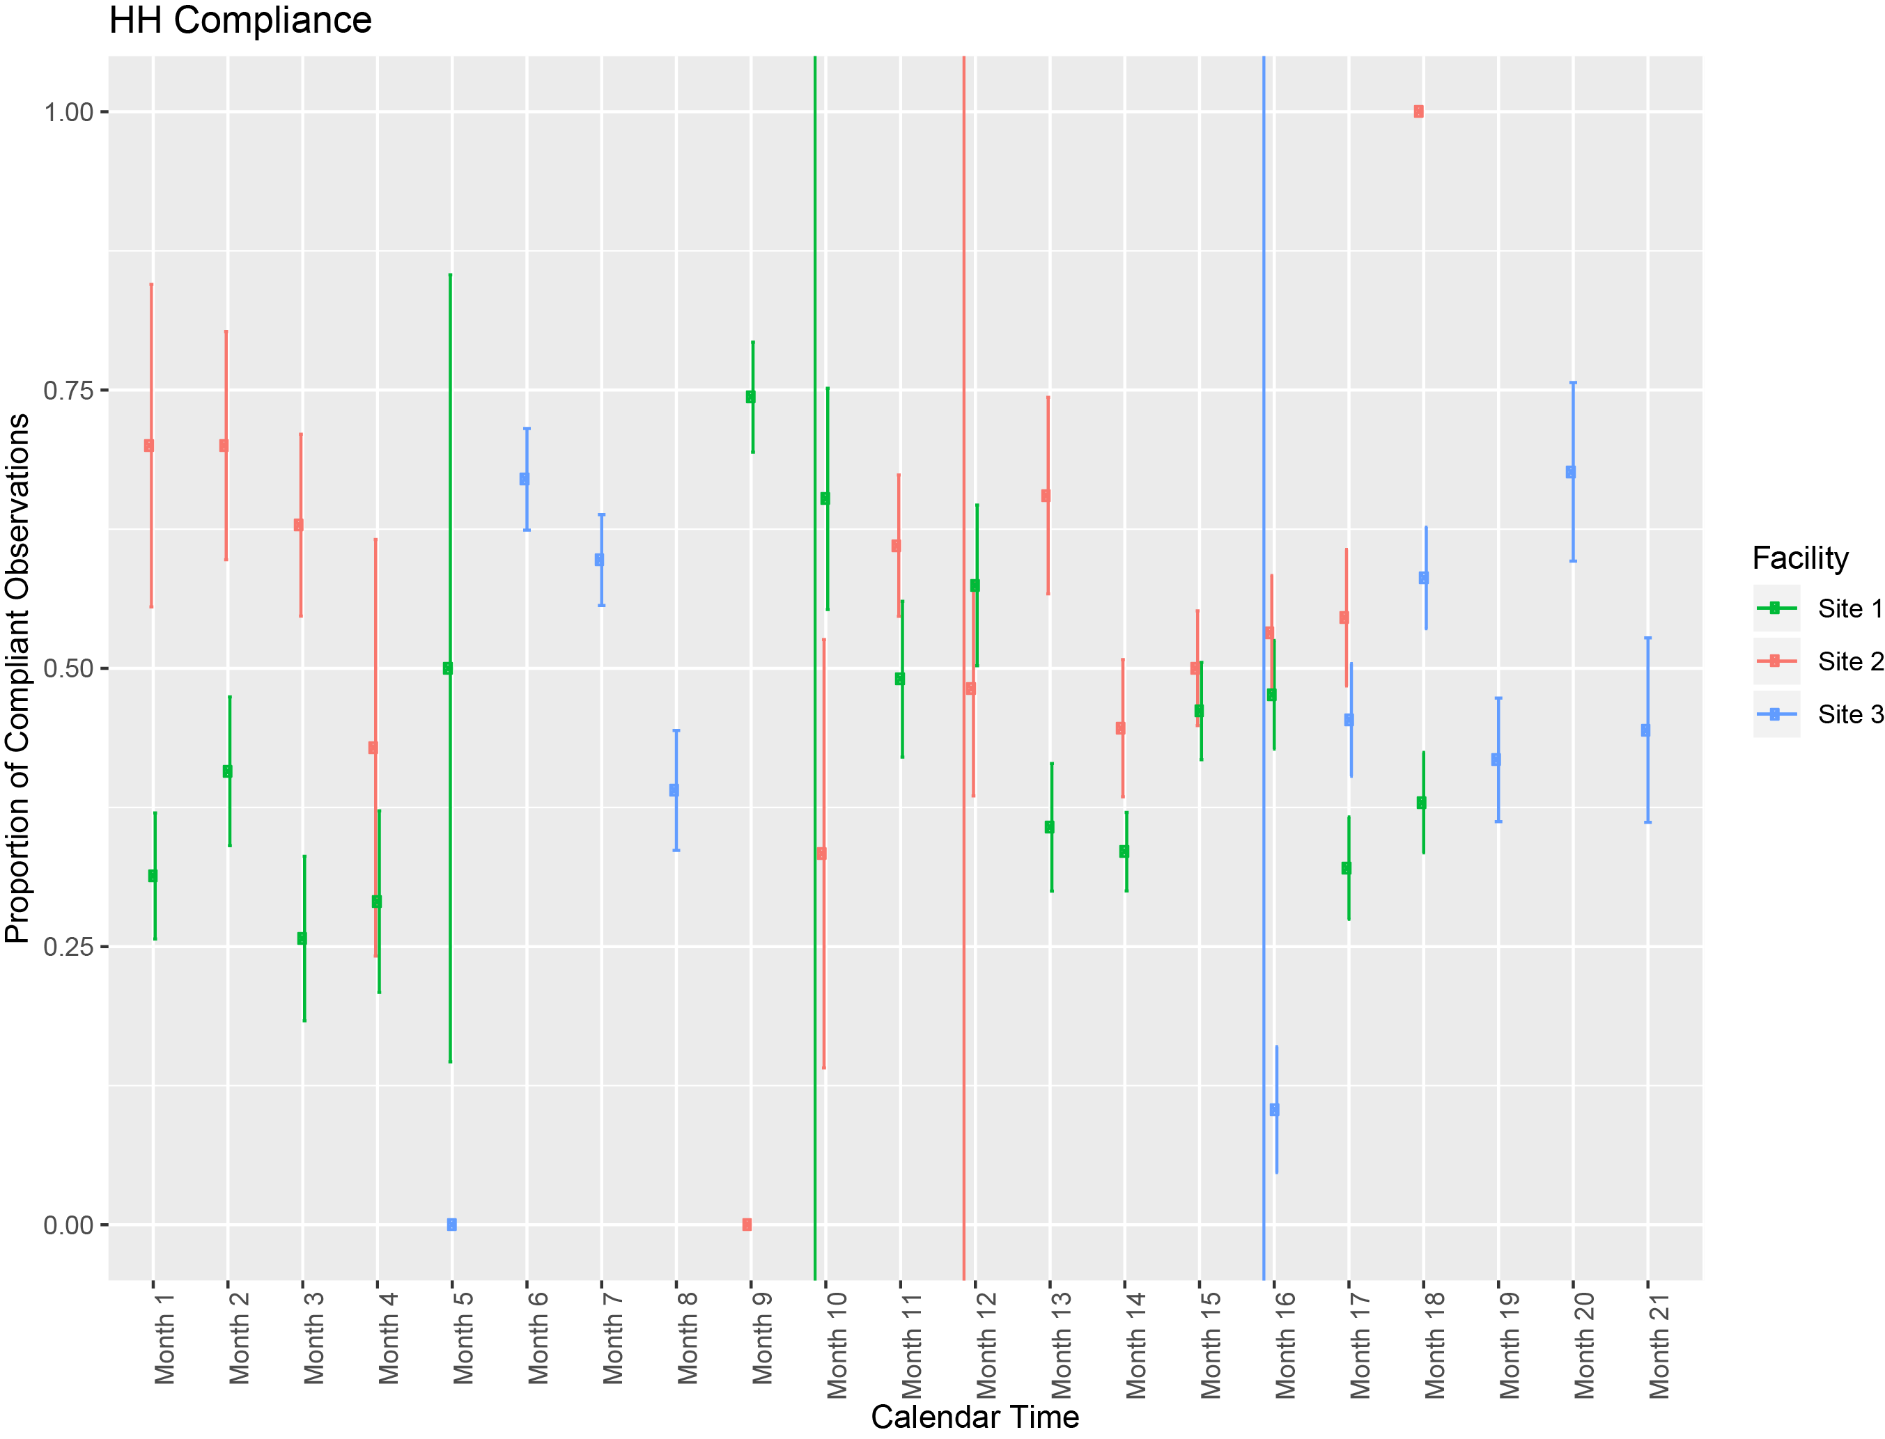

Vertical green line corresponds to intervention start at Site 1; red line to intervention start at Site 2; blue line to intervention start at Site 3.

Supplemental Figure 2b: PPE Compliance Plotted Over Study Duration

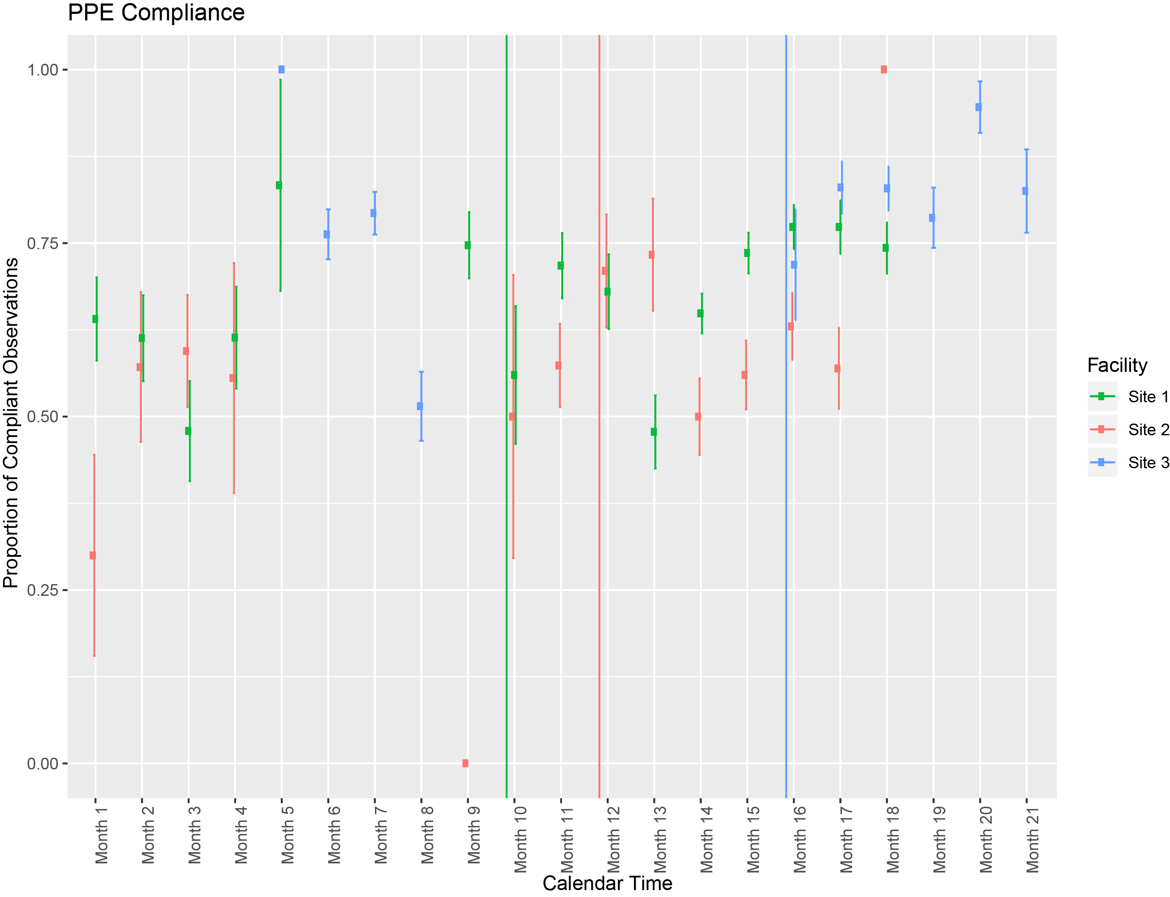

Vertical green line corresponds to intervention start at Site 1; red line to intervention start at Site 2; blue line to intervention start at Site 3.

