Supplement 1. Number and Percentage of Reported Confirmed and Suspected* Norovirus Outbreaks by Setting, National Outbreak Reporting System, 2009-2015, United States
Setting | Frequency | (%)
Healthcare-associated
Long-term care/nursing home/ assisted living facility | 5,165 | (46.1)
Hospital | 279 | (2.5)
Other healthcare facility | 98 | (0.9)
Non-healthcare-associated
Restaurant | 1,367 | (12.2)
School/college/university | 617 | (5.5)
Event space | 292 | (2.6)
Private home/residence | 223 | (2.0)
Child day care | 208 | (1.9)
Office/indoor workplace | 112 | (1.0)
Camp | 77 | (0.7)
Hotel/motel | 52 | (0.5)
Prison/jail | 42 | (0.4)
Religious facility | 33 | (0.3)
Festival/fair | 7 | (0.1)
Ship/boat | 5 | (0.1)
Other | 212 | (1.9)
Unknown | 13 | (0.1)
Missing | 2,410 | (21.5)
Total | 11,212 | (100.0)

*If two or more laboratory-confirmed cases were reported, the outbreak etiology was considered “confirmed.” If a reported etiology was associated with less than two laboratory-confirmed cases or based solely on clinical or epidemiologic criteria, the outbreak was classified as “suspected.”
Supplement 2. Characteristics of Outbreak by Each Setting, from the National Outbreak Reporting System (NORS) Database, 2009-2015, the United States
Outbreaks | Healthcare-associated  (N=5,542) | Non-healthcare-associated  (N=3,260) |  | Setting-unknown  (N=2,410) | Total  (N=11,212) | p-value^{*5}
Primary mode of transmission* (n, column %)  Person-to-person  Food  Environment  Other/Unknown | 5,248 (94.7)  37 (0.7)  4 (0.1)  253 (4.6) | 1,240 (38.2)  1,723 (53.1)  17 (0.5)  267 (8.2) | 1,983 (81.8)  122 (5.0)  18 (0.7)  300 (12.4) |  | 8,471 (75.6)  1,882 (16.8)  39 (0.4)  820 (7.31) | <0.0001
Total Primary Cases | 207,314 | 99,091 | 90,743 |  | 397,148
Number of primary cases  Range  Median | 2 - 670  30 | 2 - 2,500  15 | 2 - 699  25 |  | 2 - 2,500  25
Age^{*1} (cases, column %)  under 1  1 - 4  5 - 9  10 - 19  20 - 49  50 - 74  75 +  unknown | 54 (0.1)  68 (0.1)  76 (0.1)  960 (1.0)  15,466 (16.5)  18,668 (19.9)  58,360 (62.3)  94,526 | 382 (0.7)  2,881 (5.0)  10,618 (18.3)  11,861 (20.5)  19,178 (33.1)  11,165 (19.3)  1,905 (3.3)  29,844 | 15 (0.1)  214 (1.7)  942 (7.4)  1,602 (12.6)  2,971 (23.3)  2,458 (19.3)  4,541 (35.6)  9,807 |  | 451 (0.3)  3,163 (1.9)  11,636 (7.1)  14,423 (8.8)  37,615 (22.9)  32,291 (19.6)  64,806 (39.4)  134,177 | <0.0001
Sex^{*2} (cases, column %)  Female  Male | 104,046 (75.1%)  34,454 (24.9%) | 34,452 (52.1%)  31,732 (47.9%) | 11,135 (63.1%)  6,520 (36.9%) |  | 149,633 (67.3%)  72,706 (32.7%) | <0.0001
Death^{* 3} (cases, row %)  Number of outbreaks with deaths  Total number of deaths  Case-fatality ratio | 347 (86.8%)  479 (86.6%)  2.4 / 1,000 | 12 (3.0%)  12 (2.2%)  0.1 / 1,000 | 42 (10.5%)  62 (11.2%)  1.4 / 1,000 |  | 401  553  1.6 / 1,000 | <0.0001
Hospitalization^{*4} (cases, row %)  Number of outbreaks with hospitalizations  Total number of hospitalizations  Case-hospitalization ratio | 1,649 (72.2%)  3,569 (73.4%)  1.9 / 100 | 378 (6.6%)  579 (11.9%)  0.6 / 100 | 256 (11.2%)  717 (14.7%)  1.7 / 100 |  | 2,283  4,865  1.5 / 100 | <0.0001
* Water-borne outbreak data were only available from 2009 – 2012 (total 13 norovirus outbreaks) and were therefore excluded from the analysis.
^{*1} age information was available in 8,334 outbreaks
^{*2} sex information was available in 8,472 outbreaks
^{*3} deaths information available in 9,636 outbreaks with 337,855 primary cases
^{*4} hospitalization information available in 9,429 outbreaks (hospital outbreaks were excluded) with 333,133 primary cases
^{*5} p-value was obtained by Chi-square test between healthcare-associated and non-healthcare-associated

The number of outbreak-associated cases in each sex and age category was calculated by multiplying the percentages of each strata by the total number of primary cases, for those outbreaks where only percentages were reported. Differences in primary mode of transmission, sex, deaths and hospitalization between HOB and NOB were tested by chi-square test. Only outbreaks that reported information on each characteristic (mode of transmission, sex, age, deaths, hospitalization) were included in this analysis. Hospital outbreaks were excluded from the hospitalization analysis.

Supplement 3. R² between Monthly Number of Hospital-Associated Norovirus Outbreak and Monthly Google Trends Activity

Search Term | Highest R²
Norovirus | 0.569
Vomiting | 0.476
Diarrhea | 0.152
Nausea | 0.142
Abdominal pain | 0.095
Stomach virus | 0.790
Food poisoning | 0.454
Gastroenteritis | 0.467
Norwalk virus | 0.334
Rotavirus | 0.640

Supplement 4. The Week of Onset, Peak, and End of Season for Healthcare-Associated and Non-Healthcare-Associated Norovirus Outbreaks and Google Trends Score with “Stomach Virus” between 2009 and 2015, United States
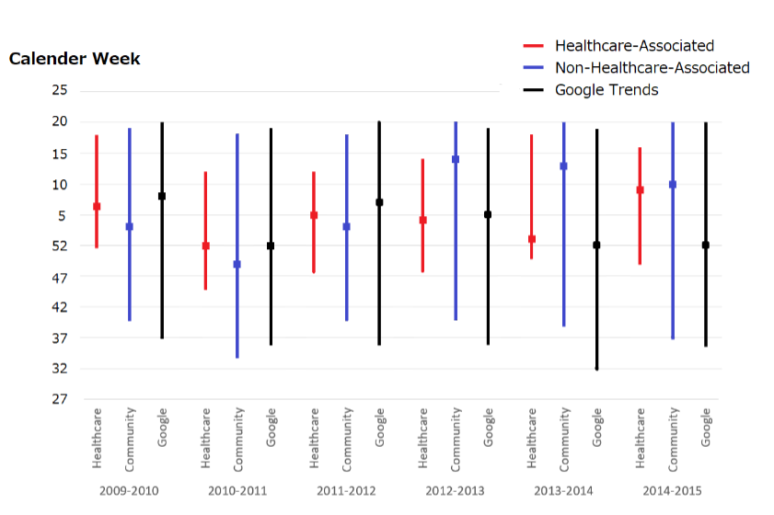

ª The bottom of the lines represent the onset and the top represent the end of each season, the boxes represent the peak
The peak was defined as the week with the highest number of outbreaks or the highest GT score in the seasonal year. The norovirus season onset was defined as the first week in which the number of outbreaks exceeded 10% of total outbreaks, or score for GT, in the seasonal year. The end of the season was defined as the first week after 90% of the total outbreaks in the seasonal year, or score for GT, had occurred.
^{b} The seasonal year was defined as from week 27 in one year to week 26 of the next

Supplement 5. The Coefficient with 95% Confidence Interval, R-square with the Regression Models with Various Lag-time: Before and After the Peak

- Healthcare and Non-healthcare-associated norovirus outbreak
 | Before the peak |  |  | After the peak
Lag (week)* | β | (95% CI) | R² | β | (95% CI) | R²
-12 | 2.07 | (1.42, 2.71) | 0.20 | 0.18** | (-0.27, 0.63) | 0.00
-11 | 2.31 | (1.75, 2.86) | 0.29 | 0.27** | (-0.18, 0.72) | 0.01
-10 | 2.33 | (1.78, 2.88) | 0.30 | 0.30** | (-0.15, 0.75) | 0.01
-9 | 2.29 | (1.75, 2.82) | 0.30 | 0.50 | (0.05, 0.75) | 0.02
-8 | 2.42 | (1.96, 2.88) | 0.39 | 0.81 | (0.38, 1.24) | 0.07
-7 | 2.38 | (1.95, 2.80) | 0.43 | 0.98 | (0.98, 1.40) | 0.10
-6 | 2.21 | (1.78, 2.64) | 0.39 | 1.14 | (1.14, 1.55) | 0.13
-5 | 2.01 | (1.57, 2.45) | 0.33 | 1.27 | (1.27, 1.66) | 0.17
-4 | 2.06 | (1.62, 2.49) | 0.35 | 1.52 | (1.52, 1.89) | 0.25
-3 | 1.61 | (1.21, 2.01) | 0.28 | 1.77 | (1.77, 2.11) | 0.34
-2 | 1.45 | (1.07, 1.83) | 0.26 | 1.98 | (1.98, 2.30) | 0.43
-1 | 1.34 | (0.95, 1.72) | 0.22 | 2.08 | (2.08, 2.40) | 0.45
0 | 1.42 | (1.05, 1.78) | 0.26 | 2.28 | (2.28, 2.57) | 0.54
+1 | 1.38 | (1.02, 1.74) | 0.26 | 2.26 | (2.26, 2.57) | 0.51
+2 | 1.30 | (0.93, 1.66) | 0.24 | 2.33 | (2.33, 2.65) | 0.51
+3 | 1.26 | (0.89, 1.63) | 0.22 | 2.31 | (2.31, 2.64) | 0.48
+4 | 1.22 | (0.84, 1.60) | 0.20 | 2.26 | (2.26, 2.61) | 0.45
+5 | 1.04 | (0.64, 1.44) | 0.14 | 2.28 | (2.28, 2.63) | 0.46
+6 | 0.95 | (0.54, 1.36) | 0.12 | 2.28 | (2.28, 2.64) | 0.44
+7 | 0.85 | (0.42, 1.27) | 0.09 | 2.22 | (2.22, 2.59) | 0.41
+8 | 0.73 | (0.29, 1.17) | 0.07 | 2.09 | (2.09, 2.48) | 0.36
+9 | 0.73 | (0.30, 1.17) | 0.07 | 2.01 | (1.60, 2.42) | 0.32
+10 | 0.80 | (0.37, 1.23) | 0.08 | 1.84 | (1.40, 2.27) | 0.25
+11 | 0.55 | (0.11, 0.99) | 0.04 | 1.39 | (0.90, 1.89) | 0.13
+12 | 0.39 | (-0.06, 0.83) | 0.02 | 1.08 | (0.58, 1.58) | 0.08
*Negative lag means that the non-healthcare outbreaks’ data is prior to the healthcare-associated outbreaks’ data.
**not significant

- Healthcare-associated norovirus outbreak and Google Trend
 | Before the peak |  |  | After the peak
Lag (week)* | β | (95% CI) | R² | β | (95% CI) | R²
-12 | 0.70 | (0.45, 0.94) | 0.16 | 0.13 | (-0.01, 0.28) | 0.02
-11 | 0.76 | (0.52, 0.99) | 0.2 | 0.23 | (0.09, 0.38) | 0.05
-10 | 0.82 | (0.61, 1.04) | 0.26 | 0.35 | (0.21, 0.49) | 0.12
-9 | 0.84 | (0.65, 1.03) | 0.32 | 0.45 | (0.32, 0.58) | 0.2
-8 | 0.84 | (0.67, 1.01) | 0.36 | 0.50 | (0.38, 0.63) | 0.25
-7 | 0.85 | (0.69, 1.01) | 0.40 | 0.55 | (0.43, 0.67) | 0.31
-6 | 0.87 | (0.71, 1.02) | 0.44 | 0.61 | (0.50, 0.71) | 0.38
-5 | 0.94 | (0.80, 1.07) | 0.54 | 0.65 | (0.55, 0.75) | 0.46
-4 | 0.97 | (0.86, 1.08) | 0.63 | 0.67 | (0.58, 0.77) | 0.50
-3 | 0.92 | (0.81, 1.03) | 0.63 | 0.69 | (0.60, 0.78) | 0.53
-2 | 0.89 | (0.79, 1.00) | 0.65 | 0.73 | (0.65, 0.82) | 0.59
-1 | 0.86 | (0.77, 0.95) | 0.68 | 0.77 | (0.69, 0.85) | 0.65
0 | 0.81 | (0.72, 0.89) | 0.68 | 0.81 | (0.74, 0.89) | 0.70
+1 | 0.76 | (0.67, 0.84) | 0.65 | 0.86 | (0.79, 0.93) | 0.72
+2 | 0.72 | (0.63, 0.81) | 0.62 | 0.88 | (0.80, 0.96) | 0.70
+3 | 0.70 | (0.61, 0.79) | 0.58 | 0.87 | (0.79, 0.96) | 0.65
+4 | 0.67 | (0.57, 0.77) | 0.53 | 0.87 | (0.77, 0.96) | 0.62
+5 | 0.63 | (0.52, 0.74) | 0.46 | 0.85 | (0.75, 0.95) | 0.56
+6 | 0.58 | (0.47, 0.70) | 0.39 | 0.83 | (0.71, 0.94) | 0.50
+7 | 0.52 | (0.40, 0.64) | 0.31 | 0.79 | (0.66, 0.92) | 0.42
+8 | 0.47 | (0.34, 0.60) | 0.24 | 0.75 | (0.61, 0.89) | 0.35
+9 | 0.40 | (0.26, 0.54) | 0.17 | 0.71 | (0.56, 0.86) | 0.29
+10 | 0.32 | (0.18, 0.47) | 0.11 | 0.66 | (0.49, 0.82) | 0.23
+11 | 0.24 | (0.09, 0.39) | 0.06 | 0.60 | (0.42, 0.78) | 0.18
+12 | 0.16 | (0.01, 0.31) | 0.03 | 0.51 | (0.31, 0.70) | 0.12
*Negative lag means that the non-healthcare outbreaks’ data is prior to the healthcare-associated outbreaks’ data.

Table 1 and Supplement 5 show the results of the model of;
Y_{w} = α + β X_{w+t} + ε
where
Y_{w} is the number of HOB or NOB in week w
X_{w+t} is the number of NOB or GT score in week w+t
t is the number of weeks lagged (ranging from: -12, -11, -10…+11, +12)
ε is an error term

