Appendix Methods
Exclusion criteria and pre-visit instructions
Exclusion criteria were: 1) presence of respiratory infection, 2) presence of chronic respiratory disease that might cause distress or hypoxia during airflow limitation, or 3) presence of psychiatric condition that leads to inability to don the FFR. Before the study visit, each participant received an electronic booklet providing general information on the study and instructions for correctly donning the N95 FFR. Subjects were asked to shave their faces and to abstain from smoking for one-hour prior to the study visit. Informed consent was obtained from all participants upon arrival to the study site. The protocol of this study was approved by the institutional review board of the Armed Forces Medical Command.

Quantitative fit test (QNFT)
Before beginning the main sequence of QNFT, we measured the fit factor (FF) during normal breathing using the realtime mode. FF was calculated as FF = (average particle concentration inside the FFR)/(average ambient particle concentration). N95 companion was turned off for this measurement to obtain exact FF > 200. Overall FF was calculated as the harmonic mean of FF in each stage, excluding FF during grimacing. Subjects went through eight stages of exercise fit test: normal breathing, deep breathing, moving head from side to side, moving head up and down, talking, grimacing, bending over, and then repeat normal breathing. All stages lasted 60 seconds, except grimacing that lasted 15 seconds. Test for any specific model of FFR was done only once if the subject was able to finish the test, regardless of the result. If FFR became dislodged or was inadvertently adjusted during the test, the test was discontinued and retried once. A second such event was considered as a failure.
The study protocol required use of a particle generator if the number of ambient particles was below 30, as specified in the manufacturer’s instructions, but the ambient particle concentration at our study site never fell below the threshold.

Appendix Table 1. Characteristics of study subjects.
Characteristic | Number (%)
Total | 211 (100)
Sex
Male | 108 (51.2)
Female | 103 (48.8)
Age (median, IQR) | 26 (23, 31)
Occupation
Non-healthcare workers | 61 (28.9)
Nurses/Medical technicians | 117 (55.5)
Physicians | 33 (15.6)
Facial measurements (mm; mean, SD)
Face length¹ | 116.28 (8.73)
Face width² | 136.07 (8.69)
Respirator size by NIOSH bivariate panel
Small | 70 (33.2)
Medium | 125 (59.2)
Large | 13 (6.2)
Unclassifiable | 3 (1.4)
¹ Menton-sellion length. ² Bizygomatic width.

Appendix Figures
Appendix Figure 1. Models of N95 filtering facepiece respirators used in this study. Clockwise from top left: 3M 1860 (cup-shaped), Maskin MS6115 (cup-shaped), 3M 1870+ (flat-fold), and Kimberley-Clark 64727 (duckbill-shaped).
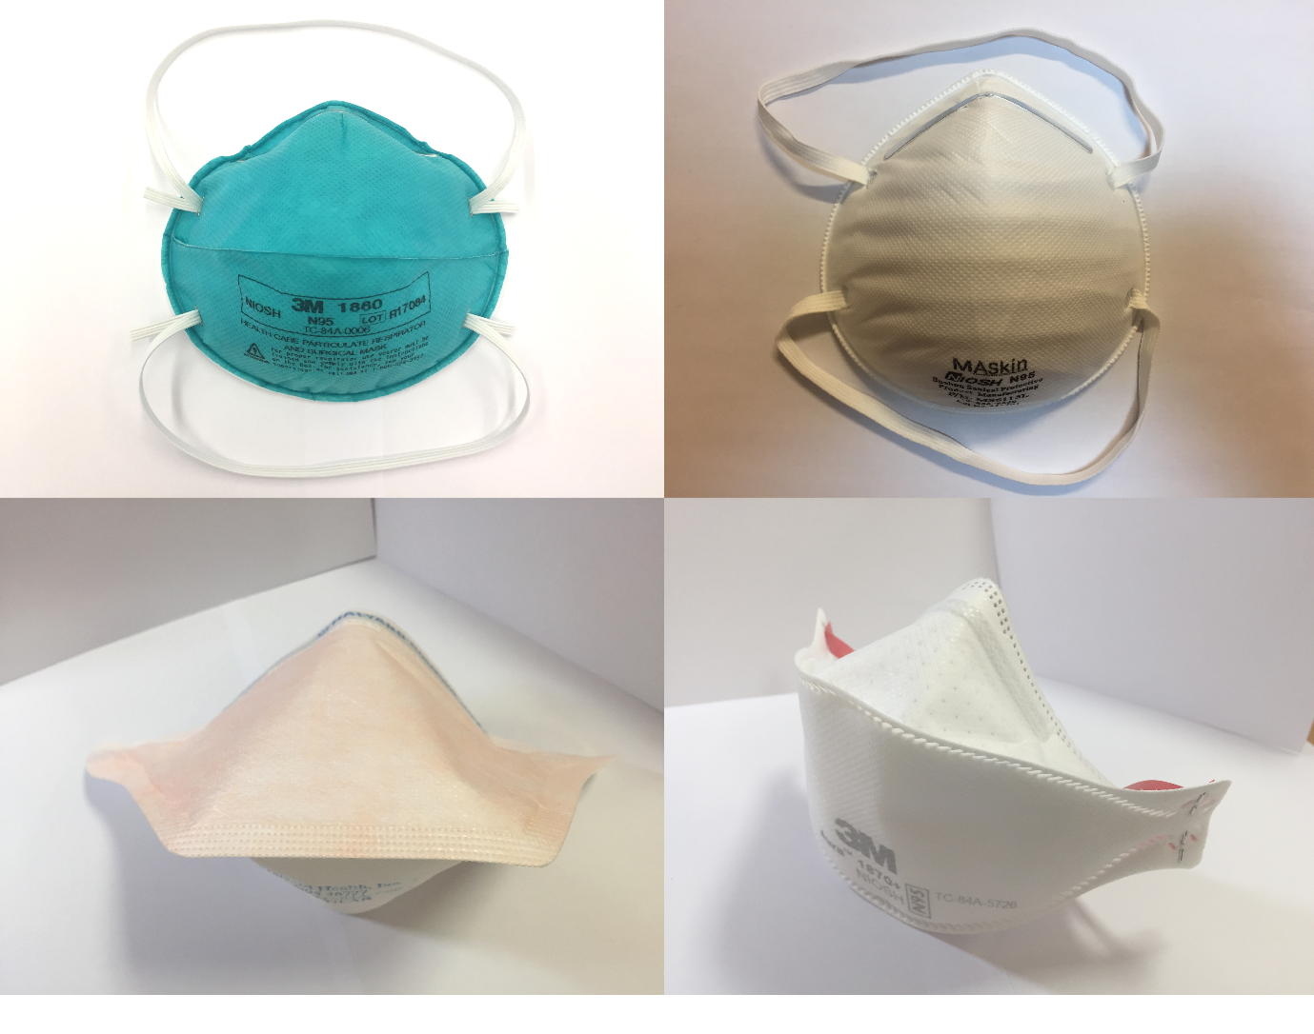
Appendix Figure 2. Distribution of the face size of study subjects by the US National Institute for Occupational Safety and Health (NIOSH) bivariate panels. Three subjects (1.4%) fell outside the range of the bivariate panel. Horizontal axis shows bizygomatic width (face width) and vertical axis shows menton-sellion length (face length). Dimensions are in milimeters.

Appendix Figure 3. Pass rates for different models of N95 filtering facepiece respirators (FFR) in overall QNFT and at two different stages. For 3M 1860, pass for either the standard (1860) or small-size model (1860S) are shown as a pass for 1860(S).

Appendix Figure 4. Proportion of subjects who passed quantitative fit test (QNFT) with different numbers of N95 filtering facepiece respirator (FFR) models.

