Supplementary information

Supplementary Figure 1. Twitter networks from the ACIPC conference 2016.
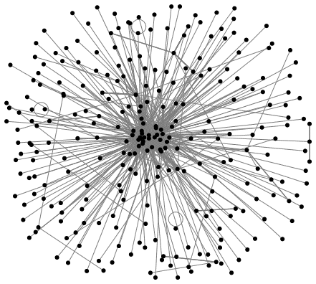

Note: The black dots indicate the username of one person. A line (edge) between usernames, indicates a relationship – a tweet sent by one person that included the username the other. ACIPC = Australasian College for Infection Prevention and Control.
Supplementary Figure 2. Twitter networks from the FIS/HIS conference 2016.
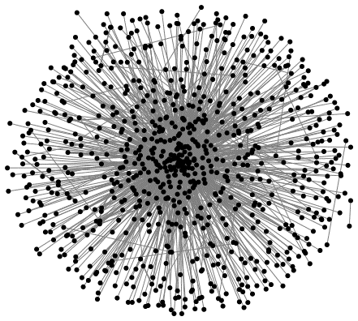

Note: The black dots indicate the username of one person. A line (edge) between usernames, indicates a relationship – a tweet sent by one person that included the username the other. FIS/HIS = Federation of Infection Societies/Hospital Infection Society.

Supplementary Figure 3. Twitter networks from the ID week 2016.
#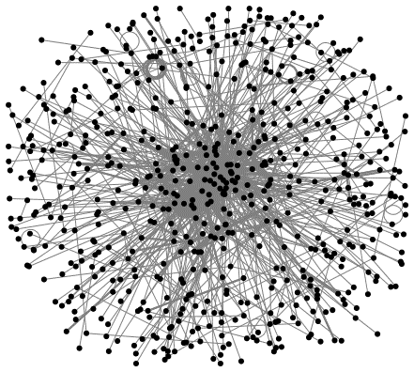

Note: The black dots indicate the username of one person. A line (edge) between usernames, indicates a relationship – a tweet sent by one person that included the username the other. FIS/HIS = Federation of Infection Societies/Hospital Infection Society.

Supplementary Figure 4. Twitter networks from the IPS conference 2016.
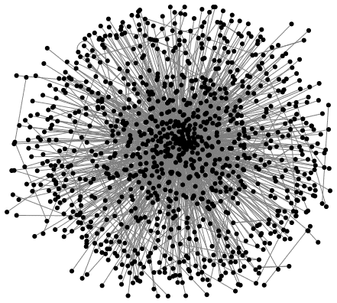

Note: The black dots indicate the username of one person. A line (edge) between usernames, indicates a relationship – a tweet sent by one person that included the username the other. IPS = Infection Prevention Society

