Support Information

Content

Figure S1 the Ultraviolet spectra of PFIO…………………………………….………2

Figure S2 1H-NMR(400MHz, CDCl3) spectra of PFIO………………………..……..3

Figure S3 Crystal packing of PFIO…………………………………………………....4

Table S1 Element analysis result of PFIO……………………………….…………….4

Table S2 Crystal and experimental data of PFIO……………….………..……………5

D:\study\李晖老师\POWDER DIFFRACTION\131223\upload\UV(131223).tifFigure S1 the Ultraviolet spectra of PFIO

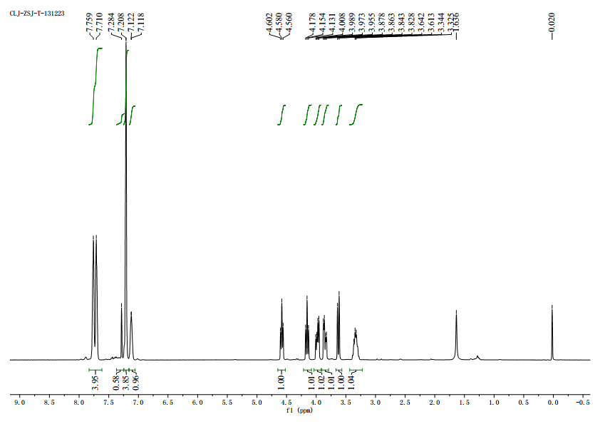

Figure S2 1H-NMR(400MHz, CDCl3) spectra of PFIO

D:\study\李晖老师\POWDER DIFFRACTION\131223\upload\Packing.tifFigure S3 crystal packing of PFIO

Table S1 Element analysis result of PFIO

|  |  |  |  |  |
| --- | --- | --- | --- | --- |
|  | N% | C% | H% | O% |
| Test 1 | 4.34 | 70.99 | 4.357 |  |
| Test 2 | 4.40 | 70.94 | 4.394 |  |
| Mean of Tests | 4.37 | 70.97 | 4.376 |  |
| Calculated value | 4.36 | 71.02 | 4.71 | 19.92 |

Table S2Crystal and experimental data of PFIO

|  |  |
| --- | --- |
| Empirical formula | C19H15NO4 |
| Formula weight | 321.32 |
| Temperature/K | 293.15 |
| Crystal system | orthorhombic |
| Space group | Pbca |
| a/Å | 8.8615(7) |
| b/Å | 14.6666(10) |
| c/Å | 24.4247(19) |
| α/° | 90 |
| β/° | 90 |
| γ/° | 90 |
| Volume/Å3 | 3174.4(4) |
| Z | 8 |
| ρcalcg/cm3 | 1.345 |
| m/mm‑1 | 0.095 |
| F(000) | 1344.0 |
| Crystal size/mm3 | 0.3 × 0.2 × 0.2 |
| Radiation | MoKα (λ = 0.71073) |
| 2θ range for data collection/° | 5.8 to 52.742 |
| Index ranges | -10 ≤ h ≤ 11, -18 ≤ k ≤ 18, -30 ≤ l ≤ 28 |
| Reflections collected | 14135 |
| Independent reflections | 3167 [Rint = 0.0206, Rsigma = 0.0201] |
| Data/restraints/parameters | 3167/0/217 |
| Goodness-of-fit on F2 | 1.029 |
| Final R indexes [I>=2σ (I)] | R1 = 0.0492, wR2 = 0.1200 |
| Final R indexes [all data] | R1 = 0.0656, wR2 = 0.1309 |
| Largest diff. peak/hole / e Å-3 | 0.41/-0.18 |