Supplementary Information
Sol-Gel Derived Silica/Polyethylene Glycol Hybrids as Potential Oligonucleotide Vectors
Derya Kapusuz
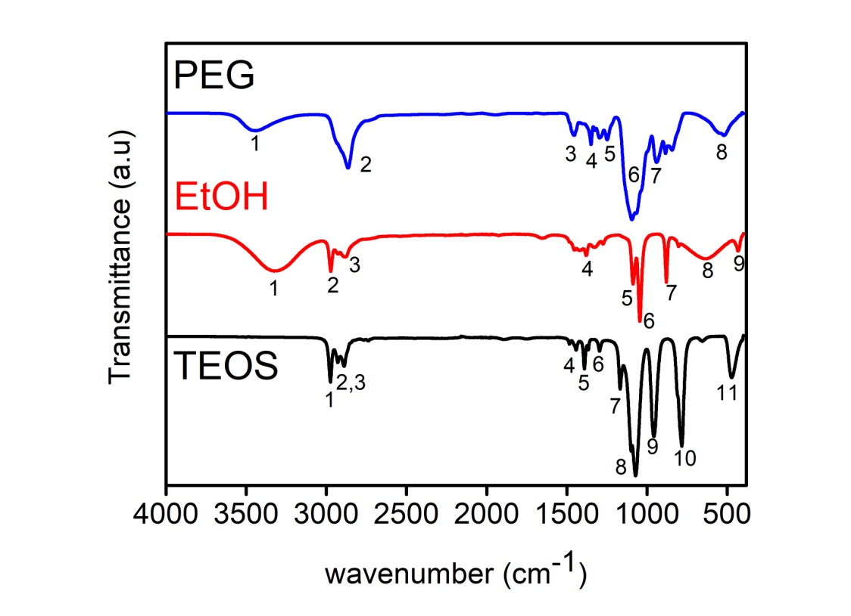
Fig S1. FTIR spectra of a) TEOS, b) PEG and c) Ethanol (EtOH) in 4000-400 cm⁻¹ wavenumber range.
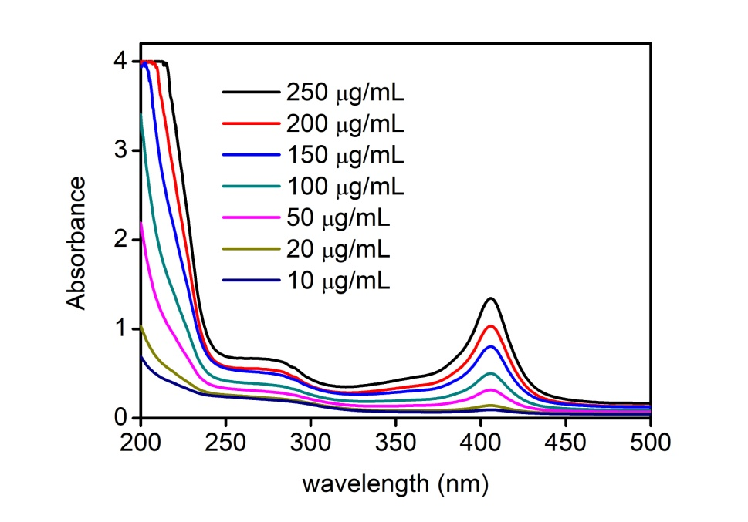
Fig S2. UV-Vis spectra of HG solutions at various concentrations (10-250 µg/mL)

Table SI. FTIR absorbance bands
TEOS |  |  | EtOH |  |  | PEG
# | Band | Assignment ^{1,2} | # | Band | Assignment^{1,2} | # | Band | Assignment^{2–5}
1 | 2976 | -OH stretching | 1 | 3320 | -OH stretching | 1 | 3450 | -OH stretching
2 | 2930 | Asym. C-H stretching (CH₃) | 2 | 2975 | Asym. C-H stretching (CH₃) | 2 | 2860 | Asym. C-H stretching (CH₂)
3 | 2888 | Asym. C-H stretching (CH₂) | 3 | 2880 | Asym. C-H stretching (CH₂) | 3 | 1455 | Asym. C-H bending
4 | 1445 | Asym. C-H bending  (CH₃) | 4 | 1380 | Sym. C-H bending | 4 | 1350 | C-H bending
5 | 1390 | Sym. C-H bending | 5 | 1085 | Asym. C-O stretching | 5 | 1250 | Alcohol C-O stretching
6 | 1290 | C-H twist  (CH₂) | 6 | 1040 | Sym. C-O stretching | 6 | 1090 | Sym. C-O-C ether stretching
7 | 1160 | C-H rocking (CH₃) | 7 | 880 | CH₃/CH₂ def. | 7 | 935 | C-C stretching
8 | 1075 | Sym. C-O stretching | 8 | 630 | - | 8 | 530 | -
9 | 970 | C-H rocking (CH₃) | 9 | 430 | O-C-C def.
10 | 790 | Asym. Si-O-Si stretching,  C-H rocking (CH₂)
11 | 475 | O-C-C def.
Asym: asymmetric; Sym: symmetric

References
1. M. C. Matos, L. M. Ilharco, and R. M. Almeida: The evolution of TEOS to silica gel and glass by vibrational spectroscopy. J. Non. Cryst. Solids 147–148, 232 (1992).
2. F. Rubio, J. Rubio, and J. L. Oteo: A FT-IR Study of the Hydrolysis of Tetraethylorthosilicate[,Spectrosc. Lett. 31, 199 (1998).
3. N. A. Alcantar, E. S. Aydil, and J. N. Israelachvili: Polyethylene glycol-coated biocompatible surfaces. J. Biomed. Mater. Res. 51, 343 (2000).
4. A. R. Polu and R. Kumar: Impedance spectroscopy and FTIR studies of PEG - Based polymer electrolytes. E-Journal Chem. 8, 347 (2011).
5. Khairuddin, E. Pramono, S. B. Utomo, V. Wulandari, A. W. Zahrotul, and F. Clegg: FTIR studies on the effect of concentration of polyethylene glycol on polimerization of Shellac. J. Phys. Conf. Ser. 776, 012053 (2016).

