Supplementary Materials for:
A comparative analysis of sound absorption performance of ZL104/aluminum fiber composite foam
Yingwu Wang¹, Xiaoqing Zuo^{1,a)}, Dehao Kong¹, Yun Zhou¹
¹School of Materials Science and Engineering, Kunming University of Science and Technology, Kunming 650093, China
^{a)}Address all correspondence to this author. e-mail: zxqdzhhm@kmust.edu.cn

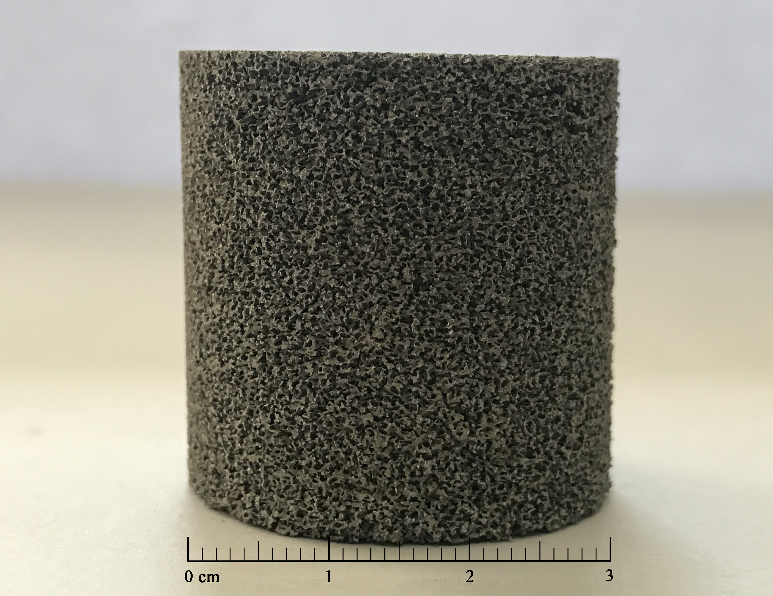
Figure S1. The photograph of the “Φ 30 × 30 mm foam” sample

