Mechanical, Tribological, and Electrochemical Behavior of Hybrid Aluminum Matrix Composite Containing Boron Carbide (B₄C) and Graphene Nanoplatelets (GNPs)

Qaisar Abbas shafqat†, Rafi-ud-din ‡,*, M. Shahzad‡, Mahmood Khan‡, Sultan Mehmood‡, Waqar Adil Syed†, Abdul Basit‡, Nasir Mehboob¥, T.Ali£

FIG. S1: Raman Spectra of (a) graphite, (b) graphene oxide, and (c) graphene; (d) XRD pattern of synthesized graphene

FIG. S2: SEMs micrographs of synthesized Graphene nanoplatelets

FIG. S3: SEM images of Al/B₄C/GNPs composite powders after wet mixing and ball milling

FIG. S4: SEM images of sintered (a,b) Al/10 wt. % B₄C/ 0.6 wt.% GNPs, (c,d) Al/10 wt. % B₄C/ 1.2 wt.% GNPs

FIG. S5: EDS mapping of sintered Al/10 wt. % B₄C/ 0.6 wt.% GNPs composite

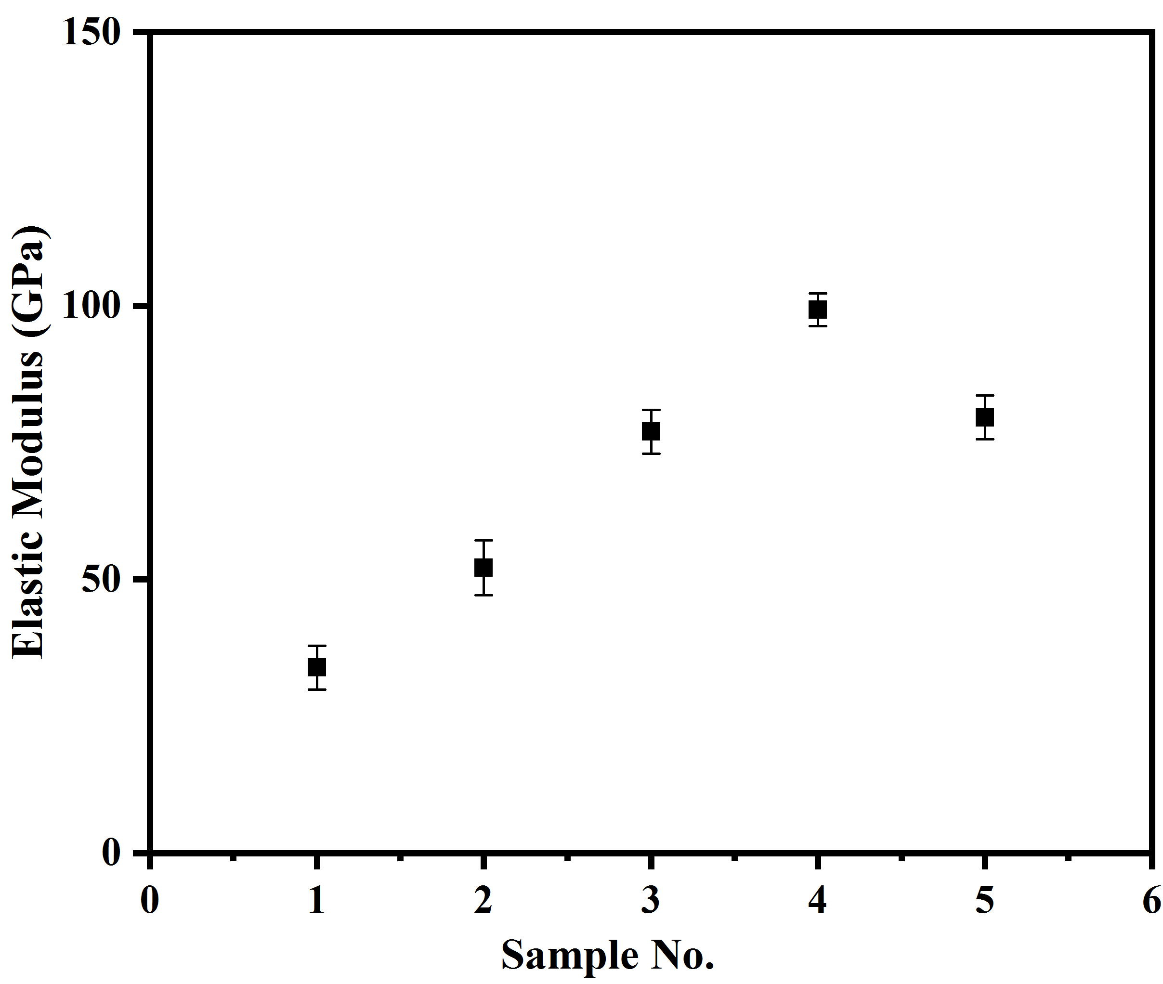

FIG. S6: Elastic moduli of Al/B₄C/GNPs composites

FIG. S7: Equivalent electronic circuit model for EIS data fitting.

Table SI. Theoretical and experimental densities of pure aluminium and aluminium matrix composites containing boron carbide and GNPs.

Samples | Theoretical Density (g/cm³) | Experimental Density (g/cm³)
1 | 2.7 | 2.64±0.3
2 | 2.68 | 2.62±0.2
3 | 2.67 | 2.61±0.4
4 | 2.67 | 2.61±0.3
5 | 2.66 | 2.59±0.4

